*Target Journal: Biological conservation*

**Using population viability analysis to inform the reintroduction of an endangered long-distance migrating passerine**

*Target Journal: Bird conservation international*

**Using population viability analysis to inform the reintroduction of the endangered Aquatic Warbler at the western margin of its breeding range**

Susanne Arbeiter1, Žymantas Morkvėnas2, xxx

1 Institute of Botany and Landscape Ecology, Greifswald University, Partner in the Greifswald Mire Centre, Greifswald, Germany

2 Baltic Environmental Forum, Vilnius, Lithuania

**Correspondence**

Institute of Botany and Landscape Ecology, Greifswald University, Partner in the Greifswald Mire Centre, Soldmannstr. 15, 17489 Greifswald, Germany

Email: susanne.arbeiter@uni-greifswald.de

**Keywords:** Aquatic Warbler, conservation management, extinction risk, habitat restoration, translocation

**Authors contribution**

**Acknowledgements**

**Using population viability analysis to inform the reintroduction of an endangered long-distance migrating passerine**

**Abstract**

Population viability analysis (PVA) is a valuable tool to guide the reintroduction of endangered bird species. In migrants, demographic data required for population projections are often deficient, making reintroduction outcomes challenging to predict. The globally threatened Aquatic Warbler *Acrocephalus paludicola* is a long-distance migrating passerine that breeds in sedge fen mires in Central Europe and winters in sub-Saharan Africa. Although conservation measures have stopped the decline in the core breeding sites, the westernmost population (Pomeranian population) is currently threatened with extinction. In this study, we used PVA simulations under different demographic scenarios to determine the most important vital parameters driving the decline and to reveal the duration of releases of juveniles, translocated from the core breeding area needed for a successful reintroduction. Probability of extinction was most sensitive to first year mortality, reproductive output and female adult mortality. Based on our simulations a minimum of 16 years of annual releases of 50 chicks (in total 800 chicks) to six release sites would be needed to achieve 90% survival after 50 years in a moderate demographic scenario and only when translocations are accompanied by habitat restorations. Higher reproductive output may reduce this duration in a best case scenario, but in a worst case scenario with constant 5% higher first year mortality, population persistence would never be achievable. Because of highly variable first year survival in a long-distance migrant, we conclude that more than 20 years of translocations are needed to reintroduce the nearly extinct Pomeranian population of Aquatic Warblers.

**Word limit abstract: 250 / Text: 8000**

**Introduction**

Worldwide, a growing number of vertebrate species are threatened with extinction (**Munstermann et al., 2021**). Anthropogenic pressure and climate change increases habitat loss and fragmentation, which accelerates the risk of population decreases (**Dale, 2001; Lees et al., 2022**). Conservationists are facing the challenge to effectively manage populations and halt ongoing declines (**Bubac et al., 2019; Davis et al., 2023**). For small and isolated populations, providing and maintaining suitable habitat is sometimes not sufficient to increase numbers again (**Dale, 2001; Armstrong and Reynolds, 2011**). Therefore, the reintroduction of a species into a part of its range from which it has disappeared is an increasingly applied conservation action to assist the recovery of endangered populations (**IUCN/SSC 2013; Bubac et al., 2019**).

Long-distance migrants had been rarely addressed in reintroduction projects so far, although migratory species are more susceptible to population changes than residents and several Afro-Palaearctic migrants have declined during the last decades (**Vickery et al., 2014; Lees et al., 2022**). The implementation of effective conservation measures for long-distance migrants has to take into account that their lifecycle includes breeding sites, staging sites during migration and the wintering site, covering different climatic zones and habitats, which in turn are subject to variable threats and alternations (**Finch et al., 2014; Vickery et al., 2014**). The habitat conditions at the breeding sites are often well studied, but most migrants spend more than 75% of the year at non-breeding sites, where preconditions and parameters affecting survival are poorly understood (**Halupka et al., 2017; Davis et al., 2023**). Carryover effects that influence survival and reproduction will also impact reintroduction outcome (**Finch et al., 2014; Davis et al., 2023**). Generally high juvenile mortality and low levels of natal philopatry in long-distance migrants reduce recruitment and may impede the establishment of a population at a given release site (**Weatherhead & Forbes, 1994; Carter et al., 2008; Imlay et al., 2010**). Long durations of releases will be required to observe changes in population size to evaluate reintroduction success (**Carter et al., 2008; Imlay et al., 2010**). Additionally, due to low recapturing rates in these species, data on survival and dispersal are often scarce making population development after translocations difficult to predict (**Heinsohn et al., 2022**).

Population viability analysis (PVA) is an important tool to guide the reintroduction of endangered bird species (**Schaub et al., 2009; Armstrong and Reynolds, 2011; Heinsohn et al., 2022**). PVA models simulate temporal changes in population size and estimate extinction probability incorporating demographic stochasticity and can also be used to predict reintroduction outcomes (**Akçakaya and Sjogren-Gulve, 2000; Armstrong and Reynolds, 2011**). Because these models rely on demographic input data, availability and quality of vital parameters are crucial for estimating future population size. However, data on survival and reproductive output are often deficient in threatened species (**Heinsohn et al., 2022; Davis et al., 2023**). Especially in long-distance migrants, survival can be expected to be highly variable due to annually changing habitat conditions during migration and wintering (**Ockendon et al., 2014; Halupka et al., 2017**), which further increases uncertainty for future predictions. But even with uncertainties, PVA models can still be useful to compare different management options (**Heinsohn et al., 2022**). Sensitivity analysis helps to identify most affected parameters and implementing several scenarios for parameters with uncertainties will provide “best case” or “worst case” outcomes (**Akçakaya and Sjogren-Gulve, 2000**). Furthermore, the calibration of projections using observed data can be essential to evaluate the validity of demographic assumptions and derived population dynamics (**Badia‐Boher et al., 2024**).

We used PVA in this study to inform the reintroduction of a long-distance migrating bird. The Aquatic Warbler *Acrocephalus paludicola* is a small passerine that breeds in mesotrophic sedge fen mires in Central Europe and winters in sub-Saharan Africa. The species was once widespread and numerous throughout Europe. During the last decades, global population experienced a severe decline (> 90%) caused by habitat loss and degradation due to drainage, peat extraction, conversion to agricultural land and eutrophication (**Flade and Lachmann, 2008; Tanneberger et al., 2011**). Today, the Aquatic Warbler is one of the rarest songbirds of continental Europe, classified under the IUCN category “vulnerable” given its small breeding range and continuing threat of habitat loss and population decline (**BirdLife International, 2024**). After the implementation of conservation measures, the decline was halted in the core breeding sites of the species. Only four breeding sites in Belarus, Poland and Ukraine hold 75% of the entire world population of about 11,000 singing males (**Flade et al., 2018).** In peripheral breeding sites, however the decline continues and the westernmost population in Germany and northwestern Poland (hereafter Pomeranian population) is currently threatened with extinction. Recently, a pilot study demonstrated the successful translocation of Aquatic Warbler chicks from Belarus to Lithuania (**Morkvėnas et al., 2024**). In 2023, the first translocation of chicks from the core breeding sites started the reintroduction within the Pomeranian population.

In this study, we aim to analyse the demographic drivers behind the fast decline of the Pomeranian population of Aquatic Warblers using a population viability analysis in retrospective to compare predictions with observed count data. Furthermore, we used the developed population viability model to reveal how many years of releases are needed to establish a stable population under different demographic scenarios and if additional conservation measures such as habitat restoration can positively affect population persistence. Our results contribute to design the reintroduction process of Aquatic Warbler translocations to successfully recover the nearly extinct Pomeranian population and may also be useful for the conservation management of other long-distance migrating passerines.

**Material and methods**

**Study population**

The Pomeranian population of the Aquatic Warbler comprises breeding sites in northwestern Poland and northeastern Germany, which are nowadays the westernmost remnants of a once widespread European breeding range (**Flade et al., 2018**). After the successive disappearance of several breeding sites in western Poland, the Pomeranian population is now geographically isolated from core breeding sites in eastern Poland (Fig. 1). Aquatic Warblers show an extraordinary promiscuous breeding system with uniparental brood care by females which attempt to breed twice between May and July (**Schulze-Hagen et al., 1999; Dyrcz et al*.*, 2018**). Females behave very secretive, but males sing continuously during the breeding season from exposed vegetation structures some hours before sunset to attract mates (**Schulze-Hagen et al., 1999; Dyrcz et al., 2018**). Therefore, population size is assessed by counting singing males in this species, which is also a good indicator for the number of nests (**Kubacka et al., 2014**). Counts take place at the end of May and end of June, during the peaks of the first and second breeding attempts. Comprehensive and largely synchronous annual counts were conducted with standardised methodology in Poland in 1993 and 1997 (**Krogulec and Kloskowski, 2003**), and from 2003 onwards in the entire range of the Pomeranian population. In the remaining years only a subset of sites was counted each year. Despite conservation actions, the Pomeranian population strongly declined during the last 30 years (**Flade et al., 2018**). After a pilot study demonstrated the successful translocation of Aquatic Warbler chicks from Belarus to Lithuania (**Morkvėnas et al., 2024**), the reintroduction of the Pomeranian population started with the first translocation from core breeding sites in eastern Poland (Biebrza National Park) to northwestern Poland (Rozwarowo Marshes) in 2023. Further translocations to former and suitable breeding sites within the Pomeranian population range (Fig. 1) are planned during the following years.

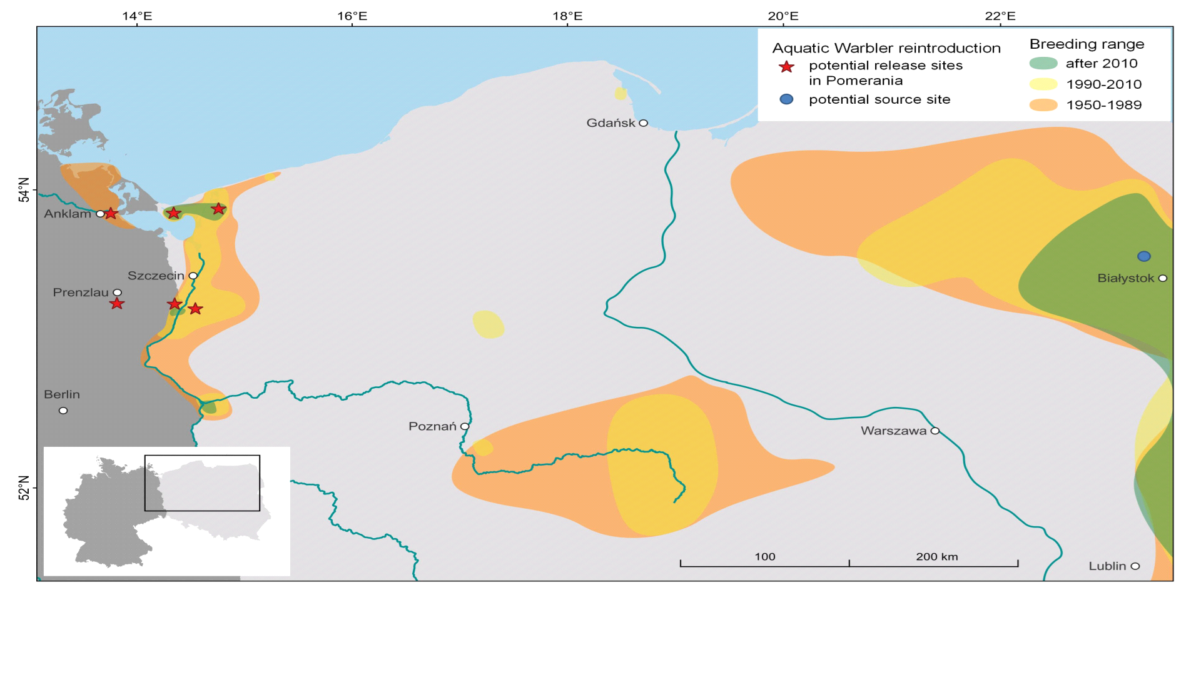

**Fig. 1.** Breeding range decline of the Aquatic Warbler and location of potential release sites for the reintroduction of the Pomeranian population.

**Statistical analysis**

**Population viability analysis**

We applied a population viability analysis (PVA) to simulate population development of the Pomeranian population between 1993 and 2023 and compared the results with the observed count data. We run simulations with 1,000 iterations using the program VORTEX (Version 10.6.0, **Lacy and Pollak, 2023**). VORTEX software is provided under a CreativeCommons Attribution-NoDerivatives International License, courtesy of the Species Conservation Toolkit Initiative ([https://scti.tools](https://scti.tools/)) and uses individual-based models accounting for demographic, environmental and genetic stochastic events. These models rely on demographic parameters like random variation in births and deaths and can include environmental factors such as food availability or natural catastrophes as well as genetic drivers like loss in genetic diversity due to inbreeding and genetic drifts (**Lacy, 2000**). We projected the model to 50 years starting from 1993 and defined species extinction when only one sex remains.

**Demographic parameters**

The breeding system of Aquatic Warblers was classified as polygynous (**Schulze-Hagen et al., 1999**). The majority of broods are fathered by more than one male, thus also females mate with several partners during the breeding season (**Dyrcz et al., 2018**). Males defend no exclusive territories and no pair bonds are formed (**Schulze-Hagen et al., 1999**). Therefore, we conclude that all males and all females of a population attempt to reproduce every year (Tab. 1). Life expectancy is unknown for the Aquatic Warbler. Based on the age distribution of related Warblers such as the Sedge Warbler *Acrocephalus schoenobaenus* (**Bielański et al., 2017**) and the Great Reed Warbler *Acrocephalus arundinaceus* (**Forstmeier et al., 2006**) we assumed a maximum lifespan of four years and reproduction between first and fourth year (Tab. 1). Annual mortality for adults was obtained from a survival estimation of 279 Aquatic Warblers (149 males, 130 females) ringed between 1987 and 1995 in Biebrza Marshes in Poland (**Dyrcz and Zdunek, 1993a; Dyrcz and Chylarecki, 2018**). Apparent survival estimate was 67% (95% confidence interval: 53.7-78.5%) for males and 42% (95% confidence interval: 29.0-56.3%) for females in this analysis (**Dyrcz and Chylarecki, 2018**). The lower estimates for females are probably attributed to a lower detection probability because of a more secretive behaviour, but may also be caused by lower site fidelity and higher dispersal probability (**Bellebaum, 2018; Dyrcz and Chylarecki, 2018**). Because the return rate of adults affects the local population development we used the estimated 58% apparent mortality (1–apparent survival) for females, including an unknown degree of dispersal, and 33% mortality for males in the population model (Tab. 1). First year (apparent) survival was estimated for juveniles translocated from Zvanets (Belarus) to Zuvintas Biosphere Reserve (Lithuania) in 2018 and 2019 (**Morkvėnas et al., 2024**). Because return rates of juveniles were different between years, we simulated also scenarios with 5% higher and lower first year mortality (Tab. 1). Clutch size varies between 3 and 6 eggs with a median of 5 eggs (**Dyrcz and Zdunek, 1993b; Schulze-Hagen et al., 1999**). Breeding success is higher than 60% and the average number of fledglings per brood is 3.5 ± 1.8 (**Kubacka et al., 2014**). A former study from the same study area revealed a similar reproductive output (**Dyrcz and Zdunek, 1993b**). In both studies, the number of fledglings was smaller in second broods (on average 2.3-2.8 fledglings) than in first broods (on average 3.5-3.8 fledglings, **Dyrcz and Zdunek, 1993b; Kubacka et al., 2014**). Under optimal conditions up to 50% of the females initiate a second brood (**Dyrcz and Zdunek, 1993b; Schulze-Hagen et al., 1999**). We applied three scenarios of 50%, 25% and 0% of second broods to vary reproductive output (Tab. 1). Sex ratio at birth is balanced (49% males, **Dyrcz et al., 2004**), adult sex ratio in the breeding population is assumed to be slightly male biased (56% males, **Dyrcz and Zdunek, 1993a**). Population assessment in the Aquatic Warbler is based on counts of singing males (**Krogulec and Kloskowski, 2003**). Therefore, we assumed that the number of males counted represents 56% of the total population size including females (Tab. 1). For the amount of suitable habitat available in 1993 we used the area of occupancy of 2965 ha described by **Flade et al. (2018)** for the Pomeranian population. The area of occupancy was calculated by constructing circular buffers of 160 m around all records of singing males, which corresponds to the maximum home range size of 8 ha (**Schaefer et al., 2000; Tanneberger et al., 2018**). Carrying capacity is difficult to derive, because breeding densities are highly variable throughout the range and are possibly lower in small and isolated sites. In large high quality habitats breeding density can be high, on average 9.6 (1.8-21.5) males per 10 ha and on average 6.0 (0.0-18.0) nests per 10 ha (**Kubacka et al., 2014**). Based on the maximum numbers of singing males divided by the area of occupancy of breeding sites (**Tanneberger et al., 2018**) an average density of 0.3 males per ha can be assumed. In Pomerania, however, these densities of singing males have never been reached, not even in the 1970s when Aquatic Warblers were still abundant. Therefore, we used a density of 0.15 males per ha for calculating carrying capacity, which represents the average of singing male densities of Pomeranian breeding sites (**Tanneberger et al., 2018**). For the population of 250 singing males in 1993 we assumed no negative impact due to inbreeding depression. Because in the strongly declined population inbreeding could further accelerates extinction risk we simulated also one scenario including inbreeding depression using the default values suggested by **Lacy and Pollak, (2022)** based on the combined effect of inbreeding on fecundity and first year survival (**O'Grady et al., 2006**, Tab. 1).

**Sensitivity analysis**

We conducted sensitivity analysis to indentify uncertainties of input parameters and their effects on model predictions. Our baseline model contained a proportion of second broods of 25%, female adult mortality of 58%, male adult mortality of 33%, an average first year mortality of 70%, a average number of 3.5 fledglings per brood and a carrying capacity of 800 individuals (Table 1). We varied the following parameters to evaluate their effect on stochastic growth rate (*r*) and on probability of extinction after 50 years: proportion of second broods between 0% and 50%, fledged brood size (± 0.25, ± 0.5), first year and adult mortality (± 5%, ± 10%) as well as carrying capacity (± 200, ± 400, Table 2). Step by step one parameter value was changed while all other parameters were kept constant during simulations. We extracted estimated values for stochastic growth rate and probability of extinction from VORTEX and plotted them in relation to parameter variation (Fig. 3). Higher steepness of the slope of the plotted relationship indicates a higher effect of a certain parameter on a given viability parameter. Additionally, we used a logistic regression approach to determine which parameter explains most of the variability in estimating probability of extinction (**Cross and Beissinger, 2001**). For each parameter combination set we ran 1,000 iterations in VORTEX, resulting in 34,000 binary observations of population extinction or persistence after 50 years. Using these values as the binary dependent variable and parameter set values as independent variables we applied a simple logistic regression in the program R (Version 4.0.0, **R Core Team, 2024**) and used standardized regressions coefficients to rank the relative importance of parameters on the estimates of extinction risk (**McCarthy et al., 1995**).

**Reintroduction scenarios**

The PVA described above was used to simulate different scenarios of supplementation to estimate the number of releases needed to re-establish a stable population. Simulations with 1,000 iterations were projected to 50 years starting 2023, when the first translocation within the Pomeranian population was performed. Population persistence was defined by achieving less than 10% extinction probability or in reverse more than 90% survival probability of the metapopulation over the next 50 years. That means out of 1,000 iterations, 100 are allowed to go extinct in 50 years. In order to incorporate most of the uncertainty of the demographic parameters in the model, we constructed worst, moderate and best case scenarios for the reintroduction process. First year mortality was included with 75%, 70% and 65% to simulate these different scenarios. Since the proportion of second broods is unknown for the Pomeranian population, we assumed 10%, 25% and 40% second broods for the worst, moderate and best case scenario, respectively. Additionally, we included one scenario with a 5% lower female adult mortality than in the baseline model (53%). Exchange within Pomeranian breeding sites is confirmed by resightings of colour-ringed males (G. Kiljan, unpubl., in **Dyrcz et al., 2018**). Also females may move to other breeding sites for the second brood (**Dyrcz and Zdunek, 1993b; Schulze-Hagen et al., 1999**). Movements both within and between breeding seasons are documented (**Dyrcz et al., 2018**). Therefore, we assumed dispersal probabilities of 5% between release sites for both sexes and all age classes. Due to the experience in the pilot translocation of Aquatic Warblers, 10 nests (about 50 chicks) per year are an optimum for logistical reasons, for the handling during feeding and to minimize impact on the source site (**Morkvėnas et al., 2024**). Hence, scenarios of releases will not include higher numbers of annual releases but different durations of years with subsequent releases to a differing number of sites. We identified six potential release sites within the range of the Pomeranian population (Fig. 1). We applied scenarios of several years of subsequent releases (up to 36 release years in total) to one, two, four or six release sites to determine the impact of number of release sites and the duration of releases on population persistence. We also tested a scenario of simultaneous translocations to two release sites without increasing total number of releases. Initial population size was two individuals (one singing male) at one release site in 2023. At all other release sites there were currently no Aquatic Warblers recorded, thus initial population size was zero. We assumed that each release site provides 200 ha of suitable habitat, which can be increased to 400 ha by habitat restoration. Increase in available habitat will result in an increase in carrying capacity for each release site (carrying capacity ± SD: 54 ± 10 before and 107 ± 20 after habitat restoration).

For validation, we used our model to project population development for the Žuvintas population of Aquatic Warblers of the pilot translocation study in Lithuania (**Morkvėnas et al., 2024**). We started the model with the initial population size of 13 individuals (7 singing males) in 2015. Our baseline model contained a proportion of 25% second broods, female adult mortality of 58%, male adult mortality of 33% and an average number of 3.5 fledglings per brood. First year mortality was included with 75%, 70% and 65% to simulate worst, moderate and best case scenarios. We also run one scenario with a female adult mortality of 43% (**Bellebaum, 2018**). We defined a carrying capacity (± SD) of 54 ± 10, because Žuvintas release site provides ~200 ha of suitable habitat. Projections were then compared to observed count data of singing males until 2024. All figures were created using ggplot2 (**Wickham, 2016**) implemented in R (Version 4.0.0, **R Core Team, 2024**).

**Results**

**Population development 1993 – 2023**

After 250 and 262 singing males were counted in 1993 and 1997, respectively, the Pomeranian population was substantially smaller in 2003 and experienced a slow but continuous decrease until 2011. In 2012 and 2013 occurred another steep decline followed by further decrease after 2018 (Fig. 2). Based on an average first year mortality of 70% and an optimum of 50% second broods the population would have remained stable over the last 30 years (Fig. 2). Lower first year mortality can compensate for a reduced proportion of second broods, but none of these simulated scenarios resembled the observed population development (Fig. 2). Low observed numbers of singing males after 1997 and the decline from 2003 onwards fit either to the simulations for the no second brood scenario or to a scenario of a reduction in the proportion of second broods in combination with increased first year mortality (Fig. 2).

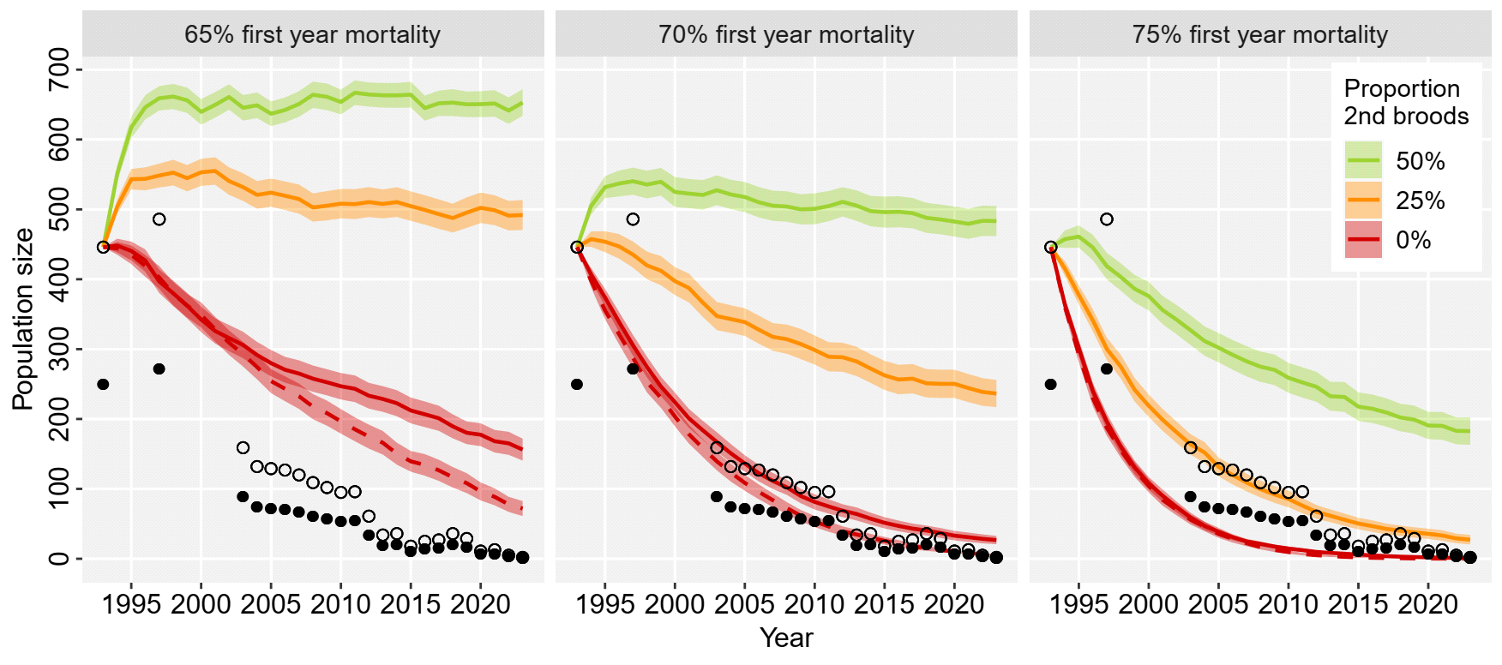

**Fig. 2**: Population development (mean size ± 95% CI) of the Pomeranian population 1993-2023 simulated in VORTEX for 50%, 25% and 0% proportion of second broods and 65%, 70% and 75% first year mortality. Dashed line indicates the simulation with inbreeding effect. Filled circles show count data of singing males, open circles population size based on an adult sex ratio of 56% males.

**Model sensitivity**

Highest sensitivity of probability of extinction after 50 years was found for first year mortality (Tab. 2). An increase of 5% in first year mortality will increase probability of extinction by more than 50% (Tab. 2, Fig. 3). Stochastic growth rate is also highly sensitive to first year mortality and a variation of 5% will change growth rate by 0.12 (Fig. 3). Fledged brood size and proportion of second broods had a similar effect on probability of extinction (Fig. 3), because both parameters were determinants of the reproductive output per female. A reduction of the average fledged brood size by 0.25, and a reduction of the proportion of second broods by 10% will increase probability of extinction by 22% and decrease growth rate by 0.05 (Fig. 3). High sensitivity was also found for variation in female mortality, but about half as strong as for first year mortality. An increase of 5% in female mortality will increase probability of extinction by 28% and reduce growth rate by 0.05 (Fig. 3). Variation in male mortality has no significant impact on population growth or probability of extinction (Fig. 3). Changes in carrying capacity will not affect growth rate, however, higher carrying capacity will reflect in a larger population size that can be reached after 50 years (Table A1, Fig. B2) and therefore reduce the probability of extinction, but only at a small rate (Fig. 3). When assuming 70% juvenile mortality and an average brood size of 3.5 fledged chicks in the baseline model a proportion of 28% second broods would be needed to achieve a positive population growth rate (Fig. 3).

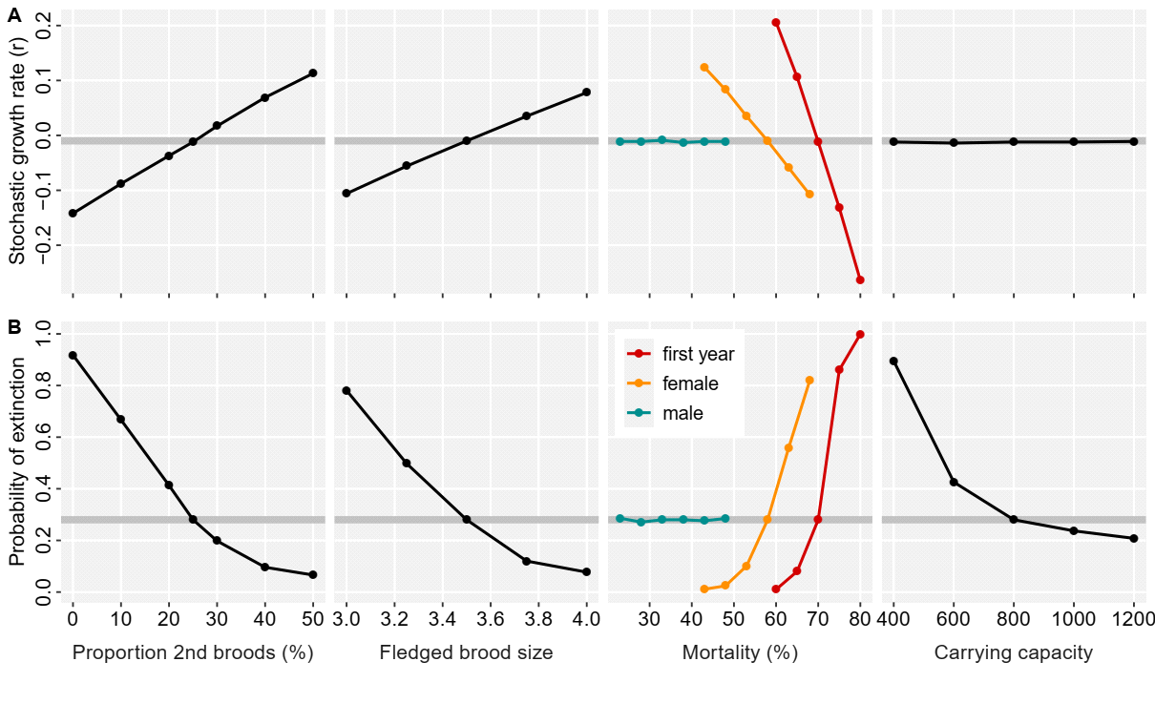

**Fig. 3.** Sensitivity of stochastic growth rate (A) and the probability of extinction after 50 years (B) to the variation of the parameters: proportion of second broods, fledged brood size, first year and adult mortality and carrying capacity simulated in VORTEX. Values of the baseline model were shaded grey.

**Reintroduction scenarios**

Estimates of population persistence were highly affected by variation in the demographic scenarios, but were also influenced by the number of release years and the number of release sites (Fig. 4, Table A1). Higher survival probabilities after 50 years were not only estimated for a longer duration of subsequent releases but also for a higher number of release sites. Four years of subsequent releases to 6 sites resulted in higher survival probability than 6 subsequent releases to 4 sites (Fig. 4). In a moderate scenario, assuming 70% first year mortality and 25% second broods, 24 years of annual releases of 50 chicks to 6 release sites, or 30 years of annual releases to 4 release sites would be needed to achieve more than 90% survival probability over 50 years of the metapopulation (Fig. 4, Table A1). Simultaneous releases to two release sites will increase, not reduce the duration of releases needed (Table A1). When assuming 5% lower female adult mortality, population persistence could be reached in one third of the time (8 years of releases to 6 sites, 10 years of releases to 4 sites, Table A1). With habitat restoration, i.e. doubling the carrying capacity at each release site, 16 years of releases to 6 sites (Fig. 4, Table A1), or 20 years of releases to 4 sites (Table A1) are needed to achieve population persistence. Assuming higher reproductive output, e.g. in a more optimistic scenario with 40% second broods, 7 years of releases to at least 4 sites would already result in a survival probability of the metapopulation of more than 90% in 50 years (Table A1). In all scenarios assuming a higher first year mortality of 75% even after 36 years of releases population persistence is not achieved (Fig. 4, Table A1, Fig. B1).

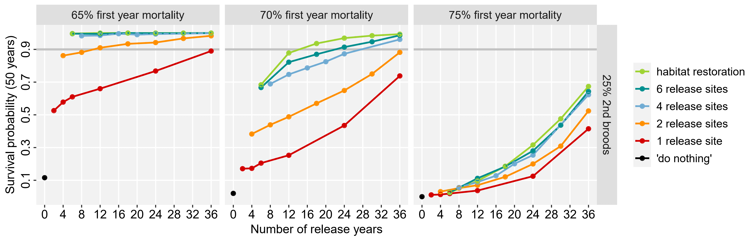

**Fig. 4.** Survival probability after 50 years in relation to the number of release years and different numbers of release sites for the reintroduction of the Pomeranian population of Aquatic Warblers by translocations. The effect of increasing carrying capacity by habitat restoration is only shown for 6 release sites. Survival probabilities were simulated in VORTEX for the demographic scenarios 65%, 70% and 75% first year mortality and 25% second broods (simulations for 10% and 40% second broods see Appendix Fig. B1). Horizontal grey line indicates 90% survival probability after 50 years.

After two years of releases of 50 Aquatic Warbler chicks each in 2018 and 2019 during the pilot translocation study in Lithuania (**Morkvėnas et al., 2024**), population size was highly variable in the subsequent years (Fig. 5). After a substantially increase in 2020, the population declined again in the subsequent years. Current population size is still in the range of the simulations for the moderate scenario with 70% first year mortality of the baseline model (Fig. 5).

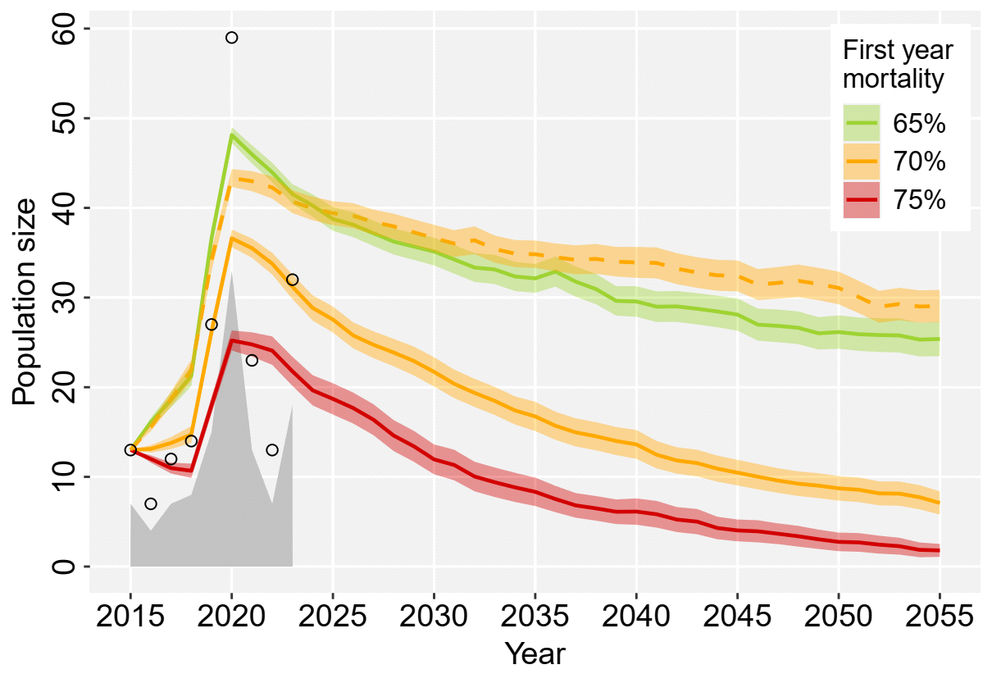

**Fig. 5.** Population size (mean size ± 95% CI) of the Žuvintas population in Lithuania after two years of releases of 50 Aquatic Warbler chicks each in 2018 and 2019, simulated with 1,000 iterations in VORTEX for 65%, 70% and 75% first year mortality and 25% second broods. Dashed line shows the simulation with 43% female adult mortality. Grey area indicates count data of singing males, open circles population size based on an adult sex ratio of 56% males. + 2024

**Discussion**

**Population development 1993 – 2023**

One aim of this study was to determine the demographic drivers behind the observed decline of the Pomeranian population of Aquatic Warblers during the last 30 years. Catastrophic events were not included in our simulations, although ongoing habitat loss until 2003 has certainly contributed to the fast collapse of the population (**Flade et al., 2018**). Large-scale drainage and increased land use intensity on fen mires drastically reduced available habitat (**Tanneberger et al., 2011**). The extent of habitat deterioration during that time period and in particular the impact on Aquatic Warbler populations is difficult to quantify. However, loss of suitable breeding habitat directly translates into demographic consequences. Our PVA suggests that the low numbers of Aquatic Warblers after 1997 are attributed to a reduction in the proportion of second broods or a reduction in reproductive output in general (Fig. 2). The majority of females are assumed to move to other breeding sites for the second brood (**Dyrcz and Zdunek, 1993b; Schulze-Hagen et al., 1999**). During the 1990s, ongoing habitat loss increased habitat fragmentation which possibly has limited movements between breeding sites. Additionally, mowing during the breeding season before July reduced the possibility for second breeding attempts and possibly also increased female mortality to some extent which also negatively influences population growth rate (Fig. 3).

Declines may also have been related to a combination of low reproductive output and increased first year mortality (Fig. 2). Mortality in migrants is highly affected by conditions on wintering grounds and during migration and therefore annually variable. In Sedge Warblers, survival and population changes are significantly related to rainfall at the wintering site (**Peach et al., 1991; Ockendon et al., 2014**). Higher survival in Common Reed Warblers *Acrocephalus scirpaceus* was associated with more precipitation at the stopover sites in Spain and Morocco (**Halupka et al., 2017**). Aquatic Warblers are insectivores and accumulate fat deposits for migration (**Kerbiriou et al., 2010**). Because they need refuelling en route, they highly rely on food availability at stopover sites (**Kerbiriou et al., 2010;** **Vickery et al., 2014**).Carryover effects may translate adverse conditions during non-breeding periods in lower reproduction in the subsequent year (**Finch et al., 2014**). We were not able to relate population changes of the Pomeranian population to rainfall at wintering or stopover sites, suggesting that negative habitat effects at both breeding and non-breeding sites have contributed to the decline.

Under the current conditions, the Pomeranian population of Aquatic Warblers is likely to go extinct in the following years. In 2023, only one singing male was recorded. Despite conservation measures were implemented and habitat quality and extent increased in the 2000s, the population was probably already too small to recover on its own. In declined and isolated populations, population growth is more difficult because years with low survival can not be compensated by immigration (**Dale, 2001; Border et al., 2017**). Additionally, small populations are more susceptible to loss in genetic diversity, inbreeding effects and demographic stochasticity, which negatively affects population growth(**Lacy 2000; O'Grady et al., 2006; Armstrong and Reynolds, 2011**). Therefore, we conclude that for population restoration, translocations of individuals of other breeding sites are needed, to avoid extinction of the Pomeranian population.

**Model sensitivity**

In our PVA, probability of extinction and population growth rate are most sensitive to first year mortality, fledged brood size and female mortality (Tab. 2). All these parameters are related to reproductive output and recruitment in the subsequent year. Whereas in long-lived species, population growth is mainly determined by adult survival (**Schaub et al., 2009; Davis et al., 2023**), in short-lived species, such as most of long-distance migrating passerines, population growth is mainly attributed to recruitment (**Dale, 2001; Border et al., 2017**). Variation in male mortality has no significant impact on population growth or probability of extinction (Fig. 3). This can be explained by the polygamous breeding system of the species without pair bonds, where females alone determine population growth. Changes in carrying capacity will also not affect growth rate, but increasing carrying capacity will increase extant population size and therefore reduce the probability of extinction (Table A1, Fig. B2). However, the demographic parameters with the highest impact on population growth rate and extinction risk (Tab. 2) are those associated with the greatest uncertainty. First year mortality was only assessed recently based on a small data set of marked juveniles of the pilot translocation study. Differences in return rates between years, ranging between 14% and more than 30% for first year males (**Morkvėnas et al., 2024**) suggest that first year survival is highly variable in Aquatic Warblers (Fig. 5). Reproductive output is determined by the number of fledglings per brood and is linked to the proportion of second broods. The average fledged brood size and the proportion of second broods is unknown for the Pomeranian population and may be lower than in the core breeding sites. Female mortality used in this analysis might be considered too high. Survival data from females are rare because of distinct lower detection probability due to their secretive behaviour (**Schulze-Hagen et al., 1999; Dyrcz et al., 2018**). Based on the observed sex ratio during migration, **Bellebaum (2018)** concluded that survival of adult females could be up to 57%. With this high survival rate we would expect a much higher increase in population size than observed in the pilot translocation study in Lithuania (**Fig. 5; Morkvėnas et al., 2024**). In simulations in VORTEX even small populations of <10 singing males would increase and remain stable, which was not confirmed in the past. Therefore, breeding site fidelity is probably rather low in Aquatic Warblers and permanent dispersal contributes to a high extent to the lower apparent survival estimates for females. Natal dispersal, which is also usually female-biased in most passerine species (**Dale, 2001**) may additionally reduce the recruitment at a given breeding site. A first year return rate of 10% for females to the release site, observed in the pilot Aquatic Warbler translocation study (**Morkvėnas et al., 2024**) is in line with return rates reported for other migrant passerines (**Grinkevich et al., 2009; Border et al., 2017**). After the first release, first year return rate of males was remarkable high (>30%), followed by a substantial population increase (**Morkvėnas et al., 2024**), indicating that at least in years with high first year survival, high population growth can be expected, possibly enough to compensate for years with lower first year survival. While our simulations assumed constant mortality, fluctuations in population size can be attributed to annually variable mortality (Fig. 5). However, the strong fluctuations in population size probably suggest that local population growth depends on immigration from other breeding sites (**Border et al., 2017**). Mortality rates (1–apparent survival) used in this study account for detection, but not for permanent emigration from the study site. Movements between breeding sites are hardly understood in Aquatic Warblers so far. Our model is based on the assumption that there is exchange between the release sites, which was confirmed in the past (**Dyrcz et al., 2018**), but the actual rate of dispersal and immigration remains unknown. Observations of colour-ringed individuals from the translocation program may help to increase the knowledge on movements between breeding sites in the future.

**Reintroduction scenarios**

Our PVA simulations suggest that all six release sites should be included in the reintroduction procedure with four subsequent release years to each release site, resulting in 24 years of annual translocations of 50 chicks (1,200 chicks in total) to achieve <10% extinction probability after 50 years for the Pomeranian metapopulation of Aquatic Warblers. Including more release sites will increase habitat area and population size is more likely to stabilize if carrying capacity is increased by increasing habitat availability (**Heinsohn et al. 2022**). Carrying capacity contributes only little to population growth (Fig. 3), but increases population size that can be reached after 24 years of releases (Fig. B2). This in turn, will decrease the extinction probability after 50 years and increase genetic diversity of the metapopulation. If carrying capacity is doubled, i.e. available breeding area is doubled to 400 ha at each release site by habitat restoration, population persistence may be reached already after 16 years of annual releases (800 chicks in total). However, carrying capacity of the habitats of the Pomeranian population is unknown and difficult to assess. Based on former population sizes, we assumed densities of 1.5 singing males / 10 ha (**Tanneberger et al., 2018**), although in core breeding sites of Aquatic Warblers, much higher densities of on average 9.6 (1.8-21.5) singing males per 10 ha are reported (**Kubacka et al., 2014**). Further investigations should address how habitat quality and food availability in Pomeranian breeding sites possibly differ from core breeding sites to verify carrying capacity.

Simultaneous translocations to two release sites does not reduce, but even increase the number of release years needed, indicating that duration of supplementation is more important than the number of released chicks. Additionally, years with simultaneous translocations would probably require an additional source site. Because the Aquatic Warbler is highly vulnerable to local population declines, the removal of more than 10 nests at one source site will be difficult to justify in this endangered species.

A growth rate > 1 and a population size close to the carrying capacity (i.e. 30 singing males / 200 ha) are good indicators for the success of the reintroduction (ref**Armstrong and Reynolds, 2011**). A comparison of observed count data with simulated population trends in the PVA can provide valuable information on the underlying demography (Fig. 5; **Badia‐Boher et al., 2024**). Projected population size after 50 years indicates a minimum of 143 individuals for population persistence of the metapopulation (Tab. A1), which refers to the 80 singing males **Flade and Lachmann, (2008**) suggested as a minimum goal for the recovery of the Pomeranian population. Because of small numbers of founders of the new population, genetic considerations should be addressed in reintroductions (**Bubac et al., 2019**). To increase genetic diversity, nests for translocation were selected from different parts of the source site to ensure fathering of different males (**J.** **Kubacka**, *pers. comm.*). A long duration of annual releases of new birds will also reduce relatedness at the release site.

**Conclusions**

Our study provides the first population viability analysis for the Aquatic Warbler. Despite uncertainties in demography and reproduction rates we were able to determine first year mortality as the most important effect on population changes. Due to highly variable first year survival and return rates in a long-distance migrant, we conclude that high effort will be needed to reintroduce the westernmost and geographically isolated Pomeranian population of the Aquatic Warbler. To our knowledge, there has been no reintroduction project of a long-distance migrating passerine so far. Translocation attempts, e.g. for a long-distance migrating non-passerine, the Corncrake *Crex crex* in the United Kingdom (**Carter et al. 2008**) and a short-distance migrating passerine, the Loggerhead Shrike *Lanius ludovicianus migrans* in Canada (**Imlay et al. 2010**) resulted in only few returns to the release site. In both, still ongoing projects more than 400 chicks has been released between 2001 and 2008, suggesting that more than 20 years of releases are needed to reintroduce a stable population of a migrant species. To date, we have no indications that the demography of the Pomeranian population may differ towards a more optimistic scenario. Population development in Lithuania after two years of releases is in line with our expected population size simulated for the moderate demographic scenario (**Fig. 5**, **Morkvėnas et al., 2024**). The first translocation implemented within the Pomeranian population resulted in a return of three males and two females in 2024 of 48 chicks, successfully released in 2023, indicating that first year survival was lower than assumed in the moderate scenario.

On the other hand, variation in survival also indicates the potential for management interventions (**Davis et al., 2023**). Based on our PVA, conservation actions are most effective when addressing first year and female adult survival and an increase in reproductive output. In a migratory species, however, main causes for mortality are found outside the breeding area (**Ockendon et al., 2014; Davis et al., 2023**). Therefore, conservation actions for Aquatic Warblers should also address wintering grounds and stopover sites. Although initial studies revealed migration patterns of Aquatic Warblers (**Salewski et al., 2019; Flade et al., 2023**), further identification of migration routes and wintering sites, in particular for individuals of the Pomeranian population is still important to understand connectivity with breeding sites. A recent study discovered long stopover durations of Aquatic Warblers in costal wetlands of Morocco and Algeria during spring migration, indicating the importance of these sites in determining return rate to the breeding site, but habitat conditions and management options there remain still unclear (**Flade et al., 2023**). This highlights the need for international efforts to identify and protect suitable habitats outside the breeding sites for Aquatic Warblers.

Although demographic parameters such as survival are more important for population persistence (**Davis et al., 2023**) habitat restoration and providing good quality habitat at the breeding site can help to increase the annual output of fledglings per females. The Aquatic Warbler is a habitat specialist, restricted to shallow inundated sedge fen mires with low (<1 m) vegetation height(**Tanneberger et al., 2018**). Due to the mainly eutrophic site conditions of the Pomeranian breeding sites, habitat maintenance depends largely on human management (**Tanneberger et al., 2018**). Most deterioration in habitat quality is associated with cessation of land use, continuously late land use or further eutrophication (**Tanneberger et al., 2011**), making habitat suitability in Pomerania highly susceptible to changes in management. Since habitat loss has been a key factor for the previous decline of Aquatic Warblers, improving and increasing breeding habitats within the Pomeranian population will also be one of the most critical factors for a successful reintroduction (**Bubac et al., 2019**).

Due to the remaining uncertainties in the demographic data we highly recommend long-term monitoring of the development of the reintroduced Pomeranian population to validate first year mortality and reproduction rates and to update the PVA when more data are available (**Akçakaya and Sjogren-Gulve, 2000**). To this end, the reintroduction project gives the opportunity to increase the knowledge of the demographic dynamics impossible to be studied in wild populations of Aquatic Warblers (**Schaub et al., 2009**). Furthermore, more effort should be made to understand the intra-seasonal movements of the species and the importance of the connection with core breeding sites. If local populations depend on immigration to compensate for variations in recruitment and mortality (**Border et al., 2017**) it will be almost impossible to maintain an isolated population of Aquatic Warblers at the margin of the breeding range.

**References**

Akçakaya, H.R., Sjogren-Gulve, P., 2000. Population viability analyses in conservation planning: overview. Ecol. Bull*.* 48, 9–21.

Armstrong, D.P., Reynolds, M.H., 2011. Modelling reintroduced populations: the state of the art and future directions. In J.G. Ewen, D.P. Armstrong, K.A. Parker, P.J. Seddon (Eds.), Reintroduction Biology: integrating science and management, Chapter 6. Wiley-Blackwell, Oxford, UK.

Badia‐Boher, J.A., Real, J., Hernández‐Matías, A., 2024. Assumptions about survival estimates and dispersal processes can have severe impacts on population viability assessments. Biol. Conserv. 292, 110550.

Bellebaum, J., 2018. Population dynamics. In: F. Tanneberger, J. Kubacka (Eds.) The Aquatic Warbler Conservation Handbook, Brandenburg State Office for Environment (LfU), Potsdam, Germany, pp. 68–71.

Bielański, W., Biedrzycka, A., Zając, T., Ćmiel, A., Solarz, W., 2017. Age-related parasite load and longevity patterns in the sedge warbler *Acrocephalus schoenobaenus*. J. Avian Biol. 48: 997–1004. doi:10.1111/jav.00949

BirdLife International, 2024. Species factsheet: *Acrocephalus paludicola*. Downloaded from [http://datazone.birdlife.org/species/factsheet/aquatic-warbler-acrocephalus-paludicola on 15/02/2024](http://datazone.birdlife.org/species/factsheet/aquatic-warbler-acrocephalus-paludicola%20on%2015/02/2024).

Border, J.A., Henderson, I.G., Hartley, I.R., 2017. Characterising demographic contributions to observed population change in a declining migrant bird. J. Avian Biol. 48, 1139–1149.

Bubac, M., Johnson, A.C., Fox, J.A., Cullingham, C.I., 2019. Conservation translocations and post-release monitoring: identifying trends in failures, biases, and challenges from around the world. Biol. Conserv. 238, 108239

Carter, I., Newbery, P., Grice, P., Hughes, J. 2008. Role of reintroductions in conserving British Birds. British Birds 101, 2–25.

Cross, P.C., Beissinger, S.R., 2001. Using logistic regression to analyze the sensitivity of PVA models: a comparison of methods based on African wild dog models. Conserv. Biol. 15, 1335–1346.

Dale, S., 2001. Female-biased dispersal, low female recruitment, unpaired males, and the extinction of small and isolated bird populations. Oikos 92, 344–356.

Davis, K.L., Saunders, S.P., Beilke, S., Ford, E.R., Fuller, J., Landgraf, A., Zipkin, E.F., 2023. Breeding season management is unlikely to improve population viability of a data-deficient migratory species in decline. Biol. Conserv. 283, 110104.

Dyrcz, A., Kozulin, A., Vergeichik, L., Kubacka, J., 2018. Breeding biology and ecology. In:Tanneberger, F., Kubacka, J. (Eds.), The Aquatic Warbler Conservation Handbook, Brandenburg State Office for Environment (LfU), Potsdam, Germany, pp. 50–61.

Dyrcz, A., Chylarecki, P., 2018. Adult survival of Aquatic Warblers breeding in the Biebrza Marshes, Poland, In:Tanneberger, F., Kubacka, J. (Eds.), The Aquatic Warbler Conservation Handbook, Brandenburg State Office for Environment (LfU), Potsdam, Germany, p. 67.

Dyrcz, A., Sauer-Gürth, H., Tkadlec, E., Wink, M., 2004. Offspring sex ratio variation in relation to brood size and mortality in a promiscuous species: the Aquatic Warbler *Acrocephalus paludicola*. Ibis 146, 269–280.

Dyrcz, A., Zdunek, W., 1993a. Breeding ecology of the Aquatic Warbler *Acrocephalus paludicola* on the Biebrza marshes, northeast Poland. Ibis 135, 181–189.

Dyrcz, A., Zdunek, W., 1993b. Breeding statistics of the Aquatic Warbler *Acrocephalus paludicola* on the Biebrza Marshes, northeast Poland. J. Ornithol. 134, 317–323.

Finch, T., Pearce-Higgins, J.W., Leech, D.I., Evans, K.L., 2014. Carry-over effects from passage regions are more important than breeding climate in determining the breeding phenology and performance of three avian migrants of conservation concern. Biodivers. Conserv. 23, 2427–2444.

Flade, M., Lisovski, S., Eigirdas, V., Giessing, B., Jiguet, F., Keišs, O., Nemtchinov, M., 2023. Migration routes and wintering sites of the Aquatic Warblers *Acrocephalus paludicola* breeding in Lithuania and North Belarus. bioRxiv2023.10.10.561376; doi: <https://doi.org/10.1101/2023.10.10.561376>.

Flade, M., Malashevich, U., Krogulec, J., Poluda, A., Preiksa, Z., Végvári, Z., Lachmann, L., 2018. World distribution, population, and trends. In:Tanneberger, F., Kubacka, J. (Eds.), The Aquatic Warbler Conservation Handbook, Brandenburg State Office for Environment (LfU), Potsdam, Germany, pp. 22–35.

Flade, M., Lachmann, L., 2008. International Species Action Plan for the Aquatic Warbler *Acrocephalus paludicola*. BirdLife International.

Forstmeier, W., Hasselquist, D., Bensch, S., Leisler, B., 2006. Does song reflect age and viability? A comparison between two populations of the great reed warbler *Acrocephalus arundinaceus*. Behav. Ecol. Sociobiol. 59, 634–643.

Grinkevich, V., Chernetsov, N., Mukhin, A., 2009. Juvenile Reed Warblers *Acrocephalus scirpaceus* see the world but settle close to home. Avian Ecol. Behav. 16, 3–10.

Halupka, L., Wierucka, K., Sztwiertnia, H., Klimczuk, E., 2017. Conditions at autumn stopover sites affect survival of a migratory passerine. J. Ornithol. 158, 979–988.

Heinsohn, R., Lacy, R., Elphinstone, A., Ingwersen, D., Pitcher, B.J., Roderick, M., Schmelitschek, E., Van Sluys, M., Stojanovic, D., Tripovich, J., Crates, R., 2022. Population viability in data deficient nomadic species: what it will take to save regent honeyeaters from extinction. Biol. Conserv. 266, 109430.

Imlay, T.I., Crowley, J.F., Argue, A.M., Steiner, J.C., Norris, D.R., Stutchbury, B.J.M. 2010. Survival, dispersal and early migration movements of captive-bred juvenile eastern loggerhead shrikes (*Lanius ludovicianus migrans*). Biol. Conserv. 143, 2578–2582.

IUCN/SSC, 2013. Guidelines for Reintroductions and Other Conservation Translocations. Version 1.0. Gland, Switzerland: IUCN Species Survival Commission.

Kerbiriou, C., Bargain, B., Le Viol, I., Pavoine, S., 2010. Diet and fuelling of the globally threatened Aquatic Warbler in autumn migration stopover as compared with two congeners. Anim. Conserv. 14, 261–270.

Krogulec, J., Kloskowski, J., 2003. Monitoring Aquatic Warbler *Acrocephalus paludicola* in Poland. Ornis Hungarica 12-13, 191–196.

Kubacka, J., Oppel, S., Dyrcz, A., Lachmann, L., Barros Da Costa, J.P.D., Kail, U., Zdunek, W., 2014. Effect of mowing on productivity in the endangered Aquatic Warbler  
*Acrocephalus paludicola*. Bird Conserv. Int. 24, 45–58. doi:10.1017/  
S0959270913000154.

Lacy, R.C., Pollak, J.P., 2023. Vortex: A stochastic simulation of the extinction process. Version 10.6.0. Chicago Zoological Society, Brookfield, Illinois, USA.

Lacy, R.C., 2000. Considering Threats to the Viability of Small Populations Using Individual-Based Models. Ecol. Bull*.* 48, 39–51.

Lees, A.C., Haskell, L., Allinson, T., Bezeng, S.B., Burfield, I.J., Renjifo, L.M., Rosenberg, K.V., Viswanathan, A., Butchart, S.H.M., 2022. State of the World’s Birds. Annu. Rev. Environ. Resour. 47, 231–260. <https://doi.org/10.1146/annurev-environ-112420-014642>.

McCarthy, M.A., Burgman, M.A., Ferson, S., 1995. Sensitivity analysis for models of population viability. Biol. Conserv. 73, 93–100.

Morkvėnas, Ž., Arbeiter, S., Kozulin, A., Riauba, G., Zhurauliou, D., Yakovich, V., Tanneberger, F. Successful translocation of a long-distance migrating passerine – new impetus for the conservation of the globally threatened Aquatic Warbler. Anim. Conserv., *under review*.

Munstermann, M.J., Heim, N.A., McCauley, D.J., Payne, J.L., Upham, N.S., Wang, S.C., Knope, M.L., 2021. A global ecological signal of extinction risk in terrestrial vertebrates. Conserv. Biol. 36, e13852. doi: 10.1111/cobi.13852.

Ockendon, N., Johnston, A., Baillie, S.R., 2014. Rainfall on wintering grounds affects population change in many species of Afro-Palaearctic migrants. J. Ornithol. 155, 905–917.

O'Grady, J.J., Brook, B.W., Reed, D.H., Ballou, J.D., Tonkyn, D.W., Frankham, R., 2006. Realistic levels of inbreeding depression strongly affect extinction risk in wild populations. Biol. Conserv. 133, 42–51.

Peach, W.J., Baillie, S., Underhill, L., 1991. Survival of Sedge Warblers *Acrocephalus schoenobaenus* in relation to West African rainfall. Ibis 133, 300–305.

R Core Team, 2024. R: A language and environment for statistical computing. R Foundation for Statistical Computing. Vienna, Austria. [https://www.R-project.org](https://www.r-project.org/).

Salewski, V., Flade, M., Lisovski, S., Poluda, A., Iliukha, O., Kiljan, G., Malashevich, U., Hahn, S. 2019. Identifying migration routes and non-breeding staging sites of adult males of the globally threatened Aquatic Warbler *Acrocephalus paludicola*. Bird Conserv. Int. 29, 503–514. doi: 10.1017/S0959270918000357.

Schaefer, H.M., Naef-Daenzer, B., Leisler, B., Schmidt, V., Müller, J.K., Schulze-Hagen, K., 2000. Spatial behaviour in the Aquatic Warbler (*Acrocephalus paludicola*) during mating and breeding. J. Ornithol. 141, 418–424.

Schaub, M., Zink, R., Beissmann, H., Sarrazin, F., Arlettaz, R., 2009. When to end releases in reintroduction programs: Demographic rates and population viability analysis of bearded vultures in the Alps. J. Appl. Ecol. 46, 92–100.

Schulze-Hagen, K., Leisler, B., Schäfer, H.M., Schmidt, V., 1999. The breeding system  
of the Aquatic Warbler *Acrocephalus paludicola* – a review of new results. Vogelwelt  
120, 87–96.

Tanneberger, F., Kloskowski, J., Knöfler, V., Kozulin, A., Marczakiewicz, Piotr Morkvėnas, Ž., Poluda, A., Végvįri, Z., Vergeichik, L., Flade, M., 2018. Breeding habitat requirements. In:Tanneberger, F., Kubacka, J. (eds), The Aquatic Warbler Conservation Handbook, Brandenburg State Office for Environment (LfU), Potsdam, Germany, pp. 34–45.

Tanneberger,F., Bellebaum, J., Dylawerski, M., Fartmann, T., Jurzyk-Nordlöw, S., Koska, I., Tegetmeyer, C., Wojciechowska, M., 2011. Habitats of the globally threatened Aquatic Warbler (*Acrocephalus paludicola*) in Pomerania – site conditions, flora, and vegetation characteristics. Plant Diversity and Evolution 129/3–4, 253–273.

Vickery, J.A., Ewing, S.R., Smith, K.W., Pain, D.J., Bairlein, F., Škorpilová, J., Gregory, R.D., 2014. The decline of afro-Palaearctic migrants and an assessment of potential causes. Ibis 156, 1–22.

Weatherhead, P.J., Forbes, M.R.L., 1994. Natal philopatry in passerine birds: genetic or ecological influence? Behav. Ecol. 5, 426–433.

Wickham, H., 2016. ggplot2: Elegant graphics for data analysis. New York: Springer-Verlag, retrieved from [https://ggplot2.tidyverse.org](https://ggplot2.tidyverse.org/).

**Table 1.** Demographic parameters of the Aquatic Warbler included in the population viability analysis of the Pomeranian population conducted with VORTEX.

|  |  |  |  |
| --- | --- | --- | --- |
| **Parameter** | **Details** | **Value** | **Source** |
| Reproductive system |  | polygynous | Schulze-Hagen et al. 1999 |
| Inbreeding depression | lethal equivalent  % due to lethal equivalents | 6.29  50 | Default values based on O'Grady et al. 2006 |
| Max. lifespan | assumed based on other *Acrocephalus* Warblers | 4 | Forstmeier et al. 2006, Bielański et al. 2017 |
| Age range of reproduction (years) | assumed based on other *Acrocephalus* Warblers | 1-4 | Forstmeier et al. 2006, Bielański et al. 2017 |
| Max. no broods per year |  | 2 | Dyrcz & Zdunek 1993b, Schulze-Hagen et al. 1999 |
| Max. no of progeny per brood |  | 5 | Dyrcz & Zdunek 1993b, Schulze-Hagen et al. 1999 |
| Sex ratio at birth (% males) |  | 50 | Dyrcz et al. 2004 |
| Proportion of males in breeding pool (%) | no pair bonds, no territories | 100 | Schulze-Hagen et al. 1999 |
| Proportion of females breeding (%) | females breed every year | 100 | Schulze-Hagen et al. 1999 |
| Number fledglings per brood (± SD) |  | 3.5 ± 1.8 | Kubacka et al. 2014, Dyrcz & Zdunek 1993b |
| Proportion of second broods (%) | Scenarios: optimal / moderate / poor conditions | 50 / 25 / 0 | Dyrcz & Zdunek 1993b, Schulze-Hagen et al. 1999 |
| Mortality from 0 to 1 (% ± SD) | Scenarios: low / average / high | 65 / 70 / 75 ± 10 | *Morkvėnas et al* |
| Annual mortality after 1 (% ± SD) | Females | 58 ± 14 | Dyrcz & Chylarecki 2018 |
| Annual mortality after 1 (% ± SD) | Males | 33 ± 12 | Dyrcz & Chylarecki 2018 |
| Initial Population size (1993)  Adult sex ratio (% males) | 250 singing males | 446  56 | Krogulec & Kloskowski 2003  Dyrcz & Zdunek 1993a |
| Suitable habitat 1993 (ha) | Area of occupancy | 2965 | Flade et al. 2018 |
| Carrying capacity (± SD) | breeding density 0.15 males / ha | 800 ± 200 | Tanneberger et al. 2018 |

**Table 2**. Sensitivity analysis of model parameters included in the population viability analysis of the Pomeranian population of Aquatic Warblers conducted with VORTEX. Variation shows the values specified for the simulations. Values of the baseline model were printed bold. The relative influence of each parameter on population extinction risk was determined using simple logistic regression and is indicated by its standardized regression coefficient (SE).

|  |  |  |
| --- | --- | --- |
| **Parameter** | **Variation** | **SE** |
| First year mortality (%) | 60, 65, **70**, 75, 80 | 0.61 |
| Fledged brood size | 3.0, 3.25, **3.5**, 3.75, 4.0 | -0.39 |
| Female adult mortality (%) | 43, 48, 53, **58**, 63, 68 | 0.24 |
| Proportion of second broods (%) | 0, 10, 20, **25**, 30, 40, 50 | -0.11 |
| Carrying capacity | 400, 600, **800**, 1000, 1200 | -0.04 |
| Male adult mortality (%) | 23, 28, **33**, 38, 43, 48 | -0.01 |

**Fig. 1.** Breeding range decline of the Aquatic Warbler and location of potential release sites for the reintroduction of the Pomeranian population. (size 140 mm, 1.5 columns)

**Fig. 2**: Population development (mean size ± 95% CI) of the Pomeranian population 1993-2023 simulated with 1,000 iterations in VORTEX for 50%, 25% and 0% proportion of second broods and 65%, 70% and 75% first year mortality. Dashed line indicates the simulation with inbreeding effect. Filled circles show count data of singing males, open circles population size based on an adult sex ratio of 56% males. (size 140 mm, 1.5 columns)

**Fig. 3.** Sensitivity of stochastic growth rate and the probability of extinction after 50 years to the variation of the parameters: proportion of second broods, fledged brood size, first year and adult mortality and carrying capacity simulated in VORTEX. Values of the baseline model were shaded grey. (size 190 mm, 2 columns)

**Fig. 4.** Survival probability after 50 years in relation to the number of release years and different numbers of release sites for the reintroduction of the Pomeranian population of Aquatic Warblers by translocations. The effect of increasing carrying capacity by habitat restoration is only shown for 6 release sites. Survival probabilities were simulated in VORTEX for the demographic scenarios 65%, 70% and 75% first year mortality and 25% second broods (simulations for 10% and 40% second broods see Appendix Fig. B1). Horizontal grey line indicates 90% survival probability after 50 years. (size 190 mm, 2

columns)

**Fig. 5.** Population size (mean size ± 95% CI) of the Žuvintas population in Lithuania after two years of releases of 50 Aquatic Warbler chicks each in 2018 and 2029, simulated with 1,000 iterations in VORTEX for 65%, 70% and 75% first year mortality and 25% second broods. Dashed line shows the simulation with 43% female adult mortality. Grey area indicates count data of singing males, open circles population size based on an adult sex ratio of 56% males. + 2024 (size 90 mm, 1 column)

**Appendix A. Supplementary tables**

**Table A1.** Number of release years needed for Aquatic Warbler reintroduction to achieve population persistence (<10% extinction probability after 50 years) simulated with 1,000 iterations in VORTEX. Baseline demographic parameters are 33% adult male mortality, 58% adult female mortality, 70% first year mortality, 25% second broods and 3.5 fledged brood size (shaded grey). Scenarios: Annually releases of 50 chicks to 1, 2, 4 and 6 release sites, sim – simultaneous releases to 2 release sites, hab – increase in carrying capacity ± SD from 54 ± 10 to 107 ± 20 by habitat restoration (shaded green), fem – lower female adult mortality (53%). Stochastic growth rate (r) is shown for the metapopulation, extinction probability after 50 years (PE50) and population size after 50 years (N50) is given for the metapopulation (meta) and as the average for single release sites (site). PE50, r and N50 are shown for the maximum of 36 years if release duration is > 36 years.

|  |  |  |  |  |  |  |  |  |
| --- | --- | --- | --- | --- | --- | --- | --- | --- |
| **Scenario** | **First year mortality (%)** | **Proportion 2nd broods (%)** | **Release duration (years)** | **PE50 (meta)** | **PE50 (site)** | **r (meta)** | **N50 (meta)** | **N50 (site)** |
| 1 site | 75 | 25 | **> 36** | 0.59 | 0.59 | 0.101 | 8.9 | 8.9 |
| 1 site | 70 | 25 | **> 36** | 0.28 | 0.28 | 0.217 | 21.7 | 21.7 |
| 1 site | 65 | 25 | **> 36** | 0.11 | 0.11 | 0.337 | 33.6 | 33.6 |
| 1 site | 70 | 10 | **> 36** | 0.42 | 0.42 | 0.169 | 12.9 | 12.9 |
| 1 site | 70 | 40 | **> 36** | 0.16 | 0.16 | 0.265 | 28.7 | 28.7 |
| 1 site - hab | 70 | 25 | **> 36** | 0.14 | 0.14 | 0.153 | 45.6 | 45.6 |
| 1 site - fem | 70 | 25 | **> 36** | 0.19 | 0.19 | 0.243 | 25.9 | 25.9 |
| 2 sites | 75 | 25 | **> 36** | 0.48 | 0.59 | 0.084 | 14.6 | 7.3 |
| 2 sites | 70 | 25 | **> 36** | 0.14 | 0.21 | 0.185 | 42.8 | 21.4 |
| 2 sites | 65 | 25 | **12** | 0.09 | 0.11 | 0.213 | 66.8 | 33.4 |
| 2 sites | 70 | 10 | **> 36** | 0.29 | 0.40 | 0.141 | 24.6 | 12.3 |
| 2 sites | 70 | 40 | **32** | 0.07 | 0.11 | 0.223 | 58.8 | 29.4 |
| 2 sites - sim | 70 | 25 | **> 36** | 0.42 | 0.48 | 0.170 | 27.5 | 26.1 |
| 2 sites - hab | 70 | 25 | **30** | 0.09 | 0.13 | 0.138 | 84.1 | 42.1 |
| 2 sites - fem | 70 | 25 | **32** | 0.10 | 0.15 | 0.192 | 53.1 | 26.6 |
| 4 sites | 75 | 25 | **> 36** | 0.38 | 0.54 | 0.062 | 37.7 | 10.5 |
| 4 sites | 70 | 25 | **30** | 0.09 | 0.16 | 0.142 | 88.8 | 22.2 |
| 4 sites | 65 | 25 | **4** | 0.03 | 0.04 | 0.187 | 152.5 | 38.1 |
| 4 sites | 70 | 10 | **> 36** | 0.14 | 0.29 | 0.093 | 53.6 | 13.4 |
| 4 sites | 70 | 40 | **7** | 0.07 | 0.09 | 0.160 | 128.5 | 32.1 |
| 4 sites - sim | 70 | 25 | **> 36** | 0.18 | 0.26 | 0.145 | 78.7 | 26.3 |
| 4 sites - hab | 70 | 25 | **20** | 0.09 | 0.13 | 0.118 | 178.6 | 44.7 |
| 4 sites - fem | 70 | 25 | **10** | 0.08 | 0.11 | 0.129 | 114.5 | 28.6 |
| 6 sites | 75 | 25 | **> 36** | 0.36 | 0.56 | 0.533 | 36.5 | 6.1 |
| 6 sites | 70 | 25 | **24** | 0.09 | 0.13 | 0.126 | 142.8 | 23.8 |
| 6 sites | 65 | 25 | **3** | 0.06 | 0.06 | 0.187 | 234.0 | 39.0 |
| 6 sites | 70 | 10 | **36** | 0.09 | 0.24 | 0.093 | 88.3 | 14.7 |
| 6 sites | 70 | 40 | **6** | 0.08 | 0.09 | 0.163 | 200.8 | 33.5 |
| 6 sites - sim | 70 | 25 | **36** | 0.11 | 0.16 | 0.140 | 143.5 | 23.9 |
| 6 sites - hab | 70 | 25 | **16** | 0.09 | 0.12 | 0.116 | 278.0 | 46.3 |
| 6 sites - fem | 70 | 25 | **8** | 0.08 | 0.09 | 0.127 | 189.1 | 31.5 |

**Appendix B. Supplementary figures**

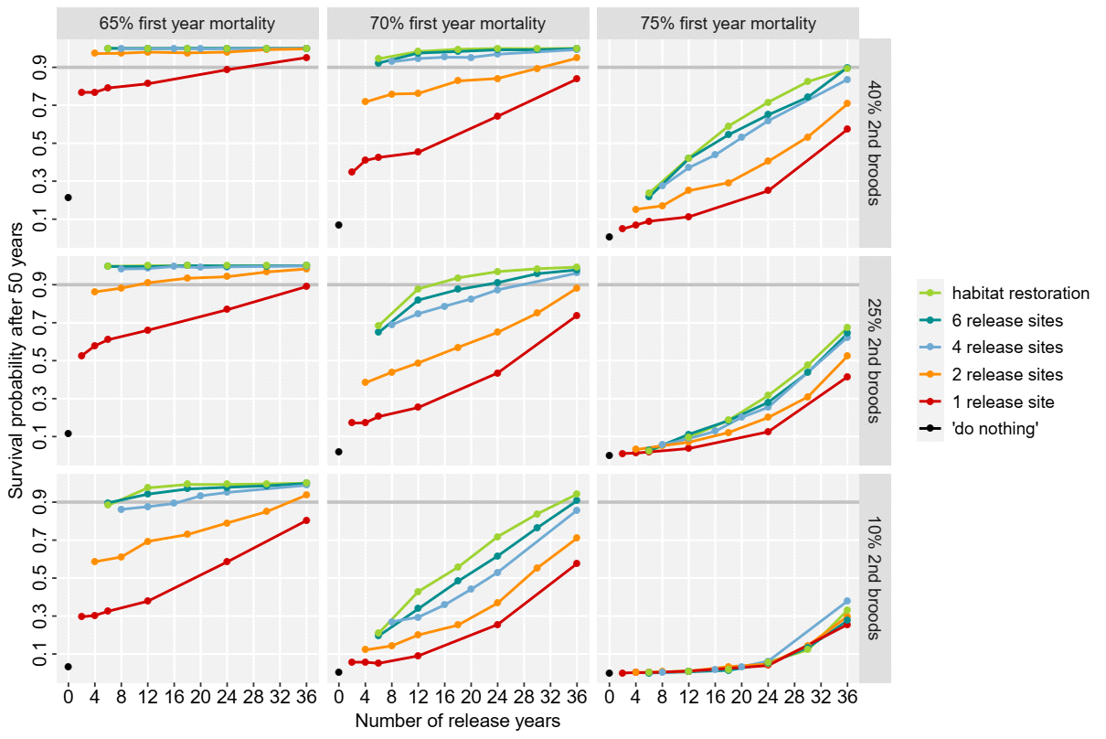

**Fig. B1.** Survival probability after 50 years in relation to the number of release years and different numbers of release sites for the reintroduction of the Pomeranian population of Aquatic Warblers by translocations. Survival probabilities were simulated in VORTEX for the demographic scenarios 65%, 70% and 75% first year mortality and 40%, 25% and 10% second broods as best, moderate and worst case scenarios. The effect of increasing carrying capacity by habitat restoration is only shown for 6 release sites. Horizontal grey line indicates 90% survival probability after 50 years.

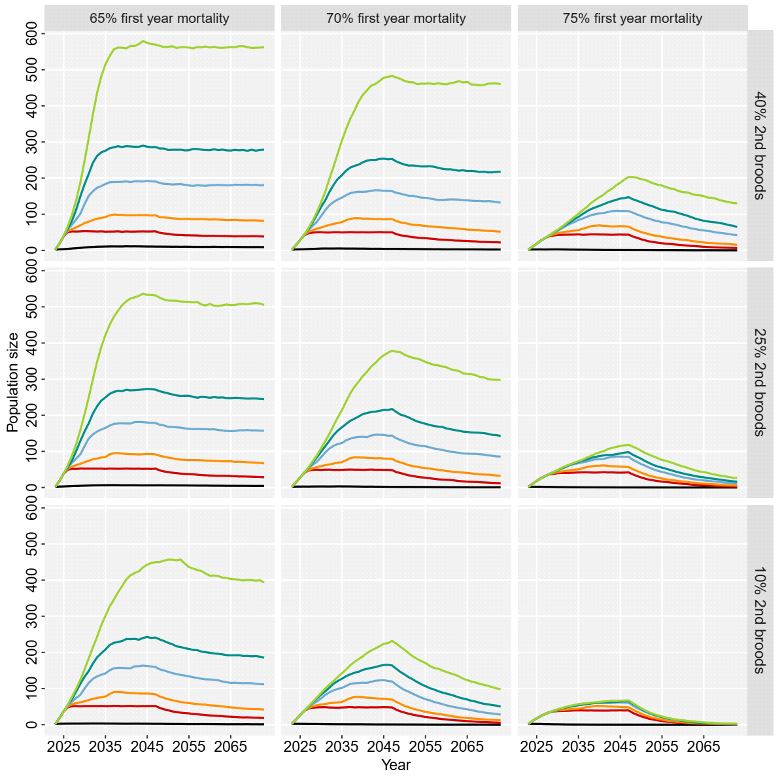

**Fig. B2.** Population size of the Pomeranian population of Aquatic Warblers with 24 years of releases of annually 50 chicks to a different number of release (starting in 2023) simulated in VORTEX for the demographic scenarios 65%, 70% and 75% first year mortality and 40%, 25% and 10% second broods as best, moderate and worst case scenarios. The effect of increasing carrying capacity by habitat restoration is only shown for 6 release sites.