Target Journal: Biological conservation
Using population viability analysis to inform the reinforcement of an endangered long-distance migrating passerine
- Reinforcement is not enough to stabilize the population of an endangered long-distance migrating passerine

Susanne Arbeiter¹, Jaume A. Badia-Boher², Steffen Oppel²

1 Institute of Botany and Landscape Ecology, Greifswald University, Partner in the Greifswald Mire Centre, Greifswald, Germany

2 Swiss Ornithological Institute, Sempach, Switzerland

Correspondence
Institute of Botany and Landscape Ecology, Greifswald University, Partner in the Greifswald Mire Centre, Soldmannstr. 15, 17489 Greifswald, Germany
Email: susanne.arbeiter@uni-greifswald.de

Keywords: Aquatic Warbler, conservation management, extinction risk, habitat restoration, population viability analysis, translocation

Authors contribution

Acknowledgements
This study was co-financed by the EU LIFE program within the project “Conservation of Europe's Rarest Continental Passerine: A Transboundary Initiative for Aquatic Warbler Population Recovery” (LIFE23-NAT-LT-LIFE4AquaticWarbler/101148281).

Abstract
Population viability analysis (PVA) is a valuable tool to guide the reinforcement of endangered bird species. In migrants, demographic data required for population projections are often deficient, making reinforcement outcomes challenging to predict. The globally threatened Aquatic Warbler Acrocephalus paludicola is a long-distance migrating passerine that breeds in sedge fen mires in Central Europe and winters in sub-Saharan Africa. Although conservation measures have stopped the decline in the core breeding sites, the westernmost breeding population in Europe (Pomeranian population) is currently threatened with extinction. In this study, we used PVA simulations under different demographic scenarios to determine the most important vital parameters driving the decline and to reveal the duration of releases of juveniles, translocated from the core breeding area needed for a stable population.
- Second broods
- Number of release years
- Habitat restoration
- Improvement of survival

Word limit abstract: 250 / Text: 8000

Introduction
Worldwide, a growing number of vertebrate species are threatened with extinction (Munstermann et al., 2021). Anthropogenic pressure and climate change increase habitat loss and fragmentation, which accelerates the risk of population decreases (Dale, 2001; Lees et al., 2022). Conservationists are facing the challenge to effectively manage populations and halt ongoing declines (Bubac et al., 2019; Davis et al., 2023). For small and isolated populations, providing and maintaining suitable habitat is sometimes not sufficient to increase numbers again (Dale, 2001; Armstrong and Reynolds, 2011). Therefore, reinforcement by translocations or captive breeding is an increasingly applied conservation action to assist the population recovery of endangered species (IUCN/SSC 2013; Bubac et al., 2019).
- Migratory species are more susceptible to population changes than residents and several Afro Palaearctic migrants have declined during the last decades (Vickery et al., 2014; Lees et al., 2022). Nevertheless, only few reinforcement projects have been directed at long-distance migrants (Pain et al., 2018; Oppel et al., 2021). The implementation of effective conservation measures for long-distance migrants has to take into account that their lifecycle includes breeding sites, staging sites during migration and the wintering site, covering different climatic zones and habitats, which in turn are subject to variable threats and alternations (Vickery et al., 2014; Oppel et al., 2024). The habitat conditions at the breeding sites are often well studied, but most migrants spend more than 75% of the year at non-breeding sites, where preconditions and parameters affecting survival are poorly understood (Halupka et al., 2017; Davis et al., 2023). Carryover effects that influence survival and reproduction will also impact reinforcement outcome (Finch et al., 2014; Davis et al., 2023).
- To our knowledge, there has been no reinforcement approach for a long-distance migrating passerine so far. Generally, high juvenile mortality and low levels of natal philopatry in long-distance migrating passerines reduce recruitment and may impede the recovery of a population at a given release site (Weatherhead & Forbes, 1994; Carter et al., 2008; Imlay et al., 2010). Long durations of releases will be required to observe changes in population size to evaluate reinforcement success (Carter et al., 2008; Imlay et al., 2010). Additionally, due to low recapture probabilities in migrating passerines, data on survival and dispersal are often scarce making population development after translocations difficult to predict (Heinsohn et al., 2022).
Population viability analysis (PVA) is an important tool to guide the reinforcement of endangered bird species (Schaub et al., 2009; Armstrong and Reynolds, 2011; Heinsohn et al., 2022). PVA models simulate temporal changes in population size and estimate extinction probability incorporating demographic stochasticity and can also be used to predict reinforcement outcomes (Akçakaya and Sjogren-Gulve, 2000; Oppel et al., 2021). Because these models rely on demographic input data, availability and quality of vital parameters are crucial for estimating future population size (Coulson et al., 2001). However, data on survival and reproductive output are often deficient in threatened species (Heinsohn et al., 2022; Davis et al., 2023). Especially in long-distance migrants, survival can be expected to be highly variable due to annually changing habitat conditions during migration and wintering (Ockendon et al., 2014; Halupka et al., 2017), which further increases uncertainty for future predictions. But even with uncertainties, PVA models can still be useful to compare different management options (Heinsohn et al., 2022). Furthermore, the calibration of projections using observed data can be essential to evaluate the validity of demographic assumptions and derived population dynamics (Badia‐Boher et al., 2024). In the last decade, PVAs have been increasingly combined with Integrated Population Models (IPMs) (Schaub & Kéry, 2021). IPMs are a modelling framework that uses the shared demographic information between different monitoring datasets from the same population (e.g., mark-recapture, productivity, counts) to provide more precise estimates of demographic estimates and population dynamics (Schaub & Abadi, 2010). Merging IPMs and PVAs guarantees 1) a correct propagation of uncertainty from the demographic estimates to the PVA projections, which is fundamental to obtain reliable PVA results (Chaudhary & Oli, 2002; Reed et al., 2002; Badia-Boher et al., 2024), and 2) a potential gain in the precision of the projections, thanks to the properties of IPMs.

In this study, we used an IPM-PVA to inform the reinforcement of a long-distance migrating bird. The Aquatic Warbler Acrocephalus paludicola is a small passerine that breeds in mesotrophic sedge fen mires in Central Europe and winters in sub-Saharan Africa. The species was once widespread and numerous throughout Europe. During the last century, the global population experienced a severe decline (> 90%) caused by habitat loss and degradation due to drainage, peat extraction, conversion to agricultural land and eutrophication (Flade and Lachmann, 2008; Tanneberger et al., 2011). Today, the Aquatic Warbler is one of the rarest songbirds of continental Europe, classified under the IUCN category “vulnerable” given its small breeding range and continuing threat of habitat loss and population decline (BirdLife International, 2024). After the implementation of conservation measures, the decline was halted in the core breeding sites of the species. Only four breeding sites in Belarus, Poland and Ukraine hold 75% of the entire world population of about 11,000 singing males (Flade et al., 2018). In peripheral breeding sites, however the decline continues and the westernmost population in Germany and northwestern Poland (hereafter Pomeranian population) is currently threatened with extinction. Recently, a pilot study demonstrated the successful translocation of young Aquatic Warblers prior to their first migration from Belarus to Lithuania (Morkvėnas et al., 2025). Following this trial, the first translocation from the core breeding sites started the reinforcement of the Pomeranian population in 2023.
In this study, we aim to identify demographic drivers behind the decline of the Pomeranian population of Aquatic Warblers using a population viability analysis in retrospective to compare predictions with observed count data. Furthermore, we used the developed population model to reveal how many years of releases may be needed to establish a stable population and whether additional conservation measures such as habitat restoration and improvements in survival are required to achieve population persistence. Our results contribute to inform the reinforcement process of Aquatic Warbler translocations to successfully recover the nearly extinct Pomeranian population and may be useful for the conservation management of other long-distance migrating passerines.

Material and methods
Study population
The Pomeranian population of the Aquatic Warbler comprises breeding sites in northwestern Poland and northeastern Germany, which are nowadays the westernmost remnants of a once widespread European breeding range (Flade et al., 2018). After the successive disappearance of several breeding sites in western Poland, the Pomeranian population is now geographically isolated from core breeding sites in eastern Poland (Fig. 1). Aquatic Warblers show an extraordinary promiscuous breeding system with uniparental brood care by females which attempt to breed twice between May and July (Schulze-Hagen et al., 1999; Dyrcz et al., 2018). Females behave very secretive, but males sing continuously during the breeding season from exposed vegetation structures some hours before sunset to attract mates (Schulze-Hagen et al., 1999; Dyrcz et al., 2018). Therefore, population size is assessed by counting singing males in this species, which is also a good indicator for the number of nests (Kubacka et al., 2014). Counts take place at the end of May and end of June, during the peaks of the first and second breeding attempts. Comprehensive and largely synchronous annual counts were conducted with standardised methodology in Poland in 1993 and 1997 (Krogulec and Kloskowski, 2003), and from 2003 onwards in the entire range of the Pomeranian population. In the remaining years only a subset of sites was counted each year. Despite conservation actions, the Pomeranian population strongly declined during the last 30 years (Flade et al., 2018). After a pilot study demonstrated the successful translocation of Aquatic Warbler chicks from Belarus to Lithuania (Morkvėnas et al., 2025), the reinforcement of the Pomeranian population started with the first translocation from core breeding sites in eastern Poland (Biebrza National Park) to northwestern Poland (Rozwarowo Marshes) in 2023. Further translocations to former and suitable breeding sites within the Pomeranian population range (Fig. 1) are planned during the following years (within a large-scale EU-funded conservation project).
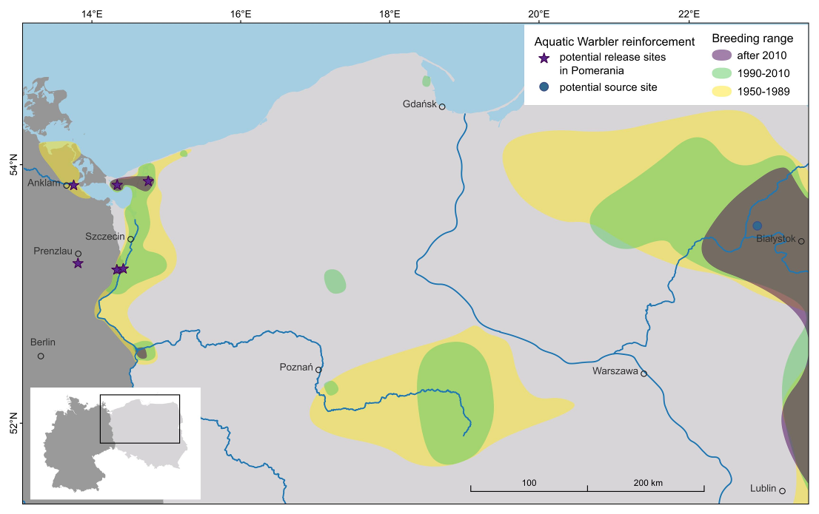
Fig. 1. Breeding range decline of the Aquatic Warbler in Germany and Poland and location of potential release sites for the reinforcement of the Pomeranian population.

Demographic parameters
Because the Pomeranian population is very small and has been decreasing for decades, very few data on the survival and fecundity of Aquatic warblers exist from this population. To construct a population model and project future population trajectories, we therefore had to adopt demographic parameters from closely related populations in Poland. These studied populations nest in similar habitat and similar latitude and follow the same migratory flyway, hence we consider it reasonable that survival and fecundity of these populations could also be realized in a restored Pomeranian population.
The breeding system of Aquatic Warblers was classified as polygynous (Schulze-Hagen et al., 1999). The majority of broods are fathered by more than one male, thus also females mate with several partners during the breeding season (Dyrcz et al., 2018). Males defend no exclusive territories and no pair bonds are formed (Schulze-Hagen et al., 1999). Therefore, we assume that all males and all females of a population (except for fledglings) attempt to reproduce every year (Tab. 1). Clutch size varies between 3 and 6 eggs with a median of 5 eggs (Dyrcz and Zdunek, 1993b; Schulze-Hagen et al., 1999). Breeding success is higher than 60% and the average number of fledglings per brood is 3.5 ± 1.8 (Kubacka et al., 2014). A former study from the same study area revealed a similar reproductive output (Dyrcz and Zdunek, 1993b). The number of fledglings was smaller in second broods (1.8 –3.7 fledglings) than in first broods (2.3 – 4.0 fledglings, Kubacka et al., 2014). Under optimal conditions up to 50% of the females initiate a second brood (Dyrcz and Zdunek, 1993b; Schulze-Hagen et al., 1999). Sex ratio at birth is balanced (49% males, Dyrcz et al., 2004), while adult sex ratio in the breeding population is assumed to be slightly male biased (56% males, Dyrcz and Zdunek, 1993a). Population assessment in the Aquatic Warbler is based on counts of singing males (Krogulec and Kloskowski, 2003). Therefore, we assumed that the number of males counted represents 56% of the total population size including females.
Annual survival for adults (males: 0.67, 95% confidence interval: 0.54–0.79; females: 0.42, 0.29.0–0.56) was obtained from a mark-recapture analysis of 279 Aquatic Warblers (149 males, 130 females) ringed between 1987 and 1995 in Biebrza Marshes in Poland (Dyrcz and Zdunek, 1993a; Dyrcz and Chylarecki, 2018). The lower estimates for females are probably attributed to a lower detection probability because of a more secretive behaviour, but may also be caused by lower site fidelity and higher dispersal probability (Bellebaum, 2018; Dyrcz and Chylarecki, 2018). Data to estimate first year survival were available from juveniles translocated from Zvanets (Belarus) to Zuvintas Biosphere Reserve (Lithuania) in 2018 and 2019 (Morkvėnas et al., 2025), and first-year survival was therefore directly estimated in our model (see below).
Carrying capacity is difficult to derive, because breeding densities are highly variable throughout the range and are possibly lower in small and isolated sites. In high quality habitats breeding density can be high, on average 9.6 (1.8-21.5) singing males per 10 ha and on average 6.0 (0.0-18.0) nests per 10 ha (Kubacka et al., 2014). In Pomerania, however, these densities of singing males have never been reached, and we therefore used a density of 1.5 males and 1.2 nests (breeding females) per 10 ha to calculate carrying capacity, which represents the average of singing male densities of Pomeranian breeding sites (Tanneberger et al., 2018).

- Population viability analysis
- Integrated population model
- Success of reinforcement = stable population = future growth rate ≥1

Reinforcement and management scenarios
- What could be the baseline model?
- habitat unconstrained? area of occupancy 2965 ha (356 females)?
- For the baseline model we used the area of occupancy of 2965 ha described by Flade et al. (2018) for the Pomeranian population as the amount of suitable habitat available during the 1990s and constant demographic parameters?
- To model past decline, reduction in reproductive output: scenario no second broods
- We also included the no second brood scenario for future projection, assuming similar low reproductive output than during the last 20 years
- Translocation of chicks for 5, 10, 15? years
- Increase habitat by restoration and including more nearby sites?
- Improvement of survival
Due to the experience in the pilot translocation of Aquatic Warblers, 10 nests (~50 chicks) per year are an optimum for logistical reasons, for the handling during feeding and to minimize impact on the source site (Morkvėnas et al., 2025). Hence, scenarios of releases will not include higher numbers of annually released birds, but different durations of years with subsequent releases (5, 10 and 15 years).
- We identified six potential release sites within the range of the Pomeranian population (Fig. 1).
- We assumed that each release site provides 200 ha of suitable habitat, which can be increased to 400 ha by habitat restoration. Increase in available habitat will result in an increase in carrying capacity for each release site.
- Increase of habitat: 200 ha for single release site, more sites, up to six = 1200 ha; plus habitat restoration, increase to 400 ha for single release site -> up to 2400 ha – > variation in carrying capacity K = 54-643 population= 30-360 sM and 24-288 F

All figures were created using ggplot2 (Wickham, 2016) implemented in R (Version 4.0.0, R Core Team, 2024). All analyses were performed using the MCMC inference package JAGS (Plummer, 2017)

Results
Population development 1993 – 2023
After 250 and 262 singing males were counted in 1993 and 1997, respectively, the Pomeranian population was substantially smaller in 2003 (89 singing males) and experienced a slow but continuous decrease until 2011. In 2012 and 2013 occurred another steep decline followed by further decrease after 2018 (Fig. 2). Can we report any extinction probability?
- When assuming constant demographic parameters for 2003-2023, the population would have remained stable over the last 20 years (mean growth rate?). The observed decline from 2003 onwards corresponds to the simulations for the no second brood scenario (mean growth rate: xx, Fig. 2).

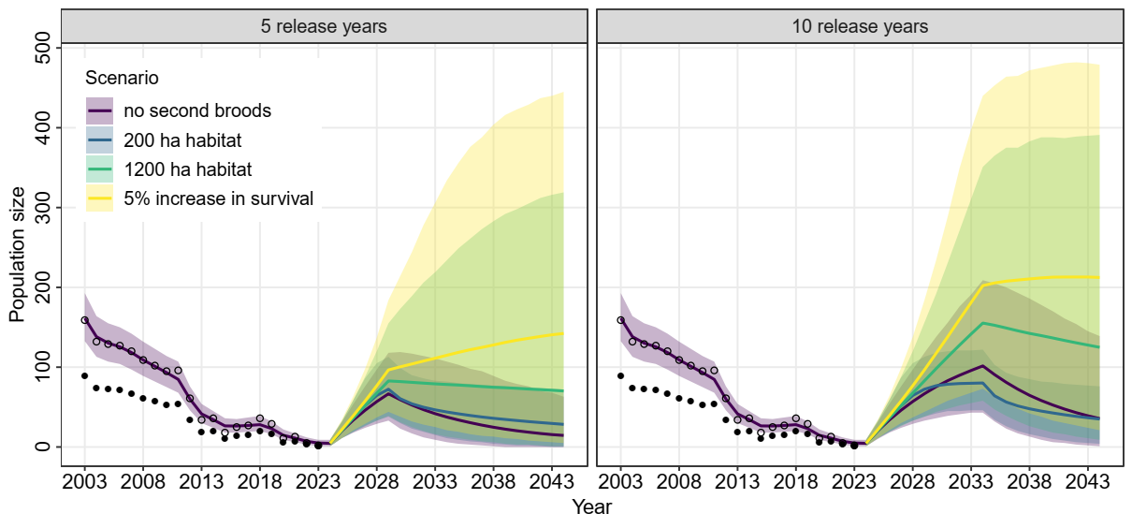
Fig. 2: Population development (mean size ± 95% CI) of the Pomeranian population of Aquatic Warblers 2003-2023 simulated for the secenarios xx. Filled circles show count data of singing males, open circles population size based on an adult sex ratio of 56% males.
- Scenarios: no second broods, (7) second broods, habitat 200 ha, (13) second broods, habitat 1200 ha, (32) second broods, habitat 1200 ha, improved survival

Reinforcement and management scenarios
- Effects on population growth rate
- No second broods in future (similar decline than in past as soon as releases stop, Fig. 3)
- Translocation of chicks for 5, 10, 15? years
- Improvement of survival
10 years reinforcement not enough, even with survival improvement (Fig. 4)
- More than 1000 ha habitat needed –> habitat restoration
Without increase in habitat, and improvement in survival, population will decline after releases stop
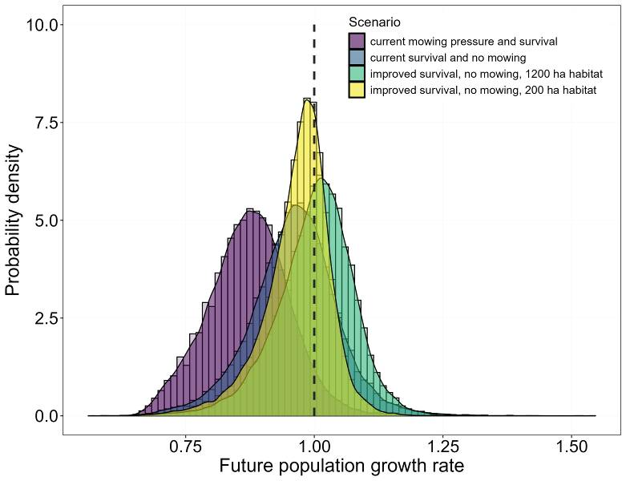
- Fig. 3. Posterior probability density for the population growth rate for the secenarios xx
- Scenarios from Fig. 2: (1) no second broods, (7) second broods, habitat 200 ha, (13) second broods, habitat 1200 ha, (32) second broods, habitat 1200 ha, improved survival

- 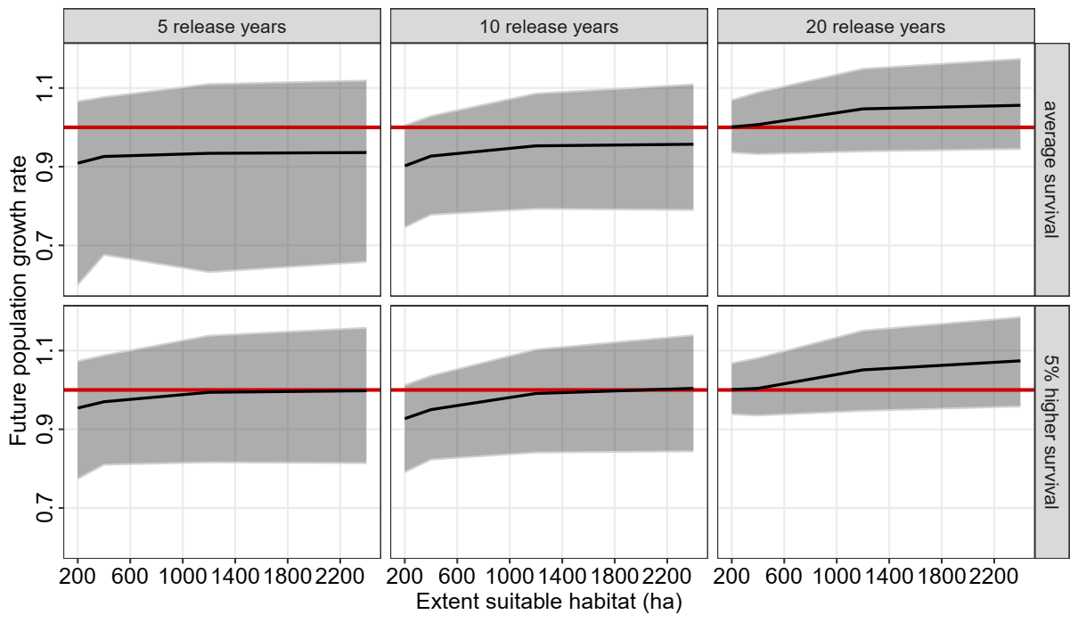
Fig. 4. Population growth rate of the reinforced Pomeranian population of Aquatic Warblers in relation to available breeding habitat (with a limit of 0.12 breeding females per ha) shown for different numbers of release years and for average and improved survival.

Discussion

Population development 1993 – 2023
In the context of the current extinction crisis, population reinforcements appear critical to prevent and mitigate local or global species extinctions (IUCN/SSC 2013; Bubac et al., 2019; Munstermann et al., 2021). Here, we use Integrated Population Models (IPMs) combined with Population Viability Analyses (PVAs) to evaluate a range of reinforcement strategies for the Aquatic Warbler, a rare, endangered long-distance migrant passerine. One aim of this study was to determine the demographic drivers behind the observed decline of the Pomeranian population of Aquatic Warblers during the last 30 years. Catastrophic events were not included in our simulations, although ongoing habitat loss until 2003 has certainly contributed to the fast collapse of the population (Flade et al., 2018). Large-scale drainage and increased land use intensity on fen mires drastically reduced available habitat (Tanneberger et al., 2011). The extent of habitat deterioration during that time period and in particular the impact on Aquatic Warbler populations is difficult to quantify. However, loss of suitable breeding habitat directly translates into demographic consequences. Our PVA suggests that the low numbers of Aquatic Warblers after 2003 are attributed to a reduction in the proportion of second broods or a reduction in reproductive output in general (Fig. 2, Fig. 3). The majority of females are assumed to move to other breeding sites for the second brood (Dyrcz and Zdunek, 1993b; Schulze-Hagen et al., 1999). Ongoing habitat loss increased habitat fragmentation which possibly has limited movements between breeding sites. Additionally, mowing during the breeding season before July reduced the possibility for second breeding attempts and possibly also increased female mortality to some extent which also negatively influences population growth rate.
Under the current conditions, the Pomeranian population of Aquatic Warblers is likely to go extinct in the following years. In 2023, only one singing male was recorded. Despite conservation measures (e.g. postponed mowing on breeding sites) have been implemented after 2008, the population was probably already too small to recover on its own. In declined and isolated populations, population growth is more difficult because years with low survival cannot be compensated by immigration (Dale, 2001; Border et al., 2017). Additionally, small populations are more susceptible to loss in genetic diversity, inbreeding effects and demographic stochasticity, which negatively affects population growth (Armstrong and Reynolds, 2011).

Reinforcement and management scenarios
- Number of release years
- More than 10 years of releases (> 500 translocated chicks)
- Increase in habitat extent
- Increase reproductive output, second broods
Reproductive output is determined by the number of fledglings per brood and is linked to the proportion of second broods. The average fledged brood size and the proportion of second broods is unknown for the Pomeranian population and may be lower than in the core breeding sites.

Our study implies that reinforcement and habitat restoration without improvements in survival rates may not be sufficient to stabilize the Pomeranian population of Aquatic Warblers. Whereas in long-lived species, population growth is mainly determined by adult survival (Schaub et al., 2009; Davis et al., 2023), in short-lived species, such as most of long-distance migrating passerines, population growth is mainly attributed to recruitment (Dale, 2001; Border et al., 2017). First year survival used in this study was only assessed recently based on a small data set of marked juveniles of the pilot translocation study. Differences in return rates between years, ranging between 14% and more than 30% for first year males (Morkvėnas et al., 2025) suggest that first year apparent survival is highly variable in Aquatic Warblers. Mortality in migrants is highly affected by conditions on wintering grounds and during migration and therefore annually variable. In Sedge Warblers, survival and population changes are significantly related to rainfall at the wintering site (Peach et al., 1991; Ockendon et al., 2014). Higher survival in Common Reed Warblers Acrocephalus scirpaceus was associated with more precipitation at the stopover sites in Spain and Morocco (Halupka et al., 2017). Aquatic Warblers are insectivores and accumulate fat deposits for migration (Kerbiriou et al., 2010). Because they need refuelling en route, they highly rely on food availability at stopover sites (Kerbiriou et al., 2010; Vickery et al., 2014). Carryover effects may translate adverse conditions during non-breeding periods in lower reproduction in the subsequent year (Finch et al., 2014). We were not able to relate population changes of the Pomeranian population to rainfall at wintering or stopover sites, suggesting that negative habitat effects at both breeding and non-breeding sites have contributed to the decline.

- Female adult survival used in this analysis might be considered too low. Survival data from females are rare because of distinct lower detection probability due to their secretive behaviour (Schulze-Hagen et al., 1999; Dyrcz et al., 2018). Breeding site fidelity is probably rather low in Aquatic Warblers and permanent dispersal contributes to a high extent to the lower apparent survival estimates for females. Natal dispersal, which is also usually female-biased in most passerine species (Dale, 2001) may additionally reduce the recruitment at a given breeding site. A first year return rate of 10% for females to the release site, observed in the pilot Aquatic Warbler translocation study (Morkvėnas et al., 2025) is in line with return rates reported for other migrant passerines (Grinkevich et al., 2009; Border et al., 2017). After the first release, first year return rate of males was remarkable high (>30%), followed by a substantial population increase (Morkvėnas et al., 2025), indicating that at least in years with high first year survival, high population growth can be expected, possibly enough to compensate for years with lower first year survival. However, the strong fluctuations in population size in Lithuania suggest that local population growth probably depends on immigration from other breeding sites (Border et al., 2017). Apparent survival rates used in this study account for detection, but not for permanent emigration from the study site. Movements between breeding sites are hardly understood in Aquatic Warblers so far. Our model is based on the assumption that there is exchange between the release sites, which was confirmed in the past (Dyrcz et al., 2018), but the actual rate of dispersal and immigration remains unknown. Observations of colour-ringed individuals from the translocation program may help to increase the knowledge on movements between breeding sites in the future.

Conclusions
Our study provides the first population viability analysis for the Aquatic Warbler. Due to highly variable first year survival and return rates (Morkvėnas et al., 2025), we conclude that high effort will be needed to reinforce the westernmost and geographically isolated Pomeranian population of the Aquatic Warbler. To our knowledge, there has been no reinforcement project of a long-distance migrating passerine so far. Translocation attempts, e.g. for a long-distance migrating non-passerine, the Corncrake Crex crex in the United Kingdom (Carter et al. 2008) and a short-distance migrating passerine, the Loggerhead Shrike Lanius ludovicianus migrans in Canada (Imlay et al. 2010) resulted in only few returns to the release site. In both, still ongoing projects more than 400 chicks has been released between 2001 and 2008, suggesting that more than 20 years of releases are needed to reintroduce a stable population of a migrant species.
On the other hand, variation in survival also indicates the potential for management interventions (Davis et al., 2023). Based on our PVA, conservation actions are most effective when addressing an improvement in first year and female adult survival. In a migratory species, however, main causes for mortality are found outside the breeding area (Ockendon et al., 2014; Davis et al., 2023). Therefore, conservation actions for Aquatic Warblers should also address wintering grounds and stopover sites. Although initial studies revealed migration patterns of Aquatic Warblers (Salewski et al., 2019; Flade et al., 2023), further identification of migration routes and wintering sites, in particular for individuals of the Pomeranian population is still important to understand connectivity with breeding sites. A recent study discovered long stopover durations of Aquatic Warblers in costal wetlands of Morocco and Algeria during spring migration, indicating the importance of these sites in determining return rate to the breeding site, but habitat conditions and management options there remain still unclear (Flade et al., 2023). This highlights the need for international efforts to identify and protect suitable habitats outside the breeding sites for Aquatic Warblers. Recently, a conservation initiative addressing stopover and wintering sites (EU-LIFE project “Aquatic Warblers on the Move”, 2025-2029, LIFE23-NAT-NL-LIFE-AWOM/101148382) has started. Simultaneous conservation actions along the whole flyway will more likely increase the success of population recovery in migrants than measures implemented on single breeding sites (Davis et al., 2023; Oppel et al., 2024).
Although demographic parameters such as survival are more important for population persistence habitat restoration and providing good quality habitat at the breeding site can help to increase the annual output of fledglings per females. The Aquatic Warbler is a habitat specialist, restricted to shallow inundated sedge fen mires with low (<1 m) vegetation height (Tanneberger et al., 2018). Due to the mainly eutrophic site conditions of the Pomeranian breeding sites, habitat maintenance depends largely on human management (Tanneberger et al., 2018). Most deterioration in habitat quality is associated with cessation of land use, continuously late land use or further eutrophication (Tanneberger et al., 2011), making habitat suitability in Pomerania highly susceptible to changes in management. Since habitat loss has been a key factor for the previous decline of Aquatic Warblers, improving and increasing breeding habitats within the Pomeranian population will also be one of the critical factors for a successful reinforcement (Bubac et al., 2019). Habitat restoration and maintenance at the release site including nearby sites to provide > 1000 ha of suitable habitat are required for establishing a stable population (Fig. 4).
Due to the remaining uncertainties in the demographic data we highly recommend long-term monitoring of the development of the reinforced Pomeranian population to validate first year survival and reproduction rates and to update the PVA when more data are available (Akçakaya and Sjogren-Gulve, 2000). To this end, the reinforcement project gives the opportunity to increase the knowledge of the demographic dynamics impossible to be studied in wild populations of Aquatic Warblers (Schaub et al., 2009). Furthermore, more effort should be made to understand the intra-seasonal movements of the species and the importance of the connection with core breeding sites. If local populations depend on immigration to compensate for variations in recruitment and mortality (Border et al., 2017) it will be almost impossible to maintain an isolated population of Aquatic Warblers at the margin of the breeding range.

References
Akçakaya, H.R., Sjogren-Gulve, P., 2000. Population viability analyses in conservation planning: overview. Ecol. Bull. 48, 9–21.
Armstrong, D.P., Reynolds, M.H., 2011. Modelling reintroduced populations: the state of the art and future directions. In J.G. Ewen, D.P. Armstrong, K.A. Parker, P.J. Seddon (Eds.), Reintroduction Biology: integrating science and management, Chapter 6. Wiley-Blackwell, Oxford, UK.
Badia‐Boher, J.A., Real, J., Hernández‐Matías, A., 2024. Assumptions about survival estimates and dispersal processes can have severe impacts on population viability assessments. Biol. Conserv. 292, 110550.
Bellebaum, J., 2018. Population dynamics. In: F. Tanneberger, J. Kubacka (Eds.) The Aquatic Warbler Conservation Handbook, Brandenburg State Office for Environment (LfU), Potsdam, Germany, pp. 68–71.

BirdLife International, 2024. Species factsheet: Acrocephalus paludicola. Downloaded from http://datazone.birdlife.org/species/factsheet/aquatic-warbler-acrocephalus-paludicola on 15/02/2024.
Border, J.A., Henderson, I.G., Hartley, I.R., 2017. Characterising demographic contributions to observed population change in a declining migrant bird. J. Avian Biol. 48, 1139–1149.
Bubac, M., Johnson, A.C., Fox, J.A., Cullingham, C.I., 2019. Conservation translocations and post-release monitoring: identifying trends in failures, biases, and challenges from around the world. Biol. Conserv. 238, 108239
- Carter, I., Newbery, P., Grice, P., Hughes, J. 2008. Role of reintroductions in conserving British Birds. British Birds 101, 2–25.
Coulson, T., Mace, G.M., Hudson, E., Possingham, H. 2001. The use and abuse of population viability analysis. Trends Ecol. Evol. 16, 219–221.

Dale, S., 2001. Female-biased dispersal, low female recruitment, unpaired males, and the extinction of small and isolated bird populations. Oikos 92, 344–356.
Davis, K.L., Saunders, S.P., Beilke, S., Ford, E.R., Fuller, J., Landgraf, A., Zipkin, E.F., 2023. Breeding season management is unlikely to improve population viability of a data-deficient migratory species in decline. Biol. Conserv. 283, 110104.
Dyrcz, A., Kozulin, A., Vergeichik, L., Kubacka, J., 2018. Breeding biology and ecology. In: Tanneberger, F., Kubacka, J. (Eds.), The Aquatic Warbler Conservation Handbook, Brandenburg State Office for Environment (LfU), Potsdam, Germany, pp. 50–61.
Dyrcz, A., Chylarecki, P., 2018. Adult survival of Aquatic Warblers breeding in the Biebrza Marshes, Poland, In: Tanneberger, F., Kubacka, J. (Eds.), The Aquatic Warbler Conservation Handbook, Brandenburg State Office for Environment (LfU), Potsdam, Germany, p. 67.
Dyrcz, A., Sauer-Gürth, H., Tkadlec, E., Wink, M., 2004. Offspring sex ratio variation in relation to brood size and mortality in a promiscuous species: the Aquatic Warbler Acrocephalus paludicola. Ibis 146, 269–280.
Dyrcz, A., Zdunek, W., 1993a. Breeding ecology of the Aquatic Warbler Acrocephalus paludicola on the Biebrza marshes, northeast Poland. Ibis 135, 181–189.
Dyrcz, A., Zdunek, W., 1993b. Breeding statistics of the Aquatic Warbler Acrocephalus paludicola on the Biebrza Marshes, northeast Poland. J. Ornithol. 134, 317–323.
Finch, T., Pearce-Higgins, J.W., Leech, D.I., Evans, K.L., 2014. Carry-over effects from passage regions are more important than breeding climate in determining the breeding phenology and performance of three avian migrants of conservation concern. Biodivers. Conserv. 23, 2427–2444.
Flade, M., Lisovski, S., Eigirdas, V., Giessing, B., Jiguet, F., Keišs, O., Nemtchinov, M., 2023. Migration routes and wintering sites of the Aquatic Warblers Acrocephalus paludicola breeding in Lithuania and North Belarus. bioRxiv2023.10.10.561376; doi: https://doi.org/10.1101/2023.10.10.561376.
Flade, M., Malashevich, U., Krogulec, J., Poluda, A., Preiksa, Z., Végvári, Z., Lachmann, L., 2018. World distribution, population, and trends. In: Tanneberger, F., Kubacka, J. (Eds.), The Aquatic Warbler Conservation Handbook, Brandenburg State Office for Environment (LfU), Potsdam, Germany, pp. 22–35.
Flade, M., Lachmann, L., 2008. International Species Action Plan for the Aquatic Warbler Acrocephalus paludicola. BirdLife International.

Grinkevich, V., Chernetsov, N., Mukhin, A., 2009. Juvenile Reed Warblers Acrocephalus scirpaceus see the world but settle close to home. Avian Ecol. Behav. 16, 3–10.
Halupka, L., Wierucka, K., Sztwiertnia, H., Klimczuk, E., 2017. Conditions at autumn stopover sites affect survival of a migratory passerine. J. Ornithol. 158, 979–988.
Heinsohn, R., Lacy, R., Elphinstone, A., Ingwersen, D., Pitcher, B.J., Roderick, M., Schmelitschek, E., Van Sluys, M., Stojanovic, D., Tripovich, J., Crates, R., 2022. Population viability in data deficient nomadic species: what it will take to save regent honeyeaters from extinction. Biol. Conserv. 266, 109430.
Imlay, T.I., Crowley, J.F., Argue, A.M., Steiner, J.C., Norris, D.R., Stutchbury, B.J.M. 2010. Survival, dispersal and early migration movements of captive-bred juvenile eastern loggerhead shrikes (Lanius ludovicianus migrans). Biol. Conserv. 143, 2578–2582.
IUCN/SSC, 2013. Guidelines for Reintroductions and Other Conservation Translocations. Version 1.0. Gland, Switzerland: IUCN Species Survival Commission.
Kerbiriou, C., Bargain, B., Le Viol, I., Pavoine, S., 2010. Diet and fuelling of the globally threatened Aquatic Warbler in autumn migration stopover as compared with two congeners. Anim. Conserv. 14, 261–270.
Krogulec, J., Kloskowski, J., 2003. Monitoring Aquatic Warbler Acrocephalus paludicola in Poland. Ornis Hungarica 12-13, 191–196.
Kubacka, J., Oppel, S., Dyrcz, A., Lachmann, L., Barros Da Costa, J.P.D., Kail, U., Zdunek, W., 2014. Effect of mowing on productivity in the endangered Aquatic Warbler
Acrocephalus paludicola. Bird Conserv. Int. 24, 45–58. doi:10.1017/
S0959270913000154.

Lees, A.C., Haskell, L., Allinson, T., Bezeng, S.B., Burfield, I.J., Renjifo, L.M., Rosenberg, K.V., Viswanathan, A., Butchart, S.H.M., 2022. State of the World’s Birds. Annu. Rev. Environ. Resour. 47, 231–260. https://doi.org/10.1146/annurev-environ-112420-014642.

Morkvėnas, Ž., Arbeiter, S., Kozulin, A., Riauba, G., Zhurauliou, D., Yakovich, V., Tanneberger, F. Successful translocation of a long-distance migrating passerine – new impetus for the conservation of the globally threatened Aquatic Warbler. Anim. Conserv., under review.
Munstermann, M.J., Heim, N.A., McCauley, D.J., Payne, J.L., Upham, N.S., Wang, S.C., Knope, M.L., 2021. A global ecological signal of extinction risk in terrestrial vertebrates. Conserv. Biol. 36, e13852. doi: 10.1111/cobi.13852.
Ockendon, N., Johnston, A., Baillie, S.R., 2014. Rainfall on wintering grounds affects population change in many species of Afro-Palaearctic migrants. J. Ornithol. 155, 905–917.

- Oppel, S., Dobrev, V., Arkumarev, V., Saravia-Mullin, V., Bashmili, K., Bino, T., Bounas, A., Chardin, A., Dobrev, D., Duro, K., Kapsalis, E., Kret, E., Marchant, M.P., Nakev, S., Petrovski, N., Papaioannou, H., Popgeorgiev, G., Selgjekaj, L., Skartsi, T., Stamenov, A., Stoychev, S., Topi, M., Vavylis, D., Velevski, M., Vorpsi, Z., Weston, J., Xeka, E., Xherri, X., Yordanov, E., Nikolov, S.C., 2024. Long-term conservation efforts at flyway scale can halt the population decline in a globally endangered migratory raptor. Anim. Conserv. 27: 374–385. https://doi.org/10.1111/acv.12917.
- Oppel, S., Saravia, V., Bounas, A., Arkumarev, V., Kret, E., Dobrev, V., Dobrev, D., Kordopatis, P., Skartsi, T., Velevski, M., Petrovski, N., Bino, T., Topi, M., Klisurov, I., Stoychev, S., Nikolov, S., 2021. Population reinforcement and demographic changes needed to stabilise the population of a migratory vulture. J. Appl. Ecol. 58, 2711–2721.
- Pain, D., Hughes, B., Syroechkovskiy, E., Zöckler, C., Chowdhury, S., Anderson, G., Clark, N., 2018. Saving the Spoon-billed Sandpiper: a conservation update. British Birds 111, 323–333.
Peach, W.J., Baillie, S., Underhill, L., 1991. Survival of Sedge Warblers Acrocephalus schoenobaenus in relation to West African rainfall. Ibis 133, 300–305.
R Core Team, 2024. R: A language and environment for statistical computing. R Foundation for Statistical Computing. Vienna, Austria. https://www.R-project.org.
Salewski, V., Flade, M., Lisovski, S., Poluda, A., Iliukha, O., Kiljan, G., Malashevich, U., Hahn, S. 2019. Identifying migration routes and non-breeding staging sites of adult males of the globally threatened Aquatic Warbler Acrocephalus paludicola. Bird Conserv. Int. 29, 503–514. doi: 10.1017/S0959270918000357.
Schaefer, H.M., Naef-Daenzer, B., Leisler, B., Schmidt, V., Müller, J.K., Schulze-Hagen, K., 2000. Spatial behaviour in the Aquatic Warbler (Acrocephalus paludicola) during mating and breeding. J. Ornithol. 141, 418–424.
Schaub, M., Zink, R., Beissmann, H., Sarrazin, F., Arlettaz, R., 2009. When to end releases in reintroduction programs: Demographic rates and population viability analysis of bearded vultures in the Alps. J. Appl. Ecol. 46, 92–100.
Schulze-Hagen, K., Leisler, B., Schäfer, H.M., Schmidt, V., 1999. The breeding system
of the Aquatic Warbler Acrocephalus paludicola – a review of new results. Vogelwelt
120, 87–96.
Tanneberger, F., Kloskowski, J., Knöfler, V., Kozulin, A., Marczakiewicz, Piotr Morkvėnas, Ž., Poluda, A., Végvįri, Z., Vergeichik, L., Flade, M., 2018. Breeding habitat requirements. In: Tanneberger, F., Kubacka, J. (eds), The Aquatic Warbler Conservation Handbook, Brandenburg State Office for Environment (LfU), Potsdam, Germany, pp. 34–45.
Tanneberger, F., Bellebaum, J., Dylawerski, M., Fartmann, T., Jurzyk-Nordlöw, S., Koska, I., Tegetmeyer, C., Wojciechowska, M., 2011. Habitats of the globally threatened Aquatic Warbler (Acrocephalus paludicola) in Pomerania – site conditions, flora, and vegetation characteristics. Plant Diversity and Evolution 129/3–4, 253–273.
Vickery, J.A., Ewing, S.R., Smith, K.W., Pain, D.J., Bairlein, F., Škorpilová, J., Gregory, R.D., 2014. The decline of afro-Palaearctic migrants and an assessment of potential causes. Ibis 156, 1–22.
Weatherhead, P.J., Forbes, M.R.L., 1994. Natal philopatry in passerine birds: genetic or ecological influence? Behav. Ecol. 5, 426–433.
Wickham, H., 2016. ggplot2: Elegant graphics for data analysis. New York: Springer-Verlag, retrieved from https://ggplot2.tidyverse.org.

Table 1. Demographic parameters of the Aquatic Warbler included in the population viability analysis of the Pomeranian population conducted with VORTEX.
Parameter | Details | Value | Source
Reproductive system |  | polygynous | Schulze-Hagen et al. 1999
Max. no broods per year |  | 2 | Dyrcz & Zdunek 1993b, Schulze-Hagen et al. 1999
Sex ratio at birth (% males) |  | 50 | Dyrcz et al. 2004
Proportion of males in breeding pool (%) | no pair bonds, no territories | 100 | Schulze-Hagen et al. 1999
Proportion of females breeding (%) | females breed every year | 100 | Schulze-Hagen et al. 1999
Number fledglings per brood | First brood  Second brood | 3.2 (2.3-4.0)  2.9 (1.8-3.7) | Kubacka et al. 2014
Proportion of second broods (%) |  | 25 (0-50) | Dyrcz & Zdunek 1993b, Schulze-Hagen et al. 1999
First year survival (%) |  | 30 (20-44) | Morkvėnas et al
Annual survival adults (%) | Females | 42 (29-56) | Dyrcz & Chylarecki 2018
Annual survival adults (%) | Males | 67 (54-78) | Dyrcz & Chylarecki 2018
Adult sex ratio (% males) |  | 56 | Dyrcz & Zdunek 1993a
Available habitat | Before / after restoration | 200-1200 / 400-2400
Males density | 0.15 males / ha | 30-360 | Tanneberger et al. 2018
Breeding density | 0.12 nest / ha | 24-288

