Target journal: Biological conservation
Reinforcement is not enough to establish a viable population of an endangered long-distance migratory passerine

Susanne Arbeiter¹, Žymantas Morkvėnas², Jaume A. Badia-Boher³, Steffen Oppel³

1 Institute of Botany and Landscape Ecology, Greifswald University, Partner in the Greifswald Mire Centre, Greifswald, Germany
2 Baltic Environmental Forum, Vilnius, Lithuania
3 Swiss Ornithological Institute, Sempach, Switzerland

Correspondence
Institute of Botany and Landscape Ecology, Greifswald University, Partner in the Greifswald Mire Centre, Soldmannstr. 15, 17489 Greifswald, Germany
Email: susanne.arbeiter@uni-greifswald.de

Keywords: Aquatic Warbler, conservation management, extinction risk, habitat restoration, population viability analysis, translocation

Acknowledgements
We thank numerous enthusiastic volunteers for counting Aquatic Warblers in Germany and Poland between 1993 and 2023 and Jochen Bellebaum and Krzysztof Stasiak for providing compiled count data of the Pomeranian population. We are also grateful to Vitali Yakovich, xx and the whole team of Baltic Environmental Forum for their enormous effort during the pilot translocation study in Lithuania.

Authors contribution
Susanne Arbeiter: Conceptualization, Methodology, Validation, Visualization, Writing – original draft, Writing – review & editing, Žymantas Morkvėnas: Data curation, Funding acquisition, Writing – review & editing, Jaume A. Badia-Boher: Conceptualization, Methodology, Formal analysis, Validation, Writing – original draft, Writing – review & editing, Steffen Oppel: Conceptualization, Methodology, Formal analysis, Validation, Writing – original draft, Writing – review & editing

Funding sources
This study was co-financed by the EU LIFE program within the project “Conservation of Europe's Rarest Continental Passerine: A Transboundary Initiative for Aquatic Warbler Population Recovery” (LIFE23-NAT-LT-LIFE4AquaticWarbler/101148281).

Highlights
- Prevention of second broods by mowing contributed to the past population decline
- Reinforcement without improving survival is unlikely to establish a viable population
- With improved survival breeding habitat becomes limiting factor
- Restoration required to provide at least 1000 ha of suitable breeding habitat
- Conservation along the whole flyway is needed to increase annual survival

Reinforcement is not enough to establish a viable population of an endangered long-distance migratory passerine

Abstract
Population viability analysis is a valuable tool to guide the reinforcement of endangered bird species. In migrants, demographic data required for population projections are often deficient, making reinforcement outcomes challenging to predict. The globally threatened Aquatic Warbler Acrocephalus paludicola is a long-distance migratory passerine that breeds in sedge fen mires in Central Europe and winters in sub-Saharan Africa. Although conservation measures have stopped the decline in the core breeding sites, the westernmost breeding population in Europe (Pomeranian population) is currently threatened with extinction. In this study, we combined integrated population models with population viability analyses to determine the demographic parameters that contributed to the past decline and to reveal the reinforcement and management required for achieving a stable population in the future. The prevention of second broods due to habitat loss and mowing during the breeding season could adequately explain the decline of the Pomeranian population. To establish a viable population, management that allows second broods still requires the restoration of available breeding habitat (> 1000 ha), an increase in annual survival probability and several years of releases of juveniles translocated from the core breeding area. Without an improvement in survival, populations may decline after releases end, but projections are surrounded by large uncertainties due to unknown spatial dispersal and recruitment processes. In long-distance migrants, most causes for mortality are found outside the breeding area. Therefore, simultaneous conservation actions along the whole flyway will likely increase the success of Aquatic Warbler population recovery more effectively than measures implemented at single breeding sites.

1. Introduction
Worldwide, a growing number of vertebrate species are threatened with extinction (Munstermann et al., 2021). Anthropogenic pressure and climate change increase habitat loss and fragmentation, which accelerates the risk of population decreases (Dale, 2001; Lees et al., 2022). Conservationists are facing the challenge to effectively manage populations and halt ongoing declines (Bubac et al., 2019; Davis et al., 2023). For small and isolated populations, providing and maintaining suitable habitat is sometimes not sufficient to increase numbers again (Dale, 2001; Armstrong and Reynolds, 2011). Therefore, reinforcement by translocations or captive breeding is an increasingly applied conservation action to assist the population recovery of endangered species (IUCN/SSC 2013; Bubac et al., 2019).
Migratory species are more susceptible to population changes than residents and several Afro-Palaearctic migrants have declined during the last decades (Vickery et al., 2014, 2023; Lees et al., 2022). Nevertheless, only few reinforcement projects have been directed at long-distance migrants (Pain et al., 2018; Oppel et al., 2021; Mayall et al., 2023). The implementation of effective conservation measures for long-distance migrants has to take into account that their lifecycle includes breeding sites, staging sites during migration and the wintering site, covering different climatic zones and habitats, which in turn are subject to variable threats and alterations (Vickery et al., 2014; Oppel et al., 2024). The habitat conditions at the breeding sites are often well studied, but most migrants spend more than 75% of the year at non-breeding sites, where conditions and parameters affecting survival are poorly understood (Halupka et al., 2017; Davis et al., 2023). Carryover effects that influence survival and reproduction will also impact reinforcement outcome (Finch et al., 2014; Davis et al., 2023).
To our knowledge, there has been no reinforcement approach for a long-distance migratory passerine so far. Generally, high juvenile mortality and low levels of natal philopatry in long-distance migratory passerines reduce return rate and may impede the recovery of a population at a given release site (Weatherhead and Forbes, 1994; Imlay et al., 2010). Long durations of releases will be required to observe changes in population size to evaluate reinforcement success (Imlay et al., 2010). Additionally, due to low recapture probabilities in migrating passerines, data on survival and dispersal are often scarce making population development after translocations difficult to predict (Heinsohn et al., 2022).
Population viability analysis (PVA) is an important tool to guide the reinforcement of endangered bird species (Schaub et al., 2009; Armstrong and Reynolds, 2011; Heinsohn et al., 2022). PVA models simulate temporal changes in population size and estimate extinction probability incorporating demographic stochasticity and can also be used to predict reinforcement outcomes (Akçakaya and Sjogren-Gulve, 2000; Oppel et al., 2021). Because these models rely on demographic input data, availability and quality of vital parameters are crucial for estimating future population size. However, data on survival and reproductive output are often deficient in threatened species (Heinsohn et al., 2022; Davis et al., 2023). Especially in long-distance migrants, survival can be expected to be highly variable due to annually changing habitat conditions during migration and wintering (Ockendon et al., 2014; Halupka et al., 2017), which further increases uncertainty for future predictions. But even with uncertainties, PVA models can still be useful to compare different management options (Heinsohn et al., 2022). Furthermore, the calibration of projections using observed data can be essential to evaluate the validity of demographic assumptions and derived population dynamics (Badia‐Boher et al., 2024). In the last decade, PVAs have been increasingly combined with Integrated Population Models (IPMs) (Schaub and Kéry, 2021). IPMs are a modelling framework that uses the shared demographic information between different monitoring datasets from the same population (e.g., mark-recapture, productivity, counts) to provide more precise estimates of demographic parameters and population dynamics (Schaub and Abadi, 2011). Merging IPMs and PVAs guarantees 1) a correct propagation of uncertainty from the demographic estimates to the PVA projections, which is fundamental to obtain reliable PVA results (Chaudhary and Oli, 2020; Reed et al., 2002; Badia-Boher et al., 2024), and 2) a potential gain in the precision of the projections, thanks to the properties of IPMs.
In this study, we used an IPM-PVA to inform the reinforcement of a long-distance migratory bird. The Aquatic Warbler Acrocephalus paludicola is a small passerine that breeds in mesotrophic sedge fen mires in Central Europe and winters in sub-Saharan Africa. The species was once widespread and numerous throughout Europe. During the last century, the global population experienced a severe decline (> 90%) caused by habitat loss and degradation due to drainage, peat extraction, conversion to agricultural land and eutrophication (Tanneberger et al., 2011; Briedis and Keiss, 2016). Today, the Aquatic Warbler is one of the rarest songbirds of continental Europe, classified under the IUCN category “vulnerable” given its small breeding range and continuing threat of habitat loss and population decline (BirdLife International, 2024). After the implementation of conservation measures, the decline was halted in the core breeding sites of the species. Only four breeding sites in Belarus, Poland and Ukraine hold 75% of the entire world population of about 11,000 singing males (Flade et al., 2018). In peripheral breeding sites, however the decline continues and the westernmost population in Germany and northwestern Poland (hereafter Pomeranian population) is currently threatened with extinction. Recently, a pilot study demonstrated the successful translocation of young Aquatic Warblers from Belarus to Lithuania prior to their first migration (Morkvėnas et al., 2025). Following this trial, the first translocation from the core breeding sites started the reinforcement of the Pomeranian population in 2023.
In this study, we first estimated which demographic parameters may have contributed to the decline of the Pomeranian population of Aquatic Warblers using observed count data. We then used the estimated parameters to project future population trajectories under different conservation management scenarios, specifically to investigate for how many years releases would be needed to establish a stable population and whether additional conservation measures such as habitat restoration and improvements in survival would be required to achieve population persistence. Our results can inform the reinforcement process of Aquatic Warbler translocations to successfully recover the nearly extinct Pomeranian population and may be useful for the conservation management of other long-distance migratory passerines.

2. Material and methods
2.1 Study population
The Pomeranian population of the Aquatic Warbler comprises breeding sites in northwestern Poland and northeastern Germany, which are nowadays the westernmost remnants of a once widespread European breeding range (Flade et al., 2018). After the successive disappearance of several breeding sites in western Poland, the Pomeranian population is now geographically isolated from core breeding sites in eastern Poland (Fig. 1). Aquatic Warblers show an extraordinary promiscuous breeding system with uniparental brood care by females which attempt to breed twice between May and July (Schulze-Hagen et al., 1999; Dyrcz et al., 2018). Females behave very secretive, but males sing continuously during the breeding season from exposed vegetation structures some hours before sunset to attract mates (Schulze-Hagen et al., 1999; Dyrcz et al., 2018). Therefore, population size is assessed by counting singing males in this species, which is also a good indicator for the number of nests (Kubacka et al., 2014). Counts take place at the end of May and end of June, during the peaks of the first and second breeding attempts. Comprehensive and largely synchronous annual counts were conducted with standardized methodology in Poland in 1993 and 1997 (Krogulec and Kloskowski, 2003), and from 2003 onwards in the entire range of the Pomeranian population. In the remaining years only a subset of sites was counted each year.

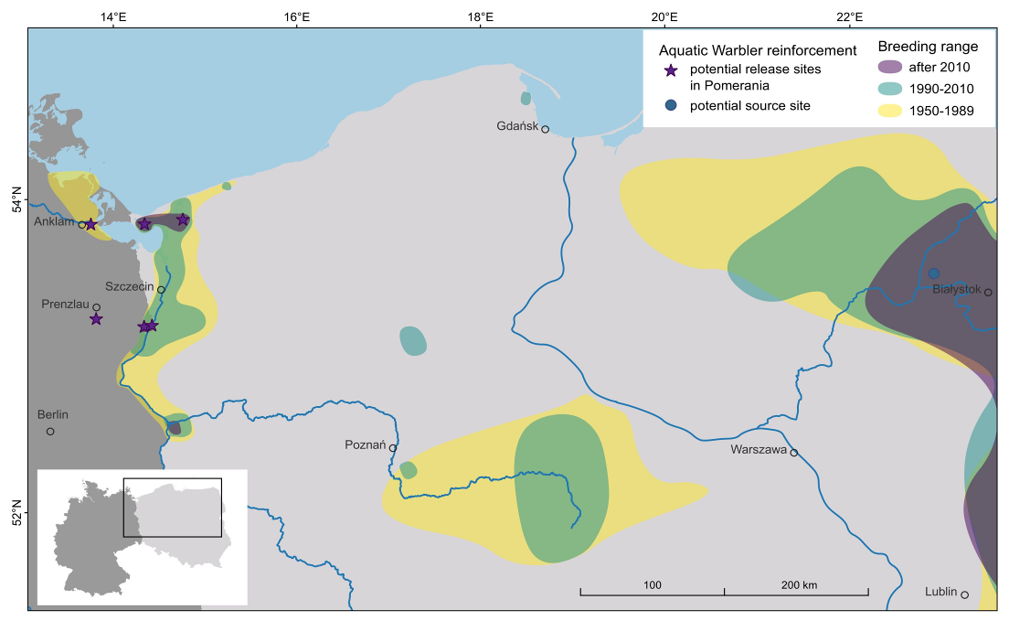
Fig. 1. Breeding range decline of the Aquatic Warbler in Germany and Poland and location of potential release sites for the reinforcement of the Pomeranian population.

The Aquatic Warbler is a habitat specialist, restricted to shallow inundated sedge fen mires with low (<1 m) vegetation height (Tanneberger et al., 2018). Due to the mainly eutrophic site conditions of the Pomeranian breeding sites, habitat maintenance depends largely on human management (Tanneberger et al., 2018). Most deterioration in habitat quality is associated with cessation of land use, continuously late land use or further eutrophication (Tanneberger et al., 2011), making habitat suitability in Pomerania highly susceptible to changes in management. Despite conservation actions, such as providing favourable habitat and locally postponing mowing during the breeding season, the Pomeranian population strongly declined during the last 30 years (Flade et al., 2018). After a pilot study demonstrated the successful translocation of Aquatic Warbler chicks from Belarus to Lithuania (Morkvėnas et al., 2025), the reinforcement of the Pomeranian population started with the first translocation from core breeding sites in eastern Poland (Biebrza National Park) to northwestern Poland (Rozwarowo Marshes) in 2023. Further translocations to former and suitable breeding sites within the Pomeranian population range (Fig. 1) are planned during the following years (within a large-scale EU-funded conservation project), with the ultimate aim to establish a population of at least 56 singing males (100 adult individuals), which can be considered a minimum number for a viable population without fitness limitations (Frankham et al., 2014).

2.2 Demographic parameters to inform population model
Because the Pomeranian population is very small and has been decreasing for decades, very few data on the survival and fecundity of Aquatic warblers exist from this population. To construct a population model and project future population trajectories, we therefore had to adopt demographic parameters from closely related populations in Poland. These studied populations nest in similar habitat, at similar latitude, follow the same migratory flyway, and are likely connected by dispersing individuals (Kubacka et al., 2024), hence we consider it reasonable that survival and fecundity of these populations could also be realized in a restored Pomeranian population.
The breeding system of Aquatic Warblers was classified as polygynandrous (Schulze-Hagen et al., 1999). The majority of broods are fathered by more than one male, and females mate with several partners during the breeding season (Dyrcz et al., 2018). Males defend no exclusive territories and no pair bonds are formed (Schulze-Hagen et al., 1999). Therefore, we assume that all males and all females in a population (except for fledglings) attempt to reproduce every year. Clutch size varies between 3 and 6 eggs with a median of 5 eggs (Dyrcz and Zdunek, 1993b; Schulze-Hagen et al., 1999). Breeding success is generally > 60% and the average number of fledglings per brood is 3.5 ± 1.8 (Dyrcz and Zdunek, 1993b; Kubacka et al., 2014). Under optimal conditions up to 50% of the females initiate a second brood (Dyrcz and Zdunek, 1993b; Schulze-Hagen et al., 1999), and the number of fledglings was smaller in second broods (1.8–3.7 fledglings) than in first broods (2.3–4.0 fledglings, Kubacka et al., 2014). Sex ratio at birth is balanced (49% males, Dyrcz et al., 2004), while adult sex ratio in the breeding population is assumed to be slightly male biased (56% males, Dyrcz and Zdunek, 1993a). Population assessments in the Aquatic Warbler are based on counts of singing males (Krogulec and Kloskowski, 2003), and we assumed that the number of males counted represented 56% of the total population size.
Annual survival for adults (males: 0.67, 95% confidence interval: 0.54–0.79; females: 0.42, 0.29.0–0.56) was obtained from a mark-recapture analysis of 279 Aquatic Warblers (149 males, 130 females) ringed between 1987 and 1995 in Biebrza Marshes in Poland (Dyrcz and Zdunek, 1993a; Dyrcz and Chylarecki, 2018). The lower estimates for females are attributed to lower site fidelity and higher dispersal probability of females (Dyrcz and Chylarecki, 2018). Data to estimate first-year survival were available from juveniles translocated from Zvanets (Belarus) to Zuvintas Biosphere Reserve (Lithuania) in 2018 and 2019 (Morkvėnas et al., 2025), and first-year survival was therefore directly estimated in our model (see below).
Carrying capacity is difficult to derive, because breeding densities are highly variable throughout the range and are possibly lower in small and isolated sites. In high quality habitats breeding density can be high, on average 9.6 (1.8–21.5) singing males per 10 ha and on average 6.0 (0.0-18.0) nests per 10 ha (Kubacka et al., 2014). In Pomerania, however, these densities of singing males have never been reached, and we therefore used a density of 1.5 males and 1.2 nests (breeding females) per 10 ha to calculate carrying capacity, which represents the average singing male densities of former Pomeranian breeding sites (Tanneberger et al., 2018).

2.3 Population model structure and estimation of growth rate
We estimated demographic parameters of the Aquatic Warbler using an integrated population model with a population structure similar to models for other Acrocephalus warblers (Sæther et al., 2004). The population model was constructed with two age classes, juveniles and adults, and assumed that all females started breeding at the age of one year, and that a certain proportion of adult birds were males (this proportion followed a normal distribution with a mean of 0.56 and a standard deviation of 0.01). We used a Leslie matrix to describe the transition probabilities of juveniles and adults from one year to the next and estimated those transition probabilities with the parameters for survival and productivity of breeders. We assumed that annual survival during the first year of life (juvenile survival) was different from annual survival for birds that were older than one year (adult survival).
Annual fecundity was decomposed into a process determined by the number of successful broods and the fledged brood size. We assumed that in the past, intensive agricultural management and early mowing of breeding habitats did not permit raising two broods, so second broods were only possible in hypothetical scenarios of the past or in future management scenarios. The proportion of birds raising two broods was assumed to follow a normal distribution with a mean of 0.25 and standard deviation of 0.07. The number of fledglings per first brood was assumed to follow a normal distribution with a mean of 3.15 and a standard deviation of 0.16, while the number of fledglings per second brood followed a normal distribution with a mean of 2.75 and a standard deviation of 0.2 (Kubacka et al., 2014).
To estimate first-year survival probabilities from individual capture-recapture data we used a Cormack-Jolly-Seber model based on 99 individually marked birds released as juveniles prior to their first migration in Lithuania in 2018 and 2019 and re-sighted every year until 2022 (Morkvėnas et al., 2025). This recapture model assumed annually constant survival and recapture probabilities, but recapture probability varied by sex. We used weakly informative priors to estimate juvenile survival in order to ease convergence (beta: 1.2, 1.2), and informative priors in sex-specific recapture probabilities (normal with mean 0.57 for males and 0.26 for females, sd 0.04 for both). Because insufficient birds were captured and recaptured as adults, we used informative priors based on other populations (Dyrcz and Zdunek, 1993a; Dyrcz and Chylarecki, 2018) to specify adult survival (normal: 0.42 ± 0.03) in all model projections.
The state process was linked to survey data of singing males from 2003 – 2023 and assumed that only males were counted with the observation error based on a Poisson distribution. We calculated the population growth rate as the geometric mean of the annual changes in total population size (N _{t+1} / N _{t}). To include the effects of density dependence and habitat limitations, we assumed that during the 1990s the area of occupancy was 2965 ha for the Pomeranian population (Flade et al., 2018), and thus permitted an upper population size of 356 females (density of 1.2 females / 10 ha * 2965 ha). If the projected number of adult females exceeded the carrying capacity K of the available habitat, then only K adult females were permitted to reproduce, while the remaining females were assumed to roam and omit breeding, but they were not removed from the population.
We fitted the integrated population model using a Bayesian approach to combine the joint likelihood with prior probability distributions of the parameters to draw inferences about all demographic parameters (Kéry and Schaub, 2012; Schaub and Kéry, 2021). We ran four Markov chains with 75,000 iterations each and discarded the first 25,000 iterations. From the remaining iterations we only used every fifth iteration for inference, and we tested for convergence using the Gelman-Rubin diagnostic (Brooks and Gelman, 1998); all estimated parameters had values of R-hat < 1.002. To calculate the posterior distributions of the parameters of interest, we used Markov chain Monte Carlo methods in JAGS v. 4.3.0 called from R v. 4.4.2 (R Core Team, 2024) via the jagsUI package (Kellner, 2016; Plummer, 2017).

2.4 Reinforcement and management scenarios
To address our main question about which management scenario may result in a stable population of Aquatic Warblers in Pomerania, we explored several plausible scenarios that considered changes in survival, productivity, extent of habitat and the duration of reinforcement.
After fitting the model to the past observation data from 2003 to 2023 including the assumption of no second broods, we explored 6 alternative (hypothetical) scenarios for the past: how the population could have developed if (1) second broods had been allowed since 2003; (2) survival had been changed (in both directions) by 5% from 2003 onwards, and (3) both the proportion of second broods and survival had been changed simultaneously in 2003.
We then explored 54 different scenarios that included the following combinations of reinforcement and other management. Based on experience from pilot translocations of Aquatic Warblers, 10 nests (~50 chicks) per year are logistically feasible and appear to be inconsequential for the source site (Morkvėnas et al., 2025). Hence, our projected future scenarios were based on 50 released individuals per year, and only explored different durations of reinforcement (5, 10 and 15 years). Three scenarios considered the different duration of reinforcement with unlimited habitat but no second broods emulating likely past conditions. All other scenarios assumed that a fraction of all female Aquatic Warblers raised two broods per year.
We identified six potential release sites within the range of the Pomeranian population (Fig. 1), and assumed that each release site provides 200 ha of suitable habitat, which could be increased to 400 ha by habitat restoration. We therefore explored four different scenarios of habitat availability, namely one or six release sites, either with or without habitat restoration, resulting in available habitat of 200, 400, 1200 or 2400 ha. This available habitat corresponded to assumed carrying capacities of 24, 48, 144, or 288 adult females, respectively. Combining those four habitat availabilities with the three reinforcement durations resulted in a total of 12 future scenarios where habitat was constrained and six scenarios (described above) where habitat was unconstrained. All of these 18 scenarios were projected either with constant survival probability, an improved survival of 5% for both adults and juveniles to reflect ongoing conservation efforts on breeding grounds and along the flyway, or survival reduced by 5% to reflect potential deteriorations of conditions along the migration route and wintering areas (Flade et al. 2011; Nemes et al. 2023). To examine which of the 54 combinations of reinforcement and management would result in a stable or increasing population trend, we projected the population size estimated by the integrated population model 25 years into the future while accounting for uncertainty in all demographic parameters (Schaub and Abadi, 2011; Schaub and Kéry, 2021; Oppel et al., 2021). For each scenario of reinforcement and survival improvement - including two ‘do nothing’ scenarios of no reinforcement and no survival improvement (but with or without second broods) - we calculated the probability to reach a target population size of 100 adults in 25 years (i.e., the end of projections. We selected this metric as it was the stated goal of the large conservation project, and a population size that reduces the risk of extinction in the short and medium term to acceptable levels (Frankham et al. 2014). We also present the probability of populations declining after the end of the reinforcement as the proportion of population simulations under each scenario where the total number of adult birds in 2049 was lower than the number of adults at the end of the reinforcement programme. This metric was chosen because it indicates which populations would eventually be self-sustainable, irrespective of whether the target population size had been achieved or not.

3. Results
3.1 Population development 1993 – 2023
After 250 and 262 singing males were counted in 1993 and 1997, respectively, the Pomeranian population was substantially smaller in 2003 (89 singing males) and experienced a slow but continuous decrease with only one singing male recorded in 2023 (Fig. 2).
Our integrated population model adequately described the population decrease under the assumption that no second broods were possible (Fig. 2). Adult survival was estimated at 0.380 (95% credible interval: 0.306 – 0.452). We estimated juvenile survival probability to be similarly high (0.366; 0.302 - 0.439). When assuming that some Aquatic Warblers had been able to raise a second brood every year since 2003, the population could have potentially remained stable over the last 20 years (mean growth rate 0.99 ± 0.04; Fig. 2). If second broods had been prevented, but survival had been increased by 5% starting in 2003, the population decline would have been slightly slower than observed, but the population would not have remained stable (mean growth rate: 0.91 ± 0.12; Fig. 2). Lower annual survival could also have contributed to the decline, but the projected decline was not as steep as with the prevention of second broods (mean growth rate: 0.93 ± 0.10; Fig. 2).

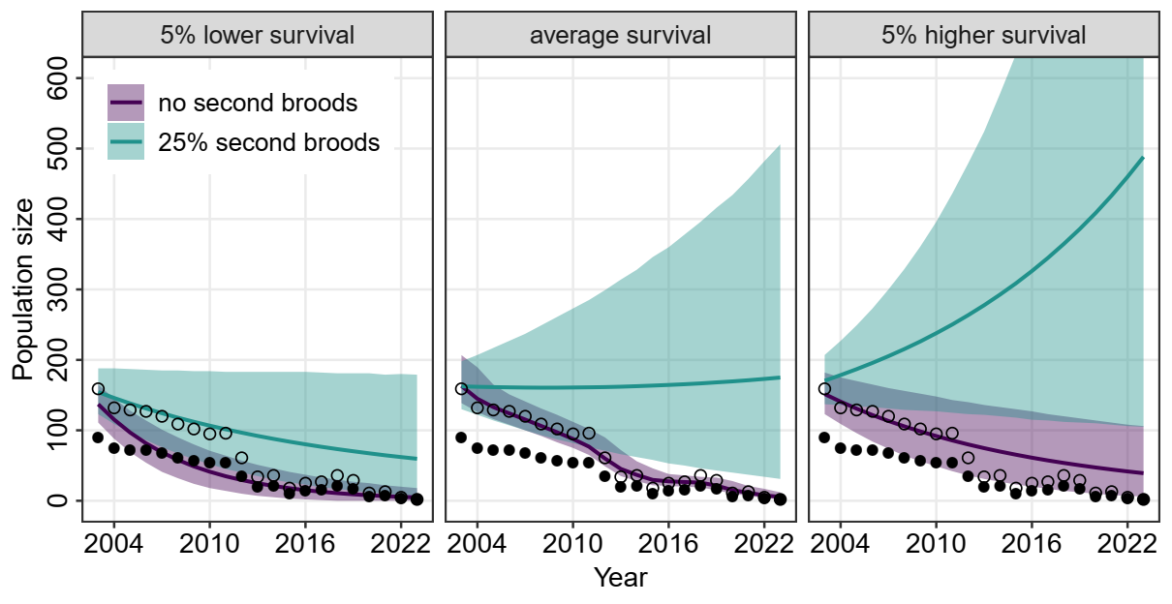
Fig. 2: Actual (“no second broods”) and hypothetical population development (mean size ± 95% CI) of the Pomeranian population of Aquatic Warblers between 2003-2023 simulated for scenarios that assumed an average proportion of 25% of breeding females raising a second brood per year and 5% higher or 5% lower annual survival probability. Filled circles show count data of singing males, open circles show total population size based on an adult sex ratio of 56% males.

3.2 Reinforcement and management scenarios
- Our future population projections indicate that survival and habitat availability are key limiting factors for the persistence of the Aquatic Warbler population in Pomerania, while the duration of reinforcement only modulated the time when a stable population may be reached (Fig. 3). Scenarios preventing second broods and using the same survival probability that we estimated for the past population trend, would not be able to retain a population regardless of the amount of available habitat or the duration of reinforcement (Figs. 4, A1). Scenarios that allow second broods still require an increase in available habitat to achieve a stable population of at least 100 adult birds (Fig. 3; Fig. 4). With less than 1000 ha available breeding habitat and no improvement in survival, populations may decline as soon as the reinforcement stops and target population size is unlikely to be reached after 25 years, even if Aquatic Warblers can raise two broods per year and releases are continued for 15 years (Fig. 3; Fig. 4). Additionally, in small habitats, releases will likely exhaust the carrying capacity of available area, and further releases might lead to overpopulation and loss of individuals (Fig. 3). Without an improvement in annual survival, restoring the population to a target size of 100 adult individuals may only be temporarily achievable, but the population would not be self-sustaining (Fig. 4). However, all the projections are surrounded by very large uncertainty and only improved survival and unlimited habitat resulted in an probability of population decline after reinforcement of 0 (Fig. 4).

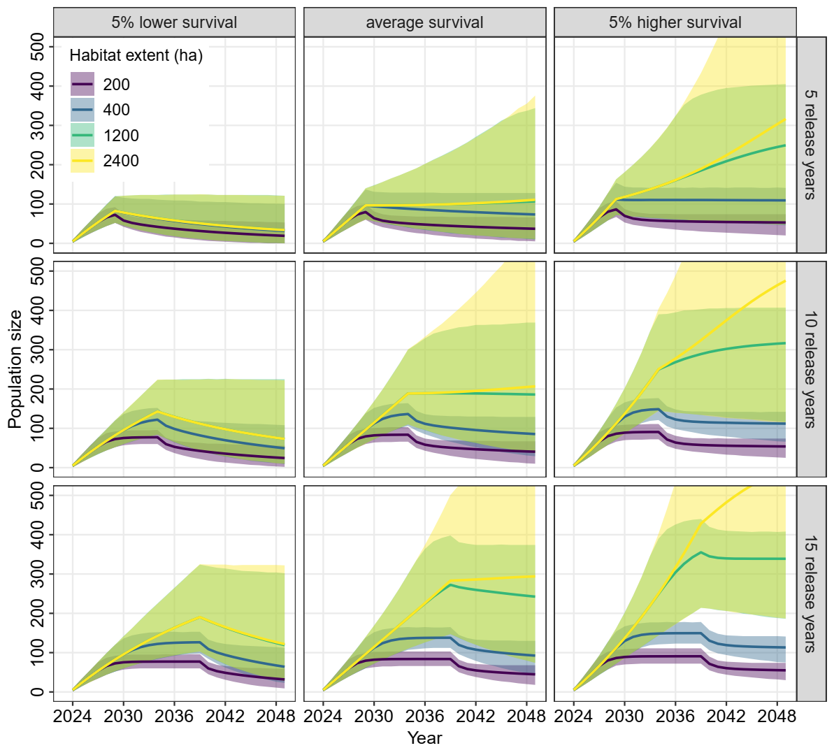Fig. 3: Population projections (mean size ± 95% CI) of the Pomeranian population of Aquatic Warblers between 2024-2049 simulated for different number of release years, for average and 5% lower and higher survival and for the scenarios of different amount of available habitat, assuming that Aquatic Warblers can raise two broods per year.

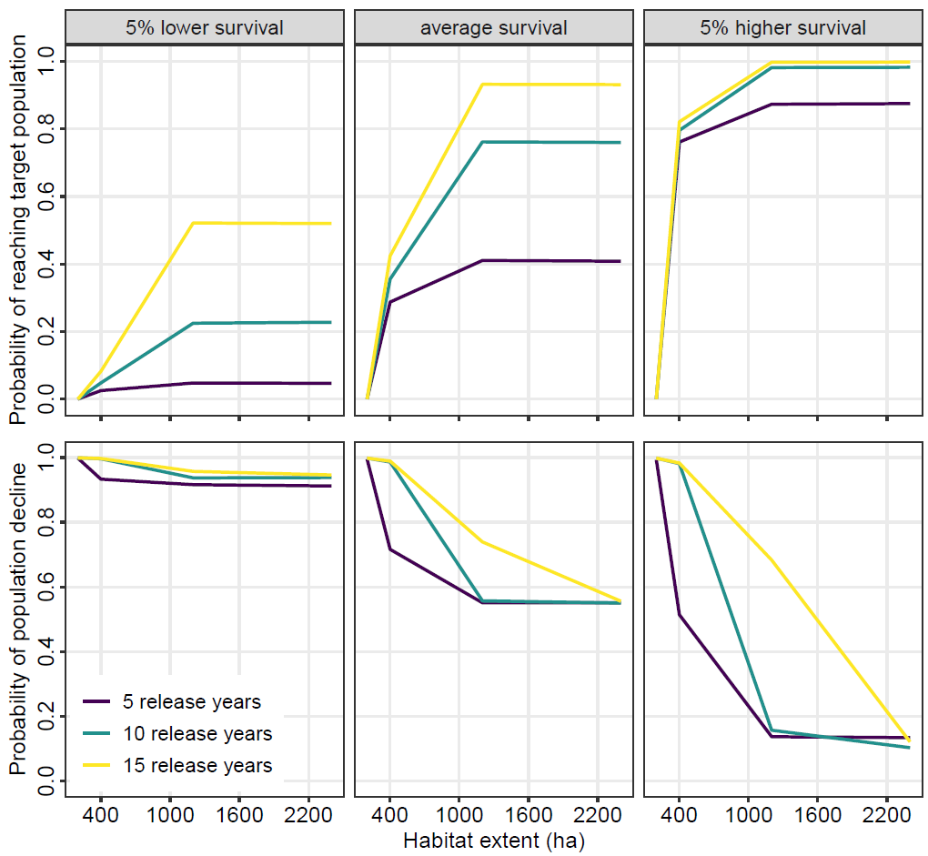
Fig. 4: Probability of achieving a target population size of 100 adult individuals after 25 years for the reinforced Pomeranian population of Aquatic Warblers in relation to the amount of available habitat (top row), and probability of the population declining between the end of the reinforcement programme and the end of projections in 2049 (bottom row); shown for different number of release years and for average and 5% lower and higher survival, assuming that Aquatic Warblers can raise two broods per year.

4. Discussion
We show that the Pomeranian population of Aquatic Warblers disappeared due to a combination of low productivity and low apparent survival, and that a higher proportion of second broods may have been sufficient to retain the population.
In the context of the current extinction crisis, population reinforcements appear critical to prevent and mitigate local or global species extinctions (IUCN/SSC 2013; Bubac et al., 2019; Munstermann et al., 2021). However, our results indicate that reinforcement alone is insufficient to restore a viable population of the Aquatic Warbler in Pomerania, unless the amount of available habitat is increased, and conservation measures are taken to increase survival and productivity by allowing second broods.

4.1 Population development 1993 – 2023
One aim of this study was to explore which demographic parameters contributed to the observed decline of the Pomeranian population of Aquatic Warblers during the last 30 years. Drainage and increased land use intensity on fen mires drastically reduced available habitat (Tanneberger et al., 2011) and large-scale habitat loss has certainly contributed to the decrease of the population (Flade et al., 2018). Our population model suggests that the low numbers of Aquatic Warblers after 2003 can be partially attributed to a reduction in the proportion of second broods (Fig. 2). The majority of females are assumed to move to other breeding sites for the second brood (Dyrcz and Zdunek, 1993b; Schulze-Hagen et al., 1999). Ongoing habitat loss increased habitat fragmentation which may have limited movements between breeding sites. Additionally, mowing during the breeding season before July reduced the possibility for second breeding attempts and probably also increased female mortality to some extent which also contributed to a negative population growth rate. The observed decline could also reflect a lower reproductive output, determined by the number of fledglings per female which is directly linked to the proportion of second broods. The average fledged brood size and the proportion of second broods is unknown for the Pomeranian population and may be lower than in the core breeding sites. However, our results indicate that intensive farming practices that reduce the opportunity to raise a second brood may be a key contributing factor to the decline of the Pomeranian Aquatic Warbler population. This finding is significant because the causes for the declines of many Palaerctic migratory birds are often assumed to lie outside of Europe (Vickery et al. 2014, 2023), but our results indicate that the decline of the Aquatic Warbler could have been prevented solely by conservation management on European breeding grounds.
Under the current conditions, the Pomeranian population of Aquatic Warblers is likely to go extinct immediately. In 2023, only one singing male was recorded. Despite conservation measures (e.g. postponed mowing on breeding sites) implemented after 2008, the population would require an increase in the annual survival probability to persist. However, as is typical in mark-recapture analyses, our model can only estimate apparent survival probability, which is affected by emigration (Badia-Boher et al., 2024). In small, fragmented populations, for a species that is known to disperse widely among other suitable patches of habitat, it is possible that our estimates of apparent survival probability are biased by chronic emigration. Larger, and more contiguous habitat patches may facilitate a greater retention of individuals, thus leading to an improved apparent annual survival probability.

4.2 Reinforcement and management scenarios
Our study implies that reinforcement and habitat restoration without improvements in survival rates may not be sufficient to stabilize the Pomeranian population of Aquatic Warblers. Whereas in long-lived species, population growth is mainly determined by adult survival (Schaub et al., 2009; Davis et al., 2023), in short-lived species, such as most long-distance migratory passerines, population growth is mainly attributed to recruitment (Dale, 2001; Border et al., 2017). First-year survival used in this study is based on a small dataset of marked juveniles of the pilot translocation study including two subsequent release years. Differences in return rates, ranging between 14% and more than 30% for first-year males (Morkvėnas et al., 2025) suggest that first-year apparent survival may be highly variable in Aquatic Warblers. Mortality in migrants can be highly affected by conditions on wintering grounds and during migration and therefore vary by year (Johnston et al. 2016). In Sedge Warblers Acrocephalus schoenobaenus, survival and population changes were significantly related to rainfall at the wintering site (Peach et al., 1991; Ockendon et al., 2014). Higher survival in Common Reed Warblers A. scirpaceus was associated with more precipitation at the stopover sites in Spain and Morocco (Halupka et al., 2017). Aquatic Warblers are insectivores and accumulate fat deposits for migration (Kerbiriou et al., 2010). Because they need to refuel en-route, they rely on food availability at stopover sites (Kerbiriou et al., 2010; Vickery et al., 2014). Carryover effects may translate adverse conditions during non-breeding periods to lower reproduction in the subsequent year (Finch et al., 2014). A recent study discovered long stopover durations of Aquatic Warblers in coastal wetlands of Morocco and Algeria during spring migration, indicating the importance of these sites in determining return rate to the breeding site, but habitat conditions and management options at these stopover sites remain unclear (Flade et al., 2023). This highlights the need for international efforts to identify and protect suitable habitats outside the breeding sites for Aquatic Warblers to increase survival.
Female apparent annual adult survival probability is extremely difficult to quantify due to the low detection probability of females owing to their secretive behavior (Schulze-Hagen et al., 1999; Dyrcz et al., 2018). Breeding site fidelity is probably rather low in Aquatic Warblers and permanent emigration may contribute to the low apparent survival estimates for females (Kubacka et al. 2024). Natal dispersal, which is also usually female-biased in most passerine species (Dale, 2001) may additionally reduce the recruitment at a given breeding site. A first-year return rate of 10% for females to the release site, observed in the pilot Aquatic Warbler translocation study (Morkvėnas et al., 2025), is consistent with return rates reported for other migrant passerines (Grinkevich et al., 2009; Border et al., 2017; Johnston et al. 2016). After the first release, the first-year return rate of males was remarkably high (>30%), followed by a substantial population increase (Morkvėnas et al., 2025), indicating that at least in years with high first-year survival, high population growth can be expected, possibly enough to compensate for years with lower first-year survival. However, the strong fluctuations in population size in Lithuania suggest that local population growth probably depends on immigration from other breeding sites (Border et al., 2017). Apparent survival used in this study accounts for detection, but not for permanent emigration from the study site. Movements between breeding sites are poorly understood in Aquatic Warblers, but must be sufficient to maintain constant gene flow (Kubacka et al., 2024). Exchange among Pomeranian breeding sites, both within and between breeding seasons was confirmed in the past (Dyrcz et al., 2018). This connection between breeding sites is also needed to increase the available breeding area for the reinforced Pomeranian population, because a single site alone will not provide enough habitat (> 1000 ha) for a stable population of at least 100 adult birds (Fig. 3; Fig. 4). Therefore, habitat restoration at all potential release sites and management that allows second broods are recommended even if survival can be improved.

4.3 Conclusions
Our study provides the first population viability analysis for the Aquatic Warbler. We conclude that high effort will be needed to reinforce the westernmost and geographically isolated Pomeranian population of the Aquatic Warbler. Based on our PVA, the most effective management would be to allow second broods, followed by restoration of habitat and improvements in survival, while the duration of reinforcement is of minor importance. In a migratory species, however, main causes for mortality are found outside the breeding area (Ockendon et al., 2014; Davis et al., 2023). Therefore, conservation actions for Aquatic Warblers should also address wintering grounds and stopover sites. Although initial studies revealed migration patterns of Aquatic Warblers (Salewski et al., 2019; Flade et al., 2023), further identification of migration routes and threats is important to inform conservation actions. Simultaneous conservation actions along the whole flyway may increase the success of population recovery in migrants more effectively than measures implemented at single breeding sites (Davis et al., 2023; Oppel et al., 2024). Since habitat loss has been a key factor for the previous decline of Aquatic Warblers, improving and increasing breeding habitats within the Pomeranian population will also be one of the critical factors for a successful reinforcement (Bubac et al., 2019). Habitat restoration and maintenance to provide more than 1000 ha of suitable breeding habitat are likely required to maintain a stable population of at least 100 adult individuals (Fig. 4). Due to the remaining uncertainties in the demographic data we highly recommend long-term monitoring of the development of the reinforced Pomeranian population to validate survival and reproduction rates and to update the PVA when more data are available (Akçakaya and Sjogren-Gulve, 2000). To this end, the reinforcement project gives the opportunity to increase the knowledge of the demographic dynamics impossible to be studied in wild populations of Aquatic Warblers (Schaub et al., 2009). Furthermore, more effort should be made to understand the intra-seasonal movements of the species and the importance of the connection with core breeding sites. If local populations depend on immigration to compensate for variations in recruitment and mortality (Border et al., 2017), it will be almost impossible to maintain an isolated population of Aquatic Warblers at the margin of the breeding range.

References
Akçakaya, H.R., Sjogren-Gulve, P., 2000. Population viability analyses in conservation planning: overview. Ecol. Bull. 48, 9–21.
Armstrong, D.P., Reynolds, M.H., 2011. Modelling reintroduced populations: the state of the art and future directions. In J.G. Ewen, D.P. Armstrong, K.A. Parker, P.J. Seddon (Eds.), Reintroduction Biology: integrating science and management, Chapter 6. Wiley-Blackwell, Oxford, UK.
Badia‐Boher, J.A., Real, J., Hernández‐Matías, A., 2024. Assumptions about survival estimates and dispersal processes can have severe impacts on population viability assessments. Biol. Conserv. 292, 110550.
BirdLife International, 2024. Species factsheet: Acrocephalus paludicola. Downloaded from http://datazone.birdlife.org/species/factsheet/aquatic-warbler-acrocephalus-paludicola on 15/02/2024.
Border, J.A., Henderson, I.G., Hartley, I.R., 2017. Characterising demographic contributions to observed population change in a declining migrant bird. J. Avian Biol. 48, 1139–1149.
Briedis, M., Keišs, O., 2016. Extracting historical population trends using archival ringing data—an example: the globally threatened Aquatic Warbler. J. Ornithol. 157, 419–425, https://doi.org/10.1007/s10336-015-1306-2
Brooks, S.P., Gelman, A., 1998. General methods for monitoring convergence of iterative simulations. J. Comput. Graph. Stat. 7, 434–455.
Bubac, M., Johnson, A.C., Fox, J.A., Cullingham, C.I., 2019. Conservation translocations and post-release monitoring: identifying trends in failures, biases, and challenges from around the world. Biol. Conserv. 238, 108239.
Chaudhary, V., Oli, M.K., 2020. A critical appraisal of population viability analysis. Conserv. Biol. 34, 26–40.
Dale, S., 2001. Female-biased dispersal, low female recruitment, unpaired males, and the extinction of small and isolated bird populations. Oikos 92, 344–356.
Davis, K.L., Saunders, S.P., Beilke, S., Ford, E.R., Fuller, J., Landgraf, A., Zipkin, E.F., 2023. Breeding season management is unlikely to improve population viability of a data-deficient migratory species in decline. Biol. Conserv. 283, 110104. https://doi.org/10.1016/j.biocon.2023.110104
Dyrcz, A., Kozulin, A., Vergeichik, L., Kubacka, J., 2018. Breeding biology and ecology. In: Tanneberger, F., Kubacka, J. (Eds.), The Aquatic Warbler Conservation Handbook, Brandenburg State Office for Environment (LfU), Potsdam, Germany, pp. 50–61.
Dyrcz, A., Chylarecki, P., 2018. Adult survival of Aquatic Warblers breeding in the Biebrza Marshes, Poland, In: Tanneberger, F., Kubacka, J. (Eds.), The Aquatic Warbler Conservation Handbook, Brandenburg State Office for Environment (LfU), Potsdam, Germany, p. 67.
Dyrcz, A., Sauer-Gürth, H., Tkadlec, E., Wink, M., 2004. Offspring sex ratio variation in relation to brood size and mortality in a promiscuous species: the Aquatic Warbler Acrocephalus paludicola. Ibis 146, 269–280.
Dyrcz, A., Zdunek, W., 1993a. Breeding ecology of the Aquatic Warbler Acrocephalus paludicola on the Biebrza marshes, northeast Poland. Ibis 135, 181–189.
Dyrcz, A., Zdunek, W., 1993b. Breeding statistics of the Aquatic Warbler Acrocephalus paludicola on the Biebrza Marshes, northeast Poland. J. Ornithol. 134, 317–323.
Finch, T., Pearce-Higgins, J.W., Leech, D.I., Evans, K.L., 2014. Carry-over effects from passage regions are more important than breeding climate in determining the breeding phenology and performance of three avian migrants of conservation concern. Biodivers. Conserv. 23, 2427–2444.
Flade, M., Diop, I., Haase, M., Le Nevé, A., Oppel, S., Tegetmeyer, C., Vogel, A., Salewski, V., 2011. Distribution, ecology and threat status of the aquatic warblers Acrocephalus paludicola in West Africa. J. Orn. 152, S129-S140.
Flade, M., Lisovski, S., Eigirdas, V., Giessing, B., Jiguet, F., Keišs, O., Nemtchinov, M., 2023. Migration routes and wintering sites of the Aquatic Warblers Acrocephalus paludicola breeding in Lithuania and North Belarus. bioRxiv2023.10.10.561376; doi: https://doi.org/10.1101/2023.10.10.561376
Flade, M., Malashevich, U., Krogulec, J., Poluda, A., Preiksa, Z., Végvári, Z., Lachmann, L., 2018. World distribution, population, and trends. In: Tanneberger, F., Kubacka, J. (Eds.), The Aquatic Warbler Conservation Handbook, Brandenburg State Office for Environment (LfU), Potsdam, Germany, pp. 22–35.
Frankham, R., Bradshaw, C.J., Brook, B.W., 2014. Genetics in conservation management: revised recommendations for the 50/500 rules, red List criteria and population viability analyses. Biol. Conserv. 170, 56–63.
- Grinkevich, V., Chernetsov, N., Mukhin, A., 2009. Juvenile Reed Warblers Acrocephalus scirpaceus see the world but settle close to home. Avian Ecol. Behav. 16, 3–10.
Halupka, L., Wierucka, K., Sztwiertnia, H., Klimczuk, E., 2017. Conditions at autumn stopover sites affect survival of a migratory passerine. J. Ornithol. 158, 979–988.
Heinsohn, R., Lacy, R., Elphinstone, A., Ingwersen, D., Pitcher, B.J., Roderick, M., Schmelitschek, E., Van Sluys, M., Stojanovic, D., Tripovich, J., Crates, R., 2022. Population viability in data deficient nomadic species: what it will take to save regent honeyeaters from extinction. Biol. Conserv. 266, 109430.
Imlay, T.I., Crowley, J.F., Argue, A.M., Steiner, J.C., Norris, D.R., Stutchbury, B.J.M. 2010. Survival, dispersal and early migration movements of captive-bred juvenile eastern loggerhead shrikes (Lanius ludovicianus migrans). Biol. Conserv. 143, 2578–2582.
IUCN/SSC, 2013. Guidelines for Reintroductions and Other Conservation Translocations. Version 1.0. Gland, Switzerland: IUCN Species Survival Commission.
Johnston, A., Robinson, R.A., Gargallo, G., Julliard, R., van der Jeugd, H., Baillie, S.R., 2016. Survival of Afro-Palaearctic passerine migrants in western Europe and the impacts of seasonal weather variables. Ibis 158, 465-480.
Kellner, K.F., 2016. jagsUI: A wrapper around rjags to streamline JAGS analyses. CRAN, https://rdrr.io/cran/jagsUI/. [R package].
Kerbiriou, C., Bargain, B., Le Viol, I., Pavoine, S., 2010. Diet and fuelling of the globally threatened Aquatic Warbler in autumn migration stopover as compared with two congeners. Anim. Conserv. 14, 261–270.
Kéry, M., Schaub, M., 2012. Bayesian population analysis using WinBUGS. Oxford, UK: Academic Press.
Krogulec, J., Kloskowski, J., 2003. Monitoring Aquatic Warbler Acrocephalus paludicola in Poland. Ornis Hungarica 12-13, 191–196.
Kubacka, J., Oppel, S., Dyrcz, A., Lachmann, L., Barros Da Costa, J.P.D., Kail, U., Zdunek, W., 2014. Effect of mowing on productivity in the endangered Aquatic Warbler Acrocephalus paludicola. Bird Conserv. Int. 24, 45–58. https://doi:10.1017/S0959270913000154
Kubacka, J., Dubiec, A., Korb, J., Salewski, V., Dyrcz, A., Foucher, J., Giessing, B., Leisler, B., Schulze-Hagen, K., Wink, M., Panagiotopoulou, H., 2024. Low genetic diversity and high gene flow in the Aquatic Warbler (Acrocephalus paludicola), a threatened marshland songbird with a fragmented breeding range. Ibis, 166, 232–251. https://doi.org/10.1111/ibi.13250
Lees, A.C., Haskell, L., Allinson, T., Bezeng, S.B., Burfield, I.J., Renjifo, L.M., Rosenberg, K.V., Viswanathan, A., Butchart, S.H.M., 2022. State of the World’s Birds. Annu. Rev. Environ. Resour. 47, 231–260. https://doi.org/10.1146/annurev-environ-112420-014642
Mayall, E., Groves, L., Kennerley, R., Hudson, M., Franco, A., 2023. Demographic consequences of management actions for the successful reintroduction of the White Stork Ciconia ciconia to the UK. Bird Conserv. Int. 33, e47. https://doi:10.1017/S0959270922000466
Morkvėnas, Ž., Arbeiter, S., Kozulin, A., Riauba, G., Zhurauliou, D., Yakovich, V., Tanneberger, F., 2025. Successful translocation of a long-distance migrating passerine – new impetus for the conservation of the globally threatened Aquatic Warbler. Anim. Conserv. 28, 147–155, https://doi.org/10.1111/acv.13018
Munstermann, M.J., Heim, N.A., McCauley, D.J., Payne, J.L., Upham, N.S., Wang, S.C., Knope, M.L., 2021. A global ecological signal of extinction risk in terrestrial vertebrates. Conserv. Biol. 36, e13852. doi: 10.1111/cobi.13852
Nemes, C.E., Cabrera-Cruz, S.A., Anderson, M.J., DeGroote, L.W., DeSimone, J.G., Massa, M.L., Cohen, E.B., 2023. More than mortality: Consequences of human activity on migrating birds extend beyond direct mortality. Ornithological Applications 125. doi: https://doi.org/10.1093/ornithapp/duad020
Ockendon, N., Johnston, A., Baillie, S.R., 2014. Rainfall on wintering grounds affects population change in many species of Afro-Palaearctic migrants. J. Ornithol. 155, 905–917.
Oppel, S., Dobrev, V., Arkumarev, V., Saravia-Mullin, V., Bashmili, K., Bino, T., Bounas, A., Chardin, A., Dobrev, D., Duro, K., Kapsalis, E., Kret, E., Marchant, M.P., Nakev, S., Petrovski, N., Papaioannou, H., Popgeorgiev, G., Selgjekaj, L., Skartsi, T., Stamenov, A., Stoychev, S., Topi, M., Vavylis, D., Velevski, M., Vorpsi, Z., Weston, J., Xeka, E., Xherri, X., Yordanov, E., Nikolov, S.C., 2024. Long-term conservation efforts at flyway scale can halt the population decline in a globally endangered migratory raptor. Anim. Conserv. 27: 374–385. https://doi.org/10.1111/acv.12917
Oppel, S., Saravia, V., Bounas, A., Arkumarev, V., Kret, E., Dobrev, V., Dobrev, D., Kordopatis, P., Skartsi, T., Velevski, M., Petrovski, N., Bino, T., Topi, M., Klisurov, I., Stoychev, S., Nikolov, S., 2021. Population reinforcement and demographic changes needed to stabilise the population of a migratory vulture. J. Appl. Ecol. 58, 2711–2721.
Pain, D., Hughes, B., Syroechkovskiy, E., Zöckler, C., Chowdhury, S., Anderson, G., Clark, N., 2018. Saving the Spoon-billed Sandpiper: a conservation update. British Birds 111, 323–333.
Peach, W.J., Baillie, S., Underhill, L., 1991. Survival of Sedge Warblers Acrocephalus schoenobaenus in relation to West African rainfall. Ibis 133, 300–305.
Plummer, M., 2017. JAGS: A Program for Analysis of Bayesian Graphical Models Using Gibbs Sampling (Version 4.3.0). [R package].
R Core Team, 2024. R: A language and environment for statistical computing. R Foundation for Statistical Computing. Vienna, Austria. https://www.R-project.org.
Reed, J.M., Mills, L.S., Dunning, J.B., Menges, E.S.,McKelvey, K.S., Frye, R., Beissinger, S.R., Anstett, M.C., Miller, P., 2002. Emerging issues in population viability analysis. Conserv. Biol. 16, 7–19. https://doi.org/10.1046/j.1523-1739.2002.99419.x
Sæther, B.-E., Engen, S., Lande, R., Møller, A.P., Bensch, S., Hasselquist, D., Beier, J., Leisler, B., 2004. Time to extinction in relation to mating system and type of density regulation in populations with two sexes. J. Anim. Ecol. 73, 925–934.
Salewski, V., Flade, M., Lisovski, S., Poluda, A., Iliukha, O., Kiljan, G., Malashevich, U., Hahn, S. 2019. Identifying migration routes and non-breeding staging sites of adult males of the globally threatened Aquatic Warbler Acrocephalus paludicola. Bird Conserv. Int. 29, 503–514. https://doi: 10.1017/S0959270918000357
Schaub, M., Kéry, M., 2021. Integrated population models: Theory and ecological applications with R and JAGS. Academic Press, Boston, USA.
Schaub, M., Abadi, F., 2011. Integrated population models: a novel analysis framework for deeper insights into population dynamics. J. Ornithol. 152, 227–237. https://doi.org/10.1007/s10336-010-0632-7
Schaub, M., Zink, R., Beissmann, H., Sarrazin, F., Arlettaz, R., 2009. When to end releases in reintroduction programs: Demographic rates and population viability analysis of bearded vultures in the Alps. J. Appl. Ecol. 46, 92–100.
Schulze-Hagen, K., Leisler, B., Schäfer, H.M., Schmidt, V., 1999. The breeding system
of the Aquatic Warbler Acrocephalus paludicola – a review of new results. Vogelwelt
120, 87–96.
Tanneberger, F., Kloskowski, J., Knöfler, V., Kozulin, A., Marczakiewicz, Piotr Morkvėnas, Ž., Poluda, A., Végvįri, Z., Vergeichik, L., Flade, M., 2018. Breeding habitat requirements. In: Tanneberger, F., Kubacka, J. (eds), The Aquatic Warbler Conservation Handbook, Brandenburg State Office for Environment (LfU), Potsdam, Germany, pp. 34–45.
Tanneberger, F., Bellebaum, J., Dylawerski, M., Fartmann, T., Jurzyk-Nordlöw, S., Koska, I., Tegetmeyer, C., Wojciechowska, M., 2011. Habitats of the globally threatened Aquatic Warbler (Acrocephalus paludicola) in Pomerania – site conditions, flora, and vegetation characteristics. Plant Diversity and Evolution 129/3–4, 253–273.
Vickery, J.A., Ewing, S.R., Smith, K.W., Pain, D.J., Bairlein, F., Škorpilová, J., Gregory, R.D., 2014. The decline of afro-Palaearctic migrants and an assessment of potential causes. Ibis 156, 1–22.
Vickery, J.A., Mallord, J.W., Adams, W.M., Beresford, A.E., Both, C., Cresswell, W., Diop, N., Ewing, S.R., Gregory, R.D., Morrison, C.A., Sanderson, F.J., Thorup, K., Van Wijk, R.E., Hewson, C.M., 2023. The conservation of Afro-Palaearctic migrants: What we are learning and what we need to know? Ibis 165, 717-738.
Weatherhead, P.J., Forbes, M.R.L., 1994. Natal philopatry in passerine birds: genetic or ecological influence? Behav. Ecol. 5, 426–433.

Fig. 3: Population projections (mean size ± 95% CI) of the Pomeranian population of Aquatic Warblers between 2024-2049 simulated for different number of release years, for average and 5% lower and higher survival and for the scenarios of different amount of available habitat, assuming that Aquatic Warblers can raise two broods per year.

Fig. 4: Probability of achieving a target population size of 100 adult individuals after 25 years for the reinforced Pomeranian population of Aquatic Warblers in relation to the amount of available habitat (top row), and probability of the population declining between the end of the reinforcement programme and the end of projections in 2049 (bottom row); shown for different number of release years and for average and 5% lower and higher survival, assuming that Aquatic Warblers can raise two broods per year.

Appendix A. Supplementary figures

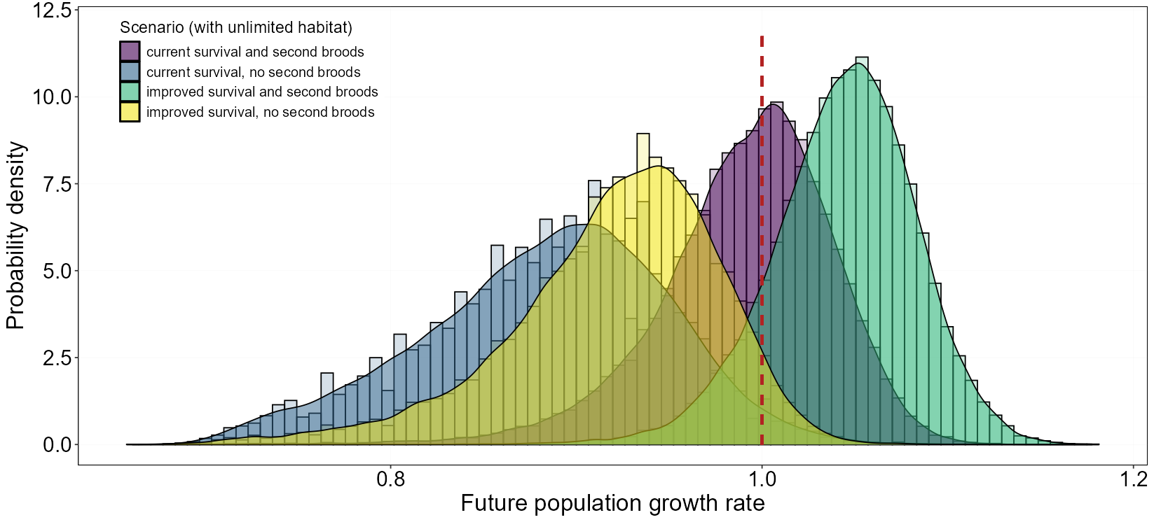
Fig. A1: Posterior probability density of population growth rates (mean± 95% CI) of the reinforced Pomeranian population of Aquatic Warblers shown for scenarios with current (average) and improved survival, and for one or two broods per year. Red vertical dashed line indicates population stability (growth rate = 1).

