Reinforcement is not enough to establish a viable population of the globally threatened Aquatic Warbler Acrocephalus paludicola at the margin of its breeding range

Abstract
Population viability analysis is a valuable tool to guide the reinforcement of endangered bird species. In migrants, demographic data required for population projections are often deficient, making reinforcement outcomes challenging to predict. The globally threatened Acrocephalus paludicola (Aquatic Warbler) is a long-distance migratory passerine that breeds in sedge fen mires in Central Europe and winters in sub-Saharan Africa. Although conservation measures, such as protecting breeding habitats from drainage and intensive grassland management have stopped the decline in the core breeding sites, the westernmost breeding population (Pomeranian population) is currently threatened with extinction. In this study, we used integrated population models to determine the demographic parameters that contributed to the past decline, and then explored different management scenarios to identify which combination of reinforcement, habitat management, and survival improvement could result in a stable population in the future. We found, that the prevention of second broods due to grassland mowing during the breeding season adequately explained the observed decline of the Pomeranian population. To re-establish a viable population, adapted grassland management that allows second broods, the restoration of breeding habitat (> 1000 ha), an increase in annual survival probability are required in addition to several years of reinforcement. Without an improvement in survival, populations may decline after releases end, but our projections are surrounded by large uncertainties due to unknown spatial dispersal and recruitment processes. In long-distance migrants, most causes for mortality are found outside the breeding area. Therefore, simultaneous conservation actions along the whole flyway are needed to increase the success of Acrocephalus paludicola population recovery at the margin of the breeding range.

Keywords: Acrocephalus paludicola, Aquatic Warbler, conservation management, extinction risk, habitat restoration, population viability analysis, translocation

Introduction
Worldwide, a growing number of vertebrate species are threatened with extinction (Munstermann et al. 2021). Anthropogenic pressure and climate change increase habitat loss and fragmentation, which accelerates the risk of population decreases (Dale 2001, Lees et al. 2022). Conservationists are facing the challenge to effectively manage populations and halt ongoing declines (Bubac et al., 2019, Davis et al. 2023). For small and isolated populations, providing and maintaining suitable habitat is sometimes not sufficient to increase numbers again (Dale 2001, Armstrong and Reynolds 2011). Therefore, reinforcement (defined as the intentional movement and release of an organism into an existing population of conspecifics) by translocations or captive breeding is an increasingly applied conservation action to assist the population recovery of endangered species (IUCN/SSC 2013, Bubac et al. 2019).
Among northern temperate bird species, migrants have generally suffered greater population declines than residents (Rosenberg et al. 2019, Lees et al. 2022, Vickery et al. 2023). Nevertheless, only few reinforcement projects have been directed at long-distance migrants (Pain et al. 2018, Oppel et al. 2021, Mayall et al. 2023). The implementation of effective conservation measures for long-distance migrants needs to consider that migrants depend on breeding sites, staging sites during migration and wintering sites, and threats in any of these critical sites could affect the viability of a population (Runge et al. 2015, Vickery et al. 2023, Oppel et al. 2024). The habitat conditions at the breeding sites are often well studied, but most migrants spend more than 75% of the year at non-breeding sites, where habitat changes and weather parameters affecting survival are poorly understood (Halupka et al. 2017, Davis et al. 2023).
To date, there has been no reinforcement approach for a long-distance migratory passerine Generally, high juvenile mortality and low levels of natal philopatry in long-distance migratory passerines reduce return rate and may impede the recovery of a population at a given release site (Weatherhead and Forbes 1994, Imlay et al. 2010). Long durations of releases will be required to observe changes in population size to evaluate reinforcement success (Imlay et al. 2010). Additionally, due to low recapture probabilities in migrating passerines, data on survival and dispersal are often scarce making population development after translocations difficult to predict (Heinsohn et al. 2022).
Population viability analysis (PVA) is an important tool to guide the reinforcement of endangered bird species (Schaub et al. 2009, Armstrong and Reynolds 2011, Heinsohn et al. 2022). PVA models simulate temporal changes in population size and estimate extinction probability incorporating demographic stochasticity and can also be used to predict reinforcement outcomes (Akçakaya and Sjogren-Gulve 2000, Oppel et al. 2021). Because these models rely on demographic input data, availability and quality of vital parameters are crucial for estimating future population size. However, data on survival and reproductive output are often deficient in threatened species (Heinsohn et al. 2022, Davis et al. 2023). Especially in long-distance migrants, survival can be expected to be highly variable due to annually changing habitat conditions during migration and wintering (Ockendon et al. 2014, Halupka et al. 2017), which further increases uncertainty for future predictions. But even with uncertainties, PVA models can still be useful to compare different management options (Heinsohn et al. 2022). Furthermore, the calibration of projections using observed data can be essential to evaluate the validity of demographic assumptions and derived population dynamics (Badia‐Boher et al. 2024). In the last decade, PVAs have been increasingly combined with Integrated Population Models (IPMs) (Schaub and Kéry 2021). IPMs are a modelling framework that uses the shared demographic information between different monitoring datasets from the same population (e.g., mark-recapture, productivity, counts) to provide more precise estimates of demographic parameters and population dynamics (Schaub and Kéry 2021). Merging IPMs and PVAs guarantees 1) a correct propagation of uncertainty from the demographic estimates to the PVA projections, which is fundamental to obtain reliable PVA results (Chaudhary and Oli 2020, Badia-Boher et al. 2024), and 2) a potential gain in the precision of the projections, thanks to the properties of IPMs.
In this study, we used an IPM-PVA to inform the reinforcement of a long-distance migratory passerine. The Acrocephalus paludicola (Aquatic Warbler) is a habitat specialist that only breeds in shallow inundated, mesotrophic fen mires with low (<1 m) sedge vegetation in Central Europe (Tanneberger et al. 2018) and winters in sub-Saharan Africa. The species was once widespread and numerous throughout Europe. During the last century, the global population experienced a severe decline (> 90%) caused by habitat loss and degradation due to drainage, peat extraction, conversion to agricultural land and eutrophication (Tanneberger et al. 2011, Briedis and Keiss 2016). Today, the Acrocephalus paludicola is globally threatened due to habitat loss (BirdLife International 2024): the breeding range is highly fragmented and only four breeding sites hold 75% of the entire world population of about 11,000 singing males (Flade et al. 2018). Improvements in hydrological conditions and the implementation of low-intensity grassland management to suppress succession secured suitable habitat and halted the decline in the core breeding area (Fig. 1). In peripheral breeding sites, however, the decline continues and the westernmost population in Germany and northwestern Poland (hereafter Pomeranian population) is currently threatened with extinction despite ongoing habitat restoration work within a large-scale conservation project (LIFE23-NAT-LT-LIFE4AquaticWarbler-101148281). In addition to the habitat restoration
, a pilot study demonstrated the successful translocation of young Acrocephalus paludicola from Belarus to Lithuania prior to their first migration (Morkvėnas et al. 2025). Following this trial, the first translocation from the core breeding sites started the reinforcement of the Pomeranian population in 2023, but so far it has been unclear whether reinforcement alone would be sufficient to secure the Pomeranian population.
In this study, we first estimated which demographic parameters may have contributed to the past decline of the Pomeranian population of Acrocephalus paludicola using observed count data. We then used the estimated parameters to project future population trajectories under different scenarios, including different durations of population reinforcement, improvements in annual survival, and the extent of suitable habitat to understand what combination of conservation measures would be required to achieve population persistence. Our results can inform the reinforcement process of Acrocephalus paludicola translocations to successfully recover the nearly extinct Pomeranian population and may be useful for the conservation management of other long-distance migratory passerines.

Material and methods
Study population
The Pomeranian population of Acrocephalus paludicola comprises breeding sites in northwestern Poland and northeastern Germany , which arenow geographically isolated from core breeding sites in eastern Poland (Flade et al. 2018, Fig. 1). Acrocephalus paludicola shows an extraordinary promiscuous breeding system with uniparental brood care by females which attempt to breed twice between May and July (Schulze-Hagen et al. 1999, Dyrcz et al. 2018). Females behave very secretive, but males sing continuously during the breeding season, and population size was assessed by counting singing males at the end of May and end of June, during the peaks of the first and second breeding attempts. Comprehensive and largely synchronous annual counts were conducted with standardized methodology in Poland from 2003 onwards in the entire range of the Pomeranian population.
Fig. 1. Breeding range decline of Acrocephalus paludicola (Aquatic Warbler) in Germany and Poland and locations of the core breeding population and potential release sites for reinforcement of the peripheral Pomeranian population.

The Acrocephalus paludicola is a habitat specialist, with habitat deterioration being a consequence of drainage and eutrophication, which can be reversed by human management (Tanneberger et al. 2018). Despite habitat management, the Pomeranian population strongly declined during the last 30 years (Flade et al. 2018), which triggered the motivation to understand the causes of decline and reinforce the remnant population. Following a successful pilot study (12-22% of 100 translocated chicks returned after their first year, Morkvėnas et al. 2025), the reinforcement of the Pomeranian population started in 2023 and further translocations to former and suitable breeding sites within the Pomeranian population range (Fig. 1) are planned between 2025 and 2028 (within the EU-funded LIFE4AquaticWarbler project). The ultimate aim of this project is to re-establish a population of at least 56 singing males (100 adult individuals), which can be considered a minimum number for a viable population without fitness limitations (Frankham et al. 2014).

Integrated Population Model to estimate population growth rate
We estimated demographic parameters and population dynamics of the Pomeranian Acrocephalus paludicola population by jointly analyzing productivity, mark-resighting, and population count data in an integrated population model (IPM). The IPM was based on an age-structured population model that related age-specific population sizes to demographic rates, and accounted for density dependence (see “Density-dependence modelling” below) and demographic stochasticity (Schaub and Kéry, 2021). The structure reflected the life cycle of the species with two age-classes – juveniles and adults – and birds started reproducing at the age of one year (Sæther et al. 2004). . The model
Because the Pomeranian population is very small and has been decreasing for decades, very few population-specific demographic data exist. Hence, we used data and informative priors from other closely related populations in Poland. These populations nest in similar habitat, at similar latitude, follow the same migratory flyway, and are likely connected by dispersing individuals (Kubacka et al. 2024), hence their demographic parameters are likely similar to those in the restored Pomeranian population.

Modelling annual productivity from multiple broods
To estimate annual productivity we decomposed the season into a first and a second breeding attempt, .We added the separately estimated number of chicks produced in the first and second attempt to yield the annual productivity per adult female.
For the first breeding attempt, we assumed that all females attempted to reproduce. We made this assumption given the polygynandrous mating system of the species, where multiple males and females mate with each other and no exclusive territories are formed. We used the estimates obtained from the eastern Polish population in the Biebrza marshes as an informative prior (a normal distribution with a mean of 3.5 fledglings per brood with a standard deviation of 1.8, Dyrcz and Zdunek 1993b, Kubacka et al. 2014), because no independent data existed from the Pomeranian population.
We assumed that intensive agricultural management and early mowing of breeding habitats did not permit a second breeding attempt in the past (Tannenberger et al. 2018). Therefore, second broods were only included in hypothetical scenarios in the past or in future management scenarios (see “Reinforcement and management scenarios”). Second breeding attempts were only attempted by up to 50% of the females in a population under optimal conditions (Dyrcz and Zdunek 1993b, Schulze-Hagen et al. 1999). To reflect the uncertainty about the fraction of second broods attempted in the study population, we modelled this proportion using a normal distribution with a mean of 0.25 and a standard deviation of 0.07. The number of chicks produced by second broods was drawn from informative prior information from the Biebrza marshes, where second broods resulted in a mean of 2.75 ± 0.2 fledglings (Kubacka et al., 2014). The productivity of second broods was therefore calculated as the proportion of females attempting a second brood, multiplied by the number of fledglings raised per second brood.

Estimation of annual survival probability
We estimated survival for two age classes (juveniles and adults) following studies from other Acrocephalus warblers (Sæther et al. 2004). To estimate first-year survival probabilities, we used individual mark-recapture data from juveniles translocated from Belarus to western Lithuania in 2018 and 2019 (Morkvénas et al. 2025) in a Cormack-Jolly-Seber model. The mark-recapture dataset consisted of 99 individuals marked as fledglings in years 2018 and 2019, with resighting data from every year between 2018 until 2022 (Morkvénas et al. 2025). Our model assumed that survival and resighting probability were constant over time, but that resighting probabilities varied by sex. We used weakly informative priors to estimate juvenile survival (beta: 1.2, 1.2), and informative priors in sex-specific recapture probabilities (normal with mean 0.57 for males and 0.26 for females, ± 0.04 standard deviation for both). We used an informative prior to specify adult survival (normal: 0.42 ± 0.03) derived from a population in the Biebrza Marshes (1987-1995, Dyrcz and Zdunek 1993a, Dyrcz and Chylarecki 2018) because data from the Pomeranian population were too sparse.

Modelling of count data
The estimated population size in the age-structured population model was linked to the counts of singing males from 2003-2023 using a Poisson error distribution (Schaub and Kéry, 2021). Importantly, our counts were only of singing males, whilst the estimated population size included both males and females. We therefore multiplied the total estimated population size by the assumed proportion of males in the breeding population to link population size to our counts of singing males. The proportion of males in the population was extracted from other populations of the species and introduced as an informative prior (Normal distribution, mean = 0.56, standard deviation = 0.01).

Accounting for density-dependence
Habitat loss is the key threat for Aquatic Warblers, and it is therefore likely that the demography of the Pomeranian population is affected by the carrying capacity and density-dependent reductions in breeding opportunities. We calculated carrying capacity as the maximum number of adult breeding females that could be supported by the available habitat.

We assumed an average density of 1.2 nests (breeding females) per 10 ha (Tanneberger et al. 2018), and multiplied this density with the area of suitable habitat available for the Pomeranian population during the 1990s (2965 ha, Flade et al., 2018), resulting in a carrying capacity of 356 females for the past. If the estimated number of adult females in our model exceeded the carrying capacity K of the available habitat in a given year, then only K adult females were permitted to reproduce in that year, while the remaining females were assumed to omit breeding, but they were not removed from the population.

Calculation of population growth rate and model settings

We calculated the population growth rate as the geometric mean of the annual changes in total population size (N _{t+1} / N _{t}).
To fit the IPM, we used Markov-Chain-Monte-Carlo-based Bayesian inference in programme JAGS v. 4.3.0 called from R v. 4.4.2 (R Core Team 2024) via the jagsUI package (Kellner 2016, Plummer 2017).

We ran four Markov chains with 75,000 iterations each and discarded the first 25,000 iterations. From the remaining iterations we only used every fifth iteration for inference, and we tested for convergence using the Gelman-Rubin diagnostic (Brooks and Gelman 1998); all estimated parameters had values of R-hat < 1.002.

Reinforcement and management scenarios
To address our main question which management scenarios would result in a stable population of Acrocephalus paludicola in Pomerania, we explored several plausible combinations of changes in survival, productivity, extent of habitat and the duration of reinforcement.
After fitting the model to the past observation data from 2003 to 2023 including the assumption of no second broods, we explored 6 alternative (hypothetical) scenarios for the past: how the population could have developed if (1) second broods had been allowed since 2003; (2) survival had changed (in both directions) by 5% from 2003 onwards, and (3) both the proportion of second broods and survival had changed simultaneously in 2003.
We then explored 54 different scenarios that included the following combinations of reinforcement and other management. Based on experience from pilot translocations of Acrocephalus paludicola, 10 nests (~50 chicks) per year are logistically feasible and appear to be inconsequential for the source site (Morkvėnas et al. 2025). Hence, our projected future scenarios were based on 50 released individuals per year, and only explored different durations of reinforcement (5, 10 and 15 years). Three scenarios considered the different duration of reinforcement with unlimited habitat but no second broods emulating likely past conditions. All other scenarios assumed that a proportion of all female Acrocephalus paludicola raised two broods per year.
We identified six potential release sites within the range of the Pomeranian population (Fig. 1), and assumed that each release site provides 200 ha of suitable habitat, which could be increased to 400 ha by further habitat restoration. Note that knowledge about the location and area of potential habitat exists, but because suitable habitat is management-dependent, our scenarios reflect the uncertainty in the amount of political will and financial resources available to restore and maintain a specified area of suitable habitat. We therefore explored four different scenarios of habitat availability, namely one or six release sites, either with or without further habitat restoration, resulting in available habitat areas of 200, 400, 1200 or 2400 ha. This available habitat corresponded to assumed carrying capacities of 24, 48, 144, or 288 adult females, respectively. Combining those four habitat availabilities with the three reinforcement durations resulted in a total of 12 future scenarios where habitat was constrained and six scenarios (described above) where habitat was unconstrained. All of these 18 scenarios were projected either with constant survival probability, an improved survival of 5% for both adults and juveniles to reflect ongoing conservation efforts on breeding grounds and along the flyway, or survival reduced by 5% to reflect potential deteriorations of conditions along the migration route and wintering areas (Flade et al. 2023, Nemes et al. 2023).
To examine which of the 54 combinations of reinforcement and management would result in a stable or increasing population trend, we projected the population size estimated by the integrated population model 25 years into the future while accounting for uncertainty in all demographic parameters (Schaub and Kéry 2021, Oppel et al., 2021). For each scenario of reinforcement and survival improvement - including two ‘do nothing’ scenarios of no reinforcement and no survival improvement (but with or without second broods) - we calculated the probability to reach a target population size of 100 adults in 25 years (i.e., the end of projections). We selected this metric as it was the stated goal of the large conservation project, and a population size that reduces the risk of extinction in the short and medium term to acceptable levels (Frankham et al. 2014). We also present the probability of populations declining after the end of the reinforcement as the proportion of population simulations under each scenario where the total number of adult birds in 2049 was lower than the number of adults at the end of the reinforcement program. This metric was chosen because it indicates which populations would eventually be self-sustainable, irrespective of whether the target population size had been achieved or not.

Results
Population development 2003 – 2023
The Pomeranian population experienced a slow but continuous decrease from 89 singing males in 2003 to only one singing male recorded in 2023 (Fig. 2). Previous data from 1993 and 1997 indicated a population size of 250 and 262 singing males, respectively (Krogulec and Kloskowski 2003), thus validating our assumed carrying capacity.
Our integrated population model adequately described the population decrease under the assumption that no second broods were possible (Fig. 2). Adult survival was estimated at 0.380 (95% credible interval: 0.306 – 0.452). We estimated juvenile survival probability to be similarly high (0.366; 95% credible interval: 0.302 – 0.439). When assuming that some females had been able to raise a second brood every year since 2003, the population could have potentially remained stable over the last 20 years (mean growth rate 0.99 ± 0.04; Fig. 2). If second broods had been prevented, but survival had been increased by 5% starting in 2003, the population decline would have been slightly slower than observed, but the population would not have remained stable (mean growth rate: 0.91 ± 0.12; Fig. 2). Lower annual survival could also have contributed to the decline, but the projected decline was not as steep as with the prevention of second broods (mean growth rate: 0.93 ± 0.10; Fig. 2).
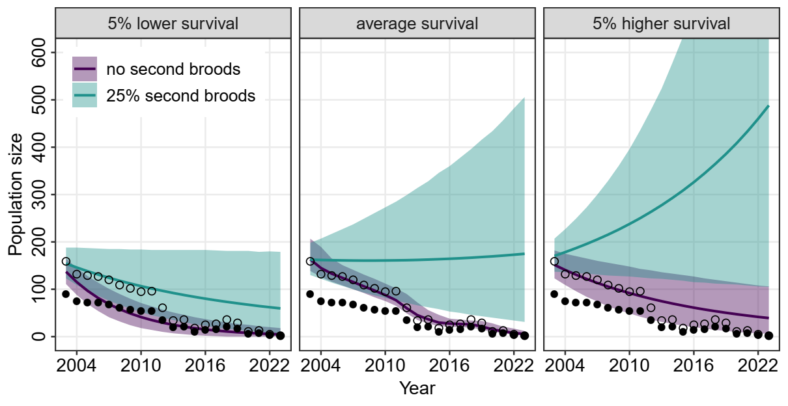
Fig. 2. Actual (“no second broods”) and hypothetical population development (mean size ± 95% CI) of the Pomeranian population of Acrocephalus paludicola (Aquatic Warbler) between 2003-2023 simulated for scenarios that assumed an average proportion of 25% of breeding females raising a second brood per year and 5% higher or 5% lower annual survival probability. Filled circles show count data of singing males, open circles show total population size based on an adult sex ratio of 56% males.

Reinforcement and management scenarios
Our future population projections indicate that survival and habitat availability are key limiting factors for the persistence of the Acrocephalus paludicola population in Pomerania, while the duration of reinforcement only modulated the time when a stable population may be reached (Fig. 3). Scenarios preventing second broods and using the same survival probability that we estimated for the past population trend, would not be able to retain a population regardless of the amount of available habitat or the duration of reinforcement (Fig. 4; Fig. A1).
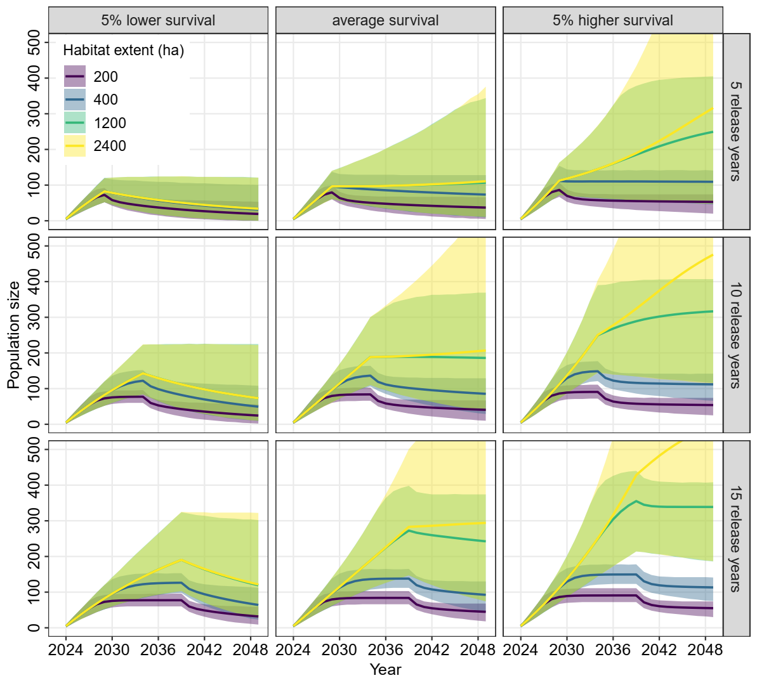
Fig. 3. Population projections (mean size ± 95% CI) of the Pomeranian population of Acrocephalus paludicola (Aquatic Warbler) between 2024-2049 simulated for different number of release years, for average and 5% lower and higher survival and for the scenarios of different amount of available habitat, assuming that birds can raise two broods per year.

Scenarios that allow second broods still require an increase in available habitat to achieve a stable population of at least 100 adult birds (Fig. 3; Fig. 4). With less than 1000 ha available breeding habitat and no improvement in survival, populations may decline as soon as the reinforcement stops and target population size is unlikely to be reached after 25 years, even if females can raise two broods per year and releases are continued for 15 years (Fig. 3; Fig. 4). Additionally, in habitats < 1000 ha, releases will likely exhaust the carrying capacity of the available area, and further releases might lead to overpopulation and loss of individuals (Fig. 3). Without an improvement in annual survival, restoring the population to a target size of 100 adult individuals may only be temporarily achievable, but the population would not be self-sustaining (Fig. 4). However, all the projections are surrounded by very large uncertainty and only improved survival and unlimited habitat resulted in a very low (< 0.10) probability of population decline after reinforcement (Fig. 4).
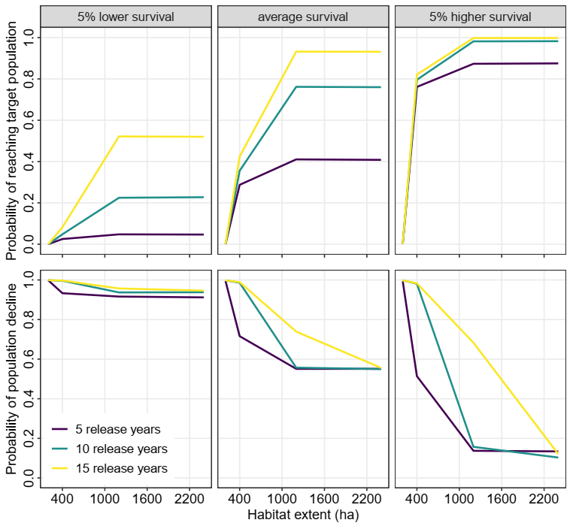
Fig. 4. Probability of reaching a target population size of 100 adult individuals after 25 years for the reinforced Pomeranian population of Acrocephalus paludicola (Aquatic Warbler) in relation to the amount of available habitat (top row), and probability of the population declining between the end of the reinforcement program and the end of projections in 2049 (bottom row); shown for different number of release years and for average and 5% lower and higher survival, assuming that birds can raise two broods per year.

Discussion
We show that the Pomeranian population of Acrocephalus paludicola disappeared due to a combination of low productivity and low apparent survival, and that a higher proportion of second broods may have been sufficient to retain the population.
In the context of the current extinction crisis, population reinforcements appear critical to prevent and mitigate local or global species extinctions (IUCN/SSC 2013, Bubac et al. 2019, Munstermann et al. 2021). However, our results indicate that reinforcement alone is insufficient to restore a viable population of the Acrocephalus paludicola in Pomerania, unless the amount of available habitat is increased, and conservation measures are taken to increase survival and productivity by allowing second broods.

Population development 1993 – 2023
One aim of this study was to explore which demographic parameters contributed to the observed decline of the Pomeranian population of Acrocephalus paludicola during the last 30 years. Drainage and increased land use intensity on fen mires drastically reduced available habitat (Tanneberger et al. 2011) and large-scale habitat loss has certainly contributed to the decrease of the population (Flade et al. 2018). Our population model suggests that the low numbers of Acrocephalus paludicola after 2003 can be attributed to a reduction in the proportion of second broods (Fig. 2). Mowing the vegetation at occupied breeding sites before July reduced the possibility for second breeding attempts and probably also increased female mortality to some extent which also contributed to a negative population growth rate. The observed decline could also reflect a lower reproductive output in general, determined by the number of fledglings per female which is directly linked to the proportion of second broods. The average fledged brood size and the proportion of second broods is unknown for the Pomeranian population and may be lower than in the core breeding sites. However, our results indicate that sub-optimal grassland management that reduces the opportunity to raise a second brood may be a key contributing factor to the decline of the Pomeranian population.
- Under the current conditions, the Pomeranian population of Acrocephalus paludicola is likely to go extinct immediately. In 2023, only one singing male was recorded. Our results suggest that the decline of the Pomeranian population could have been prevented by conservation measures solely in European breeding grounds. Despite conservation measures (e.g. postponed mowing on breeding sites) implemented locally after 2008, the population did not recover, indicating also causes outside the breeding grounds as reported for many Palearctic migratory birds (Vickery et al. 2023). Lower annual survival could also have contributed to the decline (Fig. 2) and population persistence would require an increase in the annual survival probability. However, as is typical in mark-recapture analyses, our model can only estimate apparent survival probability, which is affected by emigration (Badia-Boher et al. 2024). In small, fragmented populations, for a species that is known to disperse widely among other suitable patches of habitat, it is possible that our estimates of apparent survival probability are biased by chronic emigration. More extensive and contiguous habitat patches may facilitate a greater retention of individuals, thus leading to an improved apparent annual survival probability.

Reinforcement and management scenarios
Our study suggests that reinforcement and habitat restoration without improvements in survival rates may not be sufficient to stabilize the Pomeranian population of Acrocephalus paludicola. Whereas in long-lived species, population growth is mainly determined by adult survival (Schaub et al. 2009, Davis et al. 2023), in short-lived species, such as most long-distance migratory passerines, population growth is mainly attributed to recruitment (Dale 2001, Border et al. 2017). First-year survival used in this study is based on a small dataset of marked juveniles of the pilot translocation study including two subsequent release years. Differences in return rates, ranging between 14% and more than 30% for first-year males (Morkvėnas et al. 2025) suggest that first-year apparent survival may be highly variable in Acrocephalus paludicola. Mortality in migrants can be highly affected by weather conditions on wintering grounds and during migration and therefore vary by year (Johnston et al. 2016). In Acrocephalus schoenobaenus (Sedge Warbler), survival and population changes were significantly related to rainfall at the wintering site (Peach et al. 1991, Ockendon et al. 2014). Higher survival in A. scirpaceus (Common Reed Warbler) was associated with more precipitation at the stopover sites in Spain and Morocco (Halupka et al. 2017). A. paludicola are insectivores and accumulate fat deposits for migration (Kerbiriou et al. 2010), but also rely on fen mires and coastal marshes that provide high availability of preferred food at refueling sites, e.g. in France (Kerbiriou et al. 2010). Because many of the preferred food organisms are semi-aquatic invertebrates, food availability for refueling likely depends on water availability and rainfall. A recent study discovered long stopover durations of A. paludicola in coastal wetlands of Morocco and Algeria during spring migration, indicating the importance of these sites in determining return rate to the breeding site, but habitat conditions and management options at these stopover sites remain unclear (Flade et al. 2023). This highlights the need for international efforts to identify and protect suitable habitats outside the breeding sites for A. paludicola to increase survival.
Female apparent annual adult survival probability is extremely difficult to quantify due to the low detection probability of females owing to their secretive behavior (Schulze-Hagen et al. 1999, Dyrcz et al. 2018). Breeding site fidelity is probably rather low in A. paludicola and permanent emigration may contribute to the low apparent survival estimates for females (Kubacka et al. 2024). Natal dispersal, which is also usually female-biased in most passerine species (Dale 2001) may additionally reduce the recruitment at a given breeding site. A first-year return rate of 10% for females to the release site, observed in the pilot translocation study (Morkvėnas et al. 2025), is consistent with return rates reported for other migrant passerines (Grinkevich et al. 2009, Johnston et al. 2016, Border et al. 2017). After the first release, the first-year return rate of males was remarkably high (>30%), followed by a substantial population increase (Morkvėnas et al. 2025), indicating that at least in years with high first-year survival, high population growth can be expected, possibly enough to compensate for years with lower first-year survival. However, the strong fluctuations in population size in Lithuania suggest that local population growth probably depends on immigration from other breeding sites (Border et al. 2017). Apparent survival used in this study accounts for detection, but not for permanent emigration from the study site. Movements between breeding sites are poorly understood in A. paludicola, but must be sufficient to maintain constant gene flow (Kubacka et al. 2024). Exchange among Pomeranian breeding sites, both within and between breeding seasons was confirmed in the past (Dyrcz et al. 2018).
This connection between breeding sites is also needed to increase the available breeding area for the reinforced Pomeranian population, because a single site alone will not provide enough habitat (> 1000 ha) for a stable population of at least 100 adult birds (Fig. 3; Fig. 4). Therefore, habitat restoration at all potential release sites and management that allows second broods are recommended even if survival can be improved.

Conclusions
Our study provides the first population viability analysis for A. paludicola. We conclude that high effort will be needed to reinforce the westernmost and geographically isolated Pomeranian population of A. paludicola. Based on our PVA, the most effective management would be to allow second broods, followed by restoration of habitat and improvements in survival, while the duration of reinforcement is of minor importance. In a migratory species, however, the causes for low annual survival can operate outside the breeding area (Ockendon et al. 2014, Davis et al. 2023), thus requiring conservation actions at wintering grounds and stopover sites. The currently running EU-funded project “Aquatic Warblers on the Move” (LIFEAWOM, https://europe.wetlands.org/awom) addresses habitat restoration at stopover sites in southern Europe and wintering sites in Senegal. Although initial studies revealed migration patterns of A. paludicola (Salewski et al. 2019, Flade et al. 2023), further identification of migration routes and threats is important to inform conservation actions. Simultaneous conservation actions along the whole flyway may increase the success of population recovery in migrants more effectively than measures implemented at single breeding sites (Davis et al. 2023, Oppel et al. 2024).
Since habitat loss has been a key factor for the previous decline of A. paludicola, improving and increasing breeding habitats within the Pomeranian population will also be one of the critical factors for a successful reinforcement (Bubac et al. 2019). Main measures for habitat restoration are increasing water tables and implement low-intensity grassland management to protect nests, but at the same time provide favourable vegetation structure of intermediate height in the subsequent year (Kubacka et al. 2014). Habitat restoration and maintenance to provide more than 1000 ha of suitable breeding habitat in Pomerania are planned during the current conservation project, which is likely required to maintain a stable population of at least 100 adult individuals (Fig. 4).
Due to the remaining uncertainties in the demographic data, we highly recommend long-term monitoring of the development of the reinforced Pomeranian population to validate survival and reproduction rates and to update the PVA when more data are available (Akçakaya and Sjogren-Gulve 2000). The reinforcement project gives the opportunity to increase the knowledge of the demographic dynamics that could not be studied in wild populations of A. paludicola (Schaub et al. 2009). Furthermore, more effort should be made to understand the intra-seasonal movements of the species and the importance of the connection with core breeding sites. If local populations depend on immigration to compensate for variations in recruitment and mortality (Border et al. 2017), it will be almost impossible to maintain an isolated population of A. paludicola at the margin of the breeding range.

References
Akçakaya, H. R., and P. Sjogren-Gulve (2000). Population viability analyses in conservation planning: overview. Ecol. Bull. 48:9–21.
Armstrong, D. P., and M. H. Reynolds (2011). Modelling reintroduced populations: the state of the art and future directions. In J.G. Ewen, D.P. Armstrong, K.A. Parker and P.J. Seddon (Eds.), Reintroduction Biology: integrating science and management, Chapter 6. Wiley-Blackwell, Oxford, UK.
Badia‐Boher, J. A., J. Real, and A. Hernández‐Matías (2024). Assumptions about survival estimates and dispersal processes can have severe impacts on population viability assessments. Biol. Conserv. 292:110550.
BirdLife International (2024). Species factsheet: Acrocephalus paludicola. Downloaded from http://datazone.birdlife.org/species/factsheet/aquatic-warbler-acrocephalus-paludicola on 15/02/2024.
Border, J. A., I. G. Henderson, and I. R. Hartley (2017). Characterising demographic contributions to observed population change in a declining migrant bird. J. Avian Biol. 48:1139–1149.
Briedis, M., and O. Keišs (2016). Extracting historical population trends using archival ringing data—an example: the globally threatened Aquatic Warbler. J. Ornithol. 157:419–425, https://doi.org/10.1007/s10336-015-1306-2.
Brooks, S. P., and A. Gelman (1998). General methods for monitoring convergence of iterative simulations. J. Comput. Graph. Stat. 7:434–455.
Bubac, M., A. C. Johnson, J. A. Fox, and C. I. Cullingham (2019). Conservation translocations and post-release monitoring: identifying trends in failures, biases, and challenges from around the world. Biol. Conserv. 238:108239.
Chaudhary, V., and M. K. Oli (2020). A critical appraisal of population viability analysis. Conserv. Biol. 34:26–40.
Dale, S. (2001). Female-biased dispersal, low female recruitment, unpaired males, and the extinction of small and isolated bird populations. Oikos 92:344–356.
Davis, K. L., S. P. Saunders, S. Beilke, E. R. Ford, J. Fuller, A. Landgraf, and E.F. Zipkin (2023). Breeding season management is unlikely to improve population viability of a data-deficient migratory species in decline. Biol. Conserv. 283: 110104. https://doi.org/10.1016/j.biocon.2023.110104
Dyrcz, A., A. Kozulin, L. Vergeichik, and J. Kubacka (2018). Breeding biology and ecology. In: Tanneberger, F., Kubacka, J. (Eds.), The Aquatic Warbler Conservation Handbook, Brandenburg State Office for Environment (LfU), Potsdam, Germany, pp. 50–61.
Dyrcz, A., and P. Chylarecki (2018). Adult survival of Aquatic Warblers breeding in the Biebrza Marshes, Poland, In: Tanneberger, F., Kubacka, J. (Eds.), The Aquatic Warbler Conservation Handbook, Brandenburg State Office for Environment (LfU), Potsdam, Germany, p. 67.
Dyrcz, A., H. Sauer-Gürth, E. Tkadlec, and M. Wink (2004). Offspring sex ratio variation in relation to brood size and mortality in a promiscuous species: the Aquatic Warbler Acrocephalus paludicola. Ibis 146:269–280.
Dyrcz, A., and W. Zdunek (1993a). Breeding ecology of the Aquatic Warbler Acrocephalus paludicola on the Biebrza marshes, northeast Poland. Ibis 135:181–189.
Dyrcz, A., and W. Zdunek (1993b). Breeding statistics of the Aquatic Warbler Acrocephalus paludicola on the Biebrza Marshes, northeast Poland. J. Ornithol. 134:317–323.
Finch, T., J. W. Pearce-Higgins, D. I. Leech, and K. L. Evans (2014). Carry-over effects from passage regions are more important than breeding climate in determining the breeding phenology and performance of three avian migrants of conservation concern. Biodivers. Conserv. 23:2427–2444.
Flade, M., S. Lisovski, V. Eigirdas, B. Giessing, F. Jiguet, O. Keišs, and M. Nemtchinov (2023). Migration routes and wintering sites of the Aquatic Warblers Acrocephalus paludicola breeding in Lithuania and North Belarus. bioRxiv2023.10.10.561376; doi: https://doi.org/10.1101/2023.10.10.561376
Flade, M., U. Malashevich, J. Krogulec, A. Poluda, Z. Preiksa, Z. Végvári, and L. Lachmann (2018). World distribution, population, and trends. In: Tanneberger, F., Kubacka, J. (Eds.), The Aquatic Warbler Conservation Handbook, Brandenburg State Office for Environment (LfU), Potsdam, Germany, pp. 22–35.
Frankham, R., C. J. Bradshaw, and B. W. Brook (2014). Genetics in conservation management: revised recommendations for the 50/500 rules, red List criteria and population viability analyses. Biol. Conserv. 170:56–63.
Grinkevich, V., N. Chernetsov, and A. Mukhin (2009). Juvenile Reed Warblers Acrocephalus scirpaceus see the world but settle close to home. Avian Ecol. Behav. 16:3–10.
Halupka, L., K. Wierucka, H. Sztwiertnia, and E., Klimczuk (2017). Conditions at autumn stopover sites affect survival of a migratory passerine. J. Ornithol. 158:979–988.
Heinsohn, R., R. Lacy, A. Elphinstone, D. Ingwersen, B. J. Pitcher, M. Roderick, E. Schmelitschek, M. Van Sluys, D. Stojanovic, J. Tripovich, and R. Crates (2022). Population viability in data deficient nomadic species: what it will take to save regent honeyeaters from extinction. Biol. Conserv. 266:109430.
Imlay, T. I., J. F. Crowley, A. M. Argue, J. C. Steiner, D. R. Norris, and B. J. M. Stutchbury (2010). Survival, dispersal and early migration movements of captive-bred juvenile eastern loggerhead shrikes (Lanius ludovicianus migrans). Biol. Conserv. 143:2578–2582.
IUCN/SSC (2013). Guidelines for Reintroductions and Other Conservation Translocations. Version 1.0. Gland, Switzerland: IUCN Species Survival Commission.
Johnston, A., R. A. Robinson, G. Gargallo, R. Julliard, H. van der Jeugd, and S. R. Baillie (2016). Survival of Afro-Palaearctic passerine migrants in western Europe and the impacts of seasonal weather variables. Ibis 158:465–480.
Kellner, K.F. (2016). jagsUI: A wrapper around rjags to streamline JAGS analyses. CRAN, https://rdrr.io/cran/jagsUI/. [R package].
Kerbiriou, C., B. Bargain, I. Le Viol, and S. Pavoine (2010). Diet and fuelling of the globally threatened Aquatic Warbler in autumn migration stopover as compared with two congeners. Anim. Conserv. 14:261–270.
Kéry, M., and M. Schaub (2012). Bayesian population analysis using WinBUGS. Oxford, UK: Academic Press.
Krogulec, J., and J. Kloskowski (2003). Monitoring Aquatic Warbler Acrocephalus paludicola in Poland. Ornis Hungarica 12-13:191–196.
Kubacka, J., S. Oppel, A. Dyrcz, L. Lachmann, J. P. D. Barros Da Costa, U. Kail, and W. Zdunek (2014). Effect of mowing on productivity in the endangered Aquatic Warbler Acrocephalus paludicola. Bird Conserv. Int. 24:45–58. https://doi:10.1017/S0959270913000154
Kubacka, J., A. Dubiec, J. Korb, V. Salewski, A. Dyrcz, J. Foucher, B. Giessing, B. Leisler, K. Schulze-Hagen, M. Wink, and H. Panagiotopoulou (2024). Low genetic diversity and high gene flow in the Aquatic Warbler (Acrocephalus paludicola), a threatened marshland songbird with a fragmented breeding range. Ibis 166:232–251. https://doi.org/10.1111/ibi.13250
Lees, A. C., L. Haskell, T. Allinson, S. B. Bezeng, I. J. Burfield, L. M. Renjifo, K. V. Rosenberg, A.Viswanathan, and S. H. M. Butchart (2022). State of the World’s Birds. Annu. Rev. Environ. Resour. 47:231–260. https://doi.org/10.1146/annurev-environ-112420-014642
Mayall, E., L. Groves, R. Kennerley, M. Hudson, and A. Franco (2023). Demographic consequences of management actions for the successful reintroduction of the White Stork Ciconia ciconia to the UK. Bird Conserv. Int. 33:e47. https://doi:10.1017/S0959270922000466
Morkvėnas, Ž., S. Arbeiter, A. Kozulin, G. Riauba, D. Zhurauliou, V. Yakovich, and F. Tanneberger (2025). Successful translocation of a long-distance migrating passerine – new impetus for the conservation of the globally threatened Aquatic Warbler. Anim. Conserv. 28:147–155. https://doi.org/10.1111/acv.13018.
Munstermann, M. J., N. A. Heim, D. J. McCauley, J. L. Payne, N. S. Upham, S. C. Wang, and M. L. Knope (2021). A global ecological signal of extinction risk in terrestrial vertebrates. Conserv. Biol. 36:e13852. doi: 10.1111/cobi.13852
Nemes, C. E., S. A. Cabrera-Cruz, M. J. Anderson, L. W. DeGroote, J. G. DeSimone, M. L. Massa, and E. B. Cohen (2023). More than mortality: Consequences of human activity on migrating birds extend beyond direct mortality. Ornithological Applications 125:duad020. doi: https://doi.org/10.1093/ornithapp/duad020.
Ockendon, N., A. Johnston, and S. R. Baillie (2014). Rainfall on wintering grounds affects population change in many species of Afro-Palaearctic migrants. J. Ornithol. 155:905–917.
Oppel, S., V. Dobrev, V. Arkumarev, V. Saravia-Mullin, K. Bashmili, T. Bino, A. Bounas, A. Chardin, D. Dobrev, K. Duro, E. Kapsalis, E. Kret, M. P. Marchant, S. Nakev, N. Petrovski, H. Papaioannou, G. Popgeorgiev, L. Selgjekaj, T. Skartsi, A. Stamenov, S. Stoychev, M. Topi, D. Vavylis, M. Velevski, Z. Vorpsi, J.Weston, E. Xeka, X. Xherri, E. Yordanov, and S. C. Nikolov, (2024). Long-term conservation efforts at flyway scale can halt the population decline in a globally endangered migratory raptor. Anim. Conserv. 27:374–385. https://doi.org/10.1111/acv.12917
Oppel, S., V. Saravia, A. Bounas, V. Arkumarev, E. Kret, V. Dobrev, D. Dobrev, P. Kordopatis, T. Skartsi, M. Velevski, N. Petrovski, T. Bino, M. Topi, I. Klisurov, S. Stoychev, and S. Nikolov (2021). Population reinforcement and demographic changes needed to stabilise the population of a migratory vulture. J. Appl. Ecol. 58:2711–2721.
Pain, D., B. Hughes, E. Syroechkovskiy, C. Zöckler, S. Chowdhury, G. Anderson, and N. Clark (2018). Saving the Spoon-billed Sandpiper: a conservation update. British Birds 111:323–333.
Peach, W. J., S. Baillie, and L. Underhill (1991). Survival of Sedge Warblers Acrocephalus schoenobaenus in relation to West African rainfall. Ibis 133:300–305.
Plummer, M. (2017). JAGS: A Program for Analysis of Bayesian Graphical Models Using Gibbs Sampling (Version 4.3.0). [R package].
R Core Team (2024). R: A language and environment for statistical computing. R Foundation for Statistical Computing. Vienna, Austria. https://www.R-project.org.
Rosenberg, K. V., et al. (2019). Decline of the North American avifauna. Science 366:120-124.
Runge, C. A., J. E. M. Watson, S. H. M. Butchart, J. O. Hanson, H. P. Possingham, and R. A. Fuller (2015). Protected areas and global conservation of migratory birds. Science 350:1255-1258.
Sæther, B.-E., S. Engen, R. Lande, A. P. Møller, S. Bensch, D. Hasselquist, J. Beier, and B. Leisler, (2004). Time to extinction in relation to mating system and type of density regulation in populations with two sexes. J. Anim. Ecol. 73:925–934.
Salewski, V., M. Flade, S. Lisovski, A. Poluda, O. Iliukha, G. Kiljan, U. Malashevich, and S. Hahn (2019). Identifying migration routes and non-breeding staging sites of adult males of the globally threatened Aquatic Warbler Acrocephalus paludicola. Bird Conserv. Int. 29:503–514. https://doi: 10.1017/S0959270918000357
Schaub, M., and M. Kéry (2021). Integrated population models: Theory and ecological applications with R and JAGS. Academic Press, Boston, USA.
Schaub, M., R. Zink, H. Beissmann, F. Sarrazin, and R. Arlettaz (2009). When to end releases in reintroduction programs: Demographic rates and population viability analysis of bearded vultures in the Alps. J. Appl. Ecol. 46:92–100.
Schulze-Hagen, K., B. Leisler, H. M. Schäfer, and V. Schmidt (1999). The breeding system
of the Aquatic Warbler Acrocephalus paludicola – a review of new results. Vogelwelt
120:87–96.
Tanneberger, F., J. Kloskowski, V. Knöfler, A. Kozulin, P. Marczakiewicz, Ž. Morkvėnas, A. Poluda, Z. Végvįri, L. Vergeichik, and M. Flade (2018). Breeding habitat requirements. In: Tanneberger, F., Kubacka, J. (eds), The Aquatic Warbler Conservation Handbook, Brandenburg State Office for Environment (LfU), Potsdam, Germany, pp. 34–45.
Tanneberger, F., J. Bellebaum, M. Dylawerski, T. Fartmann, S. Jurzyk-Nordlöw, I. Koska, C. Tegetmeyer, and M. Wojciechowska (2011). Habitats of the globally threatened Aquatic Warbler (Acrocephalus paludicola) in Pomerania – site conditions, flora, and vegetation characteristics. Plant Diversity and Evolution 129/3–4:253–273.
Vickery, J. A., J. W. Mallord, W. M. Adams, A. E. Beresford, C. Both, W. Cresswell, N. Diop, S. R. Ewing, R. D. Gregory, C. A. Morrison, F. J. Sanderson, K. Thorup, R. E. Van Wijk, and C. M. Hewson (2023). The conservation of Afro-Palaearctic migrants: What we are learning and what we need to know? Ibis 165:717–738.
Weatherhead, P. J., and M. R. L. Forbes (1994). Natal philopatry in passerine birds: genetic or ecological influence? Behav. Ecol. 5:426–433.

Fig. 1. Breeding range decline of the Acrocephalus paludicola (Aquatic Warbler) in Germany and Poland and location of potential release sites for the reinforcement of the Pomeranian population.

Fig. 2. Actual (“no second broods”) and hypothetical population development (mean size ± 95% CI) of the Pomeranian population of Acrocephalus paludicola (Aquatic Warblers) between 2003-2023 simulated for scenarios that assumed an average proportion of 25% of breeding females raising a second brood per year and 5% higher or 5% lower annual survival probability. Filled circles show count data of singing males, open circles show total population size based on an adult sex ratio of 56% males.

Fig. 3. Population projections (mean size ± 95% CI) of the Pomeranian population of Acrocephalus paludicola (Aquatic Warblers) between 2024-2049 simulated for different number of release years, for average and 5% lower and higher survival and for the scenarios of different amount of available habitat, assuming that birds can raise two broods per year.

Fig. 4. Probability of achieving a target population size of 100 adult individuals after 25 years for the reinforced Pomeranian population of Acrocephalus paludicola (Aquatic Warblers) in relation to the amount of available habitat (top row), and probability of the population declining between the end of the reinforcement program and the end of projections in 2049 (bottom row); shown for different number of release years and for average and 5% lower and higher survival, assuming that birds can raise two broods per year.

Appendix A. Supplementary figures

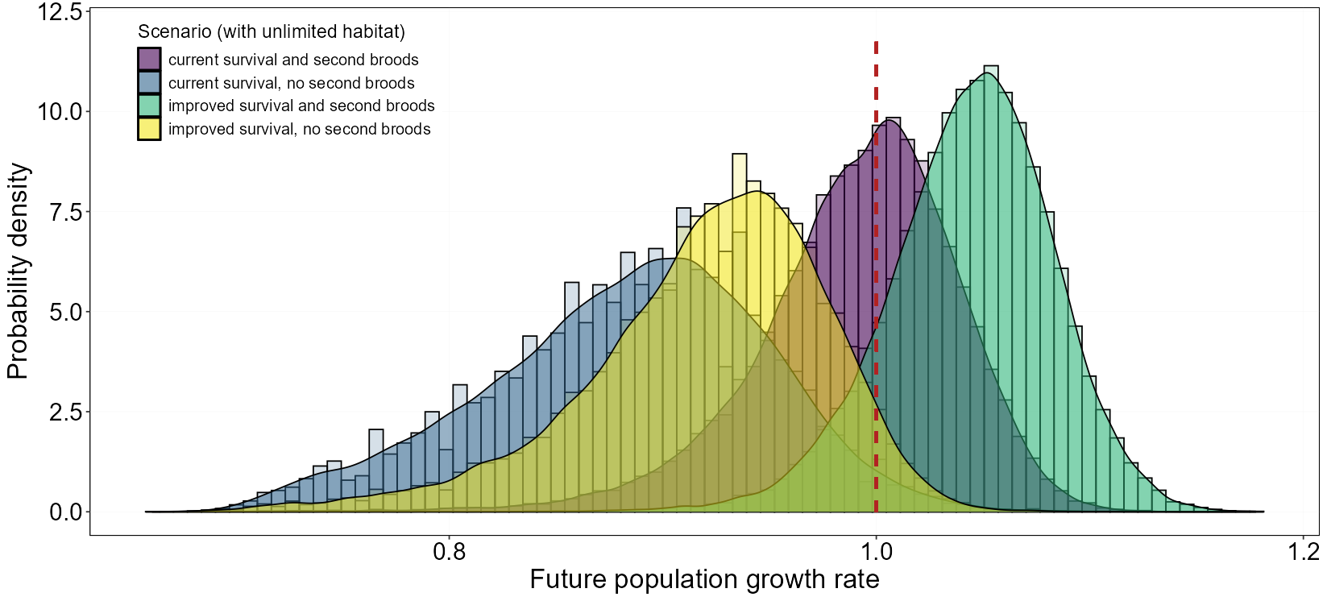
Fig. A1. Posterior probability density of population growth rates (mean± 95% CI) of the reinforced Pomeranian population of Acrocephalus paludicola (Aquatic Warblers) shown for scenarios with current (average) and improved survival, and for one or two broods per year. Red vertical dashed line indicates population stability (growth rate = 1).

