**Temporal variation in seabird bycatch and adoption of mitigation measures in a global bycatch hotspot for albatrosses and petrels**

*Dimas Gianuca, Tatiana Neves & Rodrigo Sant’Ana*

**2. METHODS**

**2.1. Fleet description**

The southern Brazilian PLL fleet is composed of around 80 vessels made of steel or wood, ranging from 17 to 30 m total length, which target tunas, swordfish and sharks, and store the catches in crushed ice (Fiedler *et al.*, 2015; Santos *et al.*, 2019). This fleet operates off southern Brazil, from 25° S to 35° S, and 45° to 55° W, based mostly in the southern ports of Rio Grande and Itajaí, and to a lesser extent, Santos (**Figure 1**)**.** Although fishing effort is concentrated along the Brazilian EEZ, particularly over continental shelf and slope areas, this fleet also operates regularly in adjacent international waters (Fiedler *et al.*, 2015) (**Figure 1**)**.**

This fleet employ the American longline System, and total number of hooks per set varies from 600 to 1,200 (Santos *et al.*, 2019). The mainline is 20-40 miles long, made of 3.0-3.8 mm nylon monofilament, with 10-25 m long branchlines made of 1.8-2.0 mm nylon monofilament containing a lead swivel (60 or 75 g) plus a hook. The distance between the weighted swivel and the hook, historically, varied from 3 to 10 m (Gianuca *et al.*, 2016). However, from 2014 onwards, Brazilian regulations mandate attach the weighted swivels within 3.5 m of the hook (Brazil, 2014). The fleet has used a variety of hook types and sizes (Sales *et al.*, 2010; Santos *et al.*, 2019; Rodrigues *et al.*, 2022), though circle hooks became mandatory in 2017 to reduce the impact of bycatch on sea turtles (Mdic/MMA, 2017).

The BSL model required by Brazilian regulations since 2011 (Brazil, 2011, 2014), broadly speaking, is composed by a 100 m long backbone, made of 3-4 mm nylon monofilament (same used as longline mainline), with bunches of six 1 m long streamers attached at 2 m intervals. Additionally, in the end of the backbone, is attached a 30 m drag section made of 8.0 mm propylene multifilament twisted cable with two 50 cm long packing strips tied at 20 cm intervals (**Figure S1**).

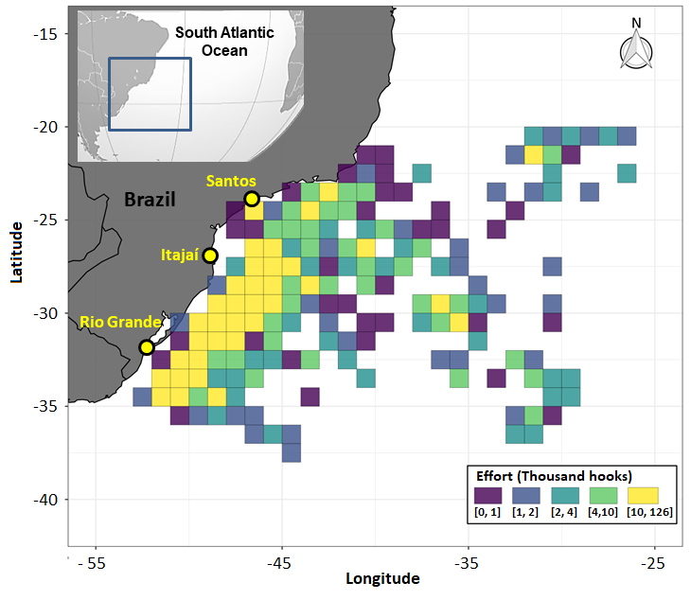

**Figure 1.** Spatial variation in the fishing effort (thousand hooks) of southern Brazilian pelagic longline fisheries monitored by on-board observers between 2000 and 2018. These fleet operates mostly across the Rio Grande, Itajaí and Santos ports, highlighted in yellow.

**2.2. *Dataset***

We analysed a long-term dataset (2000-2018) comprising 1,941 sets (2,084,903 hooks) across 151 trips aboard 46 PLL vessels operating off southern Brazil (**Figure 1**), to assess seabird bycatch and the utilization of two bycatch mitigation measures over time: BSL and night-setting. The data was collected by on-board observers from *Projeto Albatroz* and the Albatross Task Force programme, voluntarily taken on board by collaborative skippers. The period from 2003 to 2010 was a phase of increased BSL trialling and at-sea demonstration by on-board observers, when skippers were asked or encouraged to use BSLs. From 2011 onwards, when BSLs became mandatory in Brazil (Brazil, 2011, 2014), observers started to board vessels mostly for “monitoring trips”, without actively influencing skipper’s decision to use BSL, in order to establish a reliable picture of compliance.

For each set, the percentage of the longline deployed during daylight was calculated based on the geographic position, date and time of the setting operation, and sunrise/sunset times, using the package *Lunar* (Lazaridis, 2014) in *R* software (R Core Team, 2019). Sets with all hooks deployed at night (0% daylight setting) were classified as night setting (Brazil, 2014; ACAP, 2023. Moon illumination was also determined using the same package, as this can impact seabird bycatch levels on night sets (Petersen *et al.*, 2009; Jiménez *et al.*, 2020).

Standard information collected for each set includes effort (number of hooks), date, time and geographical coordinates of the longline setting (start and end), BSL use (yes or no) and the seabird bycatch numbers recorded during hauling, identified to the lowest taxonomic level possible. However, in the dataset analysed, information for one or more variable was missing for several sets.

To modelling standardized seabird bycatch rates and influential factors it was utilized a subset of data containing only sets with information on all relevant variables, which comprised 1,330 sets (66% of the total) and 1,408,257 hooks, monitored across 131 trips aboard 38 PLL vessels (**Table 1**).

**Table 1.** Summary of the total fishing effort monitored by on-board observers, including number of fishing trips, longline sets and total hooks per year.

|  |  |  |  |
| --- | --- | --- | --- |
| Year | Trips | Sets | Hooks |
| 2000 | 1 | 18 | 16,767 |
| 2001 | 5 | 54 | 55,792 |
| 2002 | 9 | 96 | 103,804 |
| 2003 | 5 | 55 | 53,887 |
| 2004 | 7 | 71 | 76,580 |
| 2005 | 13 | 177 | 188,406 |
| 2006 | 7 | 91 | 98,857 |
| 2007 | 13 | 136 | 172,295 |
| 2008 | 6 | 60 | 50,043 |
| 2009 | 6 | 80 | 98,625 |
| 2010 | 6 | 60 | 60,850 |
| 2011 | 7 | 45 | 36,716 |
| 2012 | 9 | 62 | 63,611 |
| 2013 | 5 | 44 | 40,115 |
| 2014 | 4 | 28 | 31,347 |
| 2015 | 12 | 104 | 113,947 |
| 2016 | 4 | 42 | 33,639 |
| 2017 | 6 | 53 | 48,278 |
| 2018 | 6 | 54 | 64,698 |
| **Total** | **131** | **1,330** | **1,408,257** |

***2.3. Data analysis***

2.3.1. Seabird bycatch and influential factors

Species composition of seabird bycatch, as well taxon-specific nominal bycatch rates (BPUE = birds/1000 hooks), were evaluated based on the total monitored effort (1,941 sets). Subsequently, using the sub-set of data containing only sets with all relevant information associated, Generalized Additive Models (GAMs) were used to check the effects of potential explanatory variables on seabird bycatch and to produce annual standardized estimates of BPUE with 95% confidence intervals.

The influence of year, season, moon illumination, location (geographic coordinates), proportion of the longline set at daylight and BSL use (yes or no) on seabird bycatch was modelled via GAM with a quasi-Poisson error structure. The number of hooks was included as a log-link offset to account for differences in fishing effort between sets. The variable “Season” refers to breeding (October to March) or non-breeding (April to September) season of albatrosses and petrels annual breeders in the South Hemisphere).

Finally, total seabird bycatch in Brazilian pelagic longline fisheries south of 20° S was estimated annually by expanding the annual predicted standardised bycatch rates to the total annual fishing effort for this area reported by Brazil to ICCAT. This data is available in the ICCAT website (https://www.iccat.int/en/index.asp).

2.3.2. Effect of BSL on seabird bycatch

Since the complete dataset includes the use of different configurations of BSLs and deployment methods over time, the effect of BSL use on seabird bycatch was evaluated using a sub-set of data (2009-2018), corresponding to the utilization of standard ‘short streamer’ BSLs as required by national regulations (Brazil, 2011, 2014). This subset of data contains 572 sets with aggregated information on variables relevant to seabird bycatch.

To be done

**3.RESULTS**

***3.1. Seabird bycatch***

A total of 415 seabirds were recorded as bycatch across 1,941 sets monitored from 2000 to 2018, resulting in an overall nominal BPUE = 0.22, including eight species of albatrosses and petrels**,** of which five are listed as globally threatened (IUCN, 2023). The two species most frequently captured, black-browed albatross (*Thalassarche melanophris*, n = 253) and white-chinned petrel (*Procellaria aequinoctialis*, n = 113), combined, corresponded to 81% of the observed seabird bycatch. The next two most captured species, the Atlantic yellow-nosed albatross (*Thalassarche chlororhynchos*, n = 24) and the spectacled petrel (*Procellaria cospicillata*, n = 9), corresponded to an additional 8% of the observed mortality (**Table 2**). The other captured species include Wandering albatross (*Diomedea exulans*) and, potentially, Tristan albatross (*D. dabbenena*), as these two species are indistinguishable in the field, in addition to southern giant petrel (*Macronectes giganteus*) and great shearwater (*Ardenna gravis*). An additional 40 captured individuals were not identified to species level, of which 24 (5%) were *Procellaria* petrels, 10 (2%) *Thalassarche* albatrosses, two (<1%) *Diomedea* albatrosses and four (<1%) unidentified seabirds **(Table 2)**.

The observed seabird bycatch was distributed across a wide area between the latitudes 20° S and 38° S and the longitudes -24° W and -53° W, including international waters, but was concentrated in the continental shelf and slope areas between 25°S and 35°S **(Figure 2**).

**Table 2.** Taxon-specific seabird bycatch in pelagic longline fisheries off southern Brazil recorded by on-board observers (2000-2018), including number (n), percentage (%) relative to the total bycatch, nominal bycatch rate (BPUE: Birds/1000 hooks) and IUCN conservation status (LC: Least Concern, VU: Vulnerable, EN: Endangered, Critically Endangered).

|  |  |  |  |  |  |
| --- | --- | --- | --- | --- | --- |
| **Common name** | **Species** | **n** | **%** | **BPUE** | **Status** |
| Black browed albatross | *Thalassarche melanophris* | 253 | 56,1 | 0,121 | LC |
| White-chinned petrel | *Procellaria aequinoctialis* | 113 | 25,1 | 0,054 | VU |
| Atlantic yellow-nosed albatross | *Thalassarche chlororhynchos* | 29 | 6,4 | 0,014 | EN |
| Unidentified Procellaria | *Procellaria sp.* | 24 | 5,3 | 0,012 | - |
| Unidentified mollymawks | *Thalassarche sp.* | 10 | 2,2 | 0,005 | - |
| Spectacled petrel | *Procellaria conspicilata* | 9 | 2,0 | 0,004 | VU |
| Unidentified seabirds | *-* | 4 | 0,9 | 0,002 | - |
| Wandering*/Tristan albatross | *Diomedea exulans/dabbenena* | 5 | 1,0 | 0,002 | VU/CR |
| Unidentified great albatross | *Diomeda sp.* | 2 | 0,4 | 0,001 | - |
| Great shearwater | *Ardenna gravis* | 2 | 0,4 | 0,001 | LC |
| Southern giant petrel | *Macronectes giganteus* | 1 | 0,2 | 0,000 | LC |
| * One wandering albatross was confirmed because the bird was ringed. | | | | | |

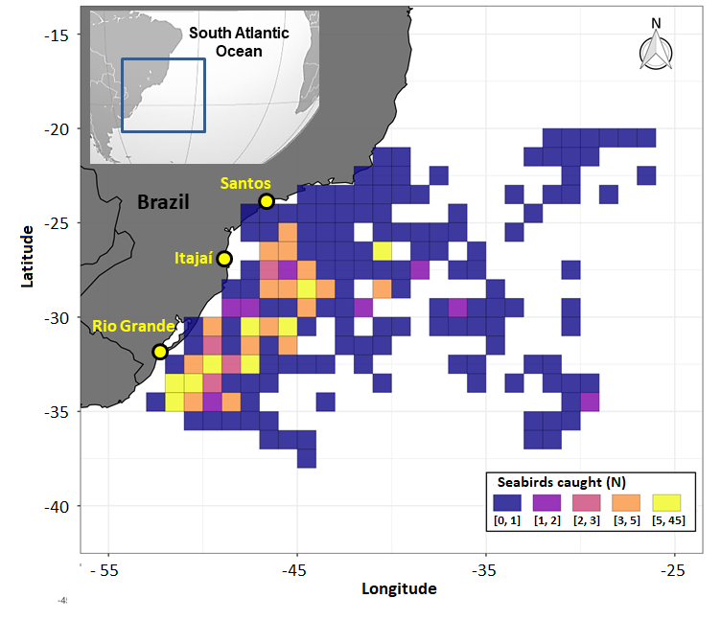

**Figure 2.** Spatial variation of seabird bycatch (number of seabirds caught) by the southern Brazilian pelagic longline fisheries monitored from 2000 to 2018 by on-board observers from *Projeto Albatroz* and Albatross Task Force taken on board voluntarily by cooperative skippers. These fleet operates mostly across the Rio Grande, Itajaí and Santos ports, highlighted in yellow.

**3.2. Factors influencing seabird bycatch**

Predicted seabird bycatch rates modelled via GAM showed significant spatiotemporal variation. Overall, bycatch increased with latitude, was consistently low north of 20 S, and showed higher values along the continental shelf and slope areas, and also in the Rio Grande Rise region, situated in international waters (**Figure 3**). There was significant interannual variation in seabird bycatch without a trend over time, and it was significantly higher during the non-breeding season compared to the breeding season (**Figures 4A, 5A and 5B**). In addition, seabird bycatch was positively influenced by the proportion of the hooks set at daylight (**Figure 4B**) and by moon illumination (**Figure 4C**).

**3.3. Total seabird bycatch estimates**

A total of 32,943 birds (95% CI, xxxx-xxxx) were estimated killed between 2000 and 2018 by the Brazilian PLL fisheries operating south of 20° S. The number of birds killed per year varying markedly without a significant trend over time, ranging from 127 in 2001 (xxxx-xxxxx) to 4,596 in 2008 (xxxx-xxxxx) (**Figure 5C**). There was no reduction in estimated seabird bycatch post 2011, when bycatch mitigation measures became mandatory for this fleet (**Figures 5C and 6**).

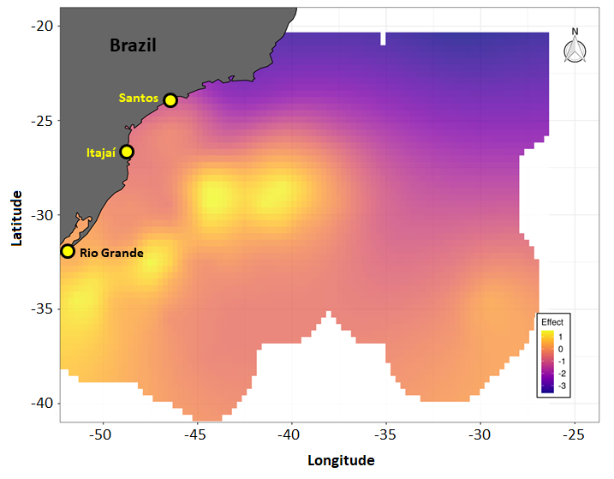

**Figure 3.** Spatial variation in seabird bycatch rates predicted by the best fitted model (on the scale of the linear predictor – logarithm), in pelagic longline fisheries off southern Brazil operating through the ports of Rio Grande-RS, Itajaí-SC and Santos-SP (yellow circles).

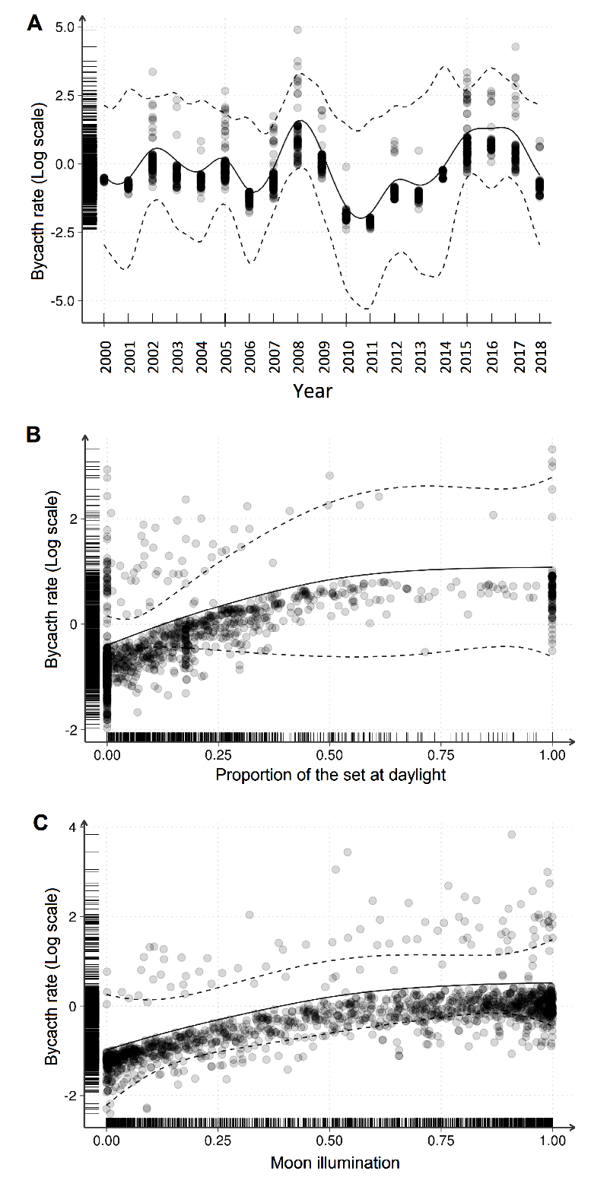

**Figure 4.** Results of GAMs (quasi-Poisson) on the effect of year (A), the percentage of the longline set in daylight (B) and moon illumination (C) and on the seabird bycatch rate (number of birds/1000 hooks in pelagic longline fisheries off southern Brazil. All plots are on the scale of the linear predictor of the models (logarithm), and shows the predicted values (solid line) and 95% confidence intervals (dashed lines) along with the observed values (dots).

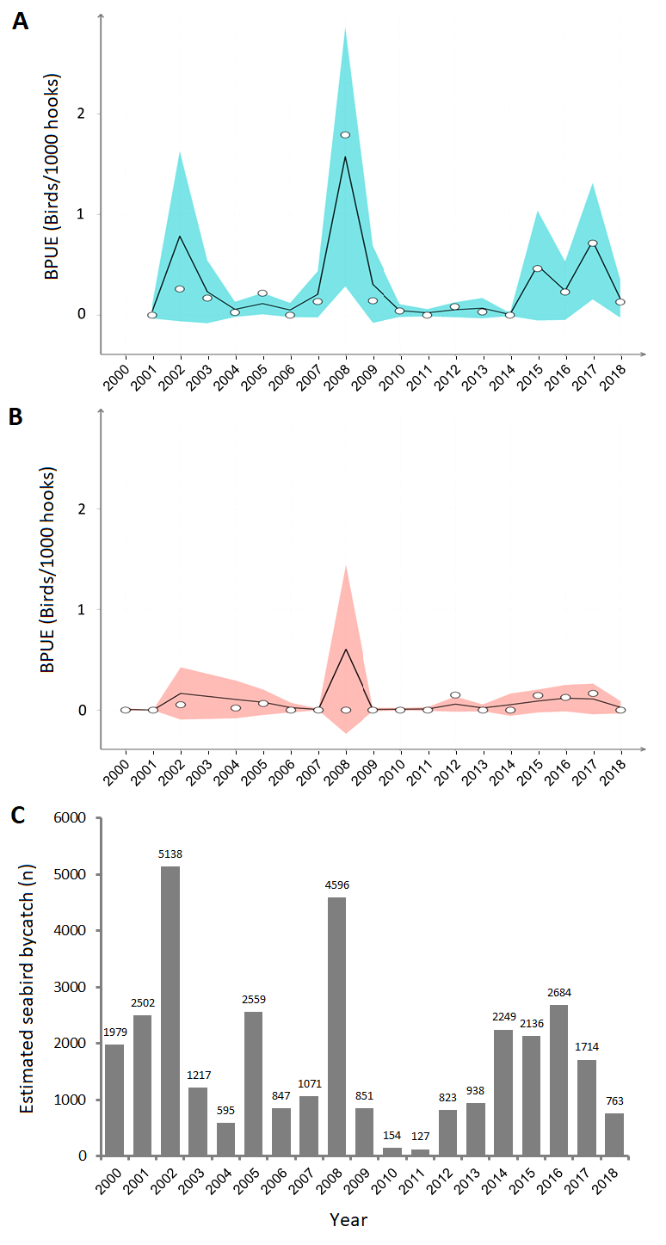

**Figure 5.** Interannual variation of seabird bycatch rates (BPUE = birds/1000 hooks) predicted by the best-fitted model (black line, 95% C.I. shaded area) and nominal (white circles), for both non-breeding (A, April-September) and breeding season (B, October-March); and total seabird bycatch estimated for the Brazilian pelagic longline fisheries operating south of 20° S (C).

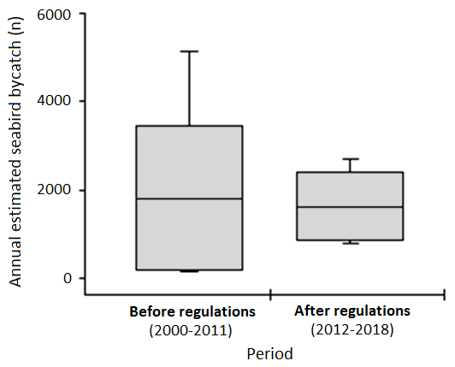

**Figure 6.** Variation in annual estimated seabird bycatch (total number of birds caught) in pelagic longline fisheries off southern Brazil (south of 20° S) before (2000-2011) and after (2012-2018) regulations were introduced to reduce seabird bycatch in this fleet. Boxplots show the mean and standard deviation, and whiskers indicate minimum and maximum values.

**3.4. Efficiency of Brazilian-standard bird scaring lines**

To be written accordingly to results of missing analysis.

***3.5. Adoption of seabird bycatch mitigation measures over time***

Bird scaring lines were used in 217 (16%) of the 1,330 analysed sets. There was an increase in the proportion of sets with BSLs deployed from 2003 (9%) to 2010 (72%), which corresponds to the BSL trialling and demonstration phase, followed by extremely low levels of compliance (0–12%) from 2011 onwards, when BSL use became mandatory in Brazil and observers started to board vessels mostly for “monitoring trips” **(Figure 7A**).

Night setting was adopted in 597 (45%) of the sets. There was marked interannual variation in the adoption of night setting without a significant trend over time. From 2014 onwards, when night setting became mandatory in Brazil, the compliance with this mitigation measure varied between 41% (2018) and 86% (2016) of the monitored sets per year (**Figure 7B**).

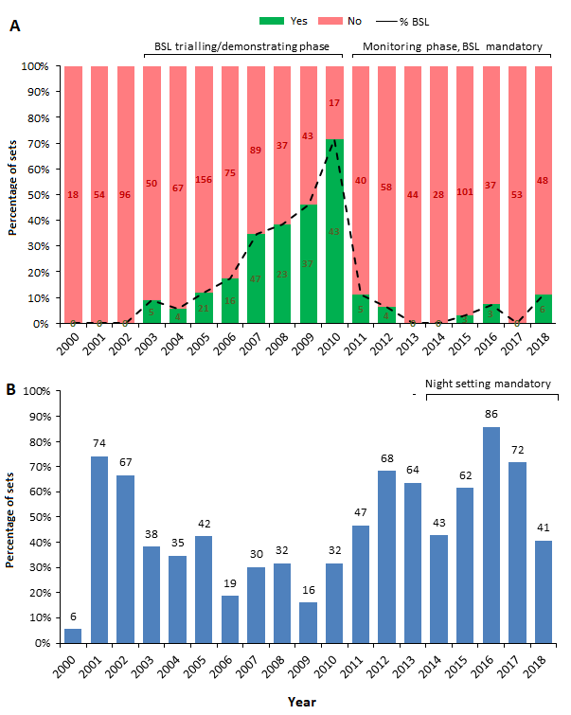

**Figure 7.** Interannual variation in the proportion of sets with and without bird scaring lines-BSL, where the number of observed sets are shown inside the bars (A), and in the percentage of ‘night setting’ sets in relation to total sets (B). In (A), the “BSL trialling/demonstration phase” refers to a period of increased BSL trialling and at-sea demonstration, while from 2011 onwards, when BSL became mandatory, observers started to board vessels for “monitoring trips”, without actively influencing skipper’s decision to use BSL (“Monitoring phase/BSL mandatory”). In (B), the period when night setting was mandatory (2014 onwards) is also highlighted.

Supplemental Material

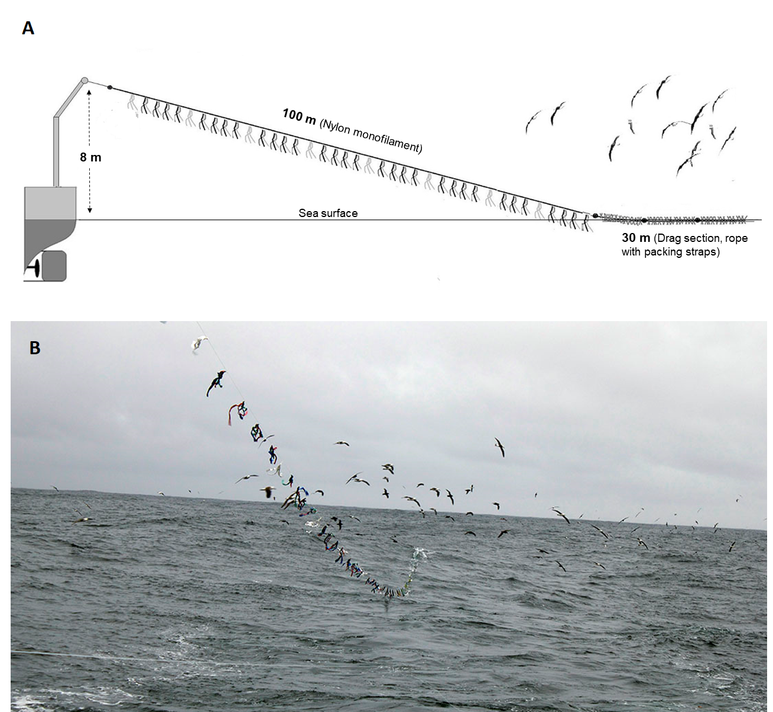

**Figure S1.** Schematic representation of the bird scaring line (BSL) model mandatory in Brazil since 2011 (A) and view of the BSL under use in southern Brazil, note the position of the mainline (bottom left) and the flock of birds displaced further astern by the BSL. Credits: Dimas Gianuca.