# ________________________________________________________________

**CSC174 server-side javascript**

________________________________________________________________________

# Unit 05 LAB: A Simple hello web site with cool ascii faces

# Objectives

In this lab assignment, students will learn:

* Node.js source file organization system
* Export and import source code modules (native, third-party, user-defined)
* Important global objects, functions, and classes/prototypes
* Best practices in source code management

# COURSE PREPARATION

You should have done your reading assignment listed under “Reading Assignment” and “Video Assignment” sections in BlackBoard. You should also have reviewed the lecture slides in BlackBoard. There is an optional section called “In Case You Don’t Know” in BlackBoard for those who have limited exposure to JavaScript language.

# WHat to submit

For this lab you need to submit the following files:

* **index.js (Part One)**
* **Short answer questions sheet (Part Two)**

# grading rubric:

Be sure to follow the Coding Standard Guidelines. You must properly indent and comment your code. This assignment is worth 100 points. (70 points from Part One and 30 points from Part Two)

* Indent code and insert comments to document your program. [5 pts]
* Program must be implemented and run with no syntax errors. [30 pts]
* Program must be implemented and run with no logic errors. [30 pts]
* Required source files should be zipped and uploaded to BlackBoard assignment drop box before the deadline. [5 points]

# ________________________________________________________________

**Part One: A Simple hello web site with cool ascii faces**

________________________________________________________________________

**Project Description:**

You are given a Node.js project based on our Hello Node project in Unit 01 Lab Part One.

The instructor should provide you the source code in ***unit05_lab.zip*** file in BlackBoard Unit 05 Lab sections. There are many files and folders in this project seen below:

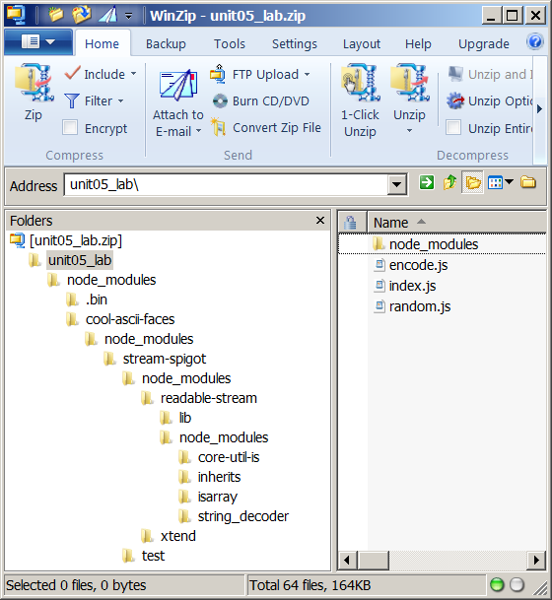

On the top level, there are three JavaScript files (***encode.js***, ***index.js***, and ***random.js***) and a folder named ***node_modules***. Here is a brief description of what they are:

* **index.js** – the entry point of this application, very similar to app.js in Unit 01 Lab
* **encode.js** – source file that exports a programmer defined function for HTML encoding
* **random.js** – source file that exports a programmer defined function for generating random numbers.

If you run this application now, you should see something like this:

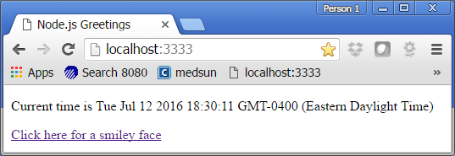

When you click on the bottom link you will get a smiley face:

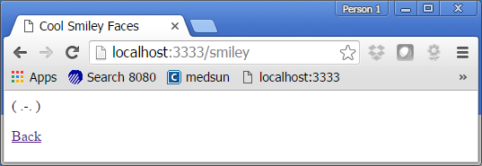

Right now you will get the same smiley face all the time. Your job is to modify this program by randomly choosing a smiley face from an array of smiley faces. You need to import the anonymous function from source file *random.js*.

After you have modified the program, you should get different smiley faces when you click the link. Here are some screenshots:

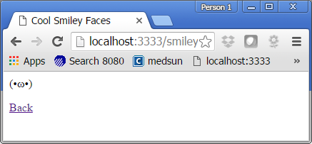 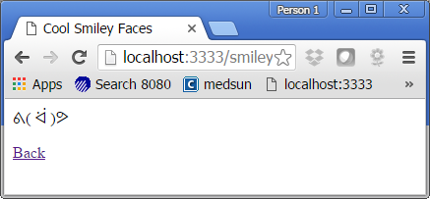 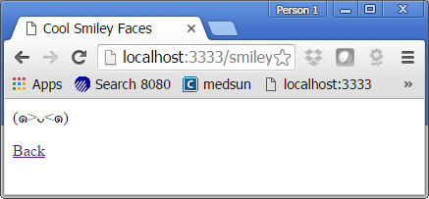

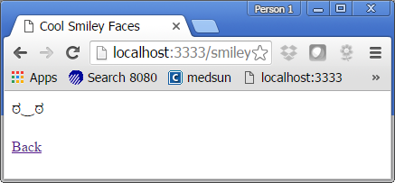 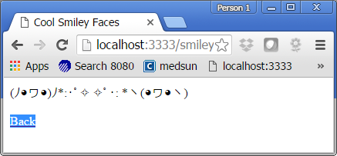 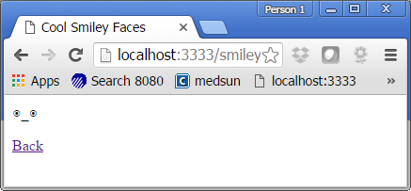

**Hint #1:** You need to import the function from random.js by using require() function. (See how encode.js is imported for clue.)

**Hint #2:** You need to replace the following highlighted code with some new code that will randomly pick a smiley face from the array named **smileyArray**.

} else if (request.url == '/smiley') {

var smileyArray = cool.faces;

var firstSmiley = smileyArray[0];

response.write("<!DOCTYPE html><html><head><title>Cool Smiley Faces</title></head>");

response.write(encode(firstSmiley));

response.write("<p><a href=\"/\">Back</a></p>");

response.end();

You need to submit only the modified index.js file.

**Note:**

There are many free Node.js projects out there. The instructor downloaded the cool-ascii-faces from this site: <https://github.com/maxogden/cool-ascii-faces>.

There are three imports at the top of index.js file:

***var http = require(‘http’);***

This is Node.js built-in module for handling HTTP request and response which you will need for any web applications.

***var cool = require(‘cool-ascii-faces’);***

This statement imports a third-party module called ‘cool-ascii-faces’. You should put your third-party modules under a specially named folder ‘node-modules’. (Chapter 4 will explain this in detail.)

***var encode = require(‘./encode’);***

This statement imports a programmer defined module (something you wrote).

# ________________________________________________________________

**Part Two: Short answer questions**

*All questions are based on the original index.js source code provided by the instructor.

Question 1: How would you modify the index.js file if the two helper JavaScript files were placed in a file structure like below? (Yellow ones are folders. Blue ones are files.)

unit05_lab

|-----------helpers|---------encode.js

|---------random.js

|-----------node_modules

|-----------index.js