# ________________________________________________________________

**CSC174 server-side javascript**

________________________________________________________________________

# Unit 09 LAB: A simple chat application

# Objectives

In this lab assignment, students will learn:

* Node.js express module/framework
* How to use express to create web servers
* Node.js middleware concepts and popular middleware for connect and express
* REST architecture and RESTful API in Node.js
* How to explore and inspect third-party Node.js modules through a chat application

# COURSE PREPARATION

You should have done your reading assignment listed under “Reading Assignment” and “Video Assignment” sections in BlackBoard. You should also have reviewed the lecture slides in BlackBoard. There is an optional section called “In Case You Don’t Know” in BlackBoard for those who have limited exposure to JavaScript language.

# WHat to submit

For this lab you need to submit the following files:

* **index.js**
* **Short answer questions sheet (Part Two)**

# grading rubric:

Be sure to follow the Coding Standard Guidelines. You must properly indent and comment your code. This assignment is worth 100 points. (70 points from Part One and 30 points from Part Two)

* Indent code and insert comments to document your program. [5 pts]
* Program must be implemented and run with no syntax errors. [30 pts]
* Program must be implemented and run with no logic errors. [30 pts]
* Required source files should be zipped and uploaded to BlackBoard assignment drop box before the deadline. [5 points]

# ________________________________________________________________

**Part One: A Simple Chat Application**

________________________________________________________________________

**Project Description:**

This project is based on an open source Node.js application posted at: <http://socket.io/get-started/chat/>. Your job is to modify the ***index.js*** page so that the app will have two new features:

1. Whenever someone joins or leaves the room, a message will be displayed to all users.
2. Instead of having a username, each user is assigned a socket generated session id when he/she first joins. See the screenshots below.

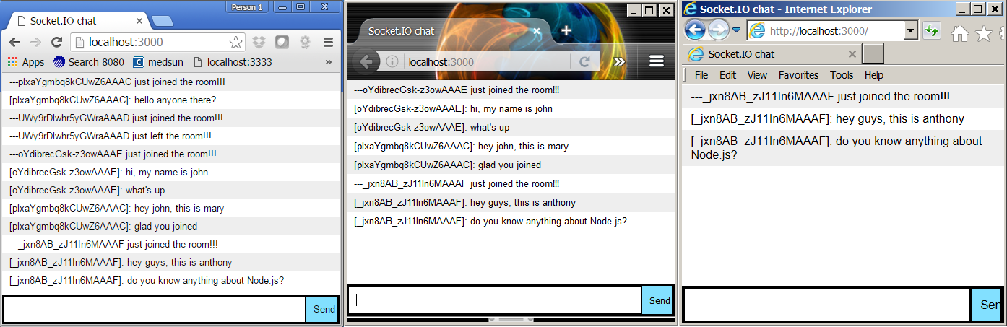

**Hint:**

1. You can download this project source code from <https://github.com/rauchg/chat-example> or use the file provided by your instructor in BlackBoard: ***unit09_lab.zip***.
2. When a user joins the chat room, you need to register the ‘connect’ event. For example:

*io.on(‘connect’, function(socket)) {*

*io.emit(‘chat message’, ‘--- someone just joined the room!!!’);*

*});*

1. When a user leaves the chat room, you need to register the ‘disconnect’ event on that particular socket. For example:

*io.on(‘connection’, function(socket) {*

*socket.on(‘disconnect’, function() {*

*io.emit(‘chat message’, ‘--- someone just left the room!!!’);*

*});*

*});*

1. To get the session Id from each user, you can use ***socket.client.id*** property. For example:

*io.emit(‘chat message’, ‘---‘ + socket.client.id + ‘ just joined the room!!!’);*

You only need to submit the modified index.js file.

# ________________________________________________________________

**Part Two: Short Answer Questions**

Question 1: What third-party modules does this project use? What are they? What are their versions? How did you find that information?

Question 2: Who are the contributors for **socket.io** module? List their names and email addresses.

Question 3: What do you need to do if the event name ‘chat message’ is changed to ‘trump’ in index.html file so that the application doesn’t break?

*var socket = io();*

*$('form').submit(function(){*

*socket.emit('trump', $('#m').val());*

*$('#m').val('');*

*return false;*

*});*

*socket.on('trump', function(msg){*

*$('#messages').append($('<li>').text(msg));*

*});*