# ________________________________________________________________

**CSC174 server-side javascript**

________________________________________________________________________

# Unit 07 LAB: LOg Customer FeedBack to a file

# Objectives

In this lab assignment, students will learn:

* event-driven programming
* streaming
* how to write to a file using streams
* how to use NPM (review from last chapter)

# COURSE PREPARATION

You should have done your reading assignment listed under “Reading Assignment” and “Video Assignment” sections in BlackBoard. You should also have reviewed the lecture slides in BlackBoard. There is an optional section called “In Case You Don’t Know” in BlackBoard for those who have limited exposure to JavaScript language.

# WHat to submit

For this lab you need to submit the following files:

* **app.js**

# grading rubric:

Be sure to follow the Coding Standard Guidelines. You must properly indent and comment your code. This assignment is worth 100 points.

* Indent code and insert comments to document your program. [10 pts]
* Program must be implemented and run with no syntax errors. [40 pts]
* Program must be implemented and run with no logic errors. [40 pts]
* Required source files should be zipped and uploaded to BlackBoard assignment drop box before the deadline. [10 points]

# ________________________________________________________________

**Log Customer Feedback to a File**

________________________________________________________________________

**Project Description:**

You are given a Wake Tech Credit Union web site made by Node.js. It’s a fake bank your instructor made and is actually hosted at <http://wtcu.herokuapp.com/>. It has the loan calculator we did in Unit 02 Lab and Google Web Speech customer form we did in Unit 03 Lab. You can play around.

The instructor should provide you the source code in ***unit07_lab.zip*** file in BlackBoard Unit 07 Lab sections. There are many files and folders in this project seen below:

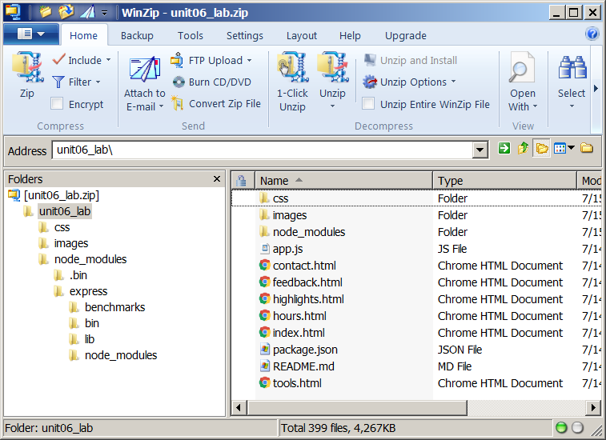  
  
Now you have a locally deployed Wake Tech Credit Union web site at <http://localhost:3333/>. Use a browser and open it and you should see something like this:



Go to the FEEDBACK page and record some customer feedback.

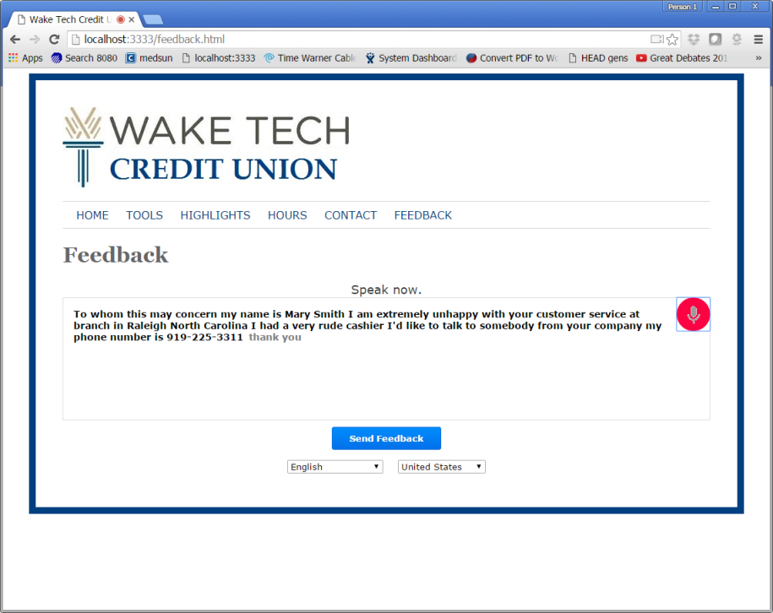

After you have sent the feedback, you should see the log in the console like below.



You can stop this program by pressing <ctrl> + C.

Your job is to use NPM to download a free module called “**moment**” described in our textbook and use Node.js built-in “**fs**” module to log the customer feedback messages to a text file named “**feedback.log**”. Each feedback has to be logged on its own line and has to be started with a time stamp in a pair of square brackets. See the following screenshot for the exact format:

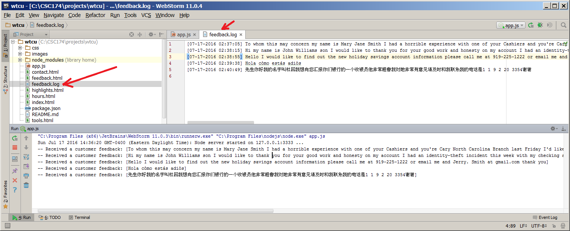

You need to submit only the modified app.js file.