# ________________________________________________________________

**CSC174 server-side javascript**

________________________________________________________________________

# midterm project: slide show

# WHat to submit

For this project you need to submit only the following file:

* **server.js**

# grading rubric:

Be sure to follow the Coding Standard Guidelines. You must properly indent and comment your code. This project is worth **25** points.

* Indent code and insert comments to document your program. [5 pts]
* Program must be implemented and run with no syntax errors. [10 pts]
* Program must be implemented and run with no logic errors. [10 pts]

**Project Description:**

You are given a file web server built upon Node.js http module described in your textbook Chapter 6, section “Creating Your Own File Web Server” (page 121-124). This web server supports HTML files and JavaScript files. However it does not support any JPEG image files. Your job is to modify this web server so it will support JPEG image files.

The instructor should provide you the source code in ***midterm.zip*** file. The project structure looks like this:

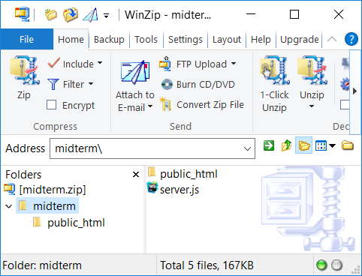 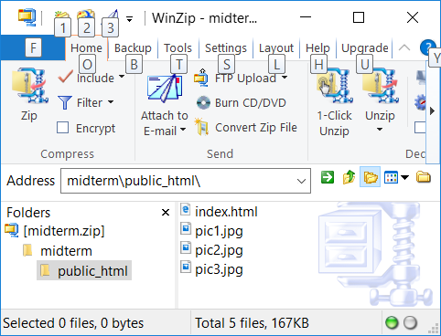

The file you need to work on is called “server.js”. There is a folder called “public_html” where a slide show web site files are stored: an HTML file called “index.html”, three JPEG image files: “pic1.jpg”, “pic2.jpg”, and “pic3.jpg”.

When you run “server.js” now, you will get a web site at <http://localhost:3000>. However, the slide show is not rendering the images. Below is what it looks like now:

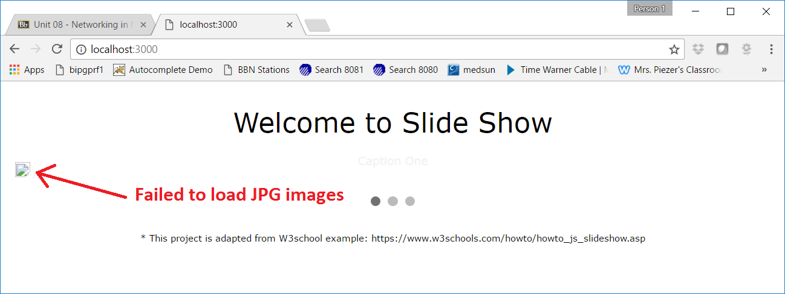

After you have successfully added support to JPEG image files on this web server, you should see the slide show like this:

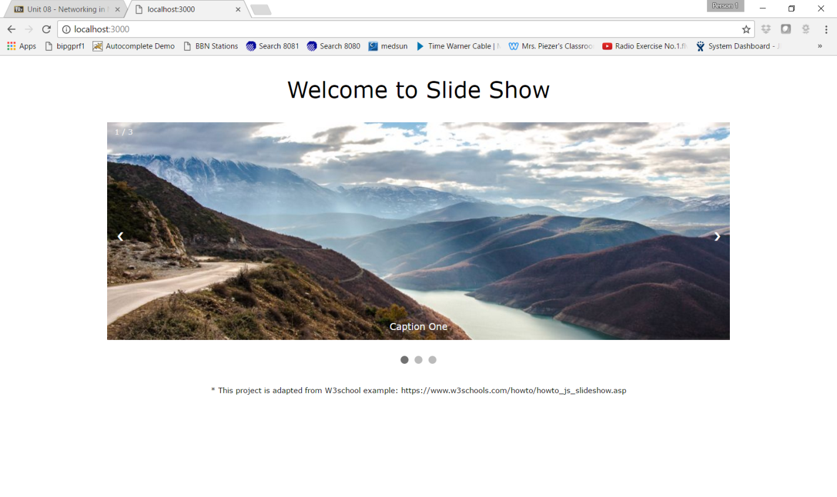

You need to submit only the modified server.js file.