Photographic Evidence in Freight Claims and Liability Management
Meta Title | Photographic Evidence in Freight Claims and Liability Management
Meta Description | How visual inspection records protect cargo, settle freight disputes, and streamline liability claims in global trade.
Keywords | cargo inspection, freight claims, container photography, shipping liability, supply chain documentation

Every Handover Creates a Boundary of Responsibility
A container arrives at its destination with crushed corners or broken seals. Between the shipper yard and consignee warehouse, that shipment moved across trucks, port terminals, ocean vessels, and rail networks. Determining who bears financial responsibility comes down to a clear visual timeline. In global freight, photo inspection records are not mere paperwork, they serve as definitive evidence that resolves disputes before legal escalations occur.

Why Standard Cargo Inspection Protocols Matter
When cargo changes hands, responsibility transfers immediately from one logistics operator to another. Gate-in and gate-out reports, seal verification images, and container condition logs establish the state of goods at every handover. Having digital records accessible on modern logistics tools likeNavo24 Freight Management System allows logistics managers to gain end-to-end visibility across global trade routes. Additionally, following International Maritime Organization standards ensures complete operational compliance.

Digital Transformation in Inspection Workflows
Managing thousands of inspection photos manually leads to misplaced files when claims arise months later. Automated cloud archives tag image metadata, container numbers, and GPS coordinates automatically. Standardizing mobile photo capture in the field ensures that freight forwarders can present incontrovertible proof to marine insurance providers whenever damage occurs.

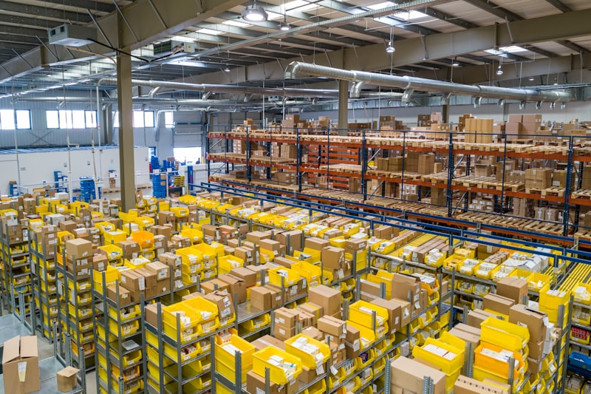
Figure 1: Global shipping and supply chain operations.

