Guide to Customs Release Types and Clearance Procedures
Meta Title | Guide to Customs Release Types and Clearance Procedures
Meta Description | Understand customs release types, carrier release mechanisms, and import clearance steps to prevent port delays.
Keywords | customs release, import clearance, carrier release, port detention, customs brokerage, bill of lading

Understanding the Difference Between Customs and Carrier Release
Import cargo cannot exit port gates without two distinct green lights: official customs clearance and carrier release. Customs release confirms that duties, taxes, and regulatory requirements have been fulfilled. Carrier release indicates that ocean freight charges, bills of lading, and port fees are paid in full. Misunderstanding these two approvals is a primary cause of costly port demurrage fees.

Key Types of Customs Clearances in Global Logistics
Customs authorities utilize distinct release mechanisms depending on cargo risk profiles and documentation completeness. Pre-arrival clearance allows entry processing before the vessel berths, minimizing dwell times. Physical inspection holds occur when documentation discrepancies or random inspections arise. Integrating automated compliance tools throughNavo24 Customs Tracking Tools allows logistics managers to gain end-to-end visibility across global trade routes. Additionally, following World Customs Organization guidelines ensures complete operational compliance.

Streamlining Import Procedures to Prevent Port Storage Charges
To maintain uninterrupted supply chains, importers must coordinate customs brokers, terminal operators, and drayage truckers. Early document submission, accurate HS code classification, and digital release tracking prevent unexpected holds. Standardized clearance workflows allow businesses to optimize port throughput and protect profit margins.

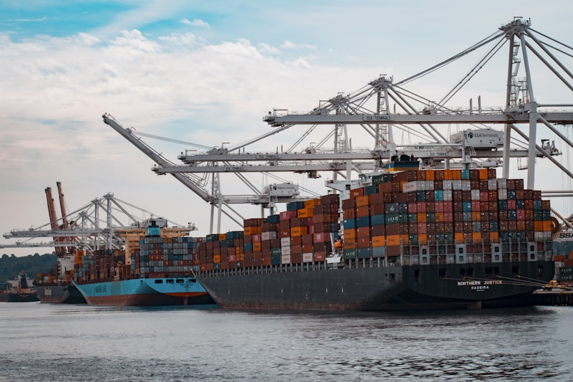
Figure 2: Global shipping and supply chain operations.

