Carrier Directory Guide How To Find Shipping Lines: Global Logistics
Meta Title | Carrier Directory Guide How To Find Shipping Lines: Global Logistics
Meta Description | Comprehensive guide on carrier directory guide how to find shipping lines for international shipping, supply chain optimization, and trade compliance.
Keywords | logistics, international shipping, supply chain, trade compliance, freight forwarding

1. Strategic Overview and Industry Context
Managing modern supply chains requires clear visibility into carrier directory guide how to find shipping lines. Every transfer point between shippers, carriers, and port terminals introduces operational variables. Establishing standardized operational protocols ensures cargo protection and eliminates unnecessary delays in global trade networks.

2. Operational Implementation and Compliance
Integrating digital tools optimizes workflows for freight forwarders and importers alike. Deploying advanced tracking capabilities throughNavo24 Freight Platform empowers logistics teams to monitor shipments in real time. Adhering to International Logistics Standards maintains full regulatory compliance across international ocean routes.

3. Long-Term Efficiency and Cost Optimization
Automation and structured documentation minimize detention, demurrage, and administrative overhead. Standardizing processes across global trade lanes allows companies to scale operations while preserving profit margins.

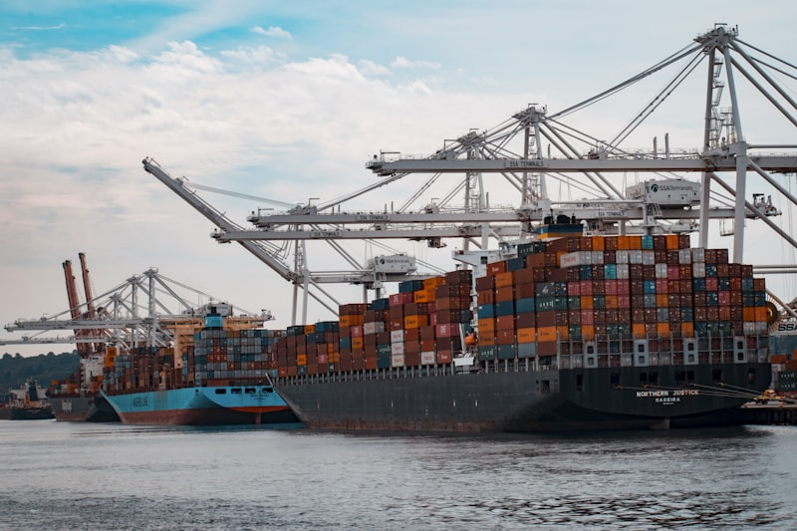
Figure 2: Operational workflow in international shipping and freight logistics.

