June 2026 Development Release Empowering Business Users: Practical F
Meta Title | June 2026 Development Release Empowering Business Users: Practical F
Meta Description | Practical guide on june 2026 development release empowering business users in ocean shipping, detailing real case studies, port clearance, and cost prevention
Keywords | freight forwarding, ocean shipping, port clearance, logistics management, cargo tracking

Real-World Operational Impact at Container Ports
A 40-foot reefer container lands on the terminal pavement at Hamburg on a damp Tuesday morning. The temperature logging screen shows a four-degree spike during transshipment at Algeciras. The consignee's surveyor refuses delivery on arrival, citing severe moisture damage to the packaging. Who pays for the spoiled cargo?
The answer isn't sitting in a generic insurance policy. It depends entirely on whether anyone captured a clear, high-resolution photograph of the temperature monitor and bolt seal before the crane lifted the box off the feeder vessel.
In international ocean freight, visual evidence isn't administrative fluff. It is the single boundary line separating an approved insurance claim from six months of finger-pointing between ocean carriers, port terminals, and drayage truckers.

Understanding Custody Transfer at Port Terminals
Every time cargo moves from a factory truck chassis to a terminal stack, or from a terminal yard to a vessel hatch, legal responsibility shifts. Lawyers refer to this as the transfer of custody. Logistics managers know it as the moment where unexpected losses occur.
Consider a typical export shipment moving through Shanghai or Rotterdam. The container gets loaded at an inland manufacturing plant, sealed with a high-security bolt seal, and hauled by a drayage carrier. At the port gate, the truck driver receives an Equipment Interchange Receipt. If the gate clerk fails to note a dented corner casting or a scraped door gasket on that receipt, the carrier legally assumes the container entered the terminal in sound condition.
When that container arrives at the destination port with ruined cartons inside, the carrier points directly to the clean gate-in receipt from origin. They claim the damage was pre-existing. Without timestamped photos showing the container exterior, seal placement, and interior loading sequence prior to gate-in, the shipper is left holding the bill.

Why Paper Inspection Receipts Are Insufficient
Paper inspection receipts are notoriously unreliable in fast-paced port environments. Gate clerks inspect hundreds of containers per shift under tight time constraints. They routinely miss hairline roof cracks, worn door gaskets, and floorboard gouges. When a dispute reaches a marine surveyor eighteen months later, a scribbled carbon-copy receipt carries far less weight than a clear photograph showing the exact physical state of the box.
Actual freight claims adjusters look for specific visual evidence when evaluating damage disputes:
- Clear close-up views of the bolt seal with legible serial numbers.
- Wide-angle shots showing full container side panels and rooflines.
- Detailed photos of structural deformation, rust spots, or door latch damage.
- Interior photos of the stuffing arrangement, showing dunnage, strapping, and weight distribution.
- Digital timestamps matched against GPS location coordinates.

Integrating Digital Verification into Workflow Tools
If field teams dump unorganized photos into messaging apps or local desktop folders, those files vanish into a black hole. When a claim arises, finding the right image for a specific container takes days. Forwarders who integrate structured inspection workflows into digital management portals like Navo24 Freight Portal keep every photo linked directly to the master bill of lading. Additionally, following International Logistics Standards ensures complete regulatory compliance across international ocean routes.

Real-World Case: The $45,000 Cargo Dispute in Antwerp
Let's examine how this functions in actual port operations. A forwarder shipped thirty pallets of high-precision electronic circuit boards from Ningbo to Antwerp. The ocean carrier issued a clean On Board Bill of Lading. When the container arrived in Antwerp, the consignee opened the doors and found three pallets crushed under shifted wooden crates.
The ocean carrier immediately blamed improper stowage by the origin factory. However, the shipper had established a mandatory pre-shipment photo protocol. They produced four high-resolution photographs taken inside the container immediately before door closure:
1. Photo 1: All thirty pallets strapped securely with heavy-duty woven polyester webbing.
2. Photo 2: Timber dunnage blocks nailed firmly to the container wooden floor.
3. Photo 3: Airbags inflated inside center void spaces between pallet rows.
4. Photo 4: High-security bolt seal locked onto the door handle mechanism.
Faced with indisputable visual proof that the cargo was properly stowed, secured, and sealed, the carrier's P&I club admitted liability. The damage resulted from rough handling during vessel discharge when the crane operator dropped the box six inches onto the quay. Without those four photos, the shipper would have absorbed a $45,000 loss.

Step-by-Step Guide to Establishing a Bulletproof Routine
Setting up an effective inspection protocol doesn't require expensive specialized hardware. What you need is strict operational discipline and a standardized photo sequence that every warehouse loader and drayage driver follows without exception.
Step 1: Inspect the empty container before loading goods. Perform a light-leak check by standing inside with the doors fully closed. If light pinpricks appear through the roof or corner seams, reject the unit immediately. Take a photo of the empty interior showing clean floorboards and intact lashing rings.
Step 2: Document the loading process at distinct intervals. Take photos when the container is one-third full, two-thirds full, and completely loaded with dunnage or straps applied. Show clearly how weight is distributed across the floorboard surface.
Step 3: Document the seal closure sequence. Capture the seal serial number close up, followed by a wide shot of the sealed container doors showing the container owner code and serial number clearly painted on the right-hand door.
Step 4: Archive images in a centralized database attached to the booking number.

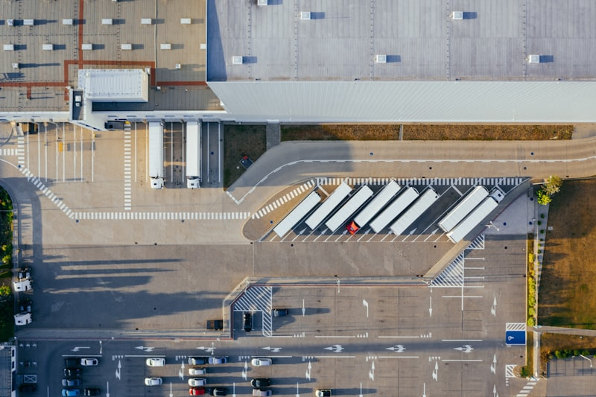
Figure 4: Ocean freight logistics and container terminal operations.

