Practical Exam PAPER 2021



Instructions to candidates: Answer ALL Questions (1.5 hour)

BEng Software Engineering Software Development for Cloud 2 Sample Nov 2021

Do All 4 Questions, All 4 carry equal marks

All new or modified .java files must be zipped up and submitted to moodle as a single file

Q1. The following example allow the client to reset a value to a new value taken from a ComboBox.

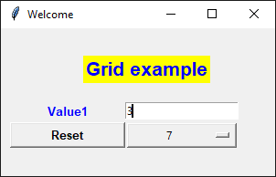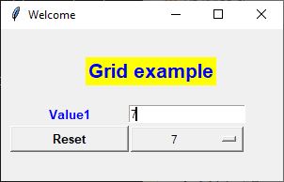

Now modify the GUI application by adding a button, comboBox , label and result Entry Box.

When clicking Add button it will add the value from new comboBox to the value in the top Entry widget and display the result in the bottom Entry widget

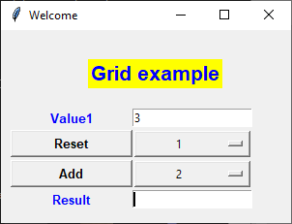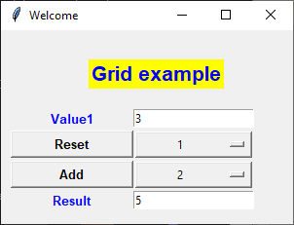

Q2. Complete the methods at the start of Q2_skelExam.py

allGreater( list, target) returns true if all elements in list are greater than the target

addGreaterThan(list,target) returns the sum of items in the list that are greater than the target

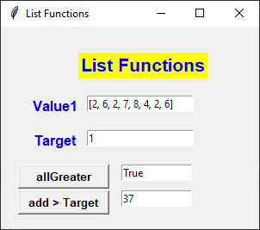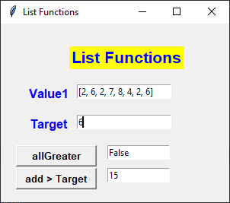

Q3. Complete the class Treble

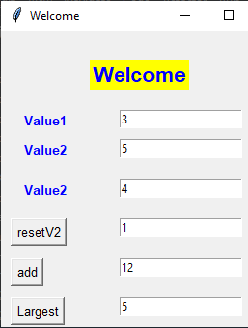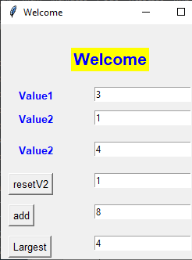

Treble
-------------------------------------
value1 (int) # private
value2 (int)
value3 (int)

--------------------------------------
__init__(int,int,int)
resetValue2(int ) # resets value2 to a new value
int getValue1() # returns value1
int getValue2()
int getValue2()
int add() # return value1+value2+value3
int largest() # return max of 3 values

Q4. While Loop

Write a Program that will allow the user to Enter numbers (1-99) in a loop until a negative number is entered and then print out the sum of the single digit numbers (See Notes Ch2)

