**Stefan:**

**Configured raspberry pi 3:**

**Command: cat /etc/os-release**

PRETTY_NAME="Raspbian GNU/Linux 10 (buster)"

NAME="Raspbian GNU/Linux"

VERSION_ID="10"

VERSION="10 (buster)"

VERSION_CODENAME=buster

ID=raspbian

ID_LIKE=debian

HOME_URL="http://www.raspbian.org/"

SUPPORT_URL="http://www.raspbian.org/RaspbianForums"

BUG_REPORT_URL="http://www.raspbian.org/RaspbianBugs"

**Filesystem:**

**Command: df -h**

Filesystem Size Used Avail Use% Mounted on

/dev/root 29G 4.1G 24G 15% /

devtmpfs 430M 0 430M 0% /dev

tmpfs 462M 0 462M 0% /dev/shm

tmpfs 462M 13M 450M 3% /run

tmpfs 5.0M 4.0K 5.0M 1% /run/lock

tmpfs 462M 0 462M 0% /sys/fs/cgroup

/dev/mmcblk0p1 253M 49M 204M 20% /boot

tmpfs 93M 4.0K 93M 1% /run/user/100

**Configured for DNS:** https://www.noip.com/

**DDNS:** mypc.webhop.me

Successfully enabled port forwarding on **port 22**

**Akeem:**

**Configured Mint OS:**

**Command: cat /etc/os-release**

NAME="Linux Mint"

VERSION="21.3 (Virginia)"

ID=linuxmint

ID_LIKE="ubuntu debian"

PRETTY_NAME="Linux Mint 21.3"

VERSION_ID="21.3"

HOME_URL="https://www.linuxmint.com/"

SUPPORT_URL="https://forums.linuxmint.com/"

BUG_REPORT_URL="http://linuxmint-troubleshooting-guide.readthedocs.io/en/latest/"

PRIVACY_POLICY_URL="https://www.linuxmint.com/"

VERSION_CODENAME=virginia

UBUNTU_CODENAME=jammy

**Filesystem:**

**Command: df -h**

Filesystem Size Used Avail Use% Mounted on

tmpfs 1.6G 1.8M 1.6G 1% /run

/dev/sda3 916G 155G 715G 18% /

tmpfs 7.8G 192K 7.8G 1% /dev/shm

tmpfs 5.0M 4.0K 5.0M 1% /run/lock

tmpfs 7.8G 216K 7.8G 1% /run/qemu

/dev/sda2 512M 34M 479M 7% /boot/efi

tmpfs 1.6G 160K 1.6G 1% /run/user/1000

Installed wireguard:

[**https://www.instructables.com/Wireguard-VPN-Server-Linux-Ubuntu-Mint-How-To/**](https://www.instructables.com/Wireguard-VPN-Server-Linux-Ubuntu-Mint-How-To/)

Enabled port forwarding:

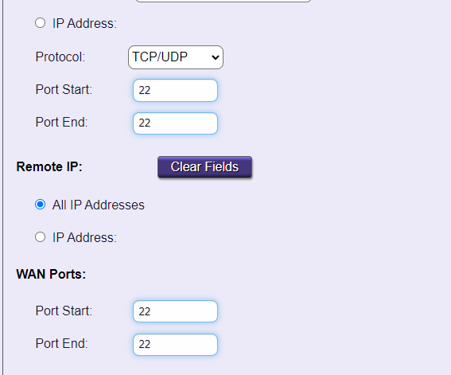

**Attempted to ssh from a remote location and was unsuccessful**

Ensured the firewall on Mint OS server allowed incoming SSH connections:

Command: **sudo ufw status**

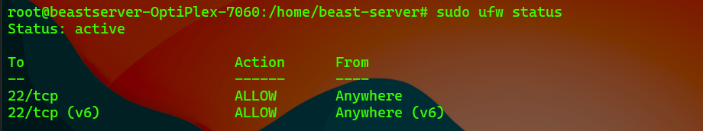

Ensured the ip on Mint OS server allowed incoming SSH connections:

Command: sudo iptables -L -n | grep 22



**Retried using a different server**

**Configured Ubuntu-Server VM:**

**Command: cat /etc/os-release**

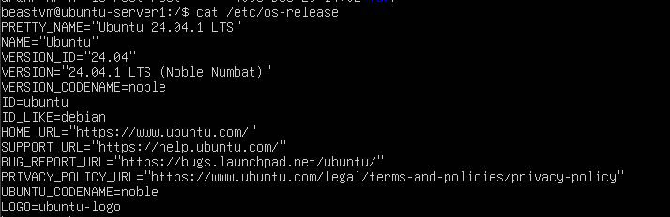

**Filesystem:**

**Command: df -h**

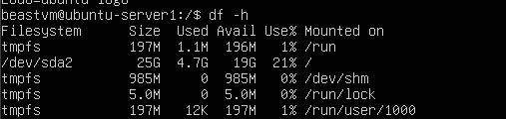

**DDNS:** https://www.noip.com/

**DDNS:** techd.ddnsking.com

Successfully enabled port forwarding on port 22