GALLERY:

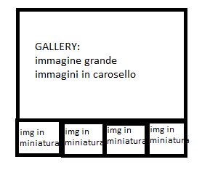

|  |  |
| --- | --- |
| CSS  **\*** {  box-sizing:border-box; }  img{  max-width: 100%; }  /*pour le saut de page, on cree une class que l'on met en display:none*/  .target{  display: none; }  /* englobe le slider */  .cadre_diapo{  max-width: 1000px;  margin: 2rem auto;  overflow: hidden;  border: 3px solid white; }  .interieur_diapo{  display: flex;  width: 400%;  **transition**: transform .6s ease-in-out; }  .description{  position: relative; }  .description span{  position: absolute;  left: 0;  top: 2%;  font-size: 75%;  **display: flex;**  padding: .5rem;  **justify-content: center;**  color: white;  background: hsla(0,0%,0%,.35); }  /*image 1*/  #image1:target ~ .cadre_diapo .interieur_diapo{  transform:translatex(0); }  /*image 2*/  #image2:target ~ .cadre_diapo .interieur_diapo{  transform:translatex(-25%); }  /*image 3*/  #image3:target ~ .cadre_diapo .interieur_diapo{  transform:translatex(-50%); }  /*image 4*/  #image4:target ~ .cadre_diapo .interieur_diapo{  transform:translatex(-75%); }  /*navigation avec images miniatures*/  .navigation_diapo{  display: flex; /*permet d'aligner les photos les unes à la suite des autres, on peut aussi utiliser le positionnement absolu*/  list-style-type: none;  margin: 0;  padding: 0; }  .navigation_diapo li {  padding: .25rem; }  .navigation_diapo img{  border: 3px solid white;  box-shadow:0 0 5px hsla(0,0%,0%,.4); }  @media (min-width:31.25rem){  .description span{  font-size: initial; } | HTML  <span id="image1" class="target"></span>  <span id="image2" class="target"></span>  <span id="image3" class="target"></span>  <span id="image4" class="target"></span>  <div class="cadre_diapo">  <div class="interieur_diapo">  <div class=description>  <span>description1</span>  <img src="/HTML/image/gallery2.jpg" alt>  </div>  <div class=description>  <span>description2</span>  <img src="/HTML/image/gallery3.jpg" alt>  </div>  <div class=description>  <span>description3</span>  <img src="/HTML/image/gallery4.jpg" alt>  </div>  <div class=description>  <span>description4</span>  <img src="/HTML/image/gallery6.jpg" alt>  </div>  </div>  <ul class="navigation_diapo">  <li><a href="#image1"><img src="/HTML/image/gallery2.jpg" alt></a></li>  <li><a href="#image2"><img src="/HTML/image/gallery3.jpg" alt></a></li>  <li><a href="#image3"><img src="/HTML/image/gallery4.jpg" alt></a></li>  <li><a href="#image4"><img src="/HTML/image/gallery6.jpg" alt></a></li></ul></div> |

MENU:

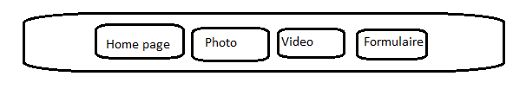

|  |  |
| --- | --- |
| .menu {  display: flex;  padding:0;  background-color: rgb(157, 174, 180);  justify-content: center; }  .menu li {  list-style-type: none ; }  .menu a {  display:block;  min-width: 120px;  margin: 0.5rem;  padding: 0.4rem 0;  text-align: center;  background-color: #ac97a2;  color: #fff;  text-decoration: none;  border: 1px solid #fff;  border-radius: 4px;  **transition**: all 1s ; }  .menu a:hover,  .menu a:hover.actif {  background-color: #514e55;  color: #f1ebf1;  border-color: #f0f0ec; }  .menu a.actif {  background-color: rgb(89, 83, 92) ;  color: #eceeee ;  border-color: #fdfffe ; } | < **head**>  < header >  <ul class="menu">  <li><a href="/HTML/index.html">Home page</a></li>  <li><a href="/HTML/formule1.html" class="actif">Photo</a></li>  <li><a href="/HTML/formule2.html">Vidéo</a></li>  <li><a href="/HTML/formulaire.html">Contactez-nous</a></li>  </ul>  </header>  < **head**> |

CSS: **transition**

Con la funzione ‘hover’ io potevo ottenere un cambio d’effetto quando sorvolavo la “zona”; con ‘transition’ io posso stabilire la durata ( in secondi)

Metodo hover CSS:

div {

width: 200px;

height: 200px;

background-color: 98d925#;

}

div:hover {

background-color: #ff5c00;

}

Metodo ‘transition in CSS:

div {

width: 200px;

height: 200px;

background-color: 98d925#;

**transition-property**: background-color;

**transition-duration**: 2s;

}

div:hover {

background-color: #ff5c00;

}

Cambio di tre colori:

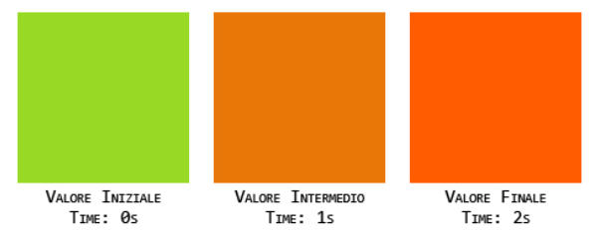

Linea di codice CSS per far apparire lo stesso con i diversi navigatori:

div {

width: 200px;

height: 200px;

background-color: #98d925; /*verde:= colore iniziale*/

**transition-property**: background-color; /\***standard**\*/

**transition-duration**: 2s;

**-webkit-transition-property:** background-color; /\***safari**\*/

**-webkit-transition-duration**: 2s;

**-o-transition-property**: background-color; /\***opera**\*/

**-o-transition-duration**: 2s;

**-moz-transition-property**: background-color; /\***firefox**\*/

**-moz-transition-duration**: 2s;

}

div:hover {

background-color: #ff5c00; /*arancio:= colore finale*/

}

