19 types:

<http://www.w3.org/TR/xmlschema-2/#built-in-primitive-datatypes>

video su perché avere tutte le date immagazzinate con grenwich:

<https://www.youtube.com/watch?v=-5wpm-gesOY>

….

Esempio json:

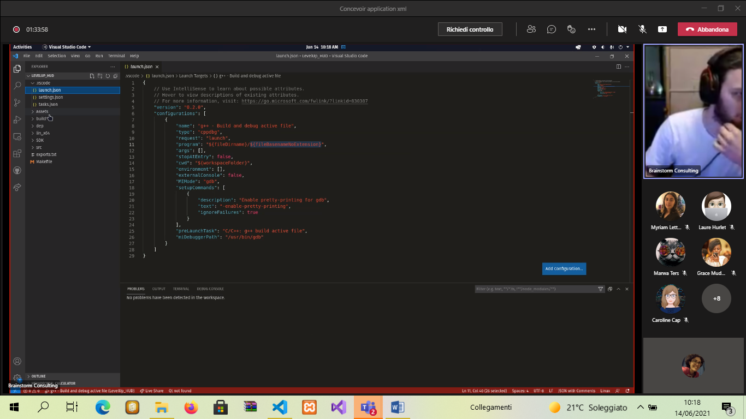

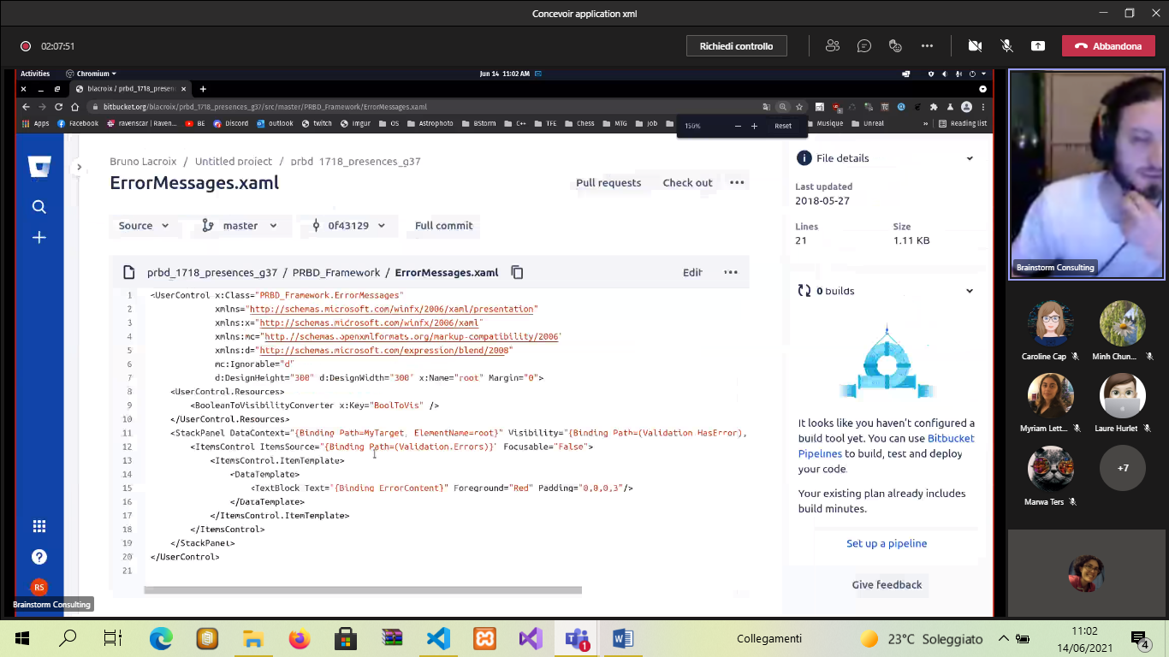

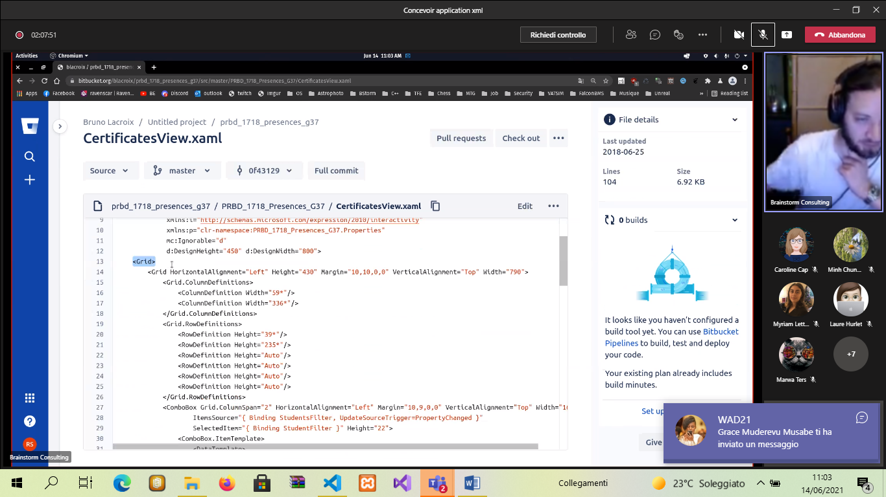

Bottone:

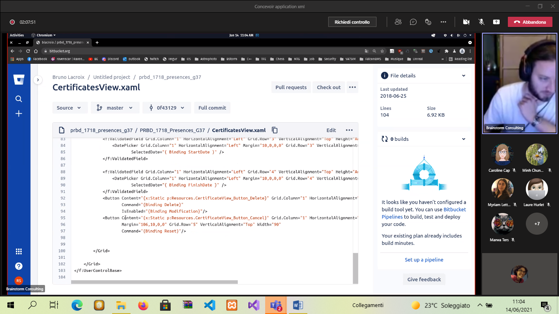

Biblio..

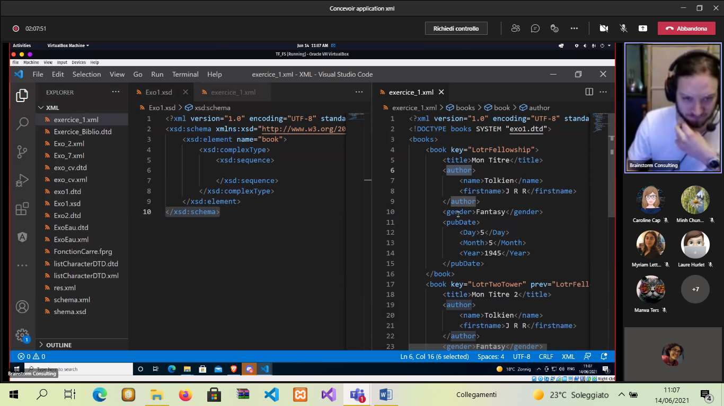

.. restriction:

<xsd:simpleType name="Day">

<xsd:restriction base="xsd:positiveInteger">

<xsd:maxInclusive value="31"/>

</xsd:restriction>

</xsd:simpleType>

…………………………………………………….

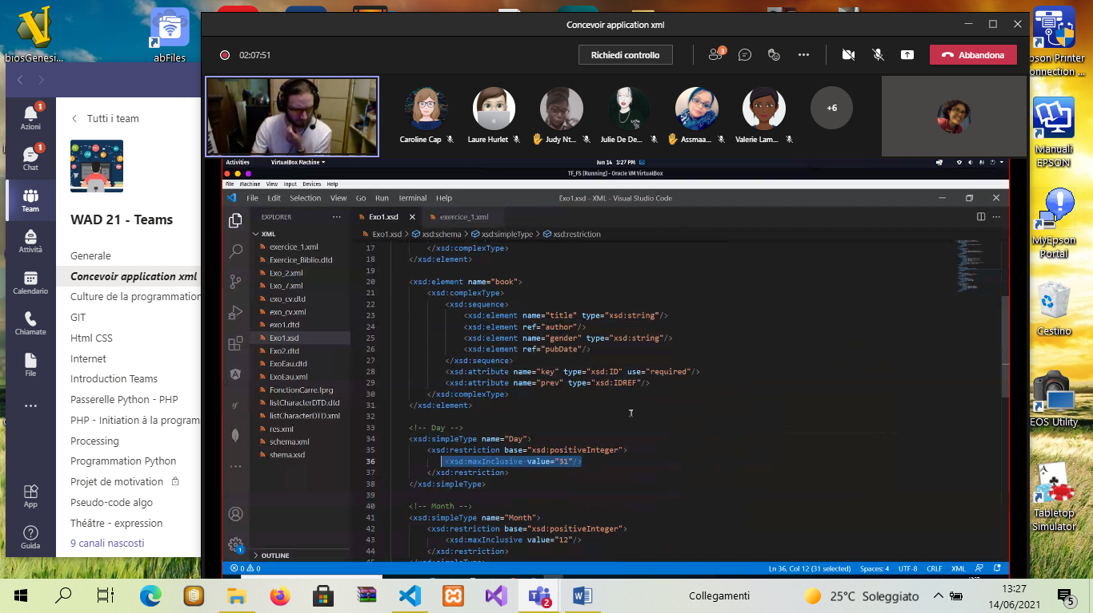

Pasword:

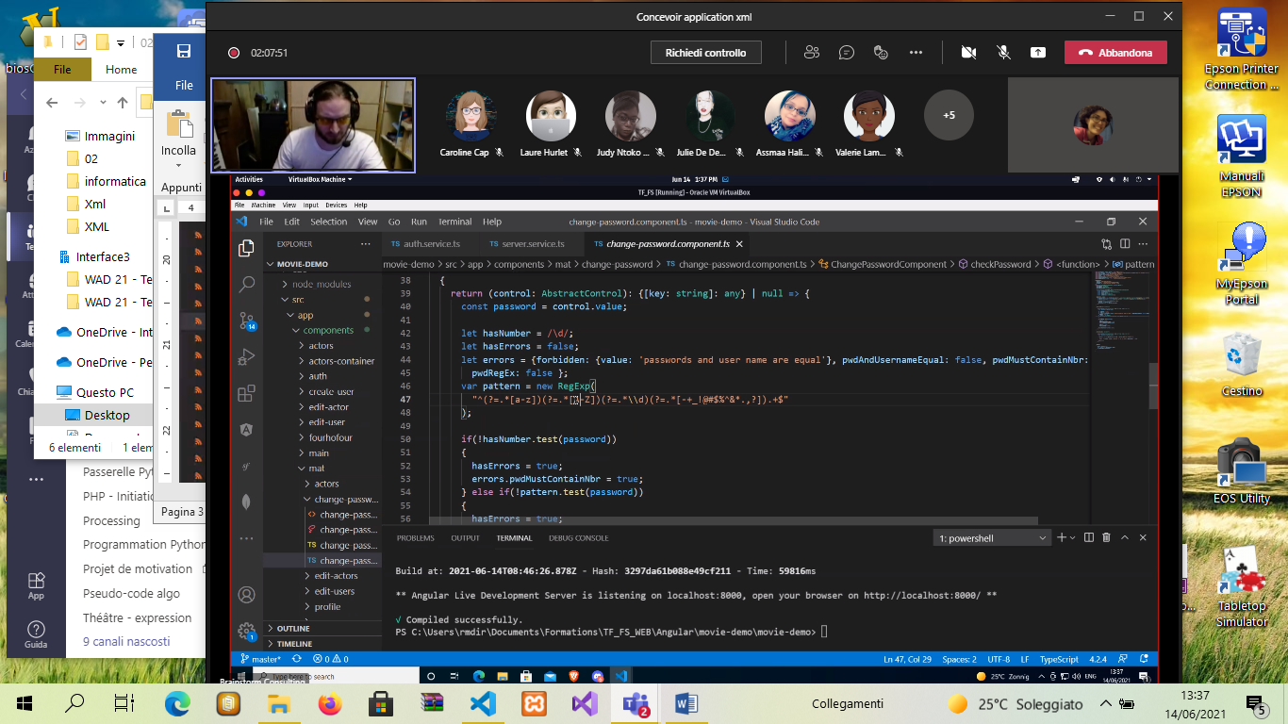

Link di ricerca:

<https://www.easycodeforall.com/generate-xpath.html>