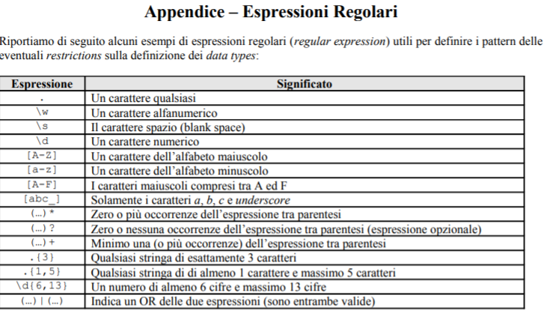

<xs:schema xmlns:ie="http://www.interviewexchange.com" xmlns:xs="http://www.w3.org/2001/XMLSchema" elementFormDefault="qualified">

<xs:element name="country">

<xs:simpleType>

<xs:restriction base="xs:string">

<xs:enumeration value="USA" />

<xs:enumeration value="UK" />

<xs:enumeration value="India" />

</xs:restriction>

</xs:simpleType>

</xs:element>

<xs:element name="state">

<xs:simpleType>

<xs:restriction base="xs:string">

<assert test="if (country eq 'USA')">

<xs:enumeration value="MA" />

<xs:enumeration value="AR" />

<xs:enumeration value="NY" />

</assert">

<assert test="if (country eq 'India')">

<xs:enumeration value="AP" />

<xs:enumeration value="TN" />

<xs:enumeration value="MP" />

</assert">

</xs:restriction>

</xs:simpleType>

</xs:element>