**Graphical User Interface for Semi-Automatic Spot Detection and Colocalization**

Authors: Johannes Stegmaier1,2, Alexandre Cunha2, Harry M. Choi3, Maayan Schwarzkopf3, Niles Pierce3,4

1Institute for Applied Computer Science, Karlsruhe Institute of Technology, Karlsruhe, Germany; 2Center for Advanced Methods in Biological Image Analysis, California Institute of Technology, Pasadena, CA, USA; 3Division of Biology & Biological Engineering, California Institute of Technology, Pasadena, CA, USA; 4Division of Engineering & Applied Science, California Institute of Technology, Pasadena, CA, USA

**Getting Started:**

1. Download the software package matching the operating system of your choice (latest versions are hosted on <https://bitbucket.org/jstegmaier/spotdetectionandcolocalizationgui/downloads/>) and extract the zip-archive to your hard disk drive. Note that the file path you extract the files to should not contain any spaces or special characters and you’ll need to have write permissions in order to temporarily store processed data.
2. In order to run the spot colocalization software, you’ll need to install MATLAB (we tested the software on MATLAB R2017a on Windows, Ubuntu and Mac OSX). Open up the file “SpotDetectionGUI.m” in the MATLAB editor and execute the script with the “F5” button or by pressing the green play button on top of the MATLAB code editor window.
3. In case you observe permission denied, try changing the permissions to the extracted software folder, such that read/write/execute are enabled. This can be performed by navigating to the respective folder (called $DIR in the following command) using the Terminal application and by executing the following command “chmod 755 -R $DIR”. This should change the permissions to read+write+execute for the current user and to read+execute for all other users.

**Example:**

1. Open and run the “SpotDetectionGUI.m” in MATLAB as described above.

1. Adjust the project settings shown in the following dialog such that it matches your image data. This comprises the physical voxel size in microns and the minimum/maximum object diameter measured in pixel. For noise removal, the raw images are initially subtly smoothed with a Gaussian filter. For noisy images, it may help to increase the variance of the Gaussian filter for further suppression of high frequency noise. Optionally, the centroids identified by the Laplacian-of-Gaussian blob detector can be refined if the “Weighted Centroid” option is set to 1 (disabled by default).

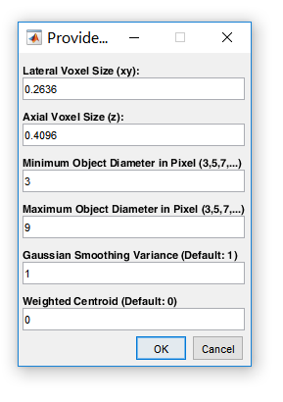

1. After confirming the project settings, three file selection dialogs will pop up. Select the two input images to use first (Note that the dimensions of the images need to be identical). In the third file selection dialog, select the output folder that will be used for saving the intermediate and the final results. Two example images can be found in the “Data” folder contained in the original zip archive of the software. Choose, e.g., the “Processing” folder also contained in the root directory of the software folder.
2. The images are automatically analyzed and the detected spots are imported to MATLAB for further analysis as shown in the following screenshot:

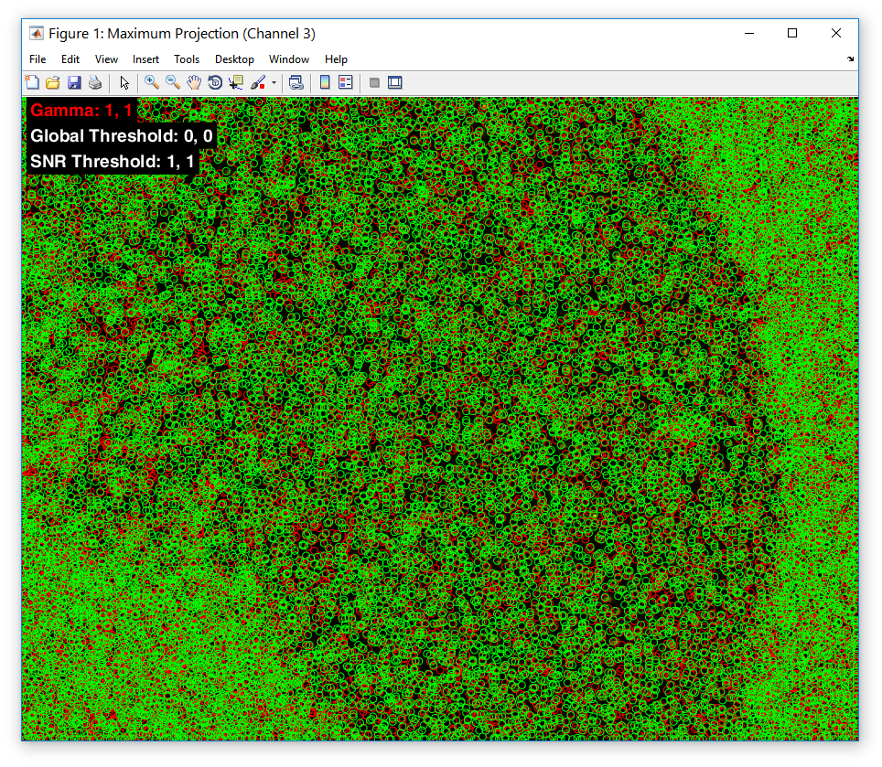

1. As a first step, it is usually advisable to adjust the contrast of the images in order to properly see the structures of interest. The buttons “1”, “2” or “3” can be used to switch between channel 1, 2 and an overlay of both channels, respectively. Select “3” and press the “Arrow Down” button to decrease the gamma value used for contrast adjustment.

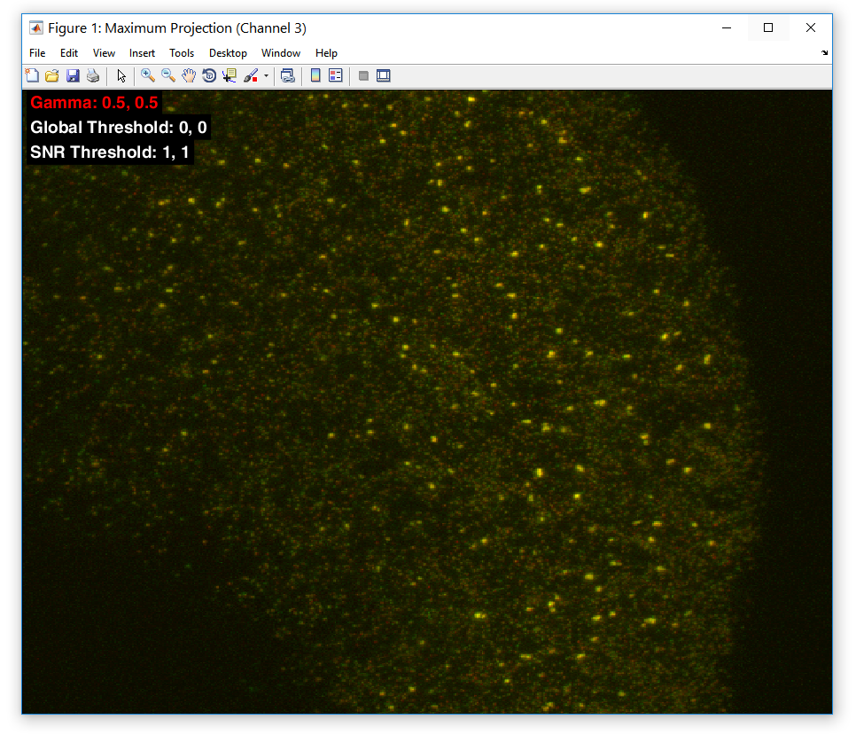

1. Now the thresholds for filtering the detections can be adjusted. Press the “T” button once to switch the threshold mode to the global threshold. By pressing the “Arrow Down” and “Arrow Up” button, the global intensity threshold can be decreased and increased, respectively. All detections with an average intensity lower than this threshold are discarded from the further analyses. You can again switch between channels 1 and 2 or use both channels using the “1”, “2” or “3” keys, in case you need to separately adjust the threshold differently for both channels. By pressing “T” again, you can switch to the SNR threshold mode and adjust this threshold to further refine the filtering of the remaining detections. The SNR threshold uses a neighborhood surrounding the detection and compares the mean intensity of the detected spot to the neighborhood region excluding the central part. The higher the threshold, the more prominent a detection has to be. For instance, a value of 2 indicates that the mean intensity of the detection has to be at least twice as high as the mean intensity of its local neighborhood.

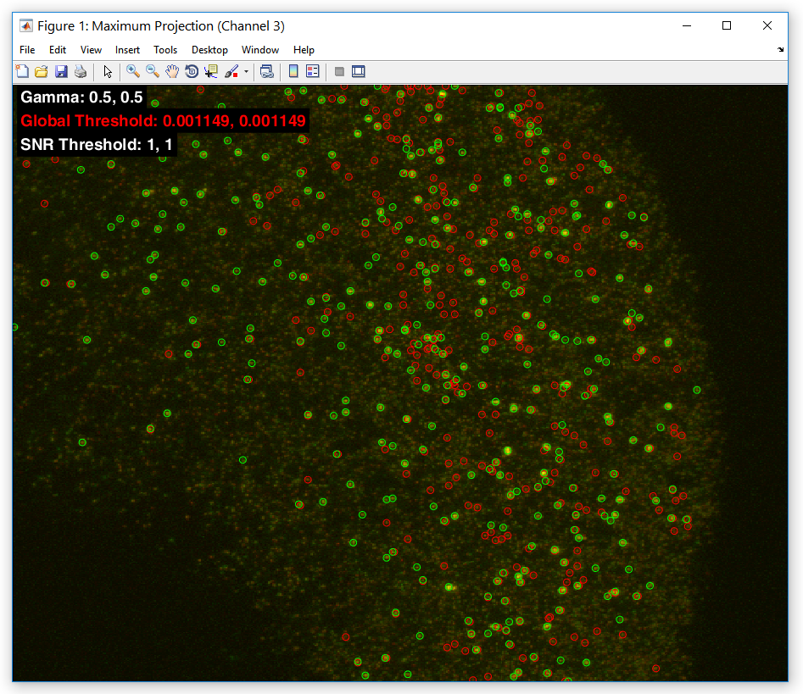

1. Once the detections are properly filtered, the actual colocalization can be performed by pressing the “C” key. Colocalized detections are highlighted in yellow as shown on the following screenshot:

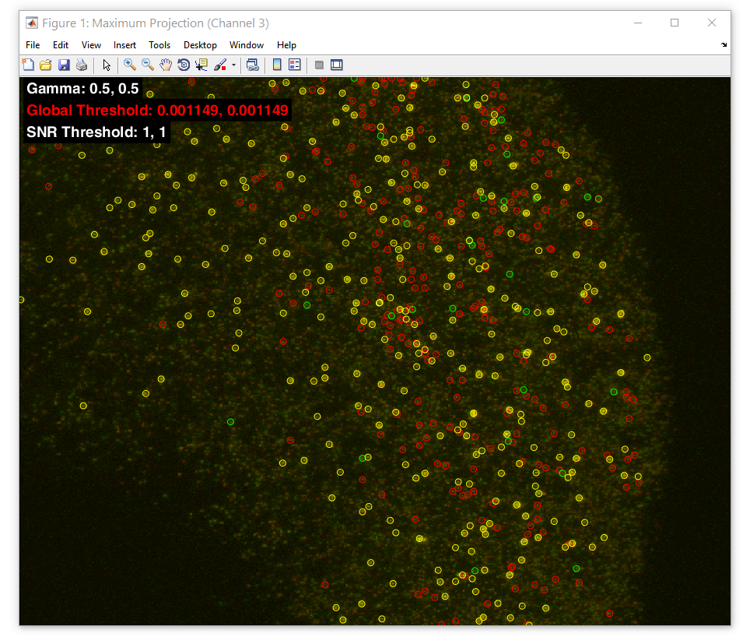

1. Finally, results can be exported by pressing the “E” key. The uncolocalized and colocalized detections are separately stored for each channel in a CSV file format that can be used for further processing, e.g., in Excel. Furthermore, a result overview file is generated in plain text format.

**Keyboard Shortcuts:**

The following hot keys can be used to control the software (a summary also shows up when pressing the “H” button for help).

* **1,2,3:** Toggles the displayed image (channel1, channel2, overlay)
* **Up Arrow:** Increase selected threshold (highlighted in red)
* **Down Arrow**: Decrease selected threshold (highlighted in red)
* **Left Arrow:** Go to previous slice (only works in slice mode)
* **Right Arrow:** Go to next slice (only works in slice mode)
* **A:** Toggle between streched mode and fixed aspect ratio
* **B:** Toggle background detections for intensity comparisons (auto-detection uses convex hull of colocalized dots and freehand tool allows arbitary masks)
* **C:** Toggle visibility of colocalized detections
* **D:** Toggle visibility of detections
* **E:** Export results
* **H:** Show this help dialog
* **I:** Show IDs of detections by hovering them with the mouse
* **L:** Show ScaLeBar at a user-defined location (lower-right corner of the scale bar)
* **M:** Switch between slice-mode and maximum projection mode
* **O:** Zoom out to the original view
* **P:** Preview of the percentage of colocalization before the final parameters are fixed for export
* **R:** Reset all thresholds
* **S:** Show scatter plots of the mean intensities of the current colocalizing detections
* **T:** Change current threshold (use 1,2,3 for changing only channel1, channel2 or both parameters, respectively)
* **Mouse Wheel:** Scroll through slices (only works in slice-mode)
* **CTRL + Mouse Wheel:** Zoom in/out in a Google-Maps like behavior

Hint: In case key presses show no effect, left click once on the image and try hitting the button again. This only happens if the window loses the focus.