|  |  |  |  |  |
| --- | --- | --- | --- | --- |
|  | |  | | |
|  |  |
|  |  |
| New Revenue Streams | |
| PG. 2  Market Overview  PG. 3  Segment Customers  PG. 4  Focus Categories | | |  |  |

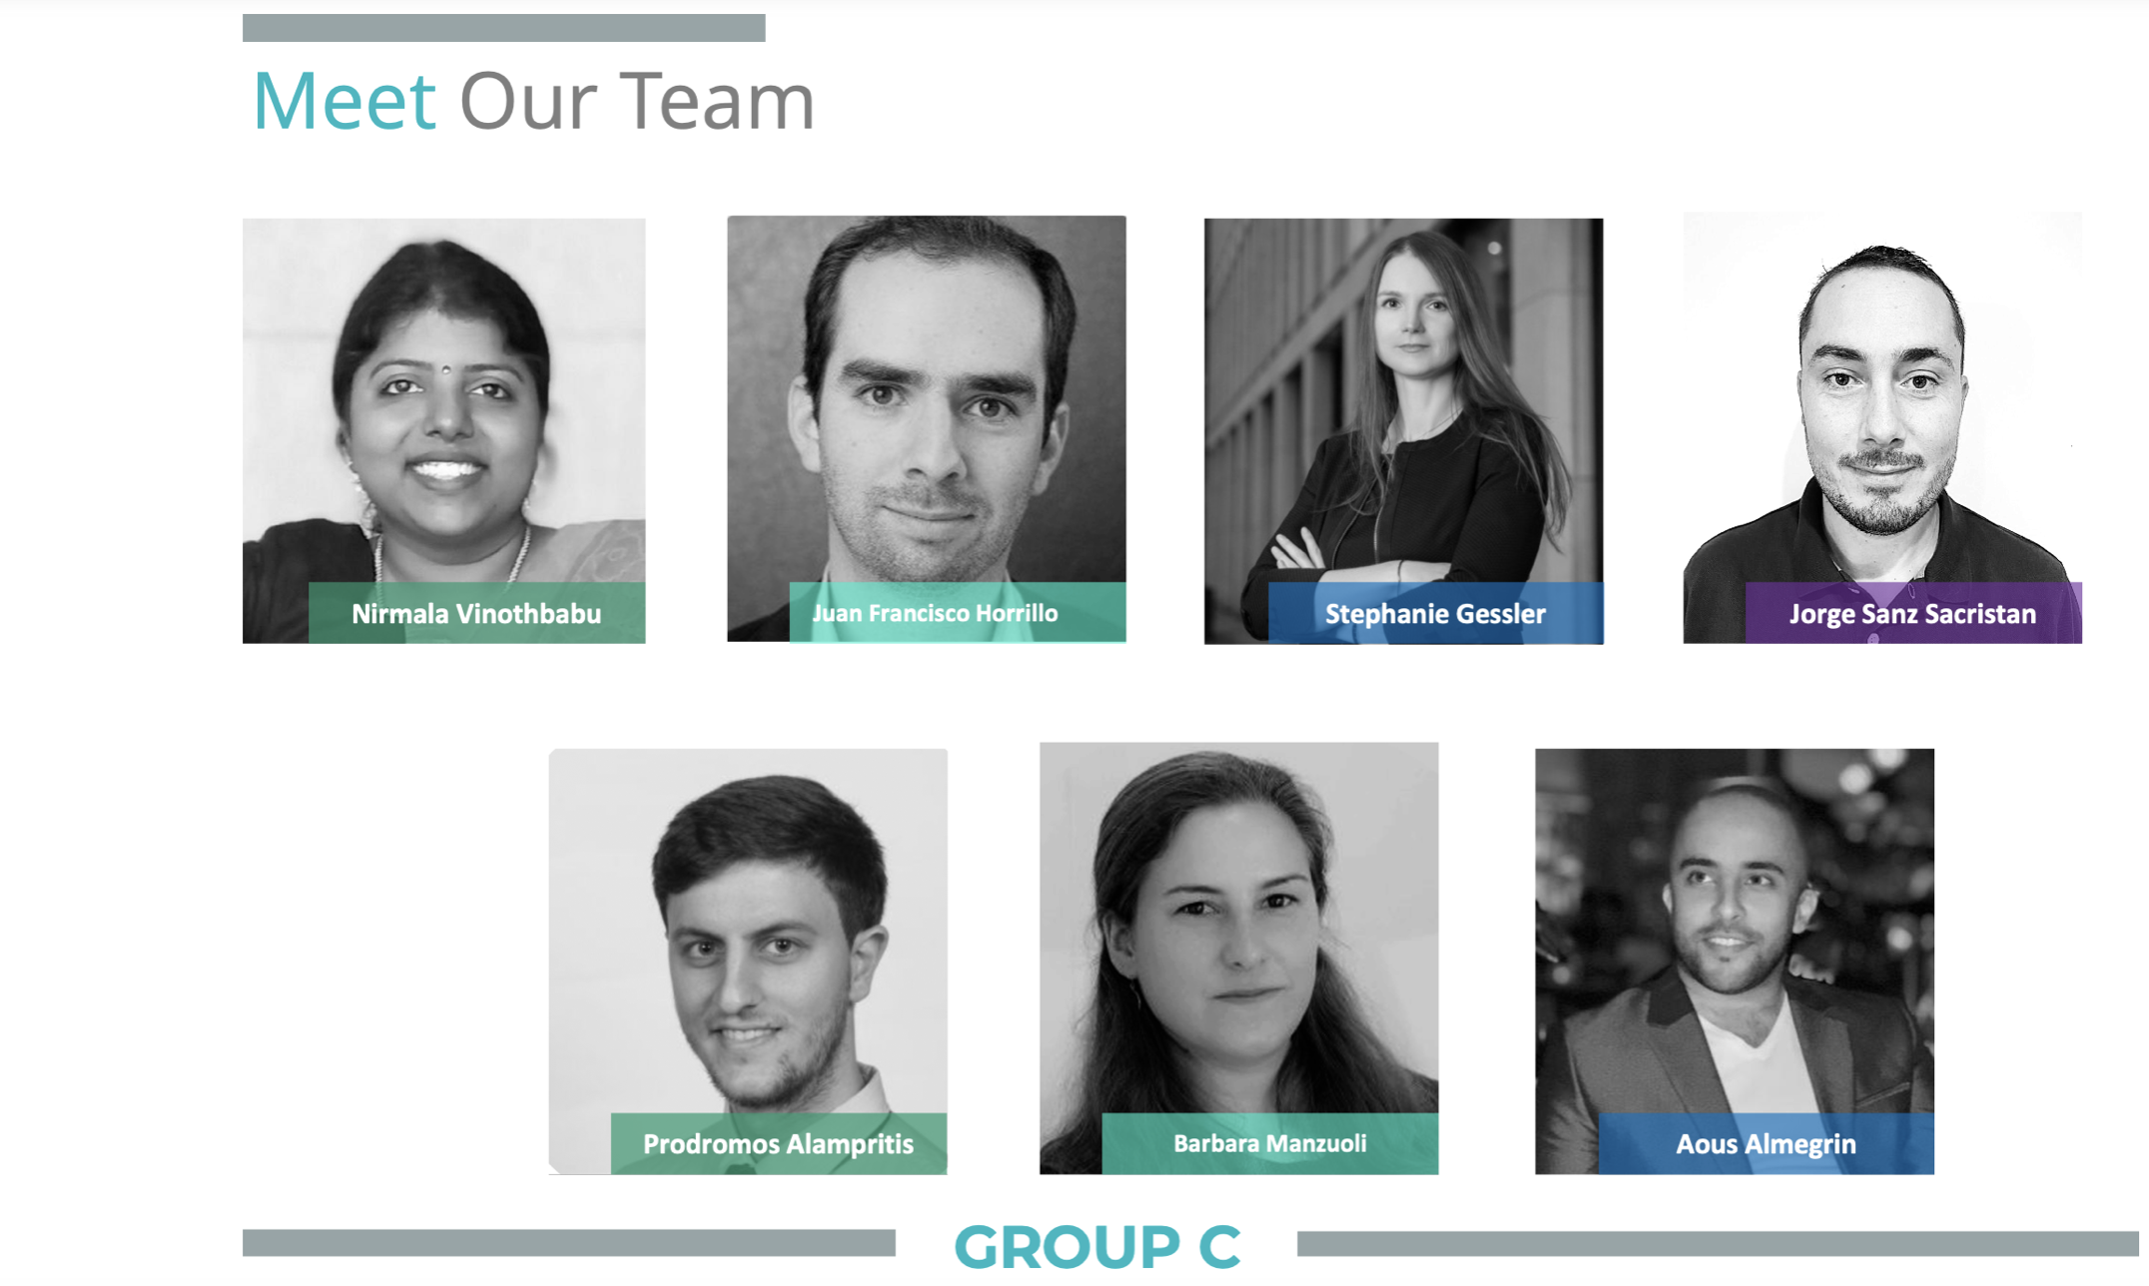

|  |  |  |  |
| --- | --- | --- | --- |
|  | |  | TITLE GOES HERESUBTITLE GOES HERE We think the design of this newsletter is great as is! But, if you do not agree, you are able to make it yours by making a few minor design tweaks! Tips on updating specific features are available throughout this example text.  To change any of the text in this document, just click on the block of text you want to update! The formatting has already been programmed for ease of formatting.  You can easily change the overall colors of the template with just a few clicks. Go to the Design tab and click on Colors. From the list of colors, you can choose a different color scheme. As you hover over the different choices, you can see how the overall feel of the document will change with each different option. |
|  |  | |  |
|  |  | |
|  | |  |
|  | |  |
|  | TITLE GOES HERESUBTITLE GOES HERE Changed the color and want to go back to the original design? Easy! Just go back to the Design tab and choose the Themes option. From the list, click the option to reset the theme of this template. And just like that, your document color scheme will be restored to its original!  Have other images you wish to use? It is simple to replace any of the pictures in this newsletter. Click twice on the image you wish to change. Some images may need an extra click as they are part a group of images. Keep clicking until your selection handles are around the one image you wish to replace.  Once the image you wish to replace is selected, you can either select “Change Picture” from the shortcut menu, or click on the “Fill” option and choose the option for “Picture.” |

|  |  |  |  |
| --- | --- | --- | --- |
|  | |  | TITLE GOES HERESUBTITLE GOES HERE In the same way you change the colors, you can update the fonts of the entire document easily! From the Design tab, choose a font combination that fits your taste.  Reset the theme to restore the template to its original state!  To change any of the text in this document, just click on the block of text you want to update! The formatting has already been programmed for ease of formatting.  In this panel, you can highlight even more information about your organization! Tell the audience why you are the best! Don’t be shy! Share, explain, and tell us what makes your company so great!  Plenty of text will fit in any of these panels. Simply click on the placeholders and add your own text. |
|  |  | |  |
|  |  | |
| TITLE GOES HERESUBTITLE GOES HERE To change any of the text in this document, just click on the block of text you want to update! The formatting has already been programmed for ease of formatting.  You can easily change the overall colors of the template with just a few clicks. Go to the Design tab and click on Colors. From the list of colors, you can choose a different color scheme. As you hover over the different choices, you can see how the overall feel of the document will change with each different option.  Changed the color and want to go back to the original design? Easy! Just go back to the Design tab and choose the Themes option. From the list, click the option to reset the theme of this template. And just like that, your document color scheme will be restored to its original!  Have other images you wish to use? It is simple to replace any of the pictures in this newsletter. Click twice on the image you wish to change. Some images may need an extra click as they are part a group of images. Keep clicking until your selection handles are around the one image you wish to replace.  Once the image you wish to replace is selected, you can either select “Change Picture” from the shortcut menu, or click on the “Fill” option and choose the option for “Picture.” | | | |

|  |  |  |
| --- | --- | --- |
|  | | |
| TITLE GOES HERESUBTITLE GOES HERE |  |  |
|  |  |
|  |  |
| Video provides a powerful way to help you prove your point. When you click Online Video, you can paste in the embed code for the video you want to add. You can also type a keyword to search online for the video that best fits your document.  To make your document look professionally produced, Word provides header, footer, cover page, and text box designs that complement each other. For example, you can add a matching cover page, header, and sidebar. Click Insert and then choose the elements you want from the different galleries.  Themes and styles also help keep your document coordinated. When you click Design and choose a new Theme, the pictures, charts, and SmartArt graphics change to match your new theme. When you apply styles, your headings change to match the new theme.  Save time in Word with new buttons that show up where you need them. To change the way a picture fits in your document, click it and a button for layout options appears next to it. When you work on a table, click where you want to add a row or a column, and then click the plus sign.  Reading is easier, too, in the new Reading view. You can collapse parts of the document and focus on the text you want. If you need to stop reading before you reach the end, Word remembers where you left off - even on another device. | | |
|  | | |

References

*Country classification - united nations*. (n.d.). Retrieved December 6, 2022, from https://www.un.org/en/development/desa/policy/wesp/wesp_current/2014wesp_country_classification.pdf

*GDP (current US$)*. Data. (n.d.). Retrieved December 6, 2022, from https://data.worldbank.org/indicator/NY.GDP.MKTP.CD

*World Bank Country and lending groups*. World Bank Country and Lending Groups – World Bank Data Help Desk. (n.d.). Retrieved December 6, 2022, from https://datahelpdesk.worldbank.org/knowledgebase/articles/906519-world-bank-country-and-lending-groups