|  |  |
| --- | --- |
| Function | Description |
| log1p | Log(1+x) |
| greater, greater_equal,  less, less_equal, equal,  not_equal | Perform element-wise comparison, yielding boolean array. Equivalent to infix operators  >, >=, <, <=, ==, != |
| arr.sort() | sorts from least to greatest |
| unique(x) | Compute the sorted, unique elements in x |
| intersect1d(x, y) | Compute the sorted, common elements in x and y |
| union1d(x, y) | Compute the sorted union of elements |
| in1d(x, y) | Compute a boolean array indicating whether each element of x is contained in y |
| setdiff1d(x, y) | Set difference, elements in x that are not in y |
| setxor1d(x, y) | Set symmetric differences; elements that are in either of the arrays, but not both |
| binomial | Draw samples a binomial distribution |
| normal | Draw samples from a normal (Gaussian) distribution |
| beta | Draw samples from a beta distribution |
| chisquare | Draw samples from a chi-square distribution |
| gamma | Draw samples from a gamma distribution |
| Pandas |  |
| append | Concatenate with additional Index objects, producing a new Index |
| diff | Compute set difference as an Index |
| intersection | Compute set intersection |
| union | Compute set union |
| isin | Compute boolean array indicating whether each value is contained in the passed collection |
| delete | Compute new Index with element at index i deleted |
| drop | Compute new index by deleting passed values |
| insert | Compute new Index by inserting element at index i |

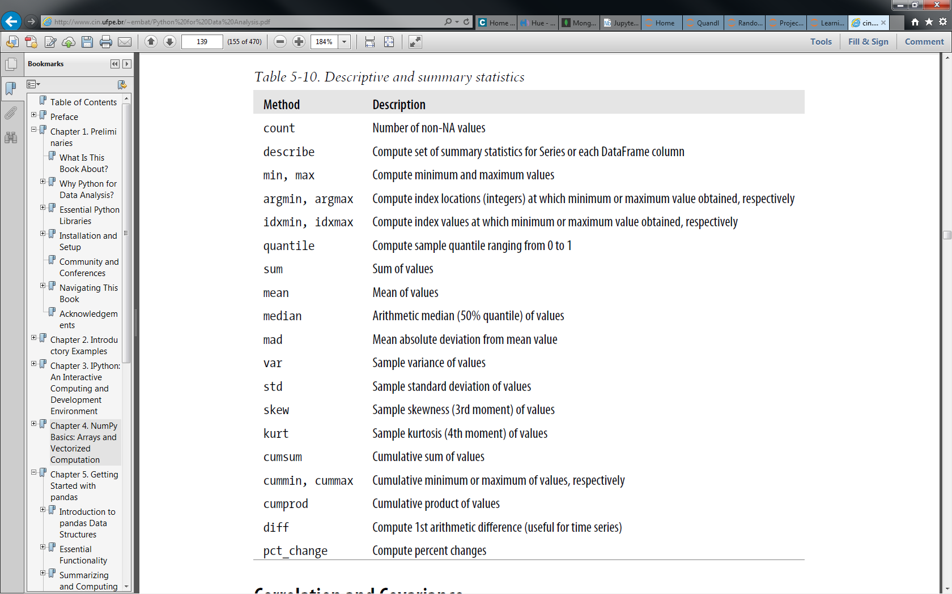

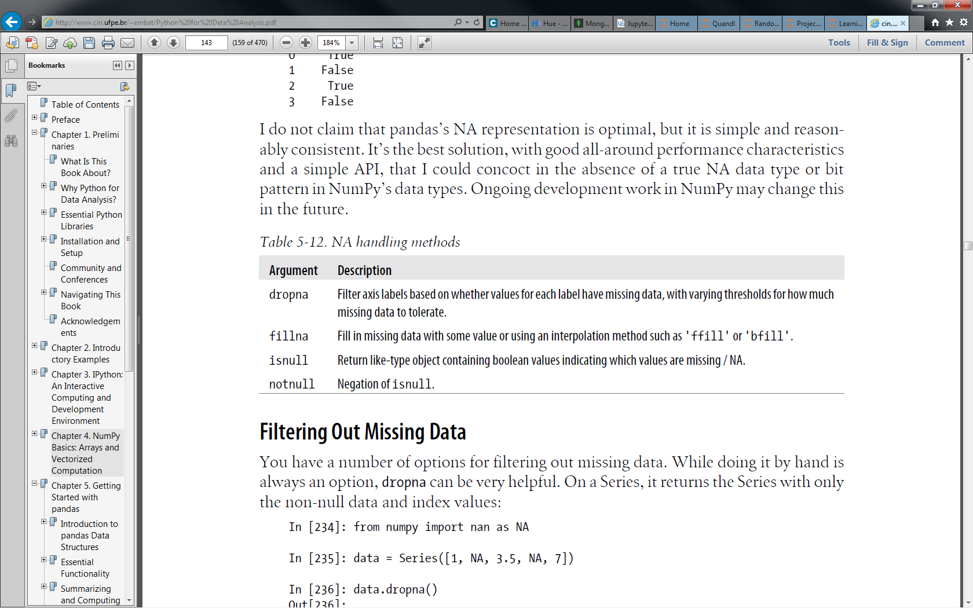

df.fillna(method='ffill')

