Longitudinal growth analysis of brain metastasis

We have developed several approaches for longitudinal growth analysis, drawing on paradigms such as Physics-Informed Neural Networks (PINNs) and Neural ODEs [1]. However, their applicability to other imaging modalities remains unclear. Recently, a large public longitudinal dataset of brain metastases imaged with contrast-enhanced MRI was released [2]. This dataset contains numerous cases, but with irregular follow-up intervals, heterogeneous imaging devices, and treatment effects that alter metastasis growth trajectories. To enable realistic forecasting, these treatment-induced effects must be accounted for, which requires stratifying patients based on the therapies they received and constructing a dataset that reflects untreated disease progression.
Related work has applied similar methods to glioblastoma forecasting [3]. Yet, whether the underlying PDEs used in that setting are equally suitable for modeling metastasis growth remains an open research question. Moreover, existing PINN-based approaches typically train models for individual patients. This thesis aims to scale such methods to the population level by introducing a shared embedding space, combined with test-time adaptation techniques to derive effective embeddings for unseen patients.

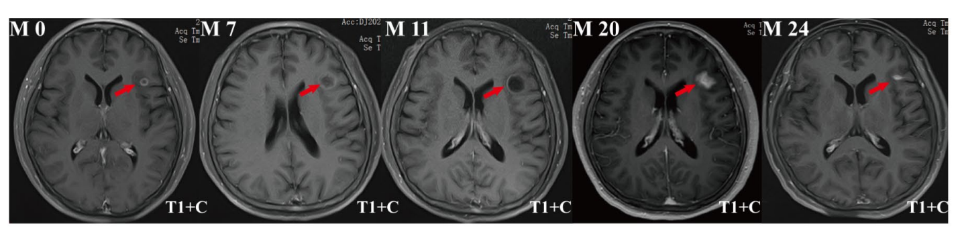
Example patient, taken from “Longitudinal MRI evaluation of the efficacy of non-enhanced lung cancer brain metastases” by Zahng et al. 2025. Shows growth of a metastasis and treatment between month 11 and 20.

Related Literature:
[1] Lachinov et al. Learning Spatio-Temporal Model of Disease Progression with NeuralODEs from Longitudinal Volumetric Data TMI 2024
[2] Yale longitudinal dataset of brain metastases on MRI with associated clinical data (Yale-Brain-Mets-Longitudinal) Li et al. The Cancer Imaging Archive, 2025
[3] Zhang et al. Personalized predictions of Glioblastoma infiltration: Mathematical models, Physics-Informed Neural Networks and multimodal scans Medical Image Analysis 2025

