Image Classification with Neural Networks

Part I: Research Question

A: Description of Purpose of Data Analysis
- Research question: can a neural network be trained to identify images of crop seedlings and help separate them from weeds?
- Goals/objectives of data analysis:
  - Use image data to train a model to identify and classify crop seedlings
  - Test model to ensure accuracy
- Type of neural network: I will use a convolutional neural network (CNN) for this task. This network will be an image classification model.
- Justification of neural network choice: I chose to use a CNN because a regular perceptron model would not be sufficient to classify images accurately. The CNN is developed specifically for image and video classification, so it is the tool that makes the most sense for this task.

Part II: Data Preparation

B: Describe Data Preparation Process on Image Dataset
- Exploratory data analysis:
  - I started by loading the data. Then I checked the shape of my data and the head of the labels data to make sure I had the information loaded correctly:
    - images = np.load("/content/drive/MyDrive/Colab Notebooks/Advanced Analytics/images.npy", allow_pickle=True)
    - labels = pd.read_csv("/content/drive/MyDrive/Colab Notebooks/Advanced Analytics/labels.csv")
    - print(images.shape)
    - print(labels.shape)
    - labels.head()
    - 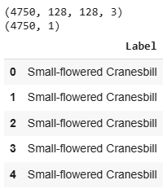
  - Next, I determined the categories for the plant labels and created a group for them:
    - labels['Label'].unique()
    - categories = ['Small-flowered Cranesbill', 'Fat Hen', 'Shepherds Purse', 'Common wheat', 'Common Chickweed', 'Charlock', 'Cleavers', 'Scentless Mayweed', 'Sugar beet', 'Maize', 'Black-grass', 'Loose Silky-bent']
    - num_categories = len(categories) # will be used to create image grid
    - print(num_categories)
    - This gave me 12 categories.
  - I used countplot to create a visual of the distribution of the categories:
    - import matplotlib.pyplot as plt # used to show plot and add information
    - import seaborn as sns # used to create plot
    - sns.countplot(x=labels.iloc[:,-1],order = labels['Label'].value_counts().index, palette='Greens_r')
    - plt.xlabel('Plant Categories')
    - plt.xticks(rotation=45)
    - 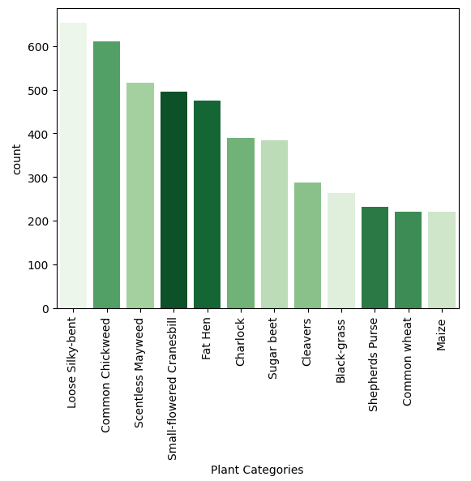
    - From this, I can see that the Loose Silky-bent category contains more images than the others, and that common wheat and maize have the fewest images.
  - I used ImageGrid to create a visual of the images and their corresponding categories. Since I have 12 categories, I created a 12 x 12 grid.
    - from mpl_toolkits.axes_grid1 import ImageGrid # used to create image grid
    - # Set grid parameters
fig = plt.figure(1, figsize=(num_categories, num_categories))
grid = ImageGrid(fig, 111, nrows_ncols=(num_categories, num_categories), axes_pad=0.05)
i = 0

# Create loop for plotting images in each category
for category_id, category in enumerate(categories):
condition = labels["Label"] == category
plant_label = labels[condition].index.tolist()
for k in range(min(12, len(plant_label))):
ax = grid[i]
ax.imshow(images[plant_label[k]])
ax.axis('off')
if i % num_categories == num_categories - 1:
# used to print the names for each category
ax.text(200, 70, category, verticalalignment='center') i += 1
plt.show()
ax.text(200, 70, category, verticalalignment='center')
i += 1
plt.show()
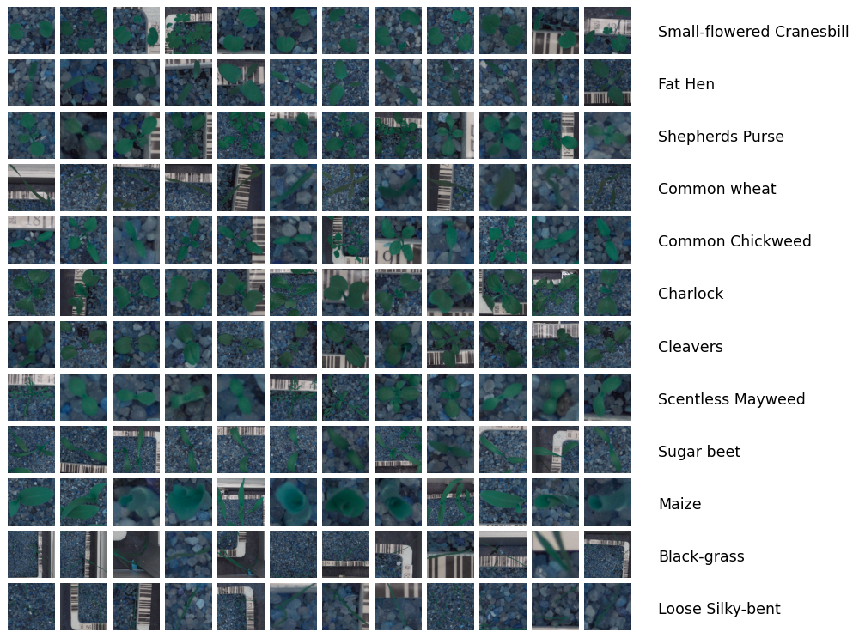
- Data augmentation:
  - I do not want to change the color on these images, as the leaves being green is important for identification purposes on a plant.
  - The direction of the picture is not important for identification purposes, as the leaves look the same upside-down or horizontally flipped. Since that is the case, I used both random horizontal flip and random vertical flip. I also used random rotation from 0 to 45 degrees.
  - I used random auto contrast to change the contrast of the pictures, leaving the color, but adjusting the brightness of it.
    - "train": transforms.Compose([
    - transforms.RandomHorizontalFlip(),
    - transforms.RandomVerticalFlip(),
    - transforms.RandomRotation(45),
    - transforms.RandomAutocontrast(),
    - transforms.ToTensor(),
    - transforms.Normalize((0.5, 0.5, 0.5), (0.5, 0.5, 0.5))
    - ])
  - I did not use the transformations in the validation or test sets, they only had the ToTensor and Normalize functions.
- Normalize the images: using the ToTensor function adjusts the data values to be between 0 and 1. After that, I use transforms.Normalize to normalize the images and used the mean and standard deviation values of the images dataset, after I determined what they were:
import torchvision.transforms as transforms

transform = transforms.Compose([
transforms.ToTensor()])

images_tr = torch.stack([transform(image) for image in images])

sumel = 0.0
countel = 0
for img in images_tr:
sumel += img.sum([1, 2])
countel += torch.numel(img[0])
mean = sumel/countel
std = torch.sqrt(sumel/countel)
print("mean: " + str(mean))
print("standard deviation: " + str(std))

  - mean = [0.2068, 0.2889, 0.3283]
std = [0.4548, 0.5375, 0.5730]
train_transforms = transforms.Compose([
transforms.ToTensor(),
transforms.Normalize(mean, std)])

  - After completing these steps, I previewed a batch of images:
    - # Obtain next batch
images = next(iter(train_loader))
image = images[0]

# Function to display image
def imshow(img, sub):
sub.imshow(np.transpose(img, (0, 1, 2)))
sub.axis('off')

# Plot images
fig, subs = plt.subplots(2, 10, figsize=(25, 4))
for i, sub in enumerate(subs.flatten()):
imshow(images[i], sub)
# Get the index of the maximum value instead of the column name
category_index = y_train.iloc[i].argmax()
sub.set_title(categories[category_index])
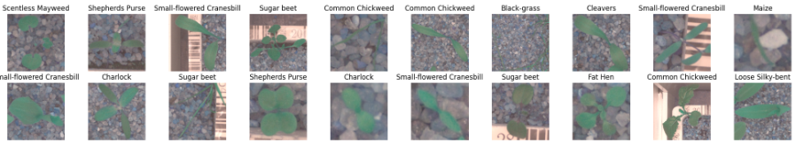
- Train-validation-test split: I used two steps to achieve the split, first I split the data and put 80% into the training dataset. Then I split the remaining 20% into the validation and test sets. The training dataset ended up with 3800 observations while the validation and test datasets each have 475 (10% of the total data).
  - from sklearn.model_selection import train_test_split
#1st split into train and test
X_train, X_test1, y_train, y_test1 = train_test_split(images, label, test_size=0.20, stratify=label, random_state = random_state)
#2nd split into test and validation
X_val, X_test, y_val, y_test = train_test_split(X_test1, y_test1, test_size=0.50, stratify=y_test1, random_state = random_state)
  - X_train.shape, X_test.shape, y_train.shape, y_test.shape, X_val.shape, y_val.shape
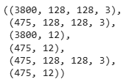
- Encode target feature: I used one-hot encoding with dtype=int to make sure the results were in the form of 0 or 1. The pd.get_dummies function will take categorical data and split it into multiple rows of true/false or 1/0. In this case, it created 12 rows because there are 12 categories in the labels dataset.
  - label = pd.get_dummies(labels, dtype=int)
print(label.head(5))
print(label.shape)
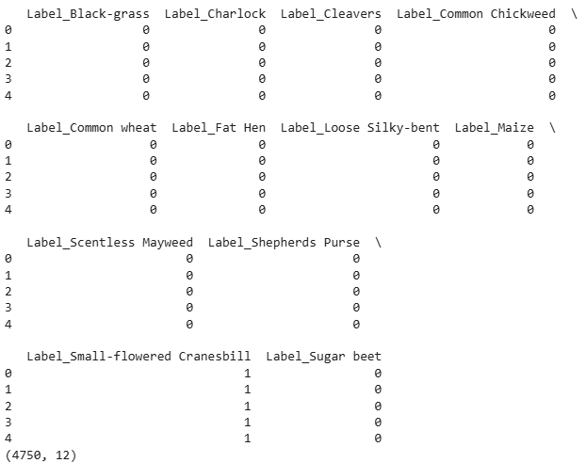
- Provide copies of datasets: copies of all datasets provided with project submission.

Part III: Network Architecture

E: Describe the Type of Network Used
- Output of model summary: 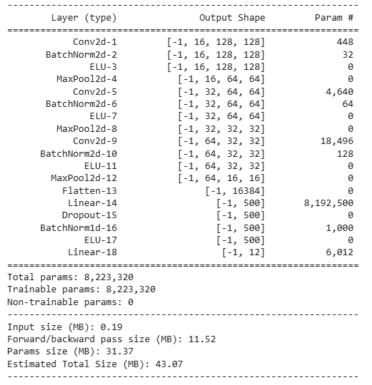
- Components of convolutional neural network architecture and justification:
  - Number of layers: I have 18 layers in the model. I wanted multiple hidden layers to help increase the model's accuracy, so this necessitated increasing the total number of layers in the model.
  - Types of layers:
    - The first layer is a convolutional layer.
    - I tried the initial experiment with and without batch normalization, the loss numbers were lower with batch normalization (shown below). Based on those results, I used batch normalization in my network.
      - Without: 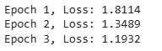
      - With: 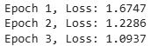
    - I used a linear function because batch normalization followed by a linear function (I used ELU) allows for deepening the image array without affecting the height and width. This process helps increase the accuracy of the training model.
    - Next came a pooling function. I used max pooling to help reduce dimensionality (discussed further in section E2E).
    - Two additional groups of layers follow this same format.
    - I included a flatten function to prepare the image for a linear function layer. Flattening takes the image array and flattens it into one line rather than a square. This step is necessary for a linear function to read the information correctly. I have one hidden linear function, and my output function is also linear, so flattening was used to prepare for those steps.
    - The next group includes a linear function, dropout function, and batch normalization (1D). This is followed by one more ELU function. The dropout function is used randomly to randomly select neuronal output to ignore during the training process. Using a dropout function helps prevent overfitting in the model.
    - The output layer is a linear function with 12 outputs. This provides the categorization of the image, as there are 12 categories. Whichever category the image falls into will be denoted with a 1, while all other categories will have a 0 as their output.
  - Nodes per layer: I wanted to include at least one hidden layer, and since this is a complicated task, I included three hidden layers to increase accuracy in my model.
    - My input layer has 3 inputs, which means it needs 3 nodes. Each input requires a separate node to process the information.
    - The output layer has 12 layers (12 categories), so it needs 12 nodes.
    - I also have 3 hidden layers:
      - Convolutional layer with 16 inputs, so 16 nodes.
      - Convolutional layer with 32 inputs, so 32 nodes
      - Linear layer with 64 inputs, so 64 nodes.
    - Total number of nodes in model = 127
  - Total number of parameters (weights, bias): Since I have 3 hidden layers, I have many parameters. Each layer includes a max pooling function to help decrease dimensionality. Increasing the number of parameters helps to increase the accuracy of the model. More layers used to process the image information means more precise information about the input image and, therefore, should lead to a more accurate model for categorization.
    - I have over 8 million parameters in my model. If I had more computing resources, I would likely add an additional hidden convolutional layer for more accuracy.
    - I calculated the total number of parameters in my model using sum(p.numel() for p in model.parameters() if p.requires_grad). Total = 8223320.
    - To manually calculate the weights, I used the following: weight = (out_channels * filter_size * filter_size * in_channels) + out_channels
    - My model is as follows:
self.model = nn.Sequential(
# convolutional layer 1 (tensor 3x128x128 -> 16x64x64)
nn.Conv2d(in_channels=3, out_channels=16, kernel_size=3, padding=1),
nn.BatchNorm2d(16),
nn.ELU(),
nn.MaxPool2d(kernel_size=2, stride=2),
nn.Conv2d(16, 32, 3, padding=1),
nn.BatchNorm2d(32),
nn.ELU(),
nn.MaxPool2d(2, 2),
nn.Conv2d(32, 64, 3, padding=1),
nn.BatchNorm2d(64),
nn.ELU(),
nn.MaxPool2d(2, 2),
nn.Flatten(),
nn.Linear(64 * 16 * 16, 500),
nn.Dropout(0.5),
nn.BatchNorm1d(500),
nn.ELU(),
nn.Linear(500, num_classes))
      - In the first convolutional layer the weights would be 16x3x3x3+16 = 448
      - Convolutional layer 2 = 32x3x3x16+32=4640
      - Convolutional layer 3 = 64x3x3x32+64=18946
      - Linear layer 1 = (64x16x16+1)x500=8192500
      - Linear layer 2 = (500+1)x12=6012
      - Total weights = 8222546
  - Activation functions:
    - Activation functions are used to help reduce overfitting. Convolutional layers add dimensionality because of the large number of layers created. Higher dimensionality causes the need for more parameters, which can cause overfitting. Pooling layers help reduce this dimensionality. I used max pooling, which places a window over each feature layer and outputs the maximum value within that window. This allows our feature map size to be reduced in width and height. Max Pooling is often used for image classification because it is better at noticing image details.
    - After using max pooling, I used the exponential linear unit (ELU) activation function. Like ReLU, ELU is less computationally expensive than tanh and sigmoid. The main difference is that ELU slowly becomes, whereas ReLU becomes smooth sharply. ELU can also produce negative outputs. One con is that it can cause the activation to blow up because the output range is [0, inf]. My model did not have problems in this area, so this function worked well for me.
- Discuss the backpropagation process:
  - Loss function: I used cross-entropy loss because I use multi-class classification. I would have used binary cross-entropy loss if I were using binary classification.
  - Optimizer: I used the Adam optimizer. This optimizer is better suited for image classification neural networks than others as it is efficient and tends to be more accurate. I experimented to determine the optimal learning rate (see below).
  - Learning rate:
    - I used the exponential learning rate scheduler to optimize the learning rate. With just the Adam optimizer, I had a loss from 1.67-1.81. Adding the scheduler brought the loss on the first epoch down to 0.97 in an initial experiment.
    - I also used a random grid search to look for the best learning rate (for optimizer) and gamma levels (for scheduler):
    - # Create random grid of learning rate and gamma
    - min_lr = 0.001
    - max_lr = 0.01
    - n_grid = 20

    - # Sample learning rate log samples
    - lrs = 10**(np.random.uniform(np.log10(min_lr), np.log10(max_lr), n_grid))
    - # Uniformly sample gamma rate
    - gamma = np.random.randint(5, 9, n_grid) / 10

    - # Plot grid
    - _ = plt.scatter(lrs, gamma)
    - _ = plt.xscale("log")
    - 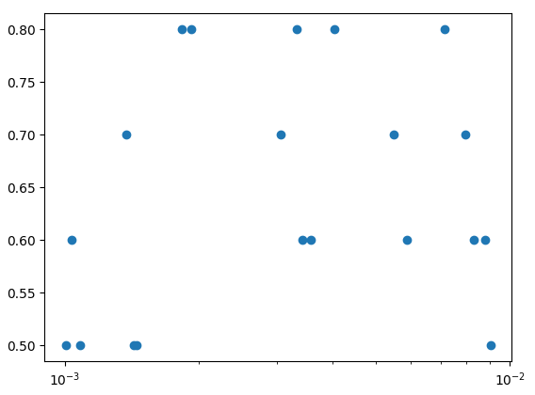
    - I used the results of the random grid search experiment to determine the final model parameters and used that model to run the test. 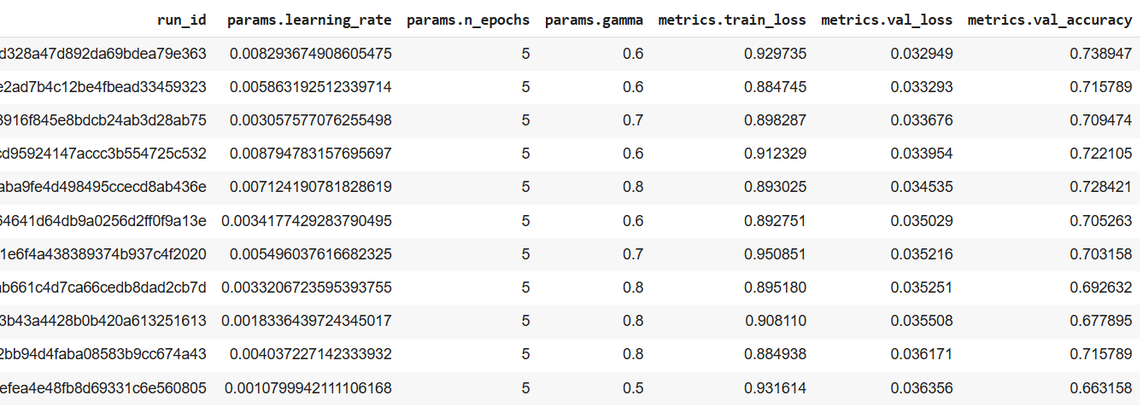The best parameters were gamma = 0.6 and learning rate=0.008.
  - Stopping criteria: I implemented a stopping class that waits 3 epochs to stop if there is no improvement. If the model continues training with no improvement, overfitting will occur, so it needs to be prevented:
    - class EarlyStopper:
def __init__(self, patience=1, min_delta=0):
self.patience = patience
self.min_delta = min_delta
self.counter = 0
self.min_val_loss = float('inf')

def early_stop(self, val_loss):
if val_loss < self.min_validation_loss:
self.min_validation_loss = validation_loss
self.counter = 0
elif val_loss > (self.min_validation_loss + self.min_delta):
self.counter += 1
if self.counter >= self.patience:
return True
return False
    - early_stopper = EarlyStopper(patience=3)
if early_stopper.early_stop(val_loss):
print ("We are at epoch:", epoch)
break
    - I also completed an experiment with 50 epochs of training to determine the best combination of low training and validation loss and high validation accuracy.
- Confusion matrix:
  - # Build confusion matrix
predicted_labels = np.argmax(preds, axis=1)
cf_matrix = confusion_matrix(actuals, predicted_labels)
df_cm = pd.DataFrame(cf_matrix / np.sum(cf_matrix, axis=1)[:, None],
index = [i for i in categories],
columns = [i for i in categories])
plt.figure(figsize = (12,7))
sn.heatmap(df_cm, annot=True)
plt.savefig('cf_matrix.png')
  - Confusion matrix screeshot: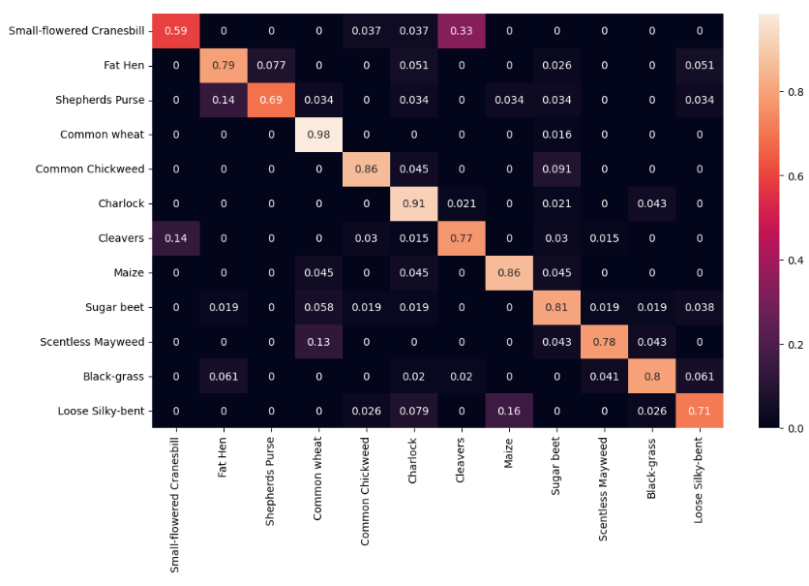
  - The confusion matrix shows how well each class performs in my model. I can see that the small-flowered cranesbill performed the worst, and the Charlock performed the best. This tells me that the classes are not performing at the same level throughout the data.

Part IV: Model Evaluation

F: Model Analysis
- Evaluate model training process and outcomes:
  - Stop criteria:
    - I chose 34 epochs based on an experiment I ran to determine the optimal number of epochs to use. This is discussed further in section 2. The screenshots below show the levels I used to decide on 34 epochs. I wanted as high validation accuracy as possible while keeping validation loss down for both the training and validation sets. While there is a slight increase in training loss between epochs 33 and 34, there is also an increase in accuracy. The training loss increases slightly, but the validation loss goes down, and accuracy goes up in the same place, so I chose this point as the best outcome considering all three measures. In the final training epoch, the training loss was slightly higher than the minimum (0.618 vs. 0.589), the validation loss was at its lowest point, and the validation accuracy was at its highest point.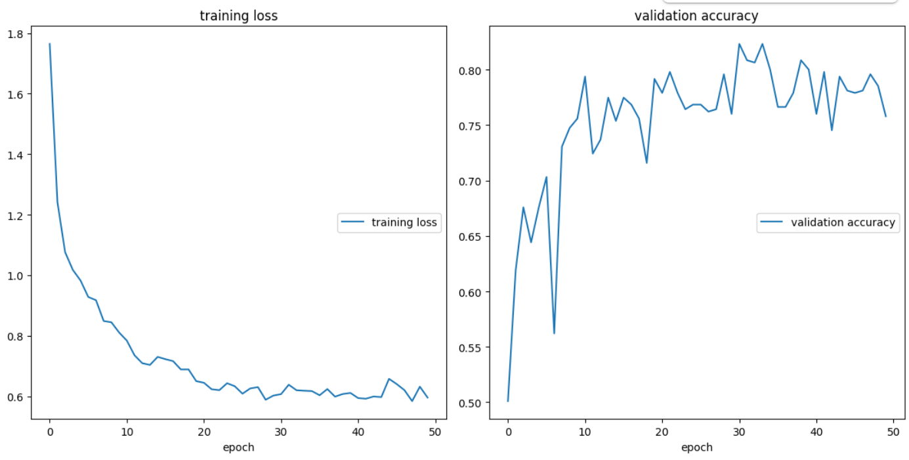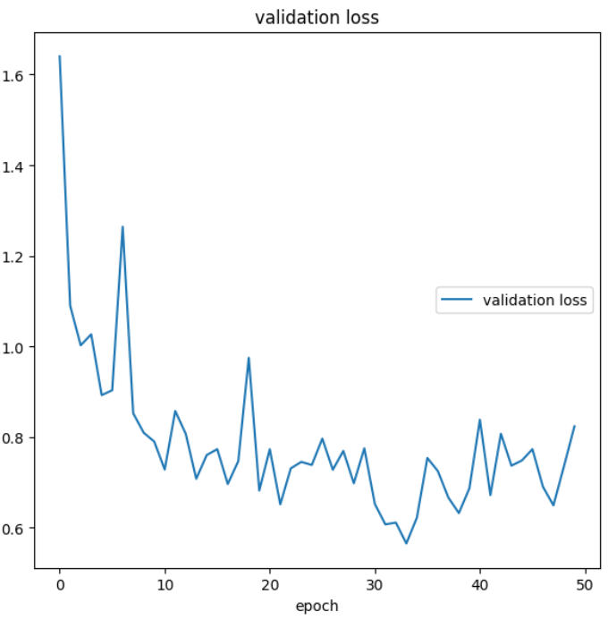
    - Final training epoch using 34 epochs to train model: 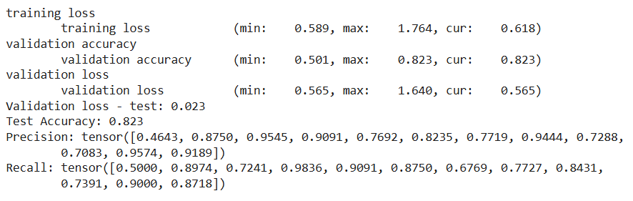
  - Training vs. Validation data:
    - On the final epoch of training for the model, the training loss was: 0.618
    - The validation loss was: 0.565
    - Accuracy cannot be used to compare training and validation, as the training process does not create predictions.
  - Visualization of training and validation loss: 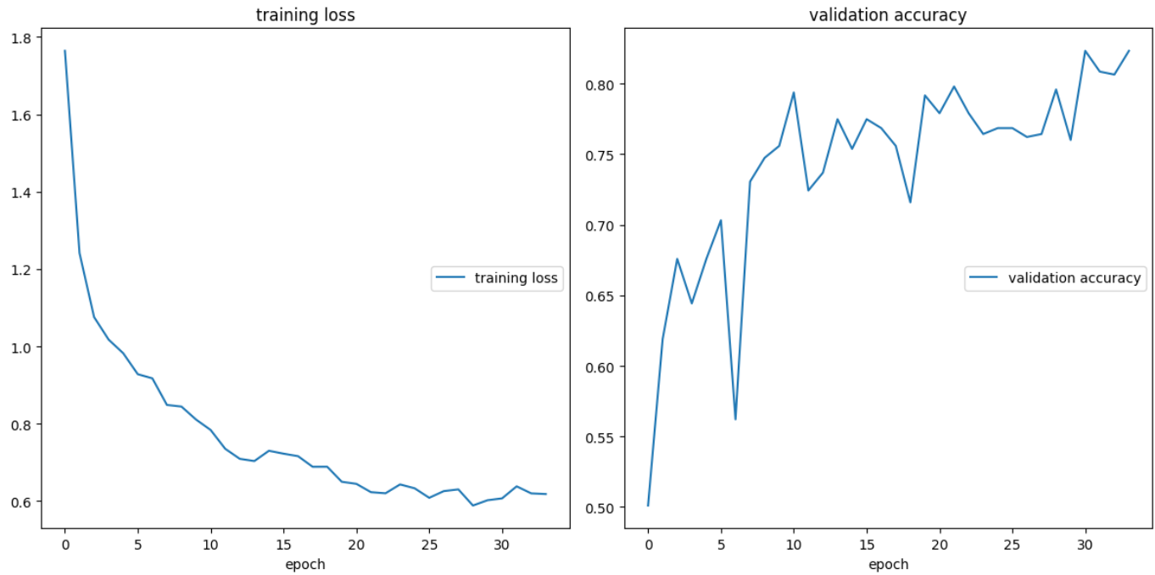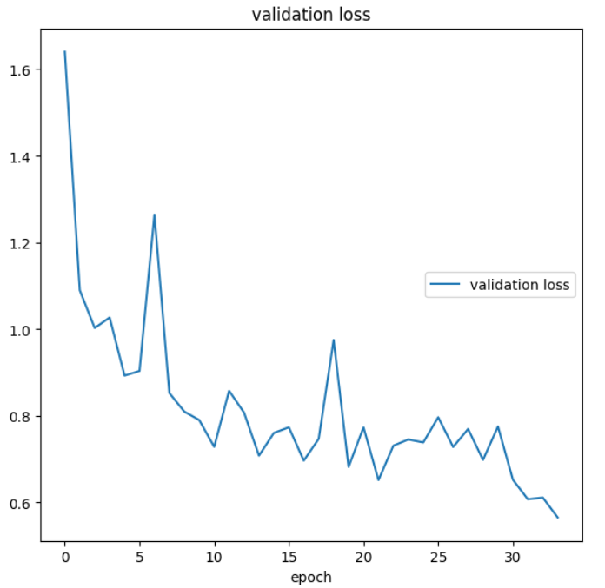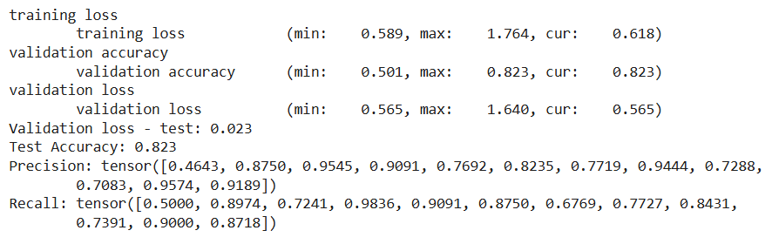
- Fitness of model: to address model fit, I used an experiment where I ran 50 epochs of the model and used validation accuracy and training and validation loss to determine the optimal number of epochs based on those metrics (as discussed in section 1a). 34 epochs is what I used (higher validation accuracy), but an argument could have been made for 31 or even fewer epochs. I used loss and accuracy to measure the performance of the model, and the validation loss in a test run during training for the model was 0.023, and the loss on the actual test set was 0.025. This suggests that the model is well-fit. The accuracy of the test run during training was 0.823, and on the test data, it was 0.811. While I suggest trying to create a model that is even more accurate (likely by adding more layers), these numbers suggest that the model does not overfit the training data. The accuracy metrics would have a larger difference if the model showed overfitting.
- Predictive accuracy of trained network:
  - trained network:
  - Test: 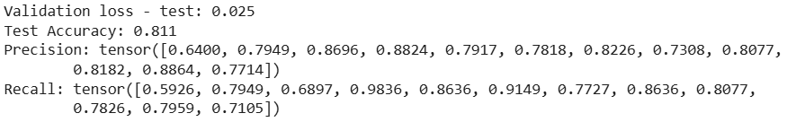
  - You can see that the test accuracy from the trained model to the test data was slightly different, 0.823 vs. 0.811. The precision and accuracy metrics also varied from the validation data to the test data (see precision and recall tensors).
  - The validation loss from the final epoch in the model training was 0.565, with a test run on the validation data at 0.023. The test run had a validation loss of 0.025, which is not much different from the test run on the validation data.

Part V: Summary and Recommendations

G: Summarize Results
- Code used to save trained network within the network:
if val_loss_min is None or(
(val_loss_min - val_loss) / val_loss_min > 0.01
):

# Save weights
filename = os.path.join(save_path, 'best_val_loss.pt')
torch.save(model.state_dict(), filename)

val_loss_min = val_loss
- Functionality of neural network:
  - Impact of network architecture: the more parameters in a neural network, the more computing resources are required to run the model. If I had unlimited computing resources, I would have added another hidden layer or two to increase the model's accuracy.
  - Parameters: I did use an experiment to determine the parameter setting for the model, so I am confident that they were good settings to use. I would have preferred to run the experiment with more epochs to see if that changed anything, but my computing resources and time would not allow it.
- Effectiveness of the model at addressing the business question: Can a neural network be trained to identify images of crop seedlings and help separate them from weeds?
  - Accuracy: the accuracy of the model on the test data was 81%. A model with an accuracy of more than 70% is typically considered satisfactory for a model. This model performs well at 81% accuracy, and I believe that additional layers could be added to increase accuracy even more. The model performs better in some categories than others:
If the accuracy on the first category (small-flowered cranesbill) was improved, we could be more confident in the model’s performance. Overall, we adressed the business question by building a model that can classify seedling images with 81% accuracy, and that is a good result.
- Lessons learned and how to improve the model:
  - I learned a lot through this process, and my main takeaway is to simplify wherever possible. The next time I create a model, it will be as simple as possible, without the extra classes where it makes sense. The more complex the model becomes, the longer it takes to process, and the more complex the troubleshooting process becomes.
  - I recommend running more epochs in the experiment to determine the optimal parameters (gamma and learning rate) if computing resources allow it. One could also try various schedulers to determine which was the most effective at decreasing the loss.
  - Changing the category weights could also help improve the model by helping increase accuracy on the categories where it was lower.
- Recommended course of action: I recommend implementing this model cautiously. Since the goal is to help keep as many crops thriving as possible, increasing the accuracy would be ideal, even though 81% accuracy is a good level on a model. The model could be run with additional layers to see if that improves the accuracy, and if so, then implemented fully.

H: Web Sources to Help with Code
Matplotlib. (n.d.). Matplotlib — Visualization with Python. Retrieved February 18, 2025, from https://matplotlib.org/
Bernecker, C. (2021, January 27). How to create a confusion matrix in PyTorch. Christian Bernecker. Retrieved February 18, 2025, from https://christianbernecker.medium.com/how-to-create-a-confusion-matrix-in-pytorch-38d06a7f04b7
Jain, S. (2021, June 12). Countplot using seaborn in Python. GeeksforGeeks. Retrieved February 18, 2025, from https://www.geeksforgeeks.org/countplot-using-seaborn-in-python/
PyTorch. (n.d.). Transforming and augmenting images — Torchvision main documentation. PyTorch. Retrieved February 18, 2025, from https://pytorch.org/vision/main/transforms.html

