Data Dictionary for Heart Attack Prediction Project
Original data and data dictionary were retrieved from the Centers for Disease Control (2023). The charts used are from the CDC data dictionary (CDC, 2023).
Description of variables in heart_pred_clean data set used for analysis.
index: number of rows in data set
male: binary classification of the biological sex of the participant. 1 = male, 0 = female.
age: age by group based on CDC grouping. Categorical variable with values of 1 – 13. The AGE variable was not available in the data set from download, likely due to protecting patient information.
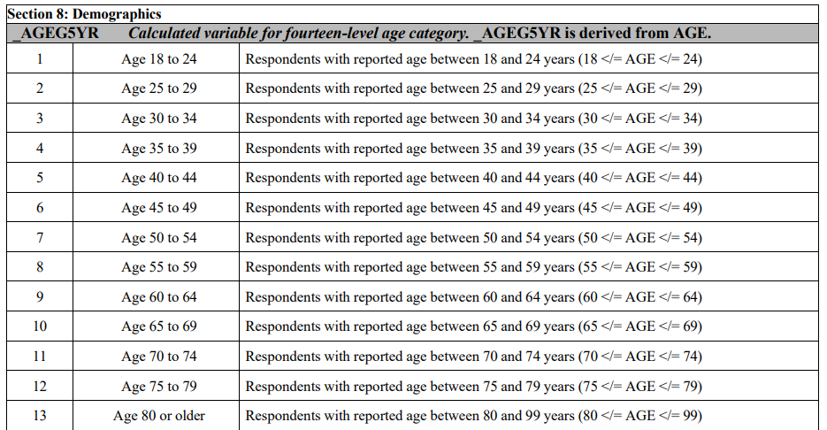
gen_health: categorical variable with values from 1 – 5. Based on CDC groupings. 1 = excellent health, 2 = very good, 3 = good, 4 = fair, 5 = poor health.
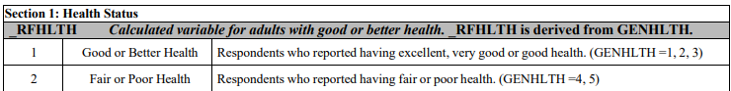
BMI: column created from height and weight columns. Continuous variable. Calculated using: df$weight*0.453/(df$height*0.0254)**2
smoker: categorical variable with values from 1 – 4. Based on CDC grouping. 1 = current smoker (smokes daily), 2 = current smoker (smokes some days), 3 = former smoker, 4 = never smoked.
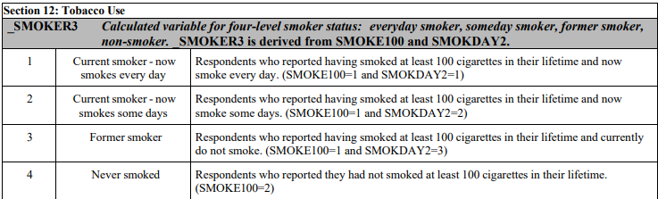
ecig_use: binary variable. 1 = currently using e-cigarettes, 0 = not using.
alc_last30: binary variable. 1 = participant reported having alcohol within the last 30 days, 0 = no alcohol use in last 30 days.
ex_last30: binary variable. 1 = participant reports having any physical activity or exercise in the last 30 days, 0 = no reported activity in the last 30 days.
hrs_sleep: continuous variable. Number of hours participant reports sleeping per night. Min of 4, max of 16 after data cleaning.
mi_chd: binary variable. 1 = patient has reported myocardial infarction (MI, heart attack) or diagnosis of coronary heart disease (CHD), 0 = no report of MI or CHD.
Original Data Source and Dictionary:
Centers for Disease Control. (n.d.). 2022 BRFSS Survey Data and Documentation. CDC. Retrieved March 7, 2025, from https://www.cdc.gov/brfss/annual_data/annual_2022.html
Centers for Disease Control. (2023, September 29). Calculated Variables in the 2022 Data File of the Behavioral Risk Factor Surveillance System. CDC. Retrieved March 13, 2025, from https://www.cdc.gov/brfss/annual_data/2022/pdf/2022-calculated-variables-version4-508.pdf

