Heart Risk Prediction Through Logistic Regression

Research Question
According to the CDC (Centers for Disease Control, 2024), heart disease is the leading cause of death in the United States. Heart disease kills more people each year than cancer does. Since heart disease increases the risk of heart attack, and there is data on whether a patient has had a heart attack (myocardial infarction or MI), I want to create a model that predicts whether someone will have a heart attack or develop coronary heart disease (CHD). If someone is at high risk of a heart attack, they likely have coronary heart disease, and vice-versa. The treatment of heart disease and heart attack increases medical costs. If we can predict whether a patient is at high risk for a heart attack or CHD, can it be addressed and prevented, which would decrease costs for the patient and providers?
I will use a public data set (Centers for Disease Control, 2023) to determine whether age, body mass index (BMI), and other health risk factors like tobacco use, sleep, physical activity, and alcohol use have a statistically significant effect on risk of a heart attack. If my hypothesis is correct, meaning there is a statistically significant effect, these patient factors will allow for the prediction of heart attack risk. This information could help identify high-risk patients so that they can implement preventative treatments and lifestyle changes that could ideally help the patient avoid a heart attack and decrease cost and resource use for the patient and healthcare system. The research question and hypothesis for this project are listed below:

Research Question: To what extent do age, BMI, and health risk factors (tobacco use, sleep, physical activity, and alcohol use) affect the risk of heart attack?
Hypothesis: Age, BMI, and health risk factors have a statistically significant effect on heart attack risk.

Data Collection
I downloaded the 2022 Behavioral Risk Factor Surveillance System (BRFSS) data directly from the Centers for Disease Control (CDC) website (Centers for Disease Control, n.d.). The biggest challenge of using this data is that it comes in a ZIP file as an XPT type file. I extracted the file and then loaded it into R Studio using read_xpt from the haven package to load and use the data.
One advantage of downloading a public data set is that it is readily available to anyone. Since it is public data, it has already had any identifying information of participants removed, so confidentiality is not an issue. One disadvantage of using a public data set is that if there are missing data points, you cannot reach out to determine what the values should be. In this case, I either will not be able to use rows that have NA in them, or I will have to replace the NA values with another value (possibly the mean). Since this is such a large dataset, I will likely remove the NA values because I want the model to be as accurate as possible.

Data Extraction and Preparation
I used the read_xpt() function from the haven package to load the data because the file was in XPT format, this is the format used to transfer CDC data. It is easy to load into SPSS or SATA programs but is not a format that is easily transferable to a CSV file.
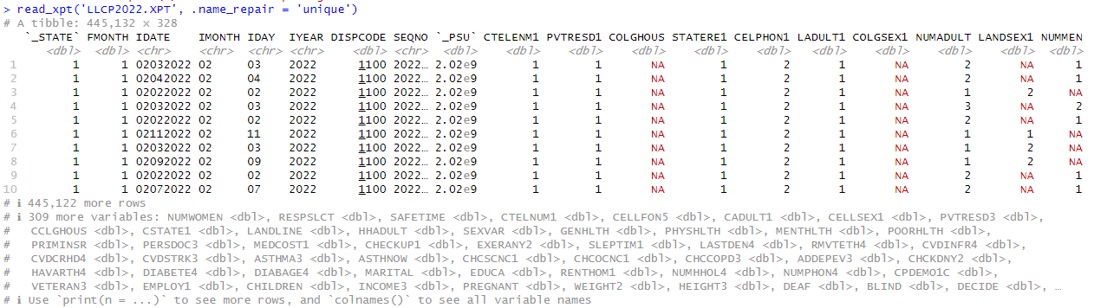
The original dataset has 328 variables, so I had to select only the columns that will be used in training the model. First, I checked the column names using the colnames() function, then I created a data frame that includes only the columns that I need to use to create the model. I used the data file from the CDC (Centers for Disease Control, 2023) to determine which columns I would be using.
To view the column names, I used the colnames() function in the base R package. This function does not require the addition of a package, so that is an advantage. One disadvantage to this method is that I cannot see the type of data in each column.
I used the column selection method to choose the columns with the variables I need for this model. Since I was creating a data frame from an existing data frame, this method allows me to select only the columns I wanted and assign them to the new data frame. It is a quick and easy method, which is an advantage.
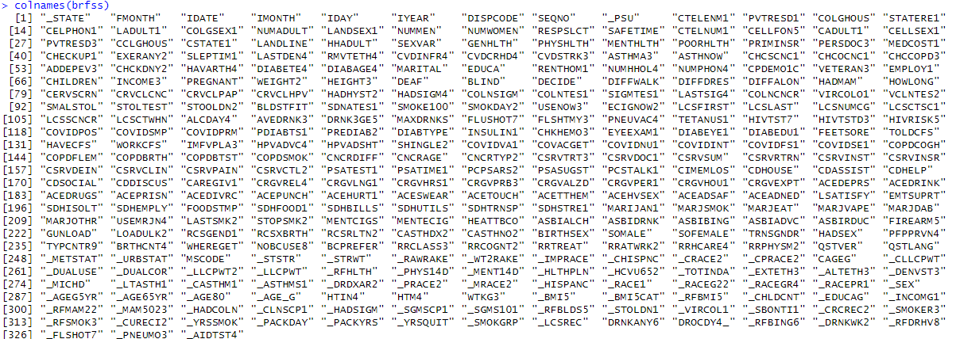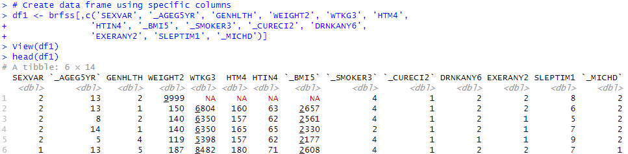
I checked the summary of the data frame using the summary function. This function is useful in that it provides the descriptive statistics of each column, which is an advantage as I can use this information to further explore my data.
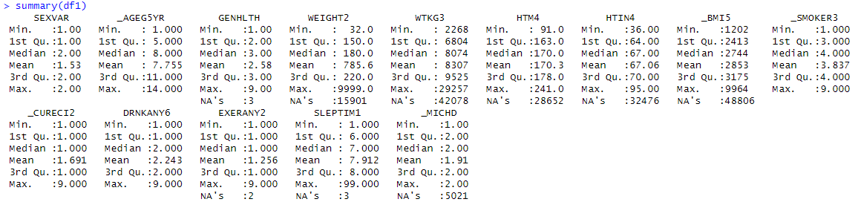This data set contains a lot of NA values. I know that this dataset started with 445132 observations:
Since I started with such a large data set, I needed to remove the rows that contain NA values. Before I removed the NA values, I needed remove a few variables. The _BMI5 column had the largest number of NA values, and it is a column that is derived from WTKG3 and HTM4. It is calculated by dividing WTKG3 by HTM4². Since the WTKG3 column and _BMI5 columns are missing decimal points anyway, and I can figure the BMI using weight in pounds and height in inches, I removed the HTM4 (height in meters), WTKG3 (weight in kilograms), and _BMI5 columns, then used HTIN4 (height in inches) and WEIGHT2 (weight in pounds) to calculate the BMI.
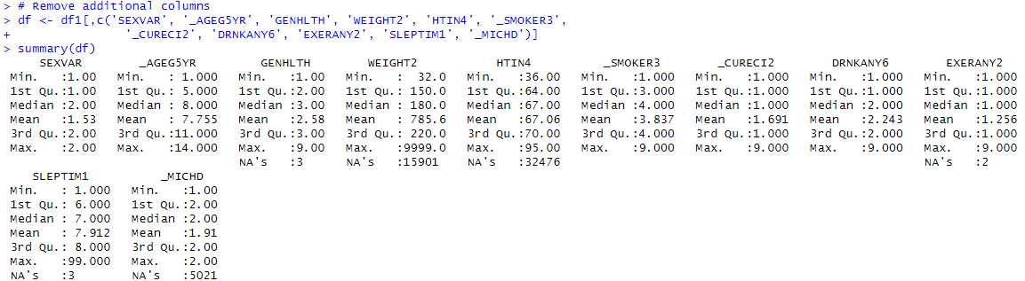Before I calculated the BMI, I needed to remove NA values. I used the na.omit() function to achieve this step. This function removes any row that contains an NA value in the data frame. One advantage of this method is it quickly removes the rows with the NA values. One disadvantage is that I cannot go through these values to ensure that they are not necessary rows for the data set.
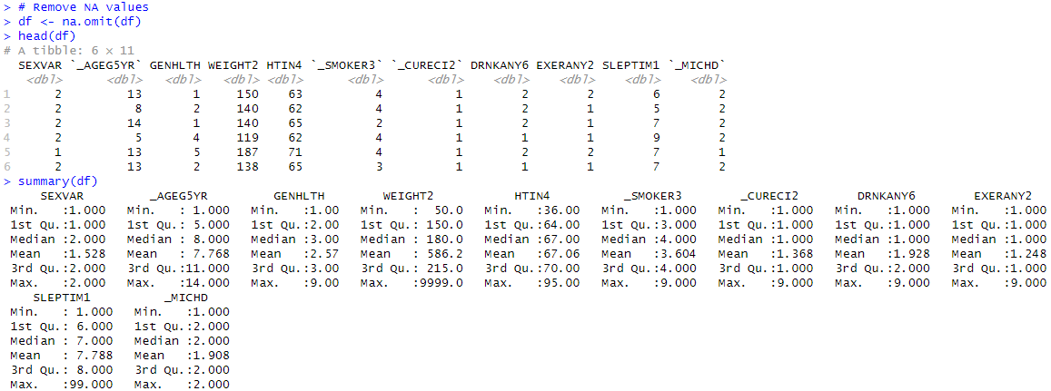
I could see that my weight column still had a max of 9999. That value is an outlier, so I needed to check my data set for additional outliers before moving on to calculations. To do this I used a boxplot visualization. This will give the mean, quartile ranges, and outliers for each variable. Boxplots are a very useful visualization tool because they provide the descriptive statistics of each variable. This is an advantage because this allows for identification of outliers, as well as comparing the descriptive statistics of each variable. One disadvantage of using boxplots is that if your variables are on different scales, you will have to plot them separately. I also renamed the columns for ease in programming using the colnames function. Since I did not create this data set, I was not familiar with all of the methods in naming the variables, so I renamed them for use in this project.
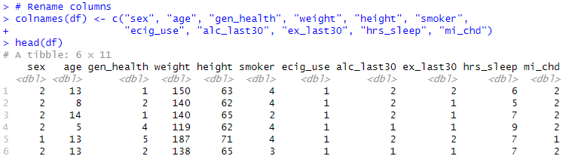
My boxplot of the whole dataset showed me that weight has the most outliers. This is likely due to the way the data was entered. I therefore needed to plot weight separately and then look at the rest of the variables
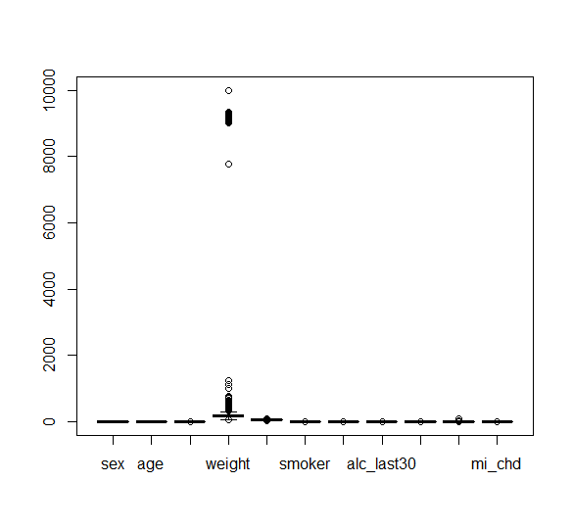

The boxplot of weight showed that more exploration is needed to determine outlier values:
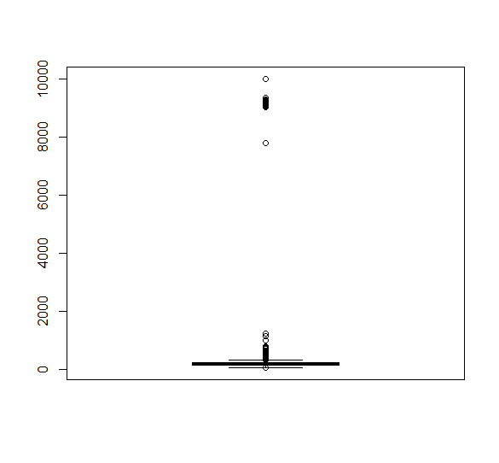
I created a boxplot of all variables except weight:
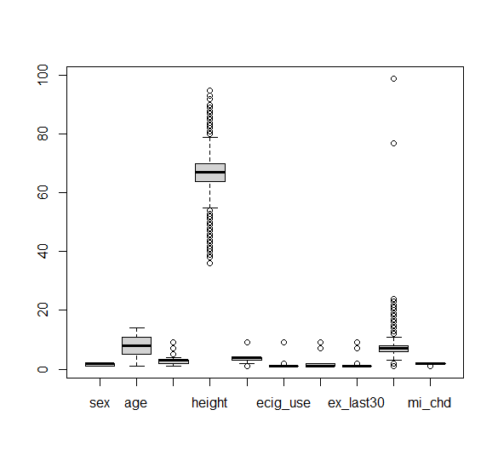
From this visualization I could see the hrs_sleep variable has outliers, and I needed to investigate height further to determine whether there were true outliers, or just a wide range of heights found in the study participants.
I wanted more information on the weight category, so I checked the values, and there are a lot of values over 9000, which would not be accurate for a human. It may be that these values should have had a decimal, it may be that these values meant unknown or not provided, and it may be that they were an error, and since I am using a public data set, I do not know the answer to why these values are there. I started by removing any values over 998. I used the filter() function to remove data points based on the specific value. This function will remove rows with values outside the range I specify. One advantage is this is another quick step to remove rows. One disadvantage is that, again, I cannot preview the rows first to make sure that they are not valuable data points. I moved forward despite the disadvantage because I was starting with a very large data set. I used the unique() function to view the unique values in the column. This gave me an idea of what the data points look like, which allowed me to make better decisions about whether to remove or keep the data.
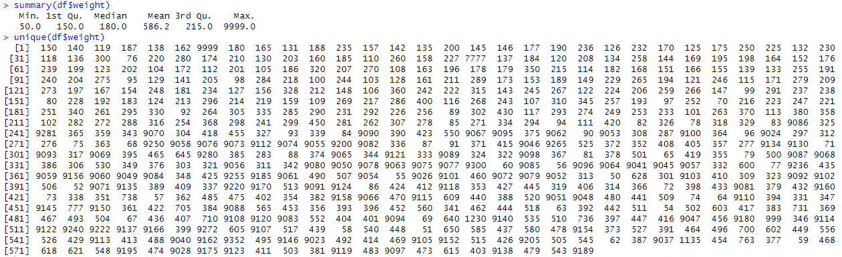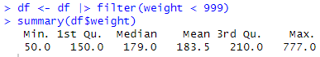
I also had a minimum of 50 pounds, which would be a very low weight for an adult. I removed weight values under 80 pounds using the filter function in case the lower entries were in error.
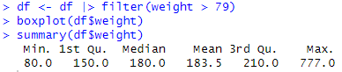
This still left me with a max weight of 777, which would be quite high for a person, but not impossible. The mean was now 183.5, which is more reasonable than a mean of 586.2. I created another boxplot just to see how it looked after removing these outliers. This looked more like a variable like weight, where there can be outliers that are actually part of the data.
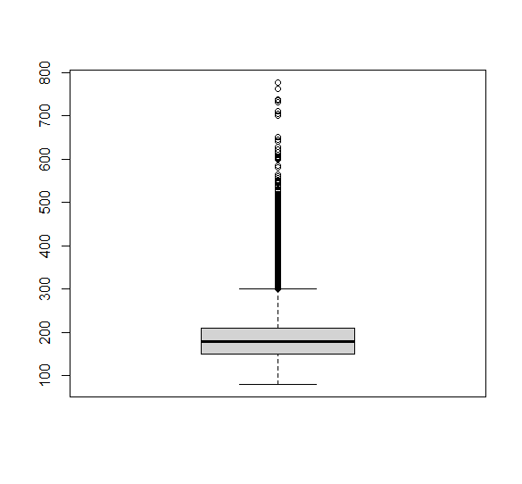
I wanted to further investigate the hours of sleep column.
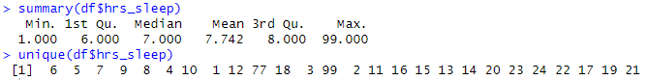
I could see that I have a max of 99 hours, and there were other values above 24 hours. There are only 24 hours in a day, so having an amount larger than that does not make sense. It was difficult to know why there are values of 18 – 24 hours for sleep, as that would be a very large amount of sleep each day. I started by removing any number above 24, as that is not a possibility.
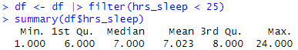
These numbers looked more reasonable, but I wanted to see how many values were at the maximum. I used the table() function to tell me how many rows of each value are in the column. This can help identify a value that has many entries which can indicate either a data entry reason for the value, or that there were many entries of that value (you can see that seven and eight hours of sleep have very large numbers of entries).
My data set still had 386,275 observations, and since someone sleeping all but 4 hours of the day is not typical and could indicate other health issues, I wanted to narrow this down further. I removed any rows with values over 16 hours. I also know that humans cannot survive on one hour of sleep per night. According to Dr. Olson from the Mayo Clinic (Olson, 2025), adults need at least seven hours of sleep per night for good health. Stephenie Slahor reports that "The bare minimum of sleep needed to live, not just thrive, is 4 hours per 24-hour period. Seven to 9 hours of sleep are needed for health, renewal, learning, and memory” (Slahor, 2008, p. 58). Because four hours is reported as the bare minimum number of sleep hours needed, I removed values less than four.
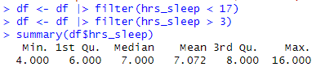
This still left me with 380,767 observations.
Next, I investigated the height column. I used the summary() and table() functions again.
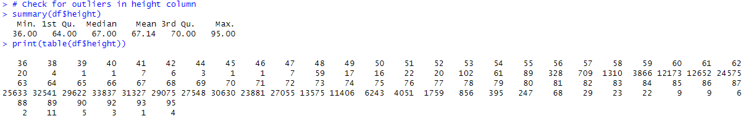
The height is in inches. I know that 84 inches would be seven feet tall. 95 inches is nearly eight feet tall. There were only 26 values over seven feet tall and I removed them. According to the Mayo Clinic, “Dwarfism generally is defined as an adult height of 4 feet, 10 inches (147 cm) or less” (Mayo Clinic, 2024). Since dwarfism can include other health complications, I removed data points under 59 inches.
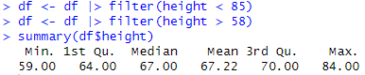
After filtering these values out, I still had 378,017 observations of the variables. This is still a very large data set. I wanted to view the summary of the whole data frame again to check for additional columns that need attention.
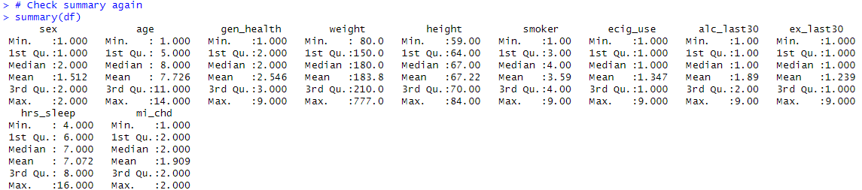
The sex column is a binary column, and I will adjust those columns later. This also applies to ecig_use, alc_last30, and ex_last30. My target variable is mi_chd (myocardial infarction or coronary heart disease), which is also binary.
The age column is broken down into categories, so the max being 14 is part of the data entry process for this category. I do know, however, that 14 means “unknown” or “not answered” (CDC, 2023).
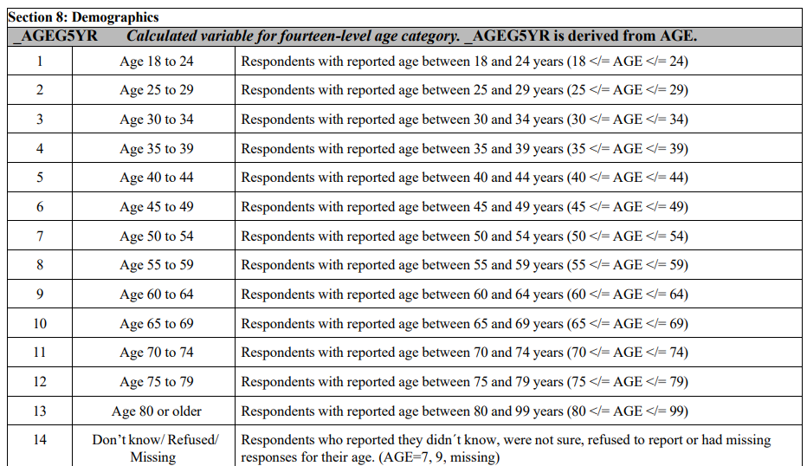
The gen_health column is also categorical base on a range of 1-5. The value 9 means “unknown” (CDC, 2023).
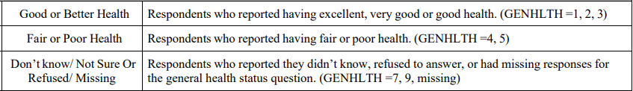
The smoker column is categorical as well (CDC, 2023).
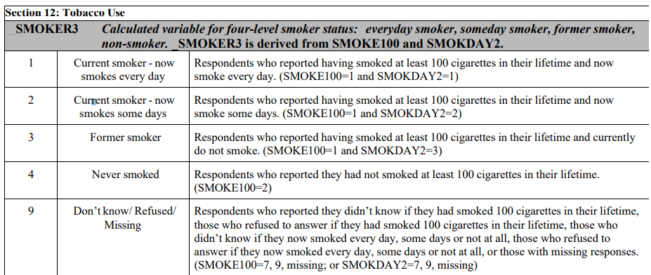
I checked each of the previously mentioned columns to determine how many rows include unknown data. To do this, I used the table() function again.
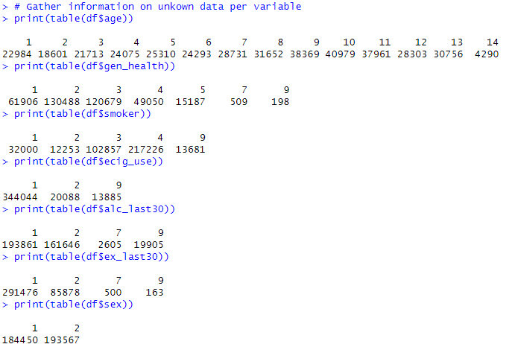
After this process I still had 347,730 observations in my data set.
For age, the value 14 means unknown. For all other variables, a value of 7 or 9 is an unknown value. Because I am fortunate to have so many observations, I removed these data points as well. I again used the filter() function to accomplish this task. Then I checked the summary of the data frame to make sure my maximum values were correct.
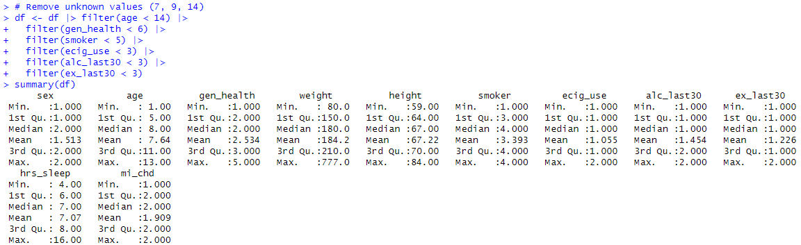
After having removed values where necessary, I created the BMI column. To determine the BMI from my existing data, I used the following equation: BMI = weight * 0.453 / (height * 0.0254)². I took the weight in pounds x 0.453 to get weight in kilograms. I took height in inches x 0.0254 to get height in meters. BMI = kg / (meters)².
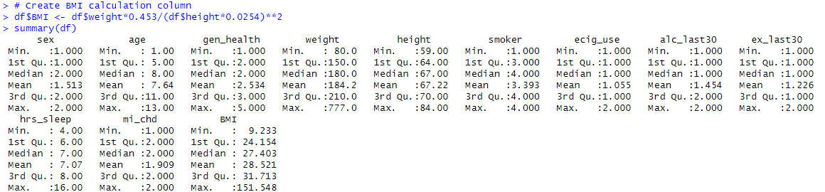
I have several binary variables (ecig_use, alc_last30, ex_last30, mi_chd) that are listed as 1 for yes and 2 for no, so I changed those to being 1 for yes and 0 for no, which is the standard format for binary variables. I also changed the sex column to a binary column and change the name to male, so a value of 1 means male, 0 means female (these were the only two sex options on the survey results I used). I used square bracket delineation for this task (df[]). This simply takes a value in a column and reassigns it to a new value. This is a quick way to change the 2 values to 0. Ecig_use is set to current users = 2, non-users = 1, so I will change this to current users = 1, non-users = 0.
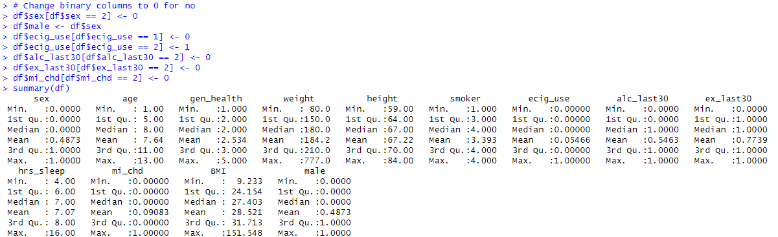
I also removed the height, weight, and sex columns, as these were used to calculate other columns and were no longer necessary.
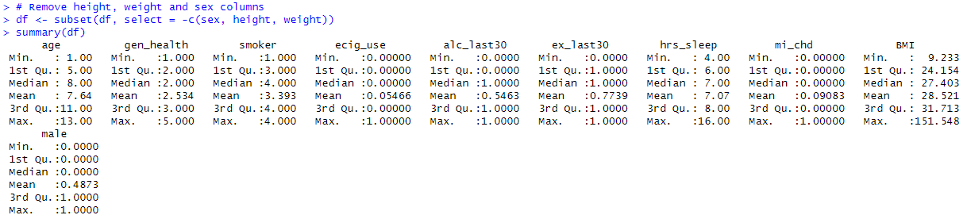
The data was now ready to be saved and used for analysis. I still have 347,730 observations in the data set.

Exploration and Analysis

Exploratory Data Analysis
Before I began the formal data analysis process, I completed exploratory data analysis. I started with data visualization. I used Tableau software to create visualizations of the data. Visualization is a great tool because it helps discover trends and patterns in the data. Tableau is a great tool for data visualization because it has many built-in analysis tools. One advantage of using Tableau is that it includes color palettes that will work for people who experience color vision impairment. One disadvantage is that not everyone knows how to use Tableau, so I will need to provide training or instructions to stakeholders to help them understand how to use the visualizations.
I will also have to go to the Tableau page when presenting the data, or present screenshots. I created a Tableau Story that has 2 dashboards on it. One of the dashboards can be filtered by age group. I used the visualization to explore the data to look for trends. I wanted to start with age and sex, as i suspected that an increase in age will increase risk of heart problems, and I wanted to see if there were notable differences based on sex.
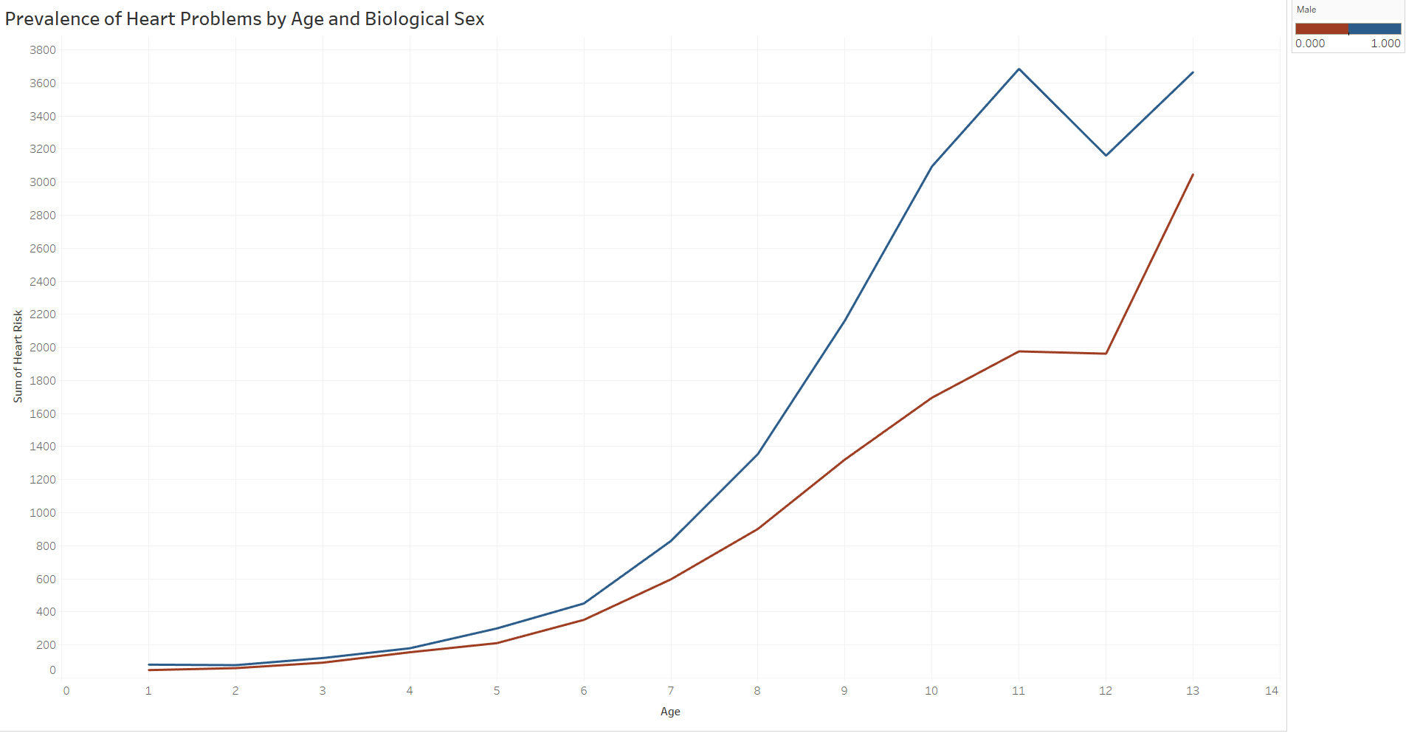
Based on this visualization, more males are prone to having heart problems than females in most age groups. The sum of heart risk is the number of patients that reported either a heart attack or having been diagnosed with coronary heart disease. The data also shows that risk of heart disease increases with age, as expected.
Next, I wanted to visualize the effects of sleep and BMI on heart risk:
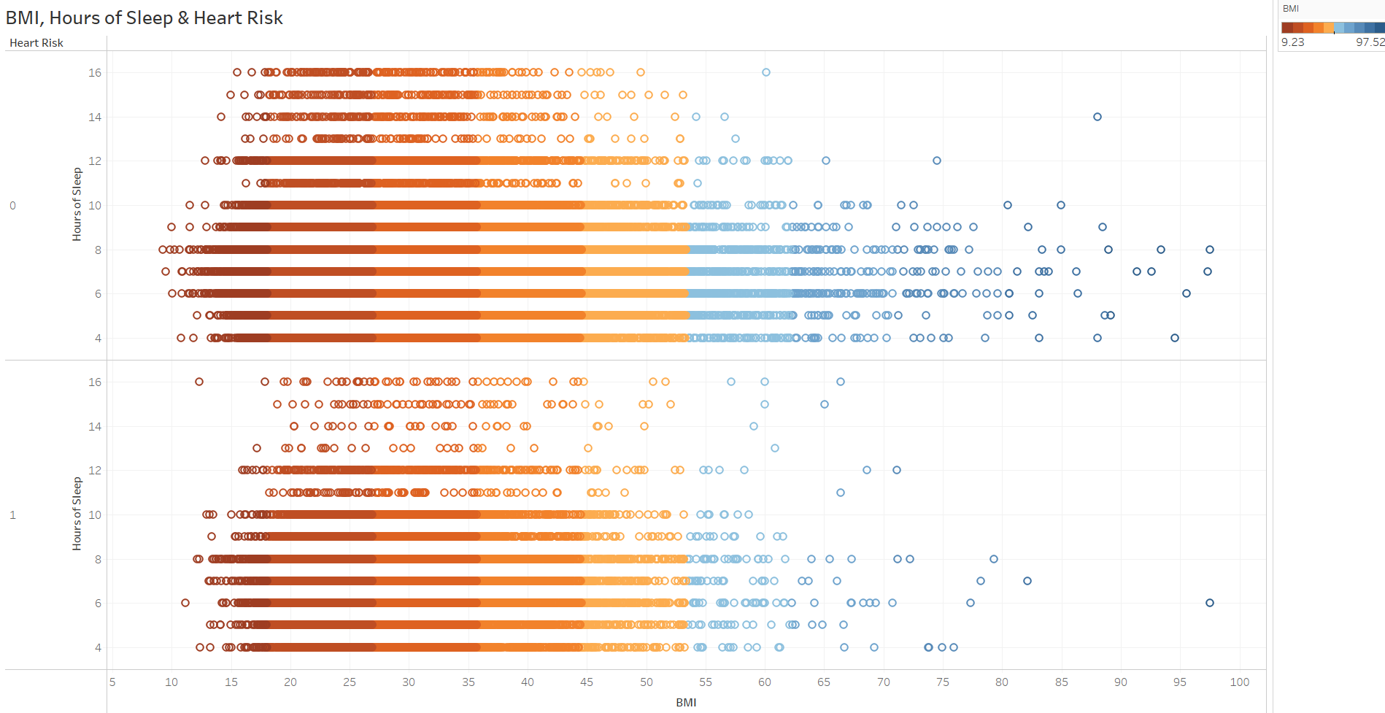There is a trend that patients in the not at-risk group (0) tend to have more data points that fall higher on the BMI scale, which is not what I expected. There are also more data points in higher numbers of hours of sleep in the not at-risk group. I did filter the BMI scale to data points from 0 to 100 for this visual to help with clarity.
I also wanted to examine whether use of substances (alcohol and nicotine) and participation in exercise affected risk:
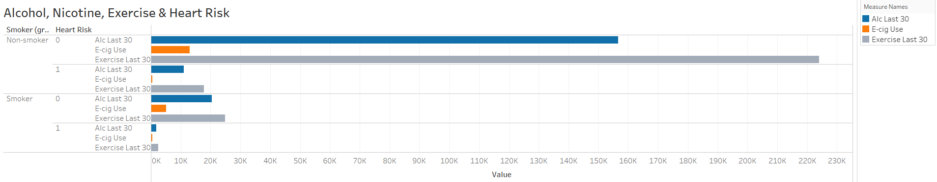
For this visualization, I created a binary grouping for the smoker variable, where participants who reported currently smoking are grouped as smokers, and those who reported not smoking are non-smokers. The group with the highest participation in exercise is the non-smoker, non-risk of heart problems group. All groups have similar proportions of these three behaviors, so there is not a trend that stands out, other than that far more people are non-smokers (traditional cigarettes) than are smokers, and there are by far more participants in the non-smoker no heart risk category than any other.
Finally, I wanted to look at age, general health ranking (1 = excellent health, 5 = very poor health), and how many people were at risk of heart problems. In the following visualization, the lightest shade of blue = 1, the darkest = 5 on the general health scale. The size of each area is determined by the number of patients in the at-risk category (1) for the mi_chd variable.
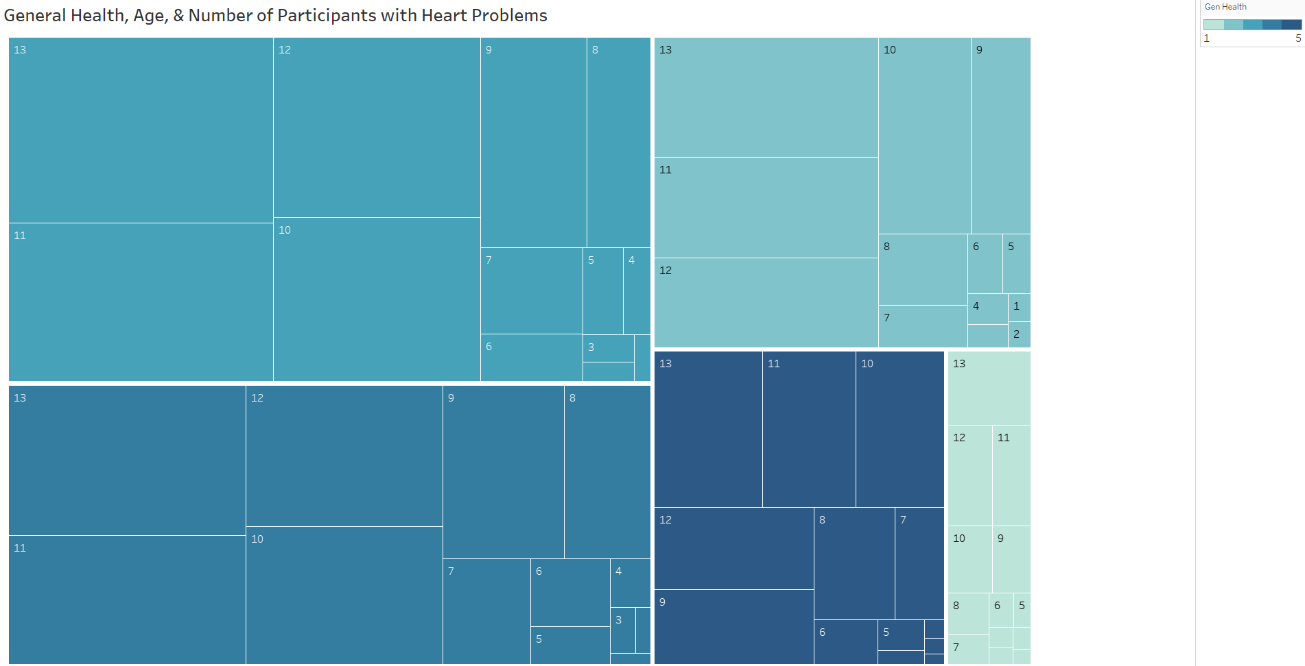
We can see that few people who ranked themselves as having excellent health are in the at-risk category for heart problems. The largest number of patients in the at-risk group are ranked as a 3 (good health). Then 4 is the next largest grouping (poor health). The numbers in each rectangle represent the age groups, the higher the number, the older the patient. The breakdown of the age groupings is listed below (CDC, 2023).
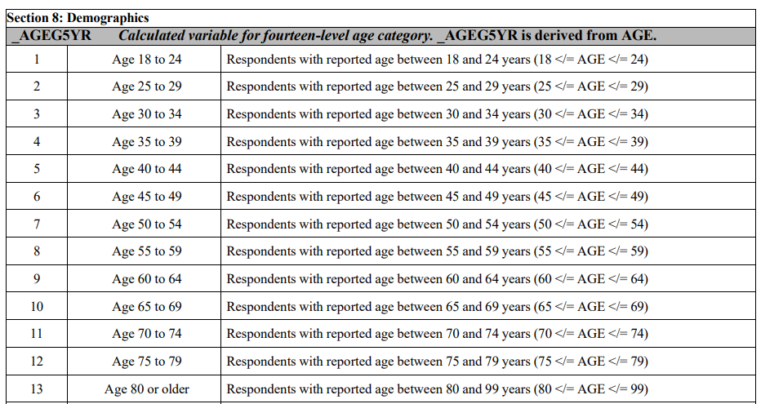
I had previously run the summary of the data frame, which provided the descriptive statistics of each variable. These included the minimum and maximum values of each variable, as well as the mean (average), median (most common value), and the 1st and 3rd quartiles. I previously used this information to help with the data cleaning process. I can also use the information to explore the data further. Descriptive statistics offer the advantage of providing mathematical insights into the data. However, since I have multiple binary variables, the descriptive statistics that the summary provides are not as helpful as they would be if the variables were continuous. This is one disadvantage of using descriptive statistics with categorical data.
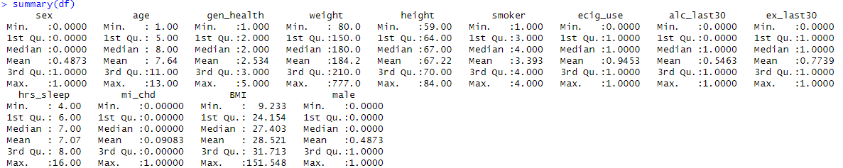
Hours of sleep for example tells me that the average patient reported about 7 hours of sleep per night, and we have a minimum of 4 and a maximum of 16 hours, after cleaning. Recall, though, that originally the column had values from 1 to over 24. The median response for general health category was 2, which represents very good health. This means that the most common response from participants was that they have very good health. The most common response in the smoker column was 4, which means never smoked. The most common response in the ecig_use column was 1, which means currently using e-cigarettes. The majority of people had used alcohol in the last 30 days and reported having exercised in the last 30 days. More of the observations were from female than male participants (median is 0). The median BMI was 27.4 and the mean was 28.5, which are pretty close to each other. Those numbers (27.4 and 28.5) refer to adults in the overweight category (25 – 29.9), according to the CDC (Centers for Disease Control, 2024).
I also wanted to look at correlation between the selected variables, so I created a corrgram to visualize correlation. One benefit of using a corrgram is that it includes categorical and binary variables. One disadvantage is that in viewing correlation, we do not know the cause and effect of that correlation. Just because two variables are correlated, it does not mean that one causes the other, or that one would not change without the other. With this visual, darker blue means stronger correlation and darker pink/red means negative correlation.

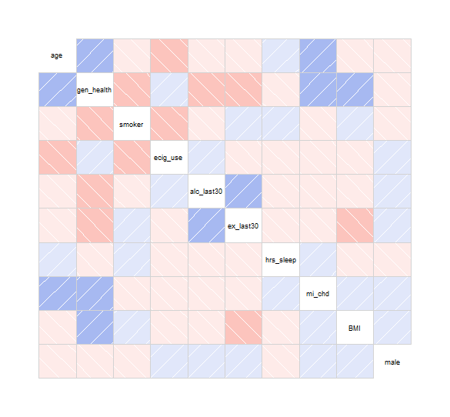
As I looked at this visual, I noticed the correlation between BMI and general health, as well as between the mi_chd column and the general health and age columns. I saw previously that as age went up, more patients reported the presence of heart attack or heart disease, so that correlation is expected. There is also a correlation between alcohol use in the last 30 days and exercise in the last 30 days, which could be interesting from a healthcare perspective. E-cigarette use and smoking are negatively correlated. General health has a negative correlation with smoking, alcohol use, and exercise. The presence of exercise here is strange and will be something to watch as we move into the regression analysis of the data. Based on these insights, I wanted to create more visualizations to further explore the data.
I used histograms to view univariate information (information based on one variable). One advantage to using histograms in this instance is that a histogram shows the number of participants that responded a certain way, so I can see the distribution of the responses of a single variable. One disadvantage is that histograms do not give information about how one variable interacts with another.
I started with biological sex of participants. Since males have a larger prevalence of reported risk, I wanted to see how many males versus females participated in the survey to check that this number is not simply due to more males participating than females. I can see that there are more female participants than male.
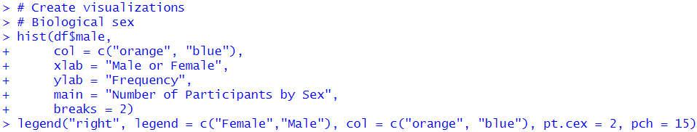
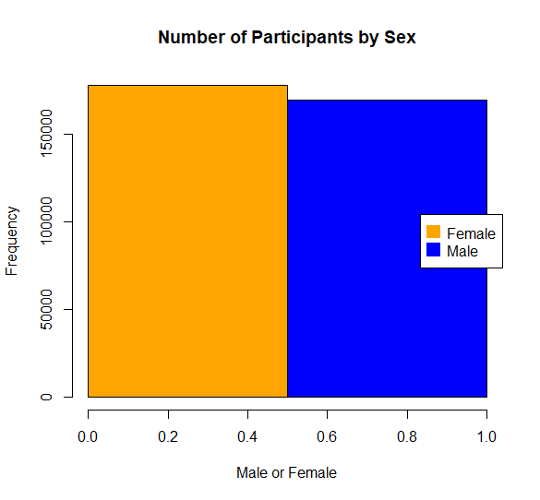
I also wanted to see how many participants are actively using nicotine. I started with whether participants reported using e-cigarettes. I can see that the vast majority of participants reported not using e-cigarettes. I also created a table of the values to examine the numbers in each category.
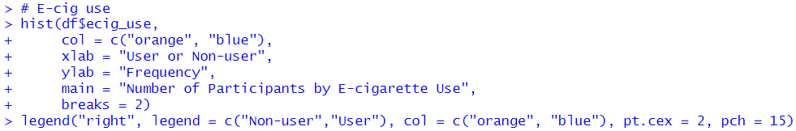
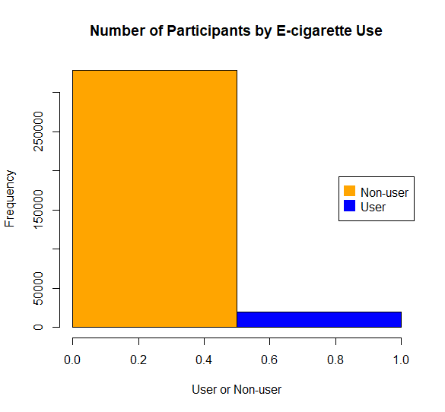
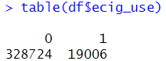
Next, I visualized the data from the smoker column. This column has data listed as values 1 – 4. 1 = current smoker (smokes daily), 2 = current smoker (smokes some days), 3 = former smoker, 4 = never smoked. The visualization showed that the majority of respondents reported currently being non-smokers.
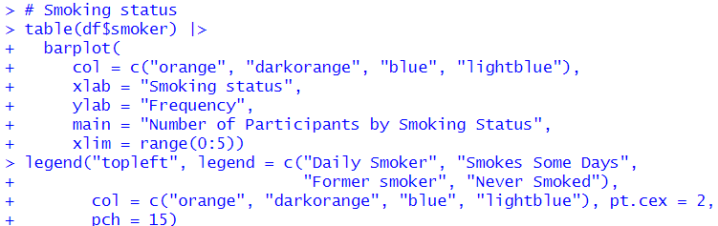
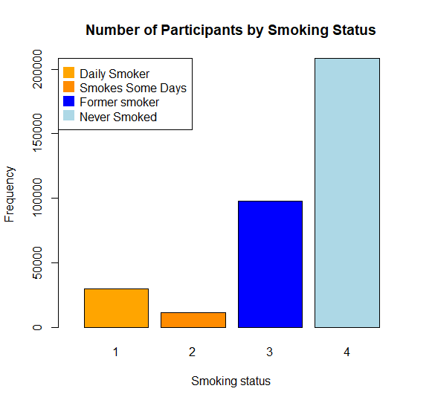
I also created a table of the column values to see the total number for each value:
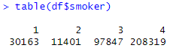
Next, I created a visualization of the alcohol use in the last 30 days column. This column has a 1 value for use in the last 30 days, and 0 for no use.
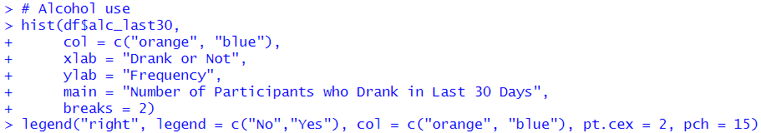
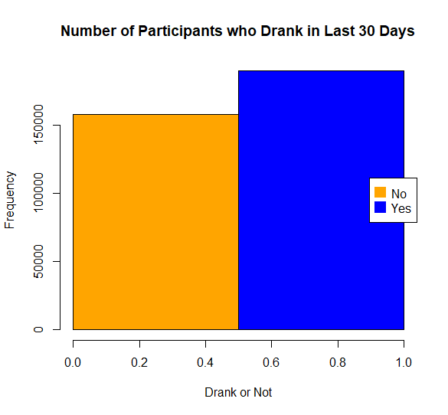
More participants reported having had an alcoholic beverage in the last 30 days than not having one. I created a table to see the total numbers for each response:
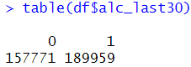
I also wanted to create a histogram for the general health column, this will allow me to see how many participants fell into each category.
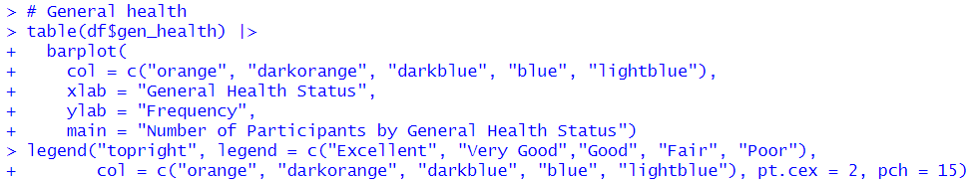
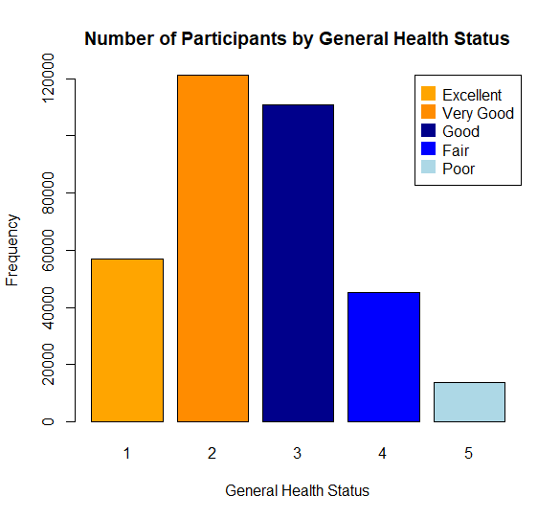
Fair and poor health were the two categories with the fewest participants. The majority of the participants reported that they fell into very good or good health. I also created a table to see the values:
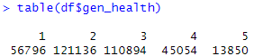
Finally, I created a visualization and table of the number of participants by age group. This showed that the age catebory with the highest number of participants was 10, which is 65 – 69 years old. Followed closely by 9 (60 – 64 years old) and 11 (70 – 74 years old).
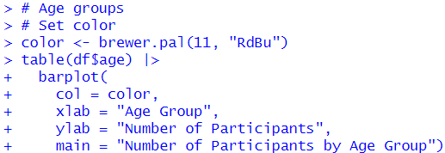
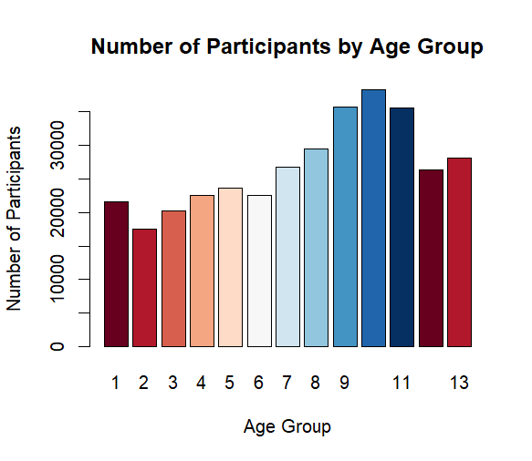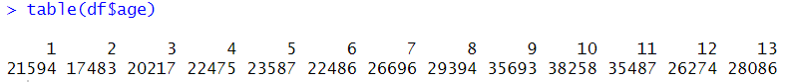

Regression Analysis
I used logistic regression for this process because my target variable is binary. One disadvantage of logistic regression is that it assumes linearity between the dependent and independent variables. It can also only be used to predict discrete functions, but since my variables are all discrete, it works for this purpose. One advantage of using logistic regression in this case is that the dependent variable (target variable) is binary, and logistic regression is based on the sigmoid function, which outputs probability, which is easily translated into a binary variable. Another advantage is that it is easy to implement and interpret.
Before I performed the regression, I created train and test sets for the data. I also reordered the columns so that the mi_chd column is at the left end of the data frame to make it easier to program the model. I used the sample.split() function in the caTools library for this process. One advantage to using caTools is that the code is straightforward, and the independent variable does not have to be separated prior to splitting the data. One disadvantage is I cannot choose whether or not I am using random data points in the sampling, as there is no random parameter. I set a seed number prior to splitting the data. This ensured that I could reproduce the results by using the same seed number in the future.
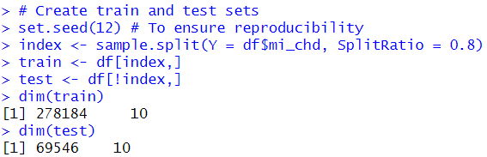
I used an 80/20 split for the train/test data to prevent overfitting the data to the training set. 80% of my data will be used to train the model, and 20% to test it. This ensured that the model was presented with a significant amount of unseen data to perform predictions on, which I used to see how accurate the model’s predictions were.
For the logistic regression model, I used the glm() function in base R. One advantage to using this function is that I would not need to download additional packages. One disadvantage to the glm() function is that it is not as flexible as other functions. The general syntax for the function is: glm(response ~ explanatory, data = dataset, family = binomial). The binomial family is used because the dependent variable has values of 0 or 1.
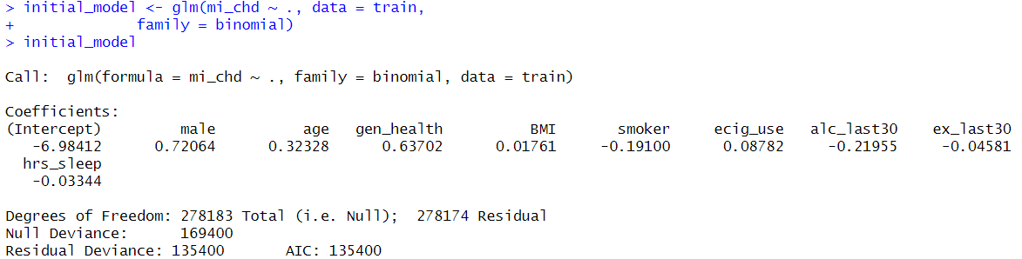
This initial model had a high AIC score. The Akaike Information Criterion (AIC) score is a gauge of the model’s goodness of fit. An AIC with lower values indicates a better fit (closer to 0 is better). One advantage to using the AIC score to determine goodness of fit is that it is calculated based on log-likelihood, which is compatible with logistic regression. One disadvantage is that it does not provide a measure of confidence in the model, which can make it difficult to determine how accurate a measurement it is. The high AIC score tells me that I have a model that may not be a good fit. I checked the model summary for more information.
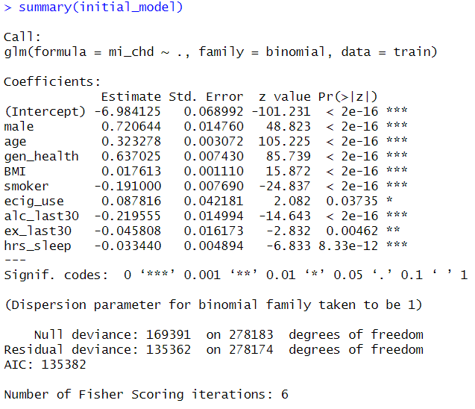
I needed to determine whether I had variables that were not helping the model be more accurate, and if so, which variables to keep. To do this, I used stepwise logistic regression. Stepwise regression adds or removes variables based on their statistical significance. Stepwise regression is an easy way to determine which independent variables have the most significant effect on the dependent variable based on the AIC score. Stepwise regression can, however, be time consuming and use a lot of computational resources (R Studio Data Lab, 2023). I have the option of forward (start with only the intercept or one variable, and add the others one at a time), backward (start with all independent variables and remove one at a time), or stepwise (both, a combination of forward and backward). Backward tends to be the most computationally expensive because it uses all of the variables to start. Forward can miss important variables if the order in which they get added is not ideal. I used stepwise regression in an effort to increase accuracy in my model but also conserve resources since this is such a large data set. I used the stepAIC() function from the MASS package to perform this process.
I ran stepwise regression, and it did not recommend removing any variables.
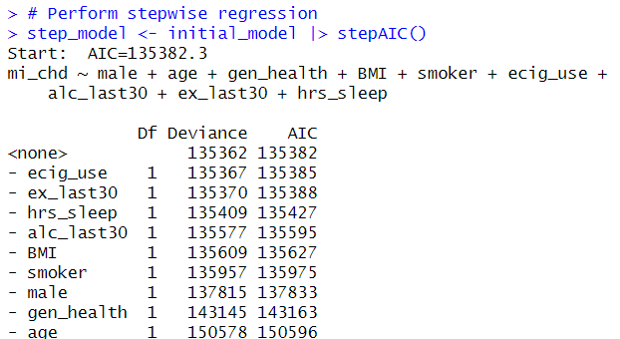
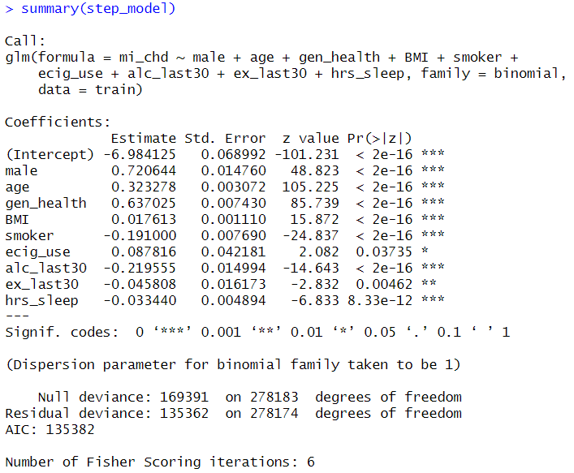
Stepwise regression also did not improve my AIC score at all. It processed very quickly, so I also completed a forward and backward regression.
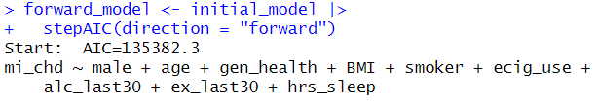
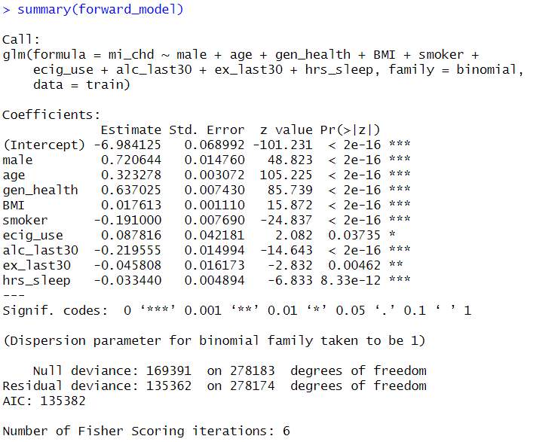
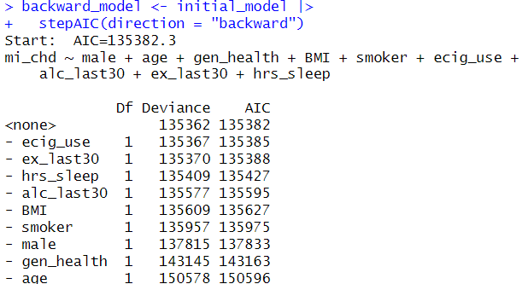
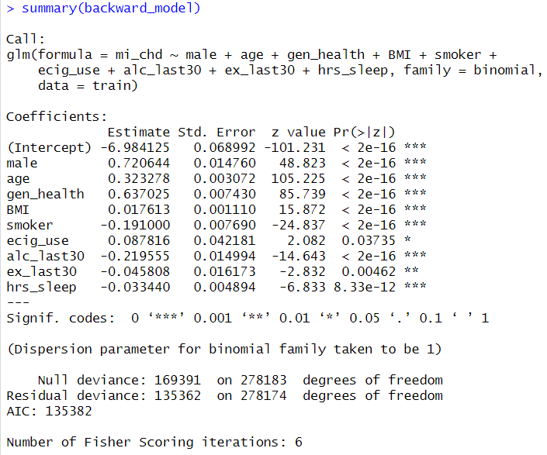
The backward and forward models also recommended keeping all of the variables. Since these also did not improve the AIC, I created a model that removes the variables with the highest p values (ecig_use, ex_last30) to see how that changed the model. A p value of 0.05 is considered statistically significant, so I could leave both variables in and still stay within that range, but I wanted to see how much difference it made to remove both.
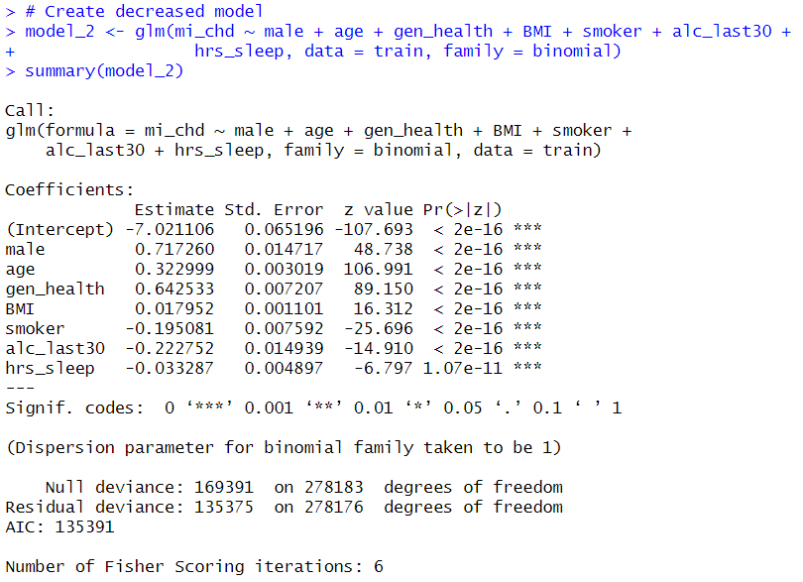
This increased the AIC score slightly, so I will continue with the initial model. In an effort to be thorough, I created two more iterations. First, I removed the gen_health variable, as it had one of the highest AIC scores of the variables in the step regression results. Then I also removed age. I checked the summary of each to determine whether either is better than the original.
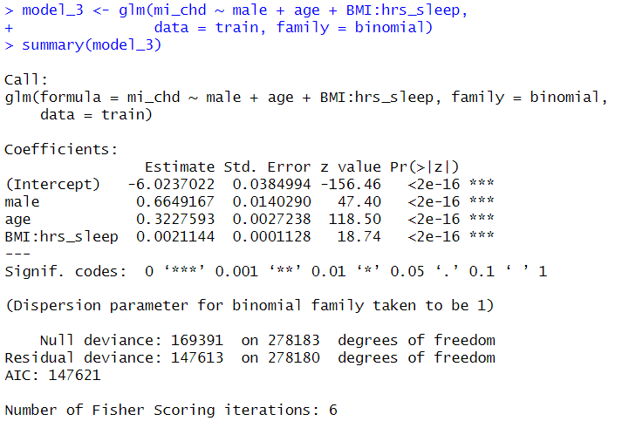
Just removing gen_health increased the AIC even more (above). Removing both gen_health and age (below) produced even worse results.
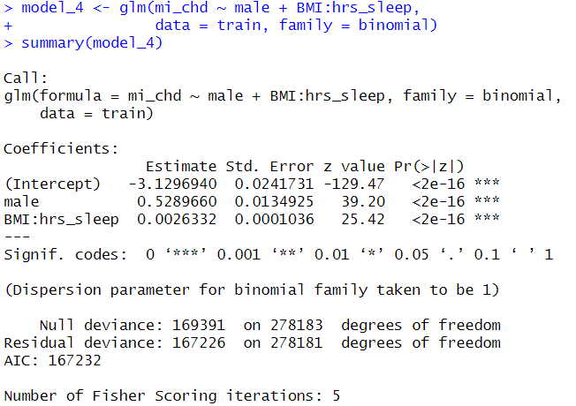
This showed that the initial model that includes all of the independent variables is the best option. I tested this model with the test data to determine how accurate it is. I used the predict() function on the model to create the predictions. Then I used the ifelse() function to change the predicted probabilities to 1 or 0 (0.5 or higher is 1). This put the predictions into the same format as the mi_chd column.
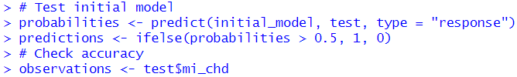
After creating the predictions and observations, I used them to create a confusion matrix. A confusion matrix will list the number of predicted 1 and 0 values, and the actual 1 and 0 values. I also created a visualization of the confusion matrix using the autoplot() function from the yardstick library. One advantage to using the confusion matrix to evaluate a model is that it allows the use of metrics like precision, sensitivity, and specificity to be used, rather than only using accuracy. This provides more detail into how the model is working. One drawback is that it requires an understanding of the underlying data. False positives might have more of an effect in some scenarios than false negatives, and vice versa.
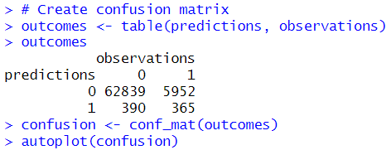
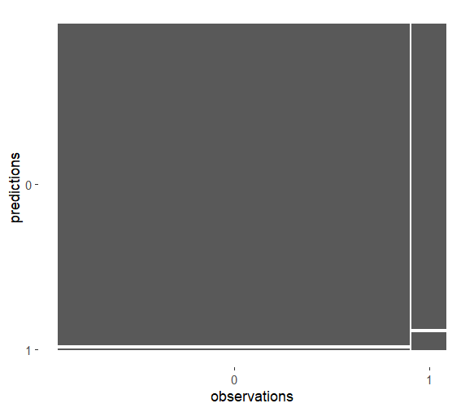
Now I could see the correct vs. incorrect predictions, but I want more information about how well this model is working, so I printed the summary of the confusion data.
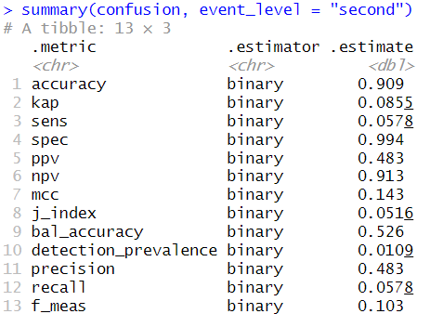
This showed me that my model predicts whether someone will have either a heart attack (MI) or have coronary heart disease (CHD) with nearly 91% accuracy (accuracy refers to the proportion of correct predictions). Sensitivity (sens in the summary) refers to the proportion of true positives. Sensitivity is calculated as true positives / (true positives + false negatives). This number is only 58%, so quite a bit lower than the overall accuracy. The proportion of true negatives, or specificity (spec) is 99%. This is calculated as true negatives / (true negatives + false positives). This tells me that the model is not incorrectly saying that people are not at risk. Precision represents the ability of the model to correctly predict the positive class. It is calculated as true positives / (true positives + false positives). In this model the precision is 48%. So, this means the model is very accurate at determining who is not at risk, but not as accurate at determining who is at risk. This is a downside to using the model for healthcare purposes.

Data Summary and Implications
My research question is “To what extent do age, BMI, and health risk factors (tobacco use, sleep, physical activity, and alcohol use) affect risk of heart attack or coronary heart disease?” I have created a model that shows that age, BMI, and health risk factors have a statistically significant effect on heart attack risk. A variable with a P-value of 0.05 or less is considered statistically significant, and every variable in this model is statistically significant based on the summary.
This model is 90.9% accurate at predicting the risk of heart attack or coronary heart disease. In general, an accuracy of 70% or higher is considered a good model. One limitation of my analysis is that the sensitivity (the proportion of true positive predictions) is only 58% and the precision (the proportion of correctly predicted positives) is only 48%. This means that the model predicts who is not at risk quite well but does not predict who is at risk as well.

Recommendation for Use
I would recommend using this model as a conversation starter with patients. Since it predicts those not at risk better than predicting who is at risk, use the model with caution. Have the model provide a prediction for the patient, then discuss risk factors for heart attack and heart disease, and what the patient can do to avoid these health problems. There were few false positive results in the predictions, so if a patient is predicted to be at risk it is likely a fairly accurate prediction. Since the model had a higher number of false negatives, if a patient is predicted not to have risk but has high-risk health factors, discussions with their medical team could still be important. This is not a perfect model, but it does provide over 90% accuracy in its predictions.

Future Study and Use of Dataset
This dataset could be used for many purposes. The original dataset contained 328 variables. It could be used for predicting risk of cancer, as there were several variables related to cancer in the dataset, including colorectal cancer and breast and cervical cancers. For patients without the means to undergo genetic testing to determine cancer risk, an accurate prediction model could be helpful. It could also be used for predicting risk for various other chronic illnesses, like asthma.
Future study with this data set could also include adding more variables to this model to see if sensitivity and precision can be improved with the addition of more independent variables. The model could also have race/ethnicity added to determine whether this demographic can help improve predictions. Health problems can affect different demographic groups differently, so using additional patient demographics could help improve the model.

References
Centers for Disease Control. (2024, March 19). Adult BMI Categories. CDC. Retrieved March 17, 2025, from https://www.cdc.gov/bmi/adult-calculator/bmi-categories.html
Centers for Disease Control. (2023, November). 2022 BRFSS Survey Data and Documentation. CDC. Retrieved March 7, 2025, from https://www.cdc.gov/brfss/annual_data/annual_2022.html
Centers for Disease Control. (2023, September 29). Calculated Variables in the 2022 Data File of the Behavioral Risk Factor Surveillance System. CDC. Retrieved March 13, 2025, from https://www.cdc.gov/brfss/annual_data/2022/pdf/2022-calculated-variables-version4-508.pdf
Centers for Disease Control. (2024, December 11). Leading Causes of Death, United States. CDC. Retrieved March 12, 2025, from https://www.cdc.gov/womens-health/lcod/index.html
Mayo Clinic. (2024, November 7). Dwarfism. Mayo Clinic. Retrieved March 14, 2025, from https://www.mayoclinic.org/diseases-conditions/dwarfism/symptoms-causes/syc-20371969
Olson, E. J. (2025, February 1). Healthy Lifestyle - Adult Health. Mayo Clinic. Retrieved March 14, 2025, from https://www.mayoclinic.org/healthy-lifestyle/adult-health/expert-answers/how-many-hours-of-sleep-are-enough/faq-20057898
R Studio Data Lab. (2023, August 7). Stepwise Logistic Regression in R: A Complete Guide. Medium. Retrieved March 18, 2025, from https://rstudiodatalab.medium.com/stepwise-logistic-regression-in-r-a-complete-guide-82fcd9e2d389
Slahor, S. (2008, April). Not Enough Sleep Is Dangerous. Law and Order, 56(4), 58-64. https://www.ojp.gov/ncjrs/virtual-library/abstracts/not-enough-sleep-dangerous#:~:text=The%20bare%20minimum%20of%20sleep,renewal%2C%20learning%2C%20and%20memory

