Sentiment Analysis Using Neural Networks

Part I: Research Question

A: Purpose of Data Analysis
- Research question: Can a classification model be trained and used to identify the sentiment in written customer reviews?
- Project objectives: create and train network, test network accuracy, report on results.
- Type of neural network used: I will be using a recurrent neural network using a gated recurrent unit (GRU) cell for this sentiment analysis project. The GRU functions similarly to the long short-term memory cell but requires fewer computational resources.

Part II: Data Preparation

B: Summary of Cleaning Process
- Exploratory data analysis: the reviews in the data set are 50% positive, and 50% negative. There are 3000 reviews in total (1500 positive, 1500 negative). 500 reviews each come from Amazon, Yelp, and IMDb.
  - I created a word cloud of the reviews just to help visualize which words occurred the most often: 
  - Unusual character search:
emoji = "['\U0001F300-\U0001F5FF'|'\U0001F600-\U0001F64F'|'\U0001F680-\U0001F6FF'|'\u2600-\u26FF\u2700-\u27BF']"
punctuation = r"[.?!'#&*]"
special = r"[\W\D\S]" # non-word, non-digit, non-whitespace
tokenizere = RegexpTokenizer(emoji)
print(len(tokenizere.tokenize(str(df))))
tokenizerp = RegexpTokenizer(punctuation)
print(len(tokenizerp.tokenize(str(df))))
tokenizers = RegexpTokenizer(special)
print(len(tokenizers.tokenize(str(df))))
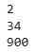
  - Vocabulary size: to find the vocabulary size, I used word_tokenize to tokenize each review, then created a set of all tokens, then determined the number of unique tokens:
# Tokenize reviews
tokenized_reviews = df.review.apply(lambda x: word_tokenize(x))
print(tokenized_reviews.head())

# Find unique tokens: combine tokens into a list then create set of unique tokens
all_tokens = [token for sublist in tokenized_reviews for token in sublist]
unique_tokens = set(all_tokens)
print(len(unique_tokens))
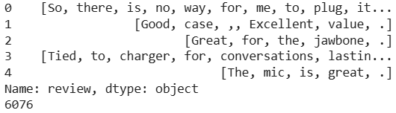
  - to find the string length of each review, I used length_reviews = df.review.str.len()
length_reviews.describe()
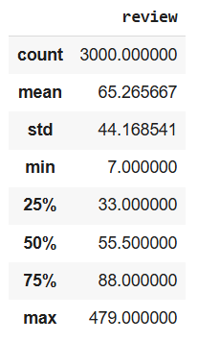
  - Word embedding length: embedding is used to extract the meaning of a word by translating each integer representing a word into a vector. Since the goal of the model is sentiment analysis, using embedding helps the process because it allows the model to group terms of similar sentiment together, thereby speeding up the analysis. I am using a length of 200. According to Udacity (n.d.), an embedding length of up to 200 can help increase accuracy, but higher than 200 may not be helpful.
  - Statistical justification for chosen maximum sequence length: using length_reviews.quantile(0.99), I know that 99% of the reviews are 215 characters or less, so 215 will be my maximum sequence length. 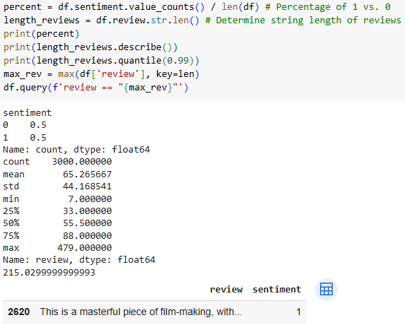
- Goals of tokenization process (including code generated and packages used):
  - The following should be accomplished during the tokenization process:
    - Avoid common terms (remove stop words)
      - Removing stop words takes out words like “the”, “and”, “or”, “a”, and similar frequently used terms that won’t affect the sentiment.
    - Remove special characters and emojis (keep only alphanumeric characters)
      - I want to remove any characters that are not words or numbers so that they do not affect the analysis of the reviews.
    - Remove punctuation – removing punctuation allows the model to focus only on words to determine the sentiment.
    - Make all words lowercase – making all words lowercase makes them easier to analyze through the machine learning model; the fewer differences there are between reviews, the more efficient the analysis will be.
    - Use lemmatization to shorten words to their stems:
      - Lemmatization takes words and shortens them to the linguistic lemma of the term, so running would be changed to run. Unlike stemming, lemmatization reduces terms to the full lemma of the word.
        - Stemming would change “changing” to “chang”
        - Lemmatization changes “changing” to “change”
    - Vectorization – vectorization takes the terms and changes them into a numeric code that the computer code can understand for processing. During the vectorization process, I create a vocabulary set of the words in my data set, then, using that vocabulary, assign numeric values to the words in the reviews.
  - Packages used and code used for preprocessing:
from nltk.tokenize import word_tokenize
from nltk.corpus import stopwords
from nltk.stem import WordNetLemmatizer
import nltk
import re
nltk.download('punkt')
nltk.download('stopwords')
nltk.download('wordnet')
import string

def preprocess_text(text):
# Tokenize text and remove stop-words
lemmatizer = WordNetLemmatizer()
tokens = word_tokenize(text.lower())
filtered_tokens = [token for token in tokens if token not in
stopwords.words('english')]

# Lemmatize tokens
lemmatized_tokens = [lemmatizer.lemmatize(token) for token in filtered_tokens]

# Join tokens back into string
string_text = ' '.join(lemmatized_tokens)

# Remove punctuation
string_text= string_text.translate(str.maketrans('','',string.punctuation))

return string_text

# Apply pre-processing to reviews
preprocessed_reviews = df['review'].apply(preprocess_text)
print(preprocessed_reviews)

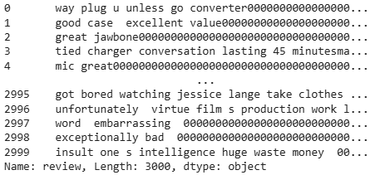
    - Vectorization code: 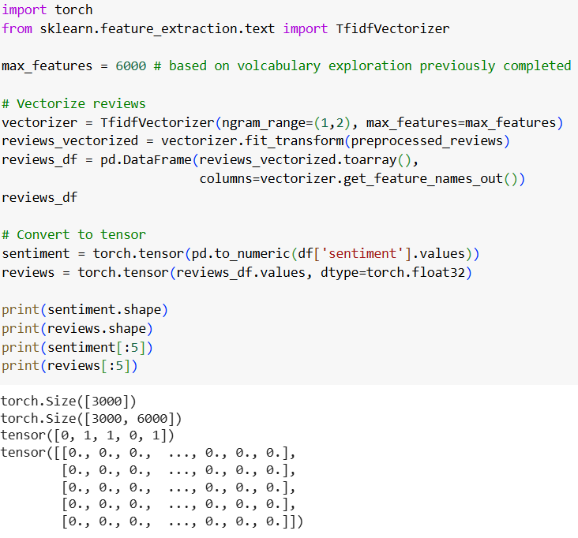
- Padding process used to standardize length of input sequences:
  - Before or after the text sequence: padding will be placed after the text sequence, and “0” will be the character used for padding.
  - Screenshot of padding code and a single padded sequence: 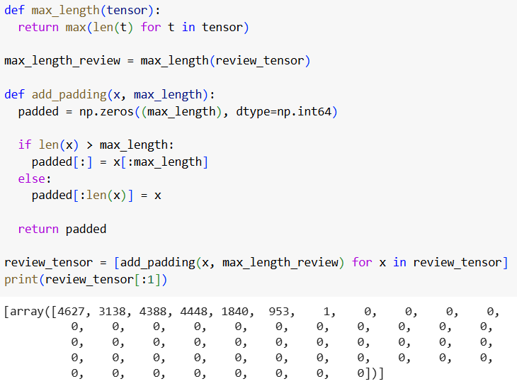
- Categories:
  - How many sentiment categories are used: there are two categories, positive (1) and negative (0).
  - Activation function for final layer: the activation function for the final layer is the sigmoid function to provide values of 0 (negative) or 1 (positive).
- Steps used to prepare data for analysis:
  - First I need to separate the data into training, validation, and test sets. I used 70% of the data for training, and 15% each for validation and testing. This allows a generous portion of the data to be used to train the model, and provides enough data for testing and validation to monitor for overfitting and to determine the accuracy of the model.
from sklearn.model_selection import train_test_split
import random

random_state = 13
random.seed(random_state)

# Split into train and test (70%/30%)
X_train, X_test1, y_train, y_test1 = train_test_split(
reviews, sentiment, test_size=0.30, stratify=sentiment, random_state = random_state)
# Split into test and validation (50/50 = 15%/15% of total)
X_val, X_test, y_val, y_test = train_test_split(
X_test1, y_test1, test_size=0.50, stratify=y_test1, random_state = random_state)

print(X_train.shape, y_train.shape, X_test.shape, y_test.shape, X_val.shape, y_val.shape)

  - Size of training dataset: 2100
  - Size of validation dataset: 450
  - Size of test dataset: 450
  - Next, I need to create the tensor dataset and data loaders to use to load the data into the machine learning model. This is done by combining the X and y data set from each group into one tensor, then creating a data loader that will batch the data (allows for more efficient processing) and shuffle the data as it is loaded: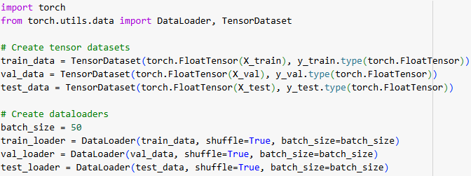
- Copy of datasets provided with project submission.

Part III: Network Architecture

C: Describe Neural Network Model
I tested a Gated Recurrent Unit (GRU) network because it works similarly to a long short-term memory network, but requiring fewer computational resources. This allows the network to “remember” information as it goes.
- Model summary: 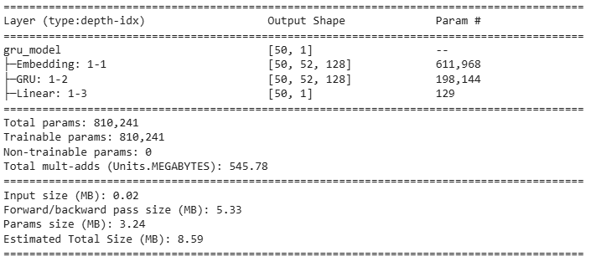
- Discuss the layers: 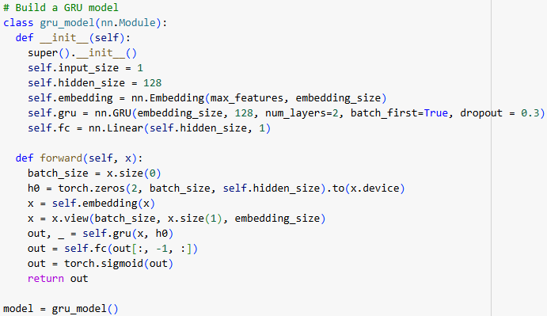
  - Number of layers: the model will have 3 layers including embedding, because with RNN models 3 layers seems to be the optimal number and increasing the number of hidden layers does not affect model accuracy much, whereas in CNNs increasing the hidden layers can help improve accuracy (Udacity). I started with embedding to get the data into the correct format.
  - Type of layers: I have embedding, then a GRU layer then a linear layer, then a sigmoid layer for the output activation layer.
    - Embedding puts the data into the correct format for the GRU layer.
    - The GRU layer has 64 nodes in the hidden layer and a dropout of 0.3 (30% of nodes will by ignored) to help reduce overfitting.
    - The linear layer decreases the size of the data to 1 to be fed into the sigmoid layer.
    - The sigmoid layer provides outputs as 0 or 1, which is necessary for this task.
  - Total number of parameters: 810, 241
- Hyperparameter justification:
  - Activation functions: the linear layer has an input of 64 and output of 1. I did not change the hyperparameters on the sigmoid function.
  - Number of nodes per layer:
    - the embedding size is 128, so 128 nodes
    - The GRU layer takes the input of 128 and outputs 128, so 128 nodes
    - The linear layer takes the input of 128, so 128 nodes
    - The sigmoid function inputs 1 and outputs 1, so 1 node
    - Total nodes = 385
  - Loss function: Binary cross entropy loss used because I am using a binary output. I did not change the defaults.
  - Optimizer: model uses Adam optimizer. The Adam optimizer is more efficient in terms of computing resources. I adjusted the learning rate using the ExponentialLR scheduler (see below for selection of hyperparameters).
  - Learning rate: I used random grid search to determine the best learning rate and gamma level for the learning rate scheduler. I tested each random rate for 13 epochs. The best parameters after 13 epochs were a learning rate of 0.016 and gamma of 0.281.
  - Stopping criteria: I created a function for early stopping if necessary
    - class EarlyStopper:
def __init__(self, patience, min_delta=0):
self.patience = patience
self.min_delta = min_delta
self.counter = 0
self.min_val_loss = float('inf')

def early_stop(self, val_loss):
if val_loss < self.min_val_loss:
self.min_val_loss = val_loss
self.counter = 0
elif val_loss > (self.min_val_loss + self.min_delta):
self.counter += 1
if self.counter >= self.patience:
return True
return False
    - When I trained my model, I used a patience level of 3, so if the validation loss increased 3 times in a row, the model would stop training.
  - Number of epochs: I tested the model by running it for 50 epochs, and based on the results and considering training loss, validation loss, and accuracy, I selected 17 epochs for the final training process: 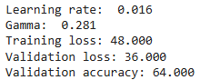 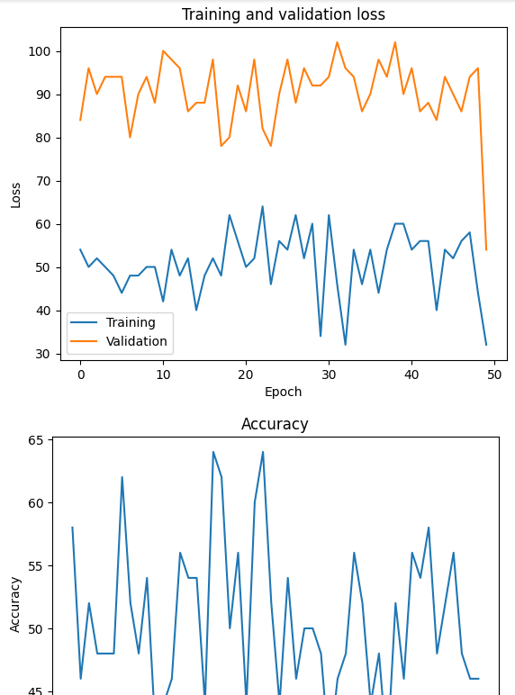

Part IV: Neural Network Model Evaluation

D: Model Training Evaluation
- Impact of stopping criteria: the model did not require early stopping because the validation loss didn’t increase more than three times before it decreased again.
  - I used experimentation to determine the number of epochs to use. The final model was trained on 17 epochs based on the results of running 50 to determine a good stopping point (visualization above).
  - Final training epoch: 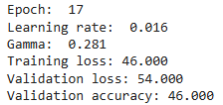
- Model fitness: The test run on the model produced a loss of 52, which is not far off from the training and validation levels. This model just did not improve much as it trained. I focused on balancing the various parameters to get the best possible model fit when determining the number of epochs to use, but the numbers did not consistently improve during the training process. I also used a random grid search to determine hyperparameters rather than arbitrarily selecting them.
- Training visualizations:
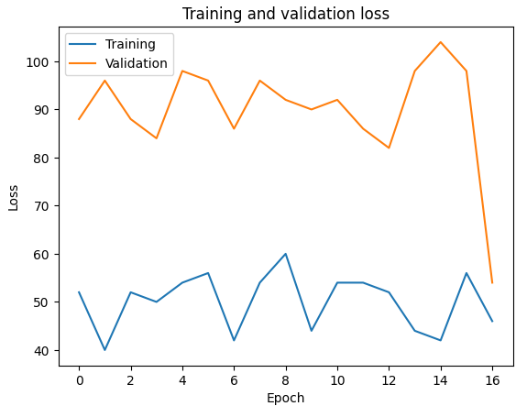
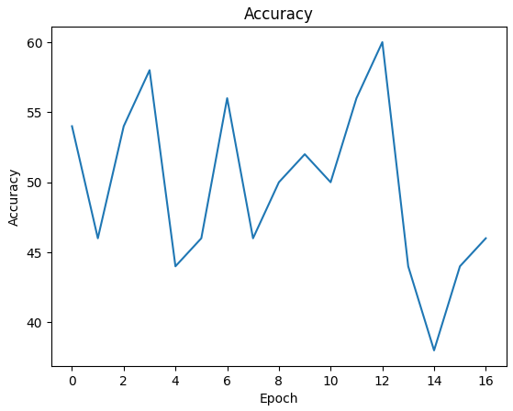
- Predictive accuracy of trained model: the model is not very accurate, unfortunately. The final accuracy on the test set was only 48%, which is less accurate than randomly guessing in a binary model. 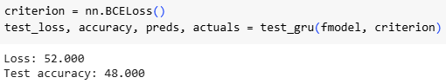
- Compliance with ethical standards:
  - Transparency: transparency comes with my ability to explain the model, its abilities, and its limitations. Coding a neural network can be complex, so including code that is as simple as possible and explaining what it does are key aspects. In section C I describe the model and what it does. In section D I evaluate the abilities of the model. Including this information with the model is an important aspect of transparency.
  - Accountability: the model should function as intended and I need to address any negative consequences. This model deals with anonymous data not related to a problem that could negatively affect stakeholders. That being said, there are no negative consequences that I have observed through the process of creating the model. The model does function as intended, it classifies reviews as having a positive or negative sentiment.
  - Fairness: fairness means that bias was prevented during the creation of the model, and it is not discriminatory. Oftentimes, a model can be trained on data that is biased in some way. This data does not include any descriptors, so should not be biased toward any subsets of the population. I have tried to avoid algorithmic bias by focusing on both accuracy and loss and trying to balance the two. If I focus only on one, it could inadvertently bias the results. I also used a learning rate scheduler to ensure that I did not introduce bias by arbitrarily selecting a learning rate. I do not believe that I have introduced human bias into this project because I was using a predetermined data set from multiple companies and the data has no identifying information.

Part V: Summary and Recommendations

E: Code used to save trained model
if val_loss_min is None or(
(val_loss_min - val_loss) / val_loss_min > 0.01
):
# Save weights
filename = os.path.join(save_path, 'best_val_loss.pt')
torch.save(gru_model.state_dict(), filename)
val_loss_min = val_loss

F: Discuss Functionality of Model:
- It is clear that this model is not working well. I chose the number of layers based on our learning (described previously). Having more than 3 layers doesn’t tend to improve an RNN model. This may be different for GRU, and adding additional layers might help improve the model performance. I didn’t use tfidf for vectorization because some of the terms that were most widely used throughout were terms that could be associated with sentiment, like “good”. For that reason, I used the count vectorizer. I did lemmatize the terms and remove punctuation to help the learning process. Leaving the sigmoid function off of the output layer might also change the performance of the model. Increasing the number of training epochs did not help improve the loss or accuracy metrics, so the model is not learning as intended.

G: Recommend Course of Action:
- Research question: Can a classification model be trained and used to identify the sentiment in written customer reviews?
- Model results: this model is less accurate than randomly assigning sentiment (the model is 48% accurate, random assignment would likely be around 50% accurate). The results are disappointing, and the model is not useful.
- Recommended course of action: I would recommend creating a different model and not using this one, because this model has an accuracy of less than 50%. For a model to be useful, it would need to have 70% accuracy or better.

Part VI: Reporting

H: Submit Code and Output
Submitted with project submission.

I: Web Sources for Coding
DataCamp. (2023, March 23). NLTK Sentiment Analysis Tutorial: Text Mining & Analysis in Python. DataCamp. Retrieved February 26, 2025, from https://www.datacamp.com/tutorial/text-analytics-beginners-nltk
GRU — PyTorch 2.6 documentation. (n.d.). PyTorch. Retrieved February 26, 2025, from https://pytorch.org/docs/stable/generated/torch.ao.nn.quantized.dynamic.GRU.html
Keras documentation: Model training APIs. (n.d.). Keras. Retrieved February 26, 2025, from https://keras.io/2.18/api/models/model_training_apis/

J: Sources
Kotzias, D. (2015). Sentiment Labelled Sentences [Dataset]. UCI Machine Learning Repository. https://doi.org/10.24432/C57604 - (Data source)
Udacity. (n.d.). Advanced computer vision and deep learning. https://learn.udacity.com/paid-courses/cd0361

