**PROJECT**

**ON**

**EXTRACTION OF**

**QUESTIONS FROM THE INTERNET USING**

**A MACHINE LEARNING APPROACH**

**Presented by**

**ALOK SAW B090924CS**

**JERRIN SHAJI GEORGE B090437CS**

**SHUBHANGAM AGRAWAL B090904CS**

**STEIN ASTOR FERNANDEZ B090006CS**

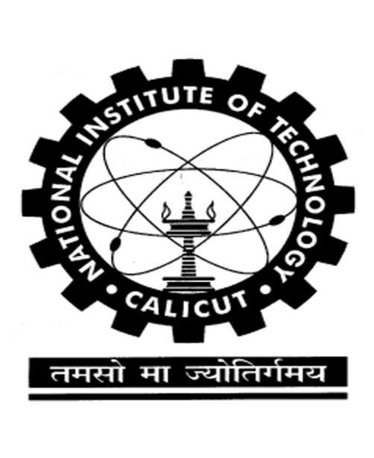

***Department of Computer Science and Engineering***

**NATIONAL INSTITUTE OF TECHNOLOGY**

**CALICUT KERALA-673601**

**Monsoon -2012**

***CERTIFICATE***

This is to certify that this project report entitled

“EXTRACTION OF

QUESTIONS FROM THE INTERNET USING

A MACHINE LEARNING APPROACH”

is a bonafide record of the project presented by

ALOK SAW B090924CS

JERRIN SHAJI GEORGE B090437CS

SHUBHANGAM AGRAWAL B090904CS

STEIN ASTOR FERNANDEZ B090006CS

during the Monsoon Semester 2012 in partial fulfillment of

the requirement for the award of B.Tech degree in

Computer Science and Engineering,

National Institute of Technology Calicut.

**Dr. Priya Chandran Anu Mary Chacko**

Guide Co-ordinator