Metriken:

Metrik | Bedeutung | Beurteilung | public int CalcGGT(int a, int b)  {  int gr = 0;  int kl = 0;  int ret = 1;  if (a == b)  {  ret = a;  }  else  {  gr = a;  kl = b;  if (a < b)  {  kl = a;  gr = b;  }  int i = gr / 2;  while (i >= gr / kl)  {  if (gr % i == 0 && kl % i == 0)  {  ret = i;  i=1;  }  i--;  } //end while  } //end else  return ret;  }
…..

OO-Metriken

Metrik | Bedeutung | Beurteilung | 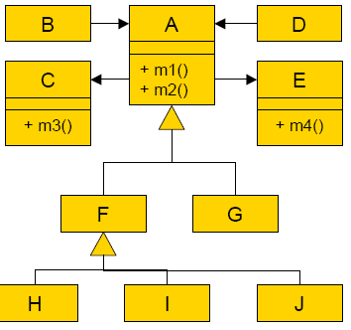
 |  | .
class A
{
public void callB()
{
B b = new B();
b.callC();
}

public void doNothingA() {
;
}
}

class B
{
public void callC
{
C c = new C();
c.doNothingC();
}
}
class C
{
public doNothingC()
{
;
}
}
class LackOfCohesion2
{
private int a;
private int b;

public void IncA()
{
a = a + 1;
}
public void IncB()
{
b = b + 1;
}
public int GetSum()
{
return a + b;
}
}

