What Explains College Students' Party Affiliation?
High School Background and Political Identification Among University Students
Skyler A. Stein
PLS 401
University of North Carolina Wilmington
Abstract
This paper examines what explains college students' party affiliation, with a particular focus on the type of high school a student attended. Party affiliation is a useful outcome to study because it shapes how students interpret politics, evaluate candidates, and engage with public life. At the same time, party identity does not form in a vacuum. Family background, religion, age, and school environment all matter. To test whether high school background helps explain college student party affiliation, I use original survey data collected from undergraduate students at four year universities in the United States, most of whom attend the University of North Carolina Wilmington. The survey includes 123 respondents. I analyze the relationship between party affiliation and high school type through descriptive tables, charts, and chi square tests. I also test an alternate explanation based on whether respondents report changing their party affiliation since registering to vote. The results show a modest descriptive relationship between high school type and party affiliation, but the relationship is not statistically significant. The alternate explanation is also not statistically significant. Overall, the findings suggest that school background may matter at the descriptive level, but this sample does not provide strong enough evidence to conclude that it independently explains college students' party affiliation.
Introduction
Party affiliation remains one of the most important concepts in political science because it shapes how people think about elections, issues, and government. In practice, party identification often becomes a shortcut. It helps people make sense of a complicated political world without needing to process every issue from scratch. For that reason, understanding what explains party affiliation is important, especially among younger Americans who are still moving through the early stages of political development. Younger voters have taken on a distinct place in the modern electorate. Pew Research Center finds that younger registered voters lean more Democratic than older voters, while older groups are more likely to associate with or lean toward the Republican Party (Pew Research Center, 2024a). That pattern makes college students a useful population for studying how partisan identity develops.
This project asks a straightforward question: what explains college students' party affiliation? More specifically, I examine whether the type of high school a student attended helps explain whether that student identifies as Democrat, Republican, Independent, or Unaffiliated in college. I also examine an alternate explanation based on whether the student has changed political party affiliation since registering to vote. The broader idea behind this project is that political identity develops through socialization. Students do not arrive on a college campus politically blank. They bring with them years of family influence, school experience, religious environment, peer interaction, and community background. If high school is a meaningful political environment, then it is reasonable to ask whether different school settings are associated with different partisan outcomes in college.
This question matters for two reasons. First, it adds to research on political socialization by moving beyond family alone and taking school environment seriously. Second, it allows for a more grounded look at how students' pre college experiences may still show up after they have already entered a university setting. This is especially relevant because college is often treated as a politically formative period. Some students arrive with stable political identities, while others are still sorting through their beliefs and issue positions. Woessner and Kelly Woessner (2020) show that political identity among college students can be more stable than specific issue positions, which suggests that college years are a mix of continuity and change rather than a complete reset.
My expectation is not that high school type fully determines party affiliation. That would be too simple. Instead, I expect school background to work as one part of a broader socialization process. Different kinds of schools can expose students to different values, authority structures, peer groups, and religious influences. Those differences may not guarantee a specific political identity, but they can shape the environment in which one develops. The sections that follow review the relevant literature, outline the hypotheses, explain the survey data and methods, and present the results from the analysis.
Previous Research
The literature on party affiliation generally begins with political socialization. Political socialization refers to the process through which individuals develop political beliefs, loyalties, and habits. One of the most common findings in this literature is that political identity starts early and is strongly influenced by the family. Ojeda and Hatemi (2015) argue that the transmission of party identification from parents to children remains one of the most important elements of political socialization in the United States. Their work is useful because it reminds us that partisan identity is often formed long before people reach college age. Parents influence the household environment, set expectations about politics, and often model partisan attachments that children later carry into adulthood.
At the same time, the literature does not treat young people as passive political copies of their parents. Political identity continues to develop through interactions with peers, institutions, and the surrounding social environment. This matters because it opens the door to other explanations beyond the family. A student may grow up in a home with strong partisan cues, but that student also spends years in classrooms, school organizations, sports teams, religious settings, and peer networks. These environments can either reinforce earlier attachments or push students to rethink them. College is one of those environments, but high school likely matters too because it is where many young people first encounter structured civic education, formal rules, and a more public set of social relationships.
That is where the school environment becomes especially relevant. Bruch and Soss (2018) argue that schooling should be understood as a formative political experience rather than simply an academic one. In their view, schools teach students not only content but also lessons about authority, fairness, participation, and belonging. Their research shows that negative experiences with school authority can reduce later political engagement and trust in government. Even though their study focuses more directly on engagement than on party affiliation, the logic still applies here. If school structures help shape how students think about authority and public life, then it is reasonable to expect school setting to matter for partisan identity as well.
Other work on youth civic development supports this broader argument. Andolina, Jenkins, Zukin, and Keeter (2003) find that youth civic engagement is influenced by habits formed at home, lessons learned at school, and opportunities offered by outside institutions. Their work does not claim that schools alone drive political outcomes, but it clearly treats schools as important political spaces. This helps justify why type of high school attended belongs in a study like this one. A traditional public school, a traditional private school, a magnet school, a boarding school, and an alternative category labeled other may each reflect different civic experiences, social expectations, and institutional cultures. The question is whether those differences show up in students' party identification once they are in college.
Religion is another major part of this discussion. School type can overlap with religion, especially when private schooling involves religious affiliation. Pew Research Center (2024b) shows that partisanship remains strongly tied to religious identity in the United States. Religious "nones" lean heavily Democratic, while some more religious groups lean more Republican. A separate Pew report also shows that a large share of private school students attend religiously affiliated schools (Pew Research Center, 2024d). That matters because students who attended private religious schools may have experienced a different political and moral environment than students who attended traditional public schools. Even if the survey in this project does not break private schooling down into detailed religious categories, the overlap between school type and religion still provides a strong reason to expect differences in party affiliation.
Age also matters. Younger voters today do not look politically identical to older generations. Pew Research Center (2024a) shows that younger registered voters lean more Democratic than older voters, and that this generational divide has been present for more than a decade. Since this project focuses on college students, it studies a group that already sits in a distinctive age based partisan location. That does not make school type irrelevant, but it does mean that partisan identity among college students may partly reflect the broader generational context in which they came of age. For this reason, any relationship between school type and party affiliation should be interpreted carefully and not as though it exists in isolation from age and generation.
The literature also shows that race, ethnicity, religion, and education continue to shape partisan identity. Pew Research Center (2024c) finds clear partisan differences across racial and ethnic groups and across educational categories. Black voters remain overwhelmingly Democratic, while white voters are more likely to identify with or lean Republican. These patterns matter because they make it clear that party affiliation is shaped by several overlapping social influences. This is one reason my research design includes control variables such as gender, race, family income, parental education, and religious affiliation, even though the present analysis focuses primarily on bivariate relationships. Any claim about high school type should be made with caution because students' school backgrounds are connected to larger social conditions.
Finally, the literature on college students specifically suggests that political identity during these years is neither fully fixed nor fully fluid. Woessner and Kelly Woessner (2020) find that college students may shift on issue positions more easily than on broad political identity. That finding is helpful for this project because it suggests that college students are old enough to report meaningful party affiliation, but they are still close enough to earlier socialization experiences for those influences to remain visible. High school type, then, is a plausible factor to examine. Even if it does not completely explain party affiliation, it may capture part of the political environment students experienced before entering college.
Overall, the literature points to three main conclusions. First, party affiliation is strongly shaped by political socialization, especially in the family. Second, schools are not politically neutral spaces and may influence how students understand authority, public life, and citizenship. Third, religion and demographic background are closely tied to partisan identity. What the literature does not address as directly is whether the specific type of high school a student attended helps explain current party affiliation among college students. That is the gap this paper addresses.
Hypotheses
The research hypothesis in this paper is that type of high school attended will be associated with college student party affiliation. Based on the literature on schooling, religion, and political socialization, I expect students from traditional public high schools to be less likely to identify as Republican than students from other high school settings. Because traditional private, boarding, magnet, and other school environments can vary widely, I do not expect a perfectly uniform pattern, but I do expect some visible difference in partisan distribution across school types.
My alternate hypothesis is that party affiliation will vary depending on whether a student has changed party affiliation since registering to vote. Students who report changing their affiliation or who are not registered may have weaker attachments to one of the two major parties and may be more likely to identify as Independent or Unaffiliated. This alternate hypothesis tests whether present party identification is better explained by political fluidity than by educational background.
Data and Methods
The data for this project come from an original cross sectional survey of undergraduate students enrolled at four year universities in the United States, with most respondents coming from the University of North Carolina Wilmington. The survey includes 123 respondents. Because this is a student administered survey rather than a nationally representative sample, the findings should be treated as exploratory. Even so, the data are useful for examining whether the patterns expected by the literature appear in a real college sample.
The dependent variable is college student party affiliation. Respondents were asked to identify their political affiliation as Democrat, Republican, Independent, or Unaffiliated. This variable is measured categorically. In the full descriptive tables I keep all four categories separate. For some of the inferential tests, I collapse Independent and Unaffiliated into a combined category of Independent or Unaffiliated so the analysis better fits the small sample size.
The main independent variable is type of high school attended. In the original research design, I planned to distinguish among public, private secular, private religious, charter, and homeschool categories. The survey instrument that was actually administered recorded five categories instead: Traditional Public, Traditional Private, Magnet, Boarding, and Other. To stay faithful to the data, I report the categories exactly as they were collected in the descriptive section of the paper. However, because several categories contain very few respondents, the chi square analysis also uses a collapsed version of the variable that compares Traditional Public to all other high school types combined. This makes the statistical test more stable and easier to interpret.
The alternate independent variable is whether the respondent has changed party affiliation since registering to vote. The survey offered three responses: No, Yes, and Not registered to vote. This variable is also categorical. As with high school type, I preserve the original categories in the descriptive results and then use a collapsed party affiliation measure for the chi square test.
The analysis proceeds in two stages. First, I present descriptive statistics for the sample and cross tabulations for the main variables. These tables and charts show the basic distribution of responses and allow for a direct comparison across categories. Second, I use chi square tests of independence to assess whether the observed relationships are likely to reflect more than random variation in the sample. Because this study relies on a relatively small and heavily UNCW based sample, the chi square results are best interpreted as a cautious test of association rather than a final statement about all college students.
A few limitations are built into the data. The sample is heavily concentrated among respondents ages 18 to 22, which is expected in a college survey but still narrows the range of cases. The sample is also majority female, and more than four fifths of respondents attended a traditional public high school. In addition, some high school categories are extremely small, especially boarding school. That means any apparent pattern across the original five school categories should be treated carefully. These limits do not make the project unusable, but they do affect how much confidence can be placed in strong causal claims.
Table 1
Sample Characteristics of Survey Respondents
Variable | Category | n | %
Gender | Female | 84 | 68%
Gender | Male | 35 | 29%
Gender | Non-binary | 2 | 2%
Gender | Other/Prefer not to say | 1 | 1%
Age | 18 to 22 | 113 | 92%
Age | 23 to 27 | 9 | 7%
Age | 33+ | 1 | 1%
Party Identification | Democrat | 54 | 44%
Party Identification | Independent | 27 | 22%
Party Identification | Republican | 26 | 21%
Party Identification | Unaffiliated | 16 | 13%
High school type | Traditional Public | 100 | 81%
High school type | Traditional Private | 8 | 7%
High school type | Magnet | 4 | 3%
High school type | Boarding | 1 | 1%
High school type | Other | 10 | 8%
Changed affiliation since registering | No | 97 | 79%
Changed affiliation since registering | Yes | 15 | 12%
Changed affiliation since registering | Not registered to vote | 11 | 9%
Note. Percentages are based on the full sample of 123 respondents.
Results
Table 1 reports the basic characteristics of the sample. The respondents are overwhelmingly college aged, with 92 percent falling in the 18 to 22 category. Women make up 68 percent of the sample, while men account for 29 percent. In terms of political affiliation, Democrats are the largest group at 44 percent, followed by Independents at 22 percent, Republicans at 21 percent, and Unaffiliated respondents at 13 percent. The sample is also heavily weighted toward traditional public high school graduates, who make up 81 percent of respondents. Most respondents, 79 percent, report that they have not changed their party affiliation since registering.
Figure 1 shows the overall distribution of party affiliation. The figure makes clear that Democrats form the largest single group in the sample, but it also shows that no single category includes a majority of respondents. That matters because it suggests the sample still contains meaningful partisan variation even though Democrats are the plurality group. In other words, there is enough variation in the dependent variable to justify testing whether school background and registration history are associated with party affiliation.
Figure 1
Party Affiliation Among Survey Respondents
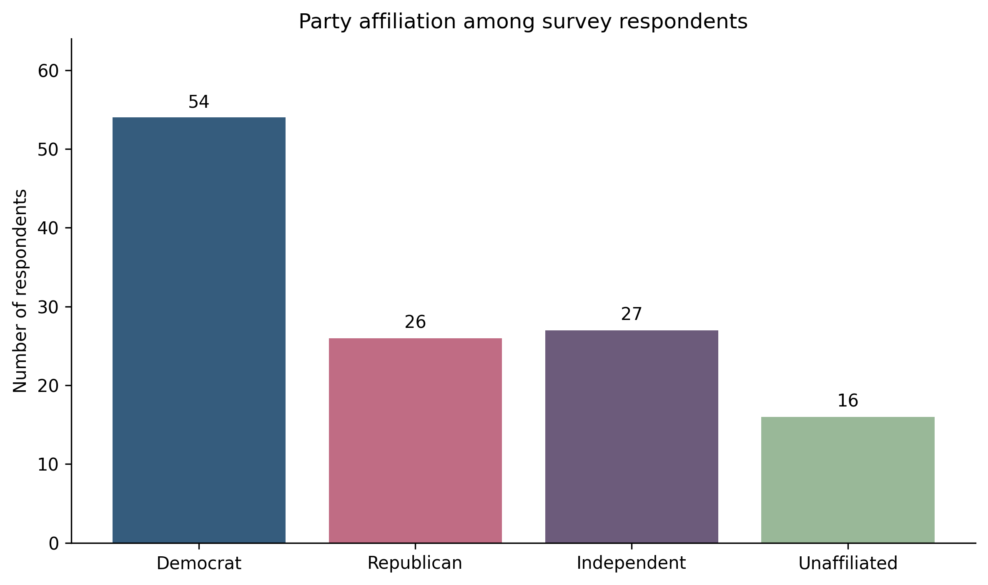
Note. Source: Author survey data.
The main hypothesis is examined in Table 2 and Figure 2. Table 2 presents the cross tabulation between grouped high school categories and the four party affiliation categories. Several descriptive patterns stand out. Among students from traditional public high schools, 46 respondents identify as Democrat, 22 as Independent, 18 as Republican, and 14 as Unaffiliated. Within that group, Democrats account for 46.0 percent and Republicans account for 18.0 percent. By contrast, the non public categories are much more mixed. Among students from traditional private high schools, Democrats and Republicans are tied at three respondents each. In the combined boarding, magnet, and other category, Democrats and Republicans are again tied at five respondents each.
These descriptive results offer weak directional support for the main hypothesis. Students from traditional public schools appear less Republican than students from the combined non public categories. When the high school variable is collapsed into Traditional Public versus Other High School Type, the difference becomes easier to see. Table 3 shows that 46.0 percent of traditional public school respondents identify as Democrat and 18.0 percent identify as Republican. Among all other high school types combined, Democrats and Republicans each account for 34.8 percent of respondents, while 30.4 percent identify as Independent or Unaffiliated. Put differently, the public school group in this sample is less Republican and somewhat more Democratic than the combined non public group.
Table 2
Political Affiliation by Type of High School Attended
 | Traditional Private  (n = 8) | Boarding/Magnet/Other  (n = 15) | Traditional Public  (n = 100)
Democrat | 3 (37.5%) | 5 (33.3%) | 46 (46.0%)
Independent | 2 (25.0%) | 3 (20.0%) | 22 (22.0%)
Republican | 3 (37.5%) | 5 (33.3%) | 18 (18.0%)
Unaffiliated | 0 (0.0%) | 2 (13.3%) | 14 (14.0%)

Figure 2
Party Affiliation by Type of High School Attended
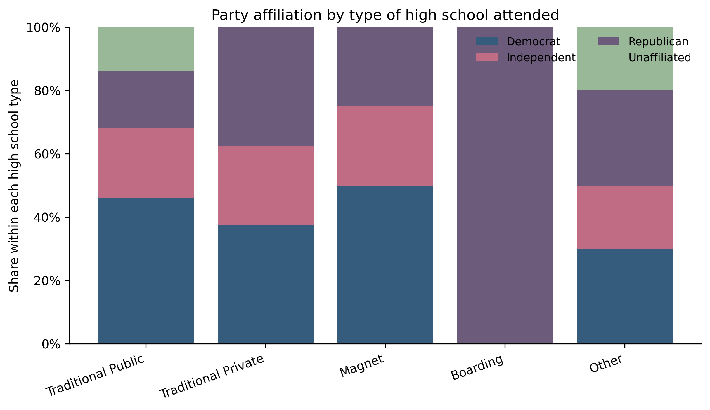
Note. Each bar displays row percentages within a high school type category.
Even so, the statistical evidence remains weak. The chi square test for the collapsed high school type variable and collapsed three category party variable is not statistically significant, χ2(2, N = 123) = 3.19, p = .203. Cramer's V is .16, which indicates only a small association. Because the p value is above conventional significance thresholds, I cannot reject the null hypothesis of independence. In practical terms, that means the observed difference may reflect real tendencies in the sample, but it is not strong enough to conclude with confidence that high school type explains party affiliation among these respondents.
Table 3
Collapsed Party Affiliation by Collapsed Type of High School Attended
 | Other High School Type  (n = 23) | Traditional Public  (n = 100)
Democrat | 8 (34.8%) | 46 (46.0%)
Independent/Unaffiliated | 7 (30.4%) | 36 (36.0%)
Republican | 8 (34.8%) | 18 (18.0%)
Note. Entries are column percentages with raw counts in parentheses. Independent and Unaffiliated are combined for this table.
The alternate hypothesis is examined in Table 4 and Figure 3. Table 4 shows party affiliation across the three responses to whether the respondent has changed party affiliation since registering. Among respondents who have not changed affiliation, Democrats remain the largest group at 43 respondents, followed by Independents at 21, Republicans at 21, and Unaffiliated respondents at 12. Among respondents who have changed affiliation since registering, Democrats again form the largest group at 7 respondents, while Republicans and Independents each account for 4 respondents. Among those not registered to vote, Unaffiliated respondents make up a larger share than in the rest of the sample.
At the descriptive level, the not registered group does look more politically detached. After collapsing Independent and Unaffiliated into one category, 54.5 percent of the not registered group fall into that combined category. That is higher than the comparable share among respondents who have changed affiliation, 26.7 percent, and also higher than the share among respondents who report no change, 34.0 percent. This part of the analysis suggests that not being registered is more closely tied to a looser partisan identity than actually changing party affiliation after registration.
Table 4
Political Affiliation by Whether Respondents Changed Affiliation Since Registering
 | Not registered  to vote  (n = 11) | No  (n = 97) | Yes  (n = 15)
Democrat | 4 | 43 | 7
Independent/Una. | 6 | 33 | 4
Republican | 1 | 21 | 4
Note. Entries are raw counts.
Figure 3
Party Affiliation by Whether Respondents Changed Affiliation Since Registering
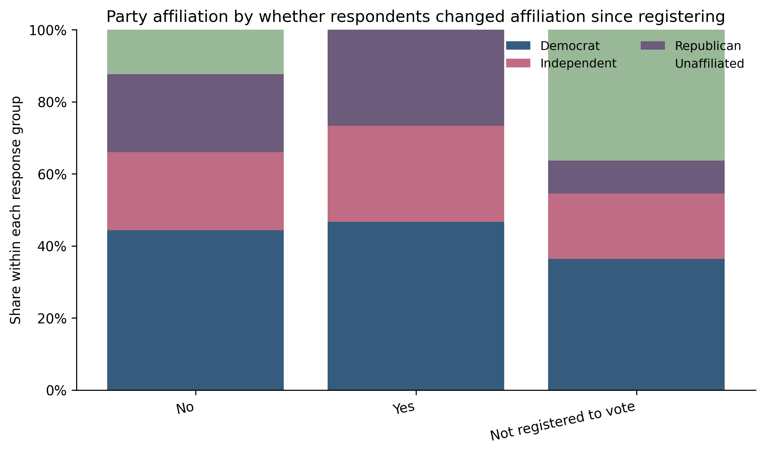
Note. Each bar displays row percentages within a response category.
To introduce the control requested in the feedback, Tables 5 and 6 break the original relationship between high school type and party affiliation down by whether respondents changed affiliation since registering. Because respondents who are not registered to vote cannot meaningfully be classified as having changed affiliation, the control tables focus on the No and Yes groups.
Among respondents who did not change affiliation, traditional public school respondents remain less Republican than students from other school backgrounds. Among respondents who did change affiliation, the same general pattern appears, but the subgroup is very small and should be interpreted cautiously.
Table 5
Political Affiliation by Type of High School Attended Among Respondents Who Did Not Change Affiliation Since Registering
 | Traditional Private  (n = 7) | Boarding/Magnet/Other  (n = 10) | Traditional Public  (n = 80)
Democrat | 2 (28.6%) | 4 (40.0%) | 37 (46.2%)
Independent | 2 (28.6%) | 3 (30.0%) | 28 (35%)
Republican | 3 (42.9%) | 3 (30.0%) | 15 (18.8%)

Table 6
Political Affiliation by Type of High School Attended Among Respondents Who Changed Affiliation Since Registering
 | Traditional Private  (n = 1) | Boarding/Magnet/Other  (n = 3) | Traditional Public  (n = 11)
Democrat | 1 (100.0%) | 1 (33.3%) | 5 (45.5%)
Independent | 0 (0.0%) | 0 (0.0%) | 4 (36.4%)
Republican | 0 (0.0%) | 2 (66.7%) | 2 (18.2%)

Still, the alternate hypothesis is also not supported by the statistical test. The chi square test for changed affiliation status and the collapsed three category party variable is not statistically significant, which indicates a very weak association. This means the pattern across the categories is small and inconsistent. It would be difficult to argue from this sample that party affiliation is strongly explained by whether a student has changed affiliation since registering.
Table 7 summarizes both chi square tests together. The main model involving high school type produces a somewhat larger association than the alternate model involving change since registering, but neither reaches statistical significance. Taken together, the results suggest that high school background may matter more than the alternate explanation in a descriptive sense, but the evidence is still too limited to make a strong claim.
There are several reasons why the results may be modest. The first is sample composition. With more than 80 percent of respondents coming from traditional public high schools, there is limited variation in the main independent variable. A second issue is small cell size. Several school categories contain only a handful of respondents, which reduces the power of the statistical tests and makes the descriptive percentages more volatile. A third issue is that party affiliation is shaped by many factors at once. Even if high school type matters, its effect may be partly absorbed by religion, parental education, race, and local political culture. A bivariate test cannot fully separate these effects.
Even though the findings are not statistically significant, they are still useful. First, they show that the original theory is not unreasonable. The descriptive gap between traditional public and non public school respondents moves in the expected direction. Second, the weak results underscore an important lesson from the political socialization literature. School background may shape political identity, but it likely does so alongside family and community influences rather than by itself. Finally, the results identify clear ways the project could be improved. A larger sample, more precise school categories, and the inclusion of multivariate controls would make the analysis stronger and allow for a more confident test of the theory.
Table 7
Summary of Chi Square Tests
Model | Coding used for test | Chi square | df | p | Cramér's V | N
High school type and party affiliation | Traditional Public vs Other high school type; Democrat, Republican, Independent/Unaffiliated | 3.19 | 2 | 0.20 | 0.16 | 123
Changed affiliation since registering and party affiliation | No, Yes, Not registered; Democrat, Republican, Independent/Unaffiliated | 2.68 | 4 | 0.61 | 0.10 | 123
Note. Chi square tests use collapsed categories because several original cells were too small for a stable test.
Discussion
Although the main and alternate hypotheses are not supported statistically, the results still say something useful about the process of political socialization. A null finding does not mean the theory is meaningless. It may instead mean that the relationship is weaker than expected, indirect, or difficult to detect with a small sample. In this case, the descriptive patterns point in the expected direction, especially when traditional public school respondents are compared with everyone else. What the data do not show is a strong enough difference to conclude that school type on its own explains party affiliation. That is an important distinction. Political identity may be shaped by school environment, but the effect may be filtered through religion, family socialization, local political context, and broader generational tendencies rather than appearing as a large direct relationship.
This matters for how the literature is interpreted. The research reviewed earlier suggests that schools are politically meaningful spaces because they shape students' experiences with authority, belonging, and civic life (Andolina et al., 2003, and Bruch & Soss, 2018). My results do not contradict that claim. Instead, they suggest that the path from school experience to party affiliation may be more complicated than a simple one to one relationship. Schools may influence political engagement more clearly than party identity, or they may influence party identity only when paired with other factors such as family ideology or religious setting. That possibility fits well with the existing literature, which consistently treats political identity as a product of overlapping institutions rather than a single influence (Ojeda & Hatemi, 2015).
The alternate hypothesis also produces a useful takeaway. Students who were not registered to vote appeared more likely to fall into a non major party category, but students who reported changing affiliation since registering did not look dramatically different from those who reported no change. This suggests that weak partisan attachment may be tied more closely to political disengagement than to the act of changing affiliation itself. In other words, registration status may capture political distance more clearly than party switching does in a college sample. That insight could help shape future revisions to the survey instrument. A follow up project might ask when a respondent changed affiliation, why they changed it, and whether that shift came before or after beginning college. Those details would make it easier to separate long term socialization from short term political movement.
Conclusion
This paper asked what explains college students' party affiliation, with a specific focus on the type of high school attended. Drawing from the literature on political socialization, I expected school setting to matter because schools expose students to authority structures, civic norms, peer groups, and sometimes religious environments that may shape political identity. I also tested an alternate explanation based on whether respondents had changed party affiliation since registering to vote.
The results provide only limited support for the main hypothesis. At the descriptive level, students from traditional public high schools in this sample were less likely to identify as Republican than students from other school backgrounds. That pattern is consistent with the theory behind the project. However, the relationship was not statistically significant once tested with a chi square model using collapsed categories. The alternate hypothesis performed even more weakly. While students who were not registered to vote were more likely to fall into an Independent or Unaffiliated category, change in affiliation since registering did not show a strong or significant relationship with current party identity.
The broader implication is that college student party affiliation is probably not explained well by one variable alone. The literature reviewed in this paper points to a more layered process. Family transmission, religion, race, age, and school environment all matter. High school type may still be one part of that story, but this sample does not support treating it as a strong stand alone explanation. Instead, the project suggests that educational background may be better understood as one piece of a larger socialization process.
If I were to continue this research, I would make several changes. I would use a larger and more diverse sample drawn from multiple universities rather than relying mostly on one campus. I would also refine the survey categories so that school type better captures distinctions such as private religious, private secular, charter, homeschool, and public. Finally, I would incorporate multivariate analysis using the control variables already identified in the research design. Even with its limitations, this project contributes to the conversation by testing a plausible explanation for party affiliation and showing where the relationship appears weak, mixed, or in need of further study.

References
Andolina, M. W., Jenkins, K., Zukin, C., & Keeter, S. (2003). Habits from home, lessons from school: Influences on youth civic engagement. PS: Political Science & Politics, 36(2), 275-280.
Bruch, S. K., & Soss, J. (2018). Schooling as a formative political experience: Authority relations and the education of citizens. Perspectives on Politics, 16(1), 36-57.
Ojeda, C., & Hatemi, P. K. (2015). Accounting for the child in the transmission of party identification. American Sociological Review, 80(6), 1150-1174.
Pew Research Center. (2024a, April 9). Age, generational cohorts and party identification.
Pew Research Center. (2024b, April 9). Party identification among religious groups and religiously unaffiliated voters.
Pew Research Center. (2024c, April 9). Partisanship by race, ethnicity and education.
Pew Research Center. (2024d, June 6). U.S. public, private and charter schools in 5 charts.
Woessner, M., & Kelly-Woessner, A. (2020). Why college students drift left: The stability of political identity and relative malleability of issue positions among college students. PS: Political Science & Politics, 53(4), 657-664.
Klofstad, C. A. (2015). The effects of parents, the workplace, and peers on young adults’ political party identification. Political Behavior, 37(4), 869–895.
Tedin, K. L. (1974). The influence of parents on the political attitudes of adolescents. American Political Science Review, 68(4), 1579–1592.
Niemi, R. G., & Jennings, M. K. (1991). Issues and inheritance in the formation of party identification. American Journal of Political Science, 35(4), 970–988.
Hatemi, P. K., & Ojeda, C. (2021). The role of child perception and motivation in political socialization. British Journal of Political Science, 51(3), 1097–1118.
Weinschenk, A. C., & Dawes, C. T. (2022). Civic education in high school and voter turnout in adulthood. British Journal of Political Science, 52(2), 934–948.

