|  |  |
| --- | --- |
| Document Title | **Haptic Knob Interface for LINAC Control** |
| Description | This document describes a generic replacement solution for the UNILAC potiboard control that is compatible with the requirements of a digital control room. |
| Division/ Organisation | ACC/OPE und ACC/LIN |
| Field of Application | FAIR GmbH and GSI GmbH |

**Document History**

|  |  |  |  |  |
| --- | --- | --- | --- | --- |
| Version | Prepared/Checked by | Date | Date of Release | Comments |
| V 1.0 | S. Reimann, A. Bloch-Späth, M. Stein | 2022-02-22 |  | first draft |
| V 2.0 | S. Reimann, A. Bloch-Späth, M. Stein | 2022-03-19 |  | new drawings, more details |
| V 3.0 | S. Reimann | 2022-05-09 |  | Information added after initial presentation and discussion with OPE, LIN and ACO |
| V 4.0 | S. Reimann, A.Bloch-Späth | 2022-XX-XX |  |  |

**Abstract**

Currently, device control at the GSI accelerator UNILAC is done via historical potentiometer boards. The devices are slowly breaking down and are also analog in design. There is therefore a need to develop a sustainable replacement solution. In addition, for the integration into the new FAIR control room, it will be necessary to develop a system that is compatible with a fully digital control room. This document specifies such a solution.

**Table of Contents**

1. Purpose and Classification of the Document 4

2. Abbreviations, Terms and Definitions 4

3. Scope of the Technical System 4

3.1. System Overview 4

3.2. Scope of Delivery 4

3.3. Spare Parts 4

4. System Specification 5

4.1. Technical Requirements for System Components 5

4.2. Functional Requirements (Parameter List) 5

4.3. Interfaces 5

4.4. System Environment and Constraints 9

5. Procedure 9

6. Quality Assurance, Tests and Acceptance 10

**List of Tables:**

none

**List of Figures:**

Figure 1: Schematic example for new potentiometer board

Figure 2: UI-Element for a selected device to be tuned via incremental encoders

Figure 3: Possible implementation within Device Control Application I

Figure 4: Possible implementation within Device Control Application II

Figure 5: Possible implementation within Device Control Application III

# Purpose and Classification of the Document

This document describes the basic requirements for the potiboard control replacement solution to be developed as part of the UNILAC Controls Upgrade Program. It therefore represents a detailed specification. The described solution should also work for other linear accelerators like p-Linac or HELIAC, as well as other applications that need a haptic interface with fast feedback, while there is no need to keep every increment in a database. In this sense, it will be applicable to all accelerator structures of the FAIR project.

# Abbreviations, Terms and Definitions

|  |  |  |
| --- | --- | --- |
| Abbreviation | Meaning | last Change |
| UNILAC | universal linear accelerator | first draft |
| p-Linac | proton linear accelerator | first draft |

<http://www-oracle.gsi.de/pls/cdb/f?p=CDB:1>

# Scope of the Technical System

## System Overview

It is an integrated system, which consists of the following components.

1. A movable device with 4-8 rotary optical incremental (quadrature) encoders and additional knobs
2. A holder by means of which the potentiometers can be integrated in a standard control room table
3. Software integration to select the devices to be controlled and to realize and display the changes of the parameters.

## Scope of Delivery

The system is part of the UNILAC Controls Upgrade Program and is required prior to the move to the FCC.

* 4 ready-to-use tabletop control units with 4-8 incremental encoders each
* Spare parts for 4 additional units
* Compatible Driver software for FCC standard console computers
* GUI software in standard controls environment

## Spare Parts

To guarantee the availability of the system, a minimum quantity of incremental encoders must be available. Four consoles with four incremental encoders each must be permanently available.

# System Specification

The system enables the user to control up to 8 (non ramped) magnets simultaneously via precise incremental encoders. The system is designed for the FAIR main control room.

## Technical Requirements for System Components

The encoders must not be too easy to turn so that the value cannot be changed by accidental touch. The encoder must not be of detent type and have a resolution between 16 and 64 points per rotation. Preferable is an encoder with a manual noticeable rotation torque to lower the risk of not wanted operations.

## Functional Requirements (Parameter List)

The response time (from turning the knob to displaying the effect on the beam) must be about 100ms but must be well below 0.5s.

*Remark: If control via LSA is too slow, direct access at device level would be a possible alternative. While the devices are selected for tuning, data can in this case supplied directly via the device interface (FESA, Device Access) independently of LSA. Data is only supplied via LSA in the moment a device is deselected, or when the potentiometer board is deactivated.*

It must be possible to operate at least four accelerator devices simultaneously from one workstation.

It must be possible to operate several workstations in parallel, each with one such control unit controlling a different or the same accelerator chain.

If the incremental encoder is adjusted e.g. by 360° to the right and back again by 360°, the original value must be reached again.

Different increment sizes for the setpoints can be selected. The selection is valid for all incremental encoders.

## Interfaces

**Interface control unit to control room computers**:

The control unit must be compatible with the standard installation of an HKR/FCC terminal computer. The interface can be USB, LAN or else, as long as all requirements are fulfilled. Should it be necessary to adapt the equipment of the control room terminal computer, care should be taken to select a solution with minimal maintenance requirements.

The control unit must be light and movable so that it can be moved to the side when not needed, like a keyboard.

**Control unit (haptical interface)**:

A control unit should be equipped with preferably eight, but at least four incremental encoders.

To minimize the interactions between mouse and GUI, in addition to the incremental encoders, buttons are required on the control unit. Figure 1 shows a possible realization of a potentiometer board with four rotators.

Button functions are:

* scroll back and forth (per button press by 4 devices to the right or left. In case of individual assignment, move one device to the right or left)
* deactivate the encoders (deactivation deselects all devices and triggers the LSA data supply)
* change the parameter view => volts, BRHO et cetera
* activate and deactivate the master mode (first partner knob controls both devices, second (third, fourth) partner is ignored
* change the increment

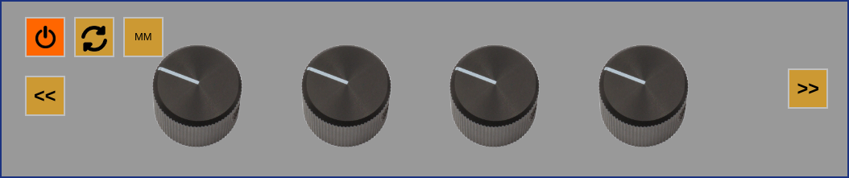

*Figure 1: Example for new potentiometer board: Four encoders and input buttons for scrolling, deactivating, and switching the increment and master mode.*

**Graphical User interface**:

Adjustable accelerator components are displayed depending on the selected chain.

*Remark: The software component could be implemented directly in Device Control Application (figure 4-6). However, a dedicated poti application is also possible.*

The user can move back and forth along the beamline and the incremental encoders can be freely assigned. The assignment is done in the following way:

The selection is made by clicking on the device or by right-clicking via a context menu. The device is assigned to the first free incremental encoder (from the left). The subsequent devices are automatically assigned in the correct order if free encoders are still available. Thus, in the context menu there are 2 possibilities of assignment.

1. assign selected device to free encoder
2. reassign all new starting from selected device on. Incremental encoders can be deselected via an X. *Remark: This action would trigger the LSA data supply.*

For a selected device it is possible to define via another button which parameter is to be set. The following possibilities should be provided:

1. percent of maximum value (for bipolar -100% to +100%).
2. angle/ correction angle (mrad) or gradient (Bl/BRho)
3. current.

For all selected devices a dedicated UI element with the necessary information is displayed (Figure 3). Thereby it is important to see which device has a DC power supply and is not pulsed and which only acts only on the selected chain.

To avoid accidental changes, the encoders can be activated and deactivated at any time.

Ein Bild, das Text enthält.

*Figure 2: Possible UI-Element for a selected device to be tuned via incremental encoders. Left the marking for a DC power supply unit and right for a pulsed one.*

Quadrupoles can be operated in master mode. All increments of the first power supply are taken over by the following quadrupoles of the group. Dipoles can be connected pairwise to be controlled by one controller only to allow a parallel shift of the beam.

Various filters are available in the application. For example, only steerer magnets can be displayed to align the beam, or all devices which are not a power supply can be hidden. Also, not all power supplies are available for the operating on the potentiometer board e.g., the ALVAREZ tank magnets are not displayed by default.

Figure 4-6 shows possible implementations.

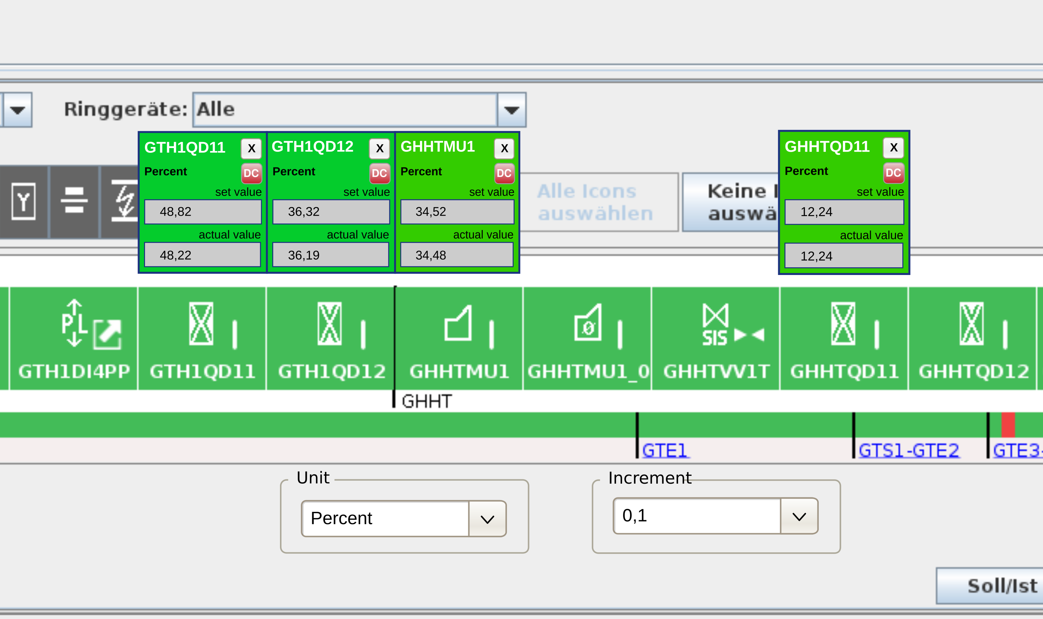

Figure 3: Possible implementation within Device Control Application. All magnet power supplies get a context button "select", which activates the potentiometer control and assigns the next free incremental encoder. Or the user can assign the devices via select field to a special encoder. The disadvantage of this view is, that devices that are not next to each other in the pictogram line cannot be displayed together. Figure 5 and 6 show alternative implementations.

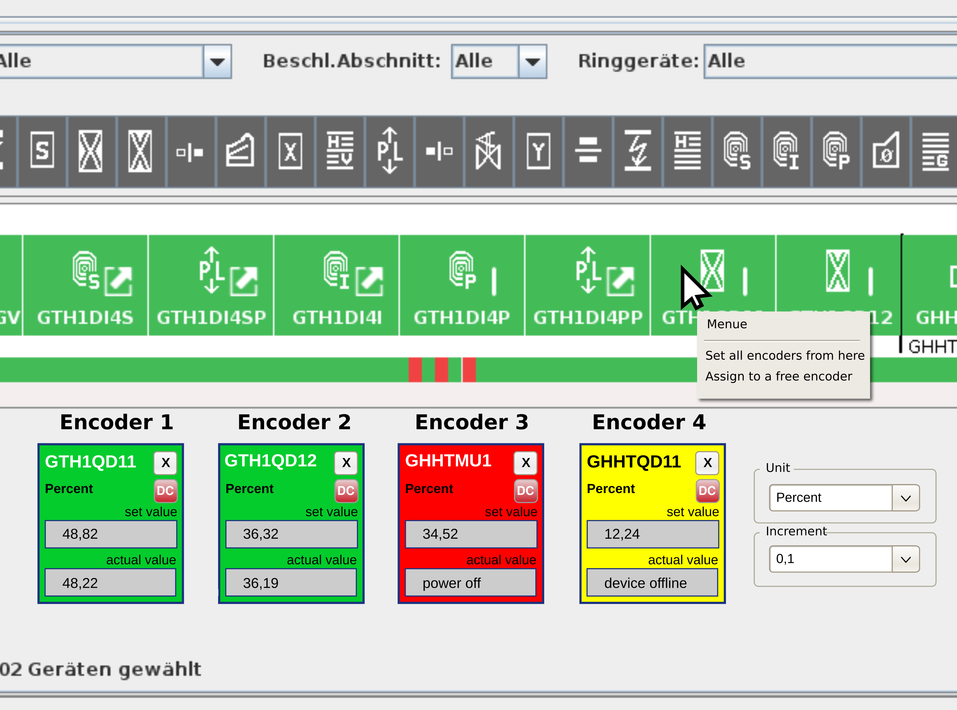

Figure 4: Possible implementation within Device Control Application. When the potentiometer board is active, the assigned devices are displayed below the pictogram line. Alternatively, this display can also be realized as a non-blocking overlay or popup. The select buttons can be realized either above the pictogram line or as an item within a context menu of the device.

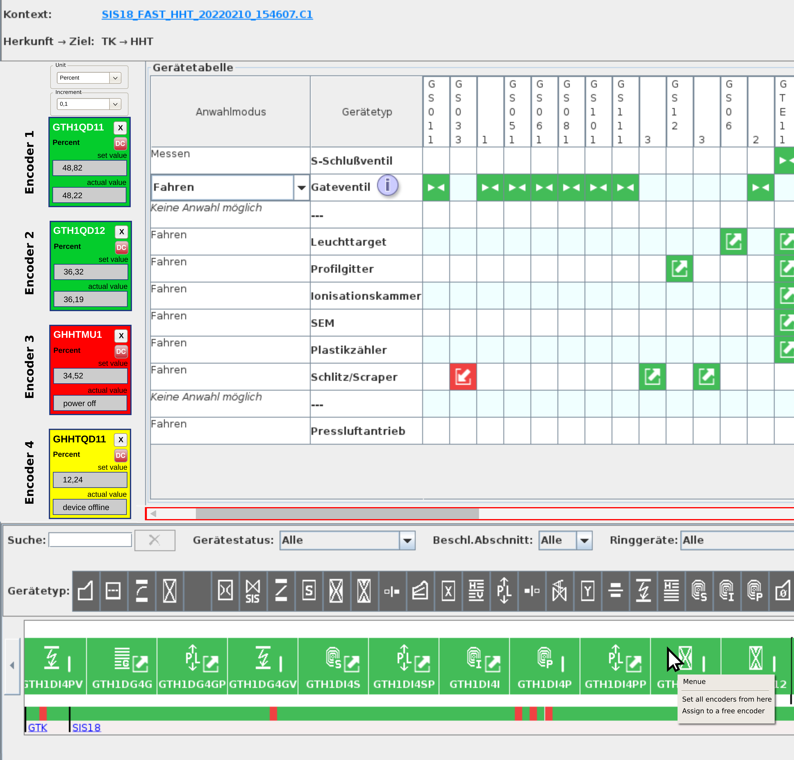

*Figure 5: Another possible implementation within Device Control Application.*

## System Environment and Constraints

The system must be compatible with the control system standards used at GSI. Accordingly, it must be compatible with LSA and FESA/DeviceAccess.

# Procedure

The exact implementation is to be coordinated via an agile process by a product owner from OPE who directly reports to the Project Leader for the UNILAC Controls upgrade.

# Quality Assurance, Tests and Acceptance

The final acceptance is carried out by the operations manager and the machine coordinator UNILAC.