Robert Stein

Project 10

Case Project 1

**Star topology is the main point of failure, if one point goes down near the center of the star topology, all the other nodes will not work. Most large scale networks are best used with mesh topology since there is no one single point of failure. If one link goes down all other nodes will still be working. Also having a single T3 might be detrimental with a large scale network, if that goes down you will have no back up, and a T3 on that scale might not handle all the bandwidth well. Also a single firewall is too little for that scale network, I would suggest a firewall for each department.**

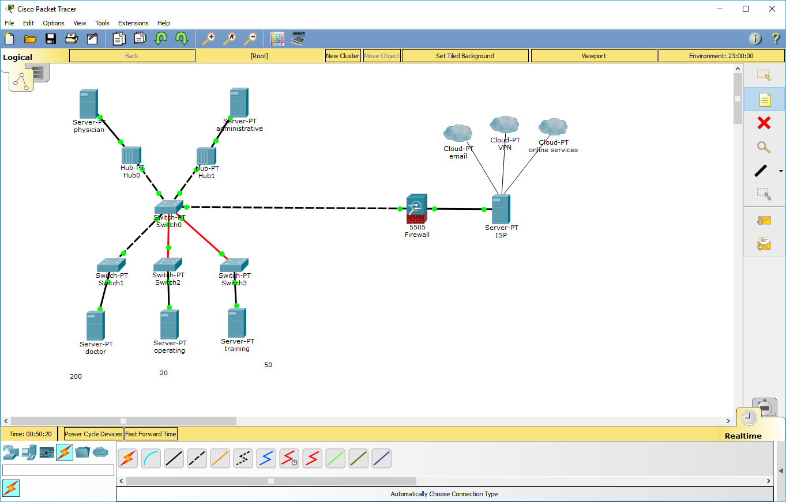

Case Project 2

**I would cut dual T3 internet, or higher internet upgrades. Switching to a mesh network from a star/bus network is absolutely essential. There’s too much redundancy in a star network that is too critical for the network. I would ask if he cares about his patients records, the security is too limited in that size of network to have only one firewall. Spending a little more money on security is absolutely crucial.**

Case Project 3

**DRP Outline:**

**Business continuity: If the network shuts you need to keep your business running, in this document should be all the critical points to keep it running. It should state in the list the critical and necessary business functions, their resource dependencies, and their level of criticality to the overall origination.**

**Battery Backup/UPS: Secondly you’re going to one backup power, so every time a power flicker happens, or power goes out you have a backup that will keep the network running. That’s where and uninterrupted power supply comes in handy.**

**End user awareness and training: Everyone should be trained in the event of a disaster. Some users more than other. You should assign certain people to know where to look for the DRP outline, business continuity plan etc. It would be best to cut your staff into teams for this situation: damage assessment team, recovery team, security team etc.**

**Hopefully there’s enough redundancy in the network to turn the system back online, if not with all your teams you put together working together, network should be restored with everyone doing their job.**