--data Validation & Claening
--Null check
SELECT
SUM(CASE WHEN State IS NULL THEN 1 ELSE 0 END) AS null_state,
SUM(CASE WHEN City IS NULL THEN 1 ELSE 0 END) AS null_city,
SUM(CASE WHEN Order_Date IS NULL THEN 1 ELSE 0 END) AS null_order_date,
SUM(CASE WHEN Restaurant_Name IS NULL THEN 1 ELSE 0 END) AS null_Restaurant_Name,
SUM(CASE WHEN Location IS NULL THEN 1 ELSE 0 END) AS null_location,
SUM(CASE WHEN Dish_Name IS NULL THEN 1 ELSE 0 END) AS null_Dish_name,
SUM(CASE WHEN Price_INR IS NULL THEN 1 ELSE 0 END) as null_price_inr,
SUM(CASE WHEN Rating IS NULL THEN 1 ELSE 0 END) AS null_rating,
SUM(CASE WHEN Rating_Count IS NULL THEN 1 ELSE 0 END) as null_rating_count
from swiggy_data;

--output
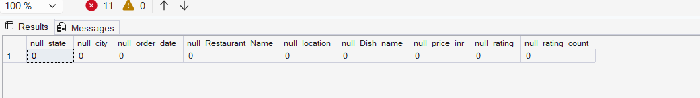

--Blank or Empty Strings
SELECT *
FROM swiggy_data
WHERE
state = ''or city = '' or location = '' or category = '' or rating = '';
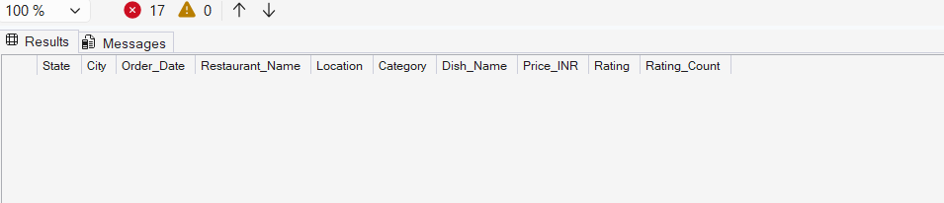

--Duplicate detection
SELECT
state,city,order_date,restaurant_name,location,
category,dish_name,price_inr,rating,rating_count,
count(*) as total_orders
FROM swiggy_data
GROUP BY state,city,order_date,restaurant_name,location,
category,dish_name,price_inr,rating,rating_count
HAVING COUNT(*) > 1;
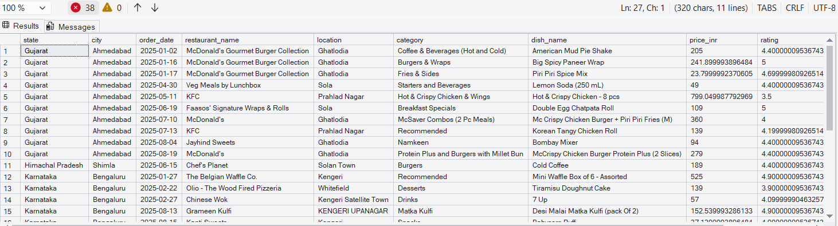

--Delete Duplication

WITH CTE AS (
SELECT *,
ROW_NUMBER() over(partition by state,city,order_date,restaurant_name,location,
category,dish_name,price_inr,rating,rating_count
ORDER BY (SELECT NULL)
) AS rn
from swiggy_data
)
DELETE FROM CTE WHERE rn > 1;
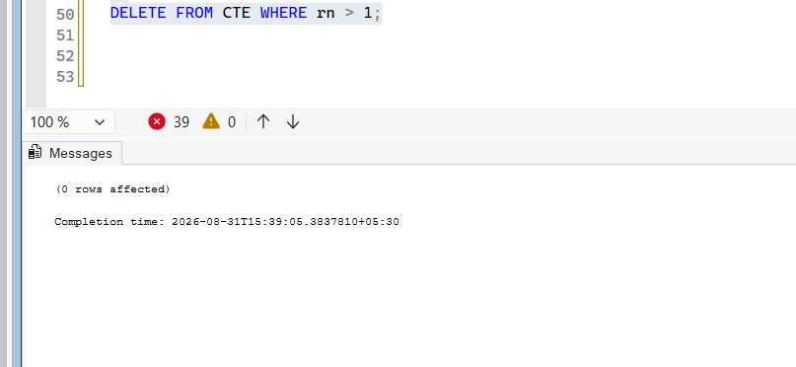
--CREATION SCHEMA
--DIMENSION TABLES
--DATE TABLE

CREATE TABLE dim_date(
date_id int identity(1,1) primary key,
full_date date,
year int,
month int,
month_name varchar(20),
quarter int,
day int,
week int
);

-- INSERT DATA IN TABLES
--DIM DATE
INSERT INTO dim_date (full_date,year,month,month_name,quarter,day,week)
SELECT DISTINCT
order_date,
year(order_date),
month(order_date),
datename(month,order_date),
datepart(quarter,order_date),
day(order_date),
datepart(week,order_date)
from swiggy_data
where order_date is not null;

select * from dim_date;
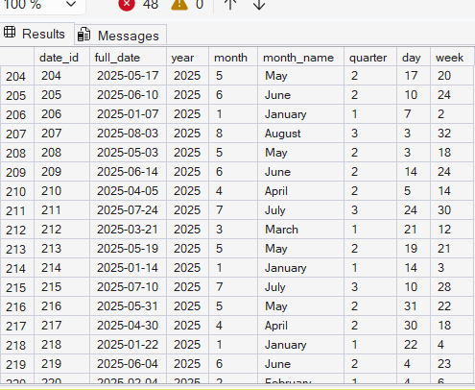

-- Dim_location
CREATE TABLE dim_location(
location_id int identity(1,1) primary key,
state varchar(100),
city varchar(100),
location varchar(200)
);

INSERT INTO dim_location (state,city,location)
SELECT DISTINCT
state,
city,
location
from swiggy_data;

select * from dim_location;
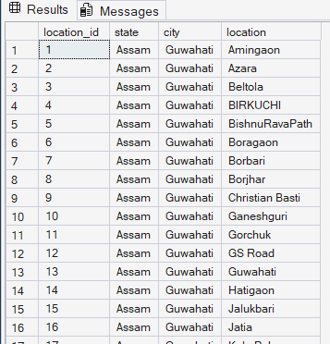

-- Dim_restaurant

CREATE TABLE dim_restaurant (
restaurant_id int identity(1,1) primary key,
restaurant_name varchar(100)
);

INSERT INTO dim_restaurant (restaurant_name)
SELECT DISTINCT
restaurant_name
from swiggy_data;

select * from dim_restaurant;
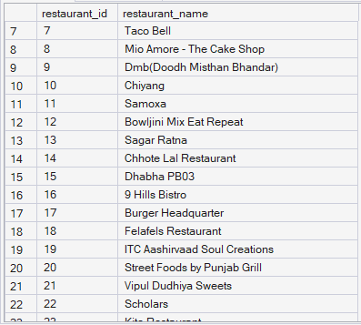

--dim_category

CREATE TABLE dim_category (
category_id int identity(1,1) primary key,
category varchar(200)
);

INSERT INTO dim_category (category)
SELECT DISTINCT
category
from swiggy_data;

select * from dim_category;
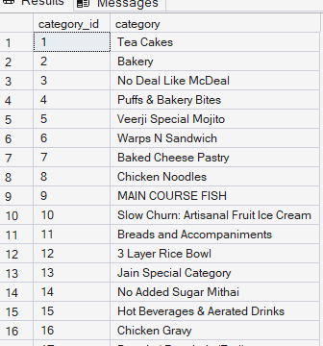

--Dim_Dish

CREATE TABLE dim_dish (
dish_id int identity(1,1) primary key,
dish_name varchar(200)
);

INSERT INTO dim_dish (dish_name)
SELECT DISTINCT
dish_name
from swiggy_data;
select * from dim_dish;

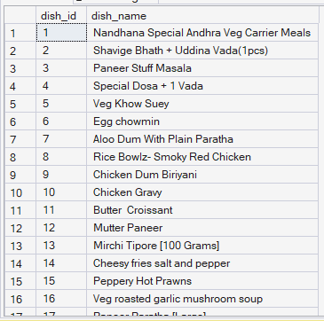

-- fact table

CREATE TABLE fact_swiggy_orders (
order_id int identity(1,1) primary key,

date_id int,
price_inr decimal(10,2),
rating decimal(4,2),
rating_count int,

location_id int,
restaurant_id int,
category_id int,
dish_id int,

FOREIGN KEY (date_id) REFERENCES dim_date(date_id),

FOREIGN KEY (location_id) REFERENCES dim_location(location_id),

FOREIGN KEY (restaurant_id) REFERENCES dim_restaurant(restaurant_id),

FOREIGN KEY (category_id) REFERENCES dim_category(category_id),

FOREIGN KEY (dish_id) REFERENCES dim_dish(dish_id)
);

-- fact_table
INSERT INTO fact_swiggy_orders
(
date_id,
price_inr,
rating,
rating_count,
location_id,
restaurant_id,
category_id,
dish_id
)
SELECT
dd.date_id,
s.price_inr,
s.rating,
s.rating_count,

dl.location_id,
dr.restaurant_id,
dc.category_id,
dsh.dish_id
from swiggy_data s

join dim_date dd
on dd.full_date = s.order_date

join dim_location dl
on dl.state = s.state
and dl.city = s.city
and dl.location = s.location

join dim_restaurant dr
on dr.restaurant_name = s.restaurant_name

join dim_category dc
on dc.category = s.category

join dim_dish dsh
on dsh.dish_name = s.dish_name;

select * from fact_swiggy_orders;

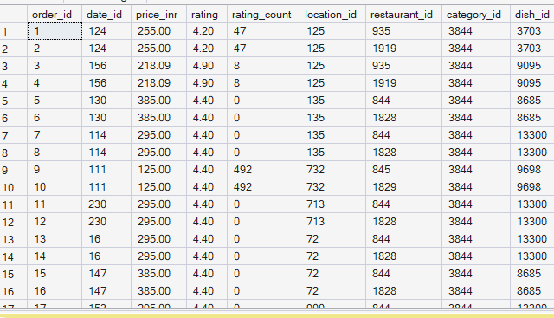

-- join all

SELECT *
FROM fact_swiggy_orders f
JOIN dim_date d
ON f.date_id = d.date_id
JOIN dim_location l
ON f.location_id = l.location_id
JOIN dim_restaurant r
ON f.restaurant_id = r.restaurant_id
JOIN dim_category c
ON f.category_id = c.category_id
JOIN dim_dish di
ON f.dish_id = di.dish_id;
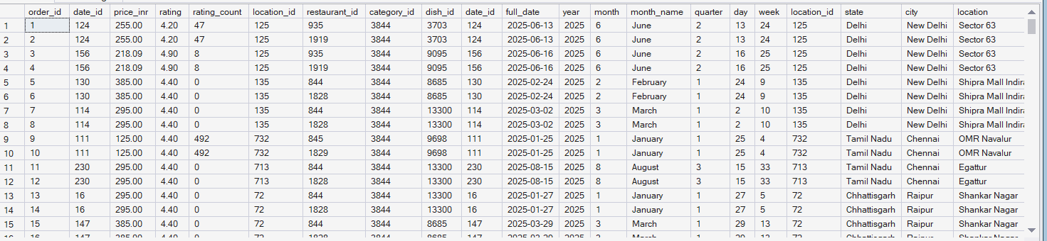

-- KPI'S
-- Total Orders

SELECT COUNT(*) AS total_orders
from fact_swiggy_orders;

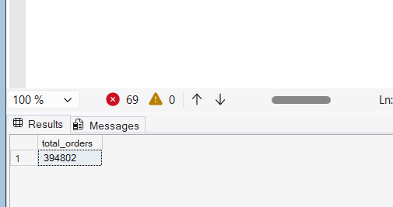

-- Total Revenue (INR Million)

SELECT SUM(PRICE_INR) as total_revenue
from fact_swiggy_orders;

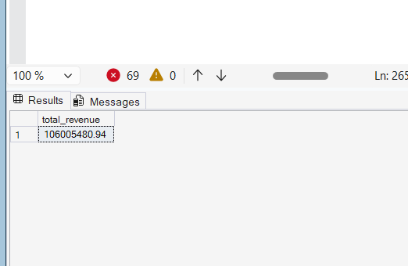
-- Average Dish Price

SELECT
FORMAT(AVG(CONVERT(FLOAT,price_inr)),'N2') + 'INR'
as total_revenue
from fact_swiggy_orders;
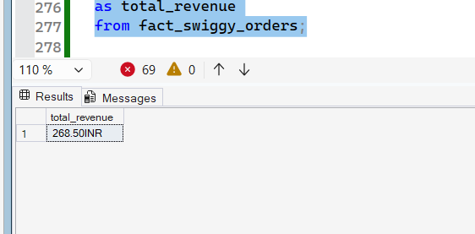

-- Average Rating

SELECT
AVG(RATING)
from fact_swiggy_orders;
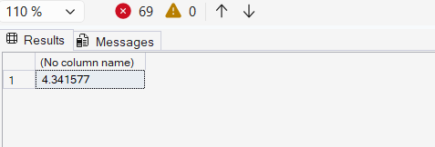

--- Deep-Dive Business Analysis

-- Monthly Order Trends

SELECT
d.year,
d.month,
d.month_name,
COUNT(*) AS total_orders
FROM fact_swiggy_orders f
JOIN dim_date d
ON f.date_id = d.date_id
GROUP BY
d.year,
d.month,
d.month_name
order by count(*) desc;

SELECT
d.year,
d.month,
d.month_name,
sum(Price_inr) AS total_revenue
FROM fact_swiggy_orders f
JOIN dim_date d
ON f.date_id = d.date_id
GROUP BY
d.year,
d.month,
d.month_name
order by sum(price_inr) desc;

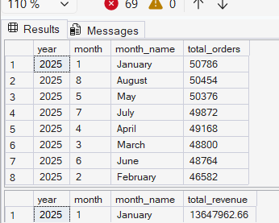

--Quaterly Trend

SELECT
d.year,
d.quarter,
count(*) as total_orders
from fact_swiggy_orders f
JOIN dim_date d on f.date_id = d.date_id
group by d.year,
d.quarter
order by count(*) desc;
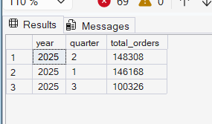

--Yearly Trend

SELECT
d.year,
count(*) as total_orders
from fact_swiggy_orders f
join dim_date d on f.date_id = d.date_id
group by d.year
order by count(*) desc;
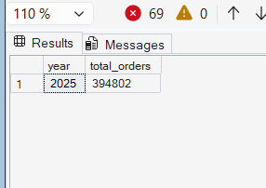

-- Orders by Day Of Week (mon-sun)

select
datename(weekday,d.full_date) as day_name,
count(*) as total_orders
from fact_swiggy_orders f
join dim_date d on f.date_id = d.date_id
group by datename(weekday,d.full_date),datepart(weekday,d.full_date)
order by datepart(weekday,d.full_date);

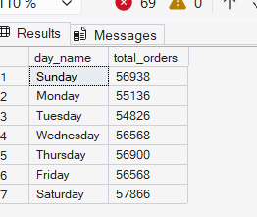

-- Top 10 Cities by order Volume

SELECT top 10
l.city,
count(*) as total_orders from fact_swiggy_orders f
join dim_location l
on l.location_id = f.location_id
group by l.city
order by count(*) desc;
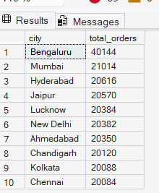

-- Revenue contribution by states

SELECT top 10
l.state,
sum(f.price_inr) as total_orders from fact_swiggy_orders f
join dim_location l
on l.location_id = f.location_id
group by l.state
order by sum(f.price_inr) desc;
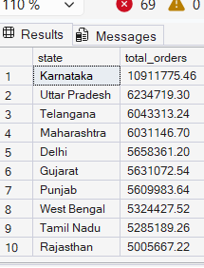

--Top 10 restaurants by orders

SELECT top 10
r.restaurant_name,
sum(f.price_inr) as total_orders from fact_swiggy_orders f
join dim_restaurant r
on r.restaurant_id = f.restaurant_id
group by r.restaurant_name
order by sum(f.price_inr) desc;

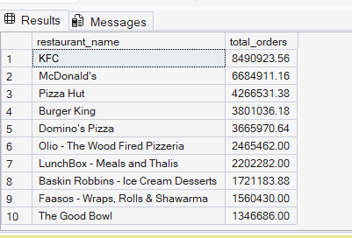

-- Top Categories by Order Volume

select top 10
c.category,
count(*) as total_orders
from fact_swiggy_orders f
join dim_category c on f.category_id = c.category_id
group by c.category
order by total_orders desc;
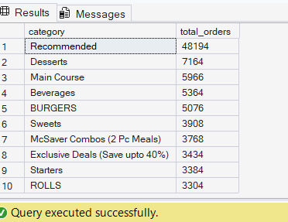

--Most order dish

select top 10
d.dish_name,
count(*) as order_count
from fact_swiggy_orders f
join dim_dish d on f.dish_id = d.dish_id
group by d.dish_name
order by order_count desc;
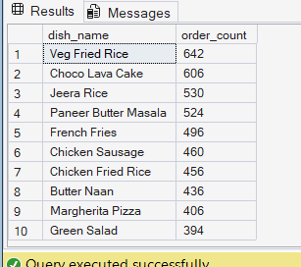

--Cuisine Performance (orders + avg rating)

select
c.category,
count(*) as total_orders,
avg(f.rating) as avg_rating
from fact_swiggy_orders f
join dim_category c on f.category_id = c.category_id
group by c.category
order by total_orders desc;
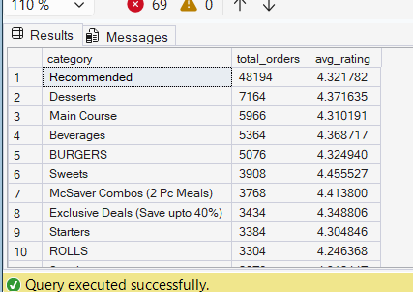

--Total Orders by Price Range

SELECT
CASE
WHEN CONVERT(FLOAT ,PRICE_INR) < 100 THEN 'under 100'
WHEN CONVERT(FLOAT,PRICE_INR) BETWEEN 100 AND 199 THEN '100 - 199'
WHEN CONVERT(FLOAT,PRICE_INR) BETWEEN 200 AND 299 THEN '200 - 299'
WHEN CONVERT(FLOAT,PRICE_INR) BETWEEN 300 AND 499 THEN '300 - 499'
ELSE '500+'
END AS PRICE_RANGE,
COUNT(*) AS TOTAL_ORDERS
FROM fact_swiggy_orders
GROUP BY
CASE
WHEN CONVERT(FLOAT ,PRICE_INR) < 100 THEN 'under 100'
WHEN CONVERT(FLOAT,PRICE_INR) BETWEEN 100 AND 199 THEN '100 - 199'
WHEN CONVERT(FLOAT,PRICE_INR) BETWEEN 200 AND 299 THEN '200 - 299'
WHEN CONVERT(FLOAT,PRICE_INR) BETWEEN 300 AND 499 THEN '300 - 499'
ELSE '500+'
END
ORDER BY TOTAL_ORDERS DESC;

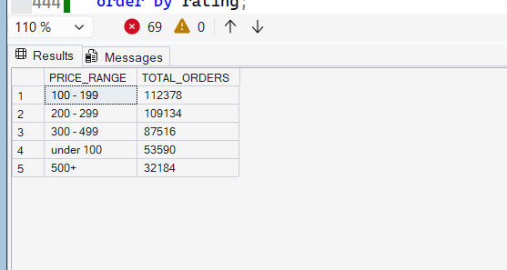

-- Rating Count Distribution (1-5)

select
rating,
count(*) as rating_count
from fact_swiggy_orders
group by rating
order by rating;
