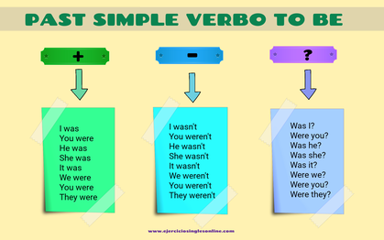

**Transforma las siguientes frases a pasado simple del verbo to be y luego pasar a las formas negativas e interrogativas:**

1. She is at home?

2. My friend and I are always in the garden.

3. I am at home at 7.00 p.m.

4. We are angry.

5. My sister is a doctor.

6. It is a new car.

7. The tv is in the bedroom.

8. My boss is fat

**Pasa las frases a pasado**

**Aquí tienes unas cuantas frases en presente. Escríbelas en**[**pasado**](https://whatsup.es/blog/como-usar-el-pasado-en-ingles-repaso-de-los-tiempos-verbales)

1. *I am not a teacher.*
2. *They are in a party.*
3. *We are in Paraguay.*
4. *He is al the university.*
5. *She is a great doctor.*
6. *You are not on the list.*
7. *This is not a cat.*
8. *You are blonde*

**Rellena los huecos**

**Completa estas frases con las palabras necesarias para que estén expresadas en pasado simple:**

1. *We ______________ in Canberra last spring.*
2. *Jamie ______________ 25 last June.*
3. *You ______________ very busy on Friday.*
4. *I ______________ at home yesterday.*
5. *______________ you at work this morning?*
6. *He ______________ not surprised by the present.*
7. *It ______________ not very dangerous.*
8. *She ______________ interested in science.*