In [14]:
import pandas as pd
import seaborn as sns
import matplotlib.pyplot as plt

# Load iris dataset
df = sns.load_dataset('iris')

# Display data
df.head()

Out[14]:
sepal_length | sepal_width | petal_length | petal_width | species

0 5.1 3.5 1.4 0.2 setosa
1
4.9
3.0
1.4
0.2 setosa
2 4.7 3.2 1.3 0.2 setosa
3
4.6
3.1
1.5
0.2 setosa
4 5.0 3.6 1.4 0.2 setosa

In [15]:
df.info()
<class 'pandas.core.frame.DataFrame'> RangeIndex: 150 entries, 0 to 149
Data columns (total 5 columns):
# Column Non-Null Count Dtype

0 |  | sepal_length | 150 | non-null |  | float64
1 |  | sepal_width | 150 | non-null |  | float64
2 |  | petal_length | 150 | non-null |  | float64
3 |  | petal_width | 150 | non-null |  | float64
4 |  | species | 150 | non-null |  | object
dtypes: float64(4), object(1) memory usage: 6.0+ KB

In [16]:
df.hist(figsize=(10,8),grid=False)
plt.suptitle("Histograms of Iris Features") plt.show()

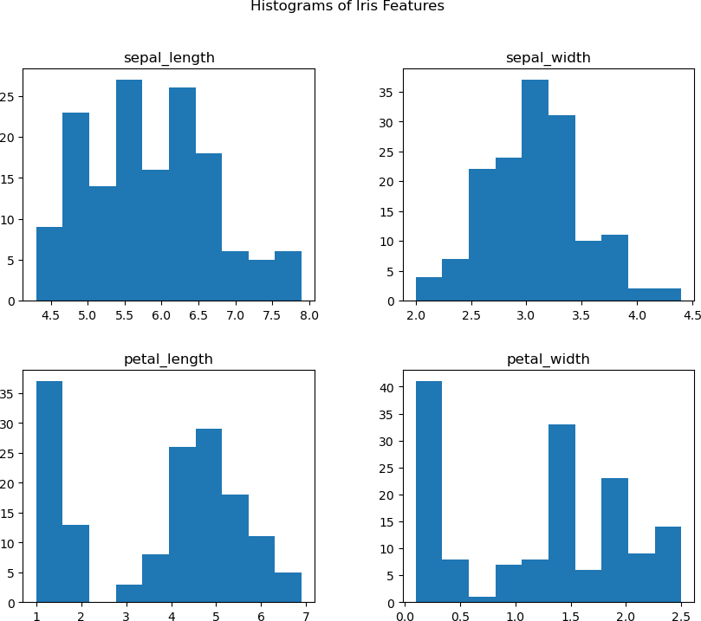

In [17]:
fig, axes = plt.subplots(2, 2, figsize=(16,9))
axes[0,0].set_title("Distribution of Sepal Length")
sns.boxplot( y="sepal_length", x= "species", data=df, axes[0,1].set_title("Distribution of Sepal Length")
sns.boxplot( y="sepal_width", x= "species", data=df, axes[1,0].set_title("Distribution of Sepal Length")
sns.boxplot( y="petal_length", x= "species", data=df, axes[1,1].set_title("Distribution of Sepal Length")
sns.boxplot( y="petal_width", x= "species", data=df,
plt.show()
orient='v' , ax=axes[0,
orient='v' , ax=axes[0, 1
orient='v' , ax=axes[1, orient='v' , ax=axes[1, 1

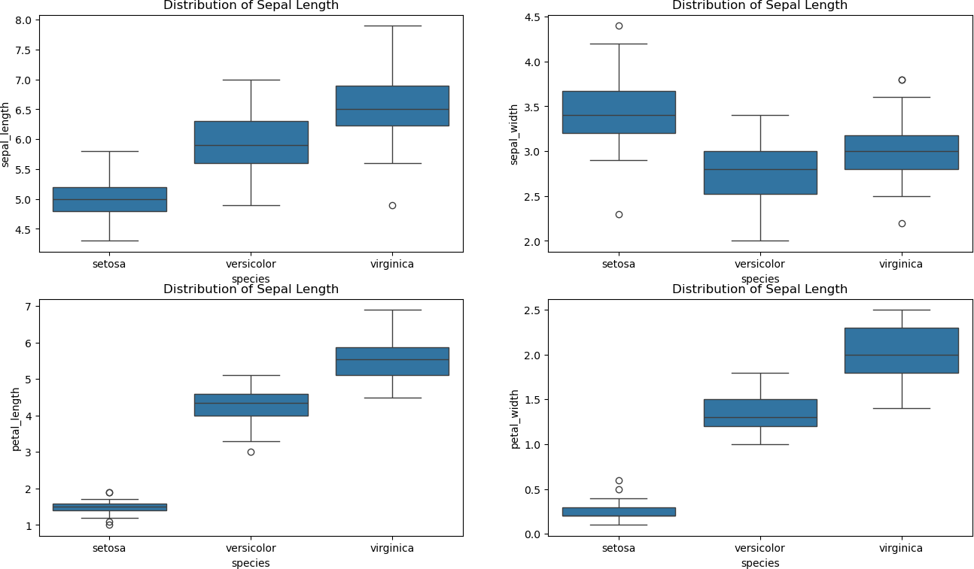

In [ ]:

