In [8]:
import seaborn as sns
import matplotlib.pyplot as plt

# Load dataset
data = sns.load_dataset('titanic')

# View first rows
#print(titanic.head())
data.head()

l
Out[8]: | survived |  | pclass | sex | age | sibsp | parch | fare | embarked | class | who | adu
 | 0 | 0 | 3 | male | 22.0 | 1 | 0 | 7.2500 | S | Third | man
 | 1 | 1 | 1 | female | 38.0 | 1 | 0 | 71.2833 | C | First | woman
 | 2 | 1 | 3 | female | 26.0 | 0 | 0 | 7.9250 | S | Third | woman
 | 3 | 1 | 1 | female | 35.0 | 1 | 0 | 53.1000 | S | First | woman
 | 4 | 0 | 3 | male | 35.0 | 0 | 0 | 8.0500 | S | Third | man

C C

Find patterns in Titanic dataset

In [19]:
# Survival count by gender
sns.countplot(x='sex', hue='survived', data=titanic) plt.title("Survival Count by Gender")
plt.show()

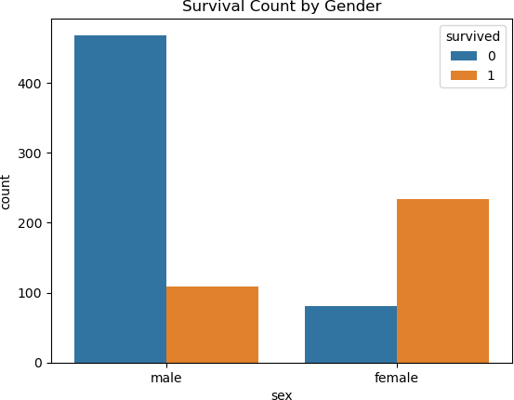

In [20]:
# Survival by passenger class
sns.countplot(x='pclass', hue='survived', data=titanic) plt.title("Survival by Class")
plt.show()

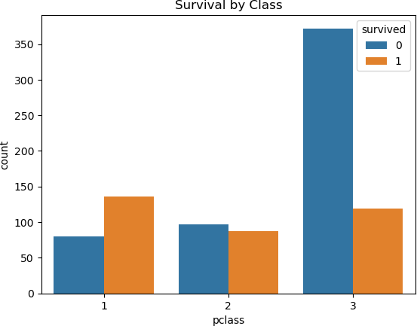

In [22]:
# Age distribution of passengers
sns.histplot(titanic['age'].dropna(), kde=True) plt.title("Age Distribution")
plt.show()

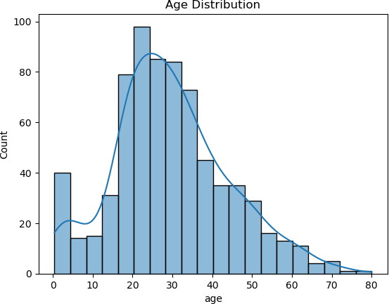

2. Histogram of Fare (Ticket Price Distribution)

In [17]:
plt.figure(figsize=(8,5))
sns.histplot(titanic['fare'], bins=30, kde=True)

plt.title("Distribution of Fare (Ticket Price)") plt.xlabel("Fare")
plt.ylabel("Frequency")

plt.show()

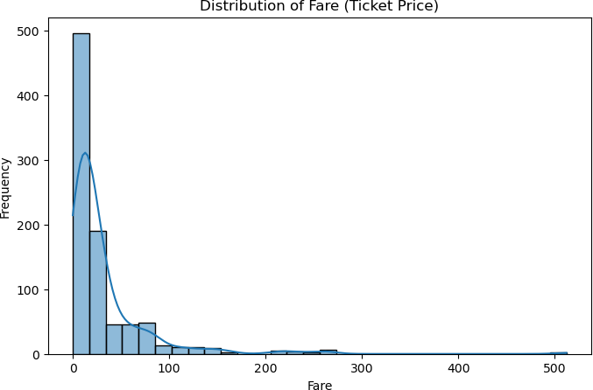

In [ ]:

