Data Visualization II
- Use the inbuilt dataset 'titanic' as used in the above problem. Plot a box plot for distribution of age with respect to each gender along with the information about whether they survived or not. (Column names : 'sex' and 'age')
- Write observations on the inference from the above statistics.

In [1]:
import seaborn as sns
import matplotlib.pyplot as plt

In [2]:
titanic = sns.load_dataset('titanic')

In [3]:
# Boxplot
sns.boxplot(x='sex', y='age', hue='survived', data=titanic)

plt.title("Age Distribution by Gender and Survival") plt.xlabel("Gender")
plt.ylabel("Age")

plt.show()

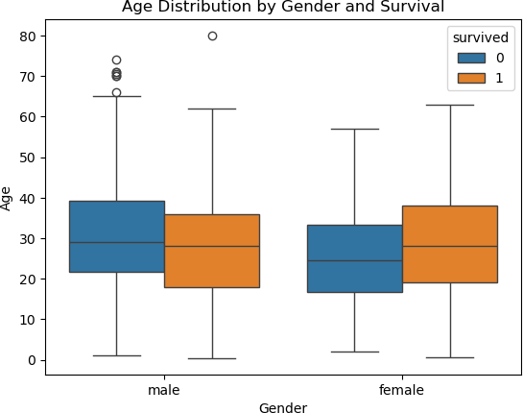

In [6]:
Q1 = titanic['age'].quantile(0.25) Q3 = titanic['age'].quantile(0.75)
IQR = Q3 - Q1

# Define limits
lower = Q1 - 1.5 * IQR upper = Q3 + 1.5 * IQR

# Filter data
titanic_clean = titanic[(titanic['age'] >= lower) & (titanic['age'] <= upper)]

In [9]:
print(lower) print(upper)

-6.6875
64.8125

In [13]:
sns.boxplot(x='sex', y='age', hue='survived', data=titanic_clean) plt.show()
#showfliers=False

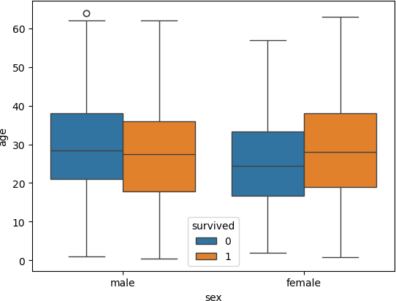

In [ ]:

