Import Libraries

In [22]:
import pandas as pd
import numpy as np
import matplotlib.pyplot as plt

from sklearn.model_selection import train_test_split
from sklearn.linear_model import LinearRegression
from sklearn.metrics import mean_squared_error, r2_score

Load Dataset

In [23]:
df = pd.read_csv('BostonHousing.csv') df.head()

Out[23]: | crim | zn | indus | chas | nox | rm | age | dis | rad | tax | ptratio | b | lsta
 | 0 0.00632 | 18.0 | 2.31 | 0 | 0.538 | 6.575 | 65.2 | 4.0900 | 1 | 296 | 15.3 | 396.90 | 4.9
 | 1 0.02731 | 0.0 | 7.07 | 0 | 0.469 | 6.421 | 78.9 | 4.9671 | 2 | 242 | 17.8 | 396.90 | 9.1
 | 2 0.02729 | 0.0 | 7.07 | 0 | 0.469 | 7.185 | 61.1 | 4.9671 | 2 | 242 | 17.8 | 392.83 | 4.0
 | 3 0.03237 | 0.0 | 2.18 | 0 | 0.458 | 6.998 | 45.8 | 6.0622 | 3 | 222 | 18.7 | 394.63 | 2.9
 | 4 0.06905 | 0.0 | 2.18 | 0 | 0.458 | 7.147 | 54.2 | 6.0622 | 3 | 222 | 18.7 | 396.90 | 5.3
C C

In [24]:
df.columns
#property

Out[24]:

In [25]:

In [26]:
x
Index(['crim', 'zn', 'indus', 'chas', 'nox', 'rm', 'age', 'dis', 'rad', 'tax', 'ptratio', 'b', 'lstat', 'medv'],
dtype='object')
# all independent but medv is dependent [medv value predict kraychi depending on

x= df[['crim', 'zn', 'indus', 'chas', 'nox', 'rm', 'age', 'dis', 'rad', 'tax', 'ptratio', 'b', 'lstat']]
y=df['medv']

Out[26]: | crim | zn | indus | chas | nox | rm | age | dis | rad | tax | ptratio | b | l
 | 0 0.00632 | 18.0 | 2.31 | 0 | 0.538 | 6.575 | 65.2 | 4.0900 | 1 | 296 | 15.3 | 396.90
 | 1 0.02731 | 0.0 | 7.07 | 0 | 0.469 | 6.421 | 78.9 | 4.9671 | 2 | 242 | 17.8 | 396.90
 | 2 0.02729 | 0.0 | 7.07 | 0 | 0.469 | 7.185 | 61.1 | 4.9671 | 2 | 242 | 17.8 | 392.83
 | 3 0.03237 | 0.0 | 2.18 | 0 | 0.458 | 6.998 | 45.8 | 6.0622 | 3 | 222 | 18.7 | 394.63
 | 4 0.06905 | 0.0 | 2.18 | 0 | 0.458 | 7.147 | 54.2 | 6.0622 | 3 | 222 | 18.7 | 396.90
 | ... ... | ... | ... | ... | ... | ... | ... | ... | ... | ... | ... | ...
 | 501 0.06263 | 0.0 | 11.93 | 0 | 0.573 | 6.593 | 69.1 | 2.4786 | 1 | 273 | 21.0 | 391.99
 | 502 0.04527 | 0.0 | 11.93 | 0 | 0.573 | 6.120 | 76.7 | 2.2875 | 1 | 273 | 21.0 | 396.90
 | 503 0.06076 | 0.0 | 11.93 | 0 | 0.573 | 6.976 | 91.0 | 2.1675 | 1 | 273 | 21.0 | 396.90
 | 504 0.10959 | 0.0 | 11.93 | 0 | 0.573 | 6.794 | 89.3 | 2.3889 | 1 | 273 | 21.0 | 393.45
 | 505 0.04741 | 0.0 | 11.93 | 0 | 0.573 | 6.030 | 80.8 | 2.5050 | 1 | 273 | 21.0 | 396.90

506 rows × 13 columns
C
C

In [27]:
y

Out[27]:

In [28]:
#train_test_split() method return this 4 values #test_size kiti madhe split kraych 0.20(20%)

x_train,x_test,y_train,y_test=train_test_split(x,y,test_size=0.2,random_state=42
0 24.0
1 21.6
2 34.7
3 33.4
4 36.2
...
501 22.4
502 20.6
503 23.9
504 22.0
505 11.9
Name: medv, Length: 506, dtype: float64

model train and test [main dataset split 80% train , 20% test]

Create Linear Regression Model

In [29]:
# find the relation between x_train and y and fit in model
model = LinearRegression() model.fit(x_train, y_train)

Out[29]:

Parameters
i ?
ssion
▾ LinearRegre

Predict Values

In [30]:
y_pred = model.predict(x_test)

In [31]:
y_pred
#jevdha testing data hota tyachi data sathi y value

Out[31]:

In [32]:

Out[32]:

In [33]:

Out[33]:

In [34]:

Out[34]:

In [41]:
# Scatter plot
plt.scatter(y_test, y_pred, color='green',marker='*')

# Add perfect prediction line (diagonal line)
plt.plot([y_test.min(), y_test.max()],
[y_test.min(), y_test.max()],
array([28.99672362, 36.02556534, 14.81694405, 25.03197915, 18.76987992,
23.25442929, 17.66253818, 14.34119 , 23.01320703, 20.63245597,

24.90850512, | 18.63883645, | -6.08842184, | 21.75834668, | 19.23922576,
26.19319733, | 20.64773313, | 5.79472718, | 40.50033966, | 17.61289074,
27.24909479, | 30.06625441, | 11.34179277, | 24.16077616, | 17.86058499,
15.83609765, | 22.78148106, | 14.57704449, | 22.43626052, | 19.19631835,
22.43383455, | 25.21979081, | 25.93909562, | 17.70162434, | 16.76911711,
16.95125411, | 31.23340153, | 20.13246729, | 23.76579011, | 24.6322925 ,
13.94204955, | 32.25576301, | 42.67251161, | 17.32745046, | 27.27618614,
16.99310991, | 14.07009109, | 25.90341861, | 20.29485982, | 29.95339638,
21.28860173, | 34.34451856, | 16.04739105, | 26.22562412, | 39.53939798,
22.57950697, | 18.84531367, | 32.72531661, | 25.0673037 , | 12.88628956,
22.68221908, | 30.48287757, | 31.52626806, | 15.90148607, | 20.22094826,
16.71089812, | 20.52384893, | 25.96356264, | 30.61607978, | 11.59783023,
20.51232627, | 27.48111878, | 11.01962332, | 15.68096344, | 23.79316251,
6.19929359, | 21.6039073 , | 41.41377225, | 18.76548695, | 8.87931901,
20.83076916, | 13.25620627, | 20.73963699, | 9.36482222, | 23.22444271,
31.9155003 , | 19.10228271, | 25.51579303, | 29.04256769, | 20.14358566,
25.5859787 , | 5.70159447, | 20.09474756, | 14.95069156, | 12.50395648,
20.72635294, | 24.73957161, | -0.164237 , | 13.68486682, | 16.18359697,
22.27621999, | 24.47902364])
#compare
model.score(x_train,y_train)
0.7508856358979673
model.score(x_test,y_test)
#accuracy value
0.6687594935356301
#find error [error kiti yet aahe konti aahe]
# mean_squared_error() --> actual value and predict madhe difference gheun ty #mean error
np.sqrt(mean_squared_error(y_test,y_pred))
np.float64(4.92860218266535)

color='green', linewidth=2)

# Labels
plt.xlabel("Actual Price")
plt.ylabel("Predicted Price")
plt.title("Actual vs Predicted House Prices")

# Show graph
plt.show()
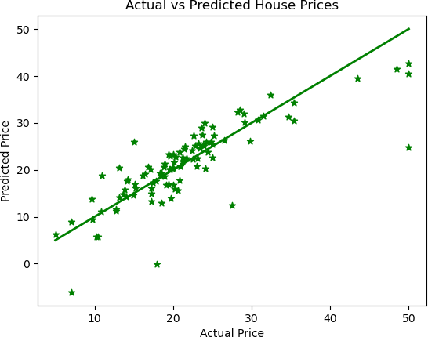

In [44]:
plt.scatter(df['rm'], df['medv']) plt.xlabel("Number of Rooms")
plt.ylabel("House Price")
plt.title("Rooms vs Price") plt.show()

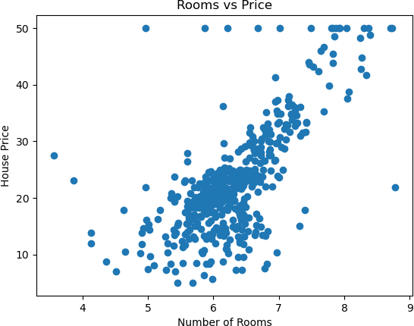

In [ ]:

