Logistic Regression using Python (Social_Network_Ads.csv)

Step 1: Import Libraries

In [1]:
import pandas as pd
import numpy as np
import matplotlib.pyplot as plt

from sklearn.model_selection import train_test_split from sklearn.linear_model import LogisticRegression from sklearn.metrics import confusion_matrix

Load Dataset

In [2]:
df = pd.read_csv('Social_Network_Ads.csv') print(df.head())

 |  | User ID | Gender | Age | EstimatedSalary | Purchased
0 |  | 15624510 | Male | 19 | 19000 | 0
1 |  | 15810944 | Male | 35 | 20000 | 0
2 |  | 15668575 | Female | 26 | 43000 | 0
3 |  | 15603246 | Female | 27 | 57000 | 0
4 |  | 15804002 | Male | 19 | 76000 | 0
 |  | 3. Select Features and Target
In | [3]: | X = df[['Age', 'EstimatedSalary']] y = df['Purchased']
 |  | 4. Split Data
In | [4]: | X_train, X_test, y_train, y_test = train_test_split( X, y, test_size=0.25, rando
 |  | 5. Feature Scaling
In | [5]: | from sklearn.preprocessing import StandardScaler sc = StandardScaler()
 |  | X_train = sc.fit_transform(X_train) X_test = sc.transform(X_test)
 |  | 6. Train Logistic Regression Model
In | [6]: | model = LogisticRegression() model.fit(X_train, y_train)
Out[6]:

Parameters
i ?
ession
▾ LogisticRegr

 |  | 7. Predict
In | [7]: | y_pred = model.predict(X_test)
 |  | 2. Confusion Matrix & Metrics
In | [8]: | cm = confusion_matrix(y_test, y_pred) print("Confusion Matrix:\n", cm)
Confusion Matrix: [[65 3]
[ 8 24]]

In [9]:
# Extract values
TN, FP, FN, TP = cm.ravel()

In [10]:
# Calculate Metrics
accuracy = (TP + TN) / (TP + TN + FP + FN)
error_rate = (FP + FN) / (TP + TN + FP + FN) precision = TP / (TP + FP)
recall = TP / (TP + FN)

In [11]:
print("Accuracy:", accuracy)
print("Error Rate:", error_rate) print("Precision:", precision)
print("Recall:", recall)

Accuracy: 0.89
Error Rate: 0.11
Precision: 0.8888888888888888
Recall: 0.75

In [12]:
import matplotlib.pyplot as plt

# Values
metrics = ['Accuracy', 'Error Rate', 'Precision', 'Recall'] values = [accuracy, error_rate, precision, recall]

# Simple bar chart
plt.bar(metrics, values)

plt.title("Performance Metrics") plt.show()

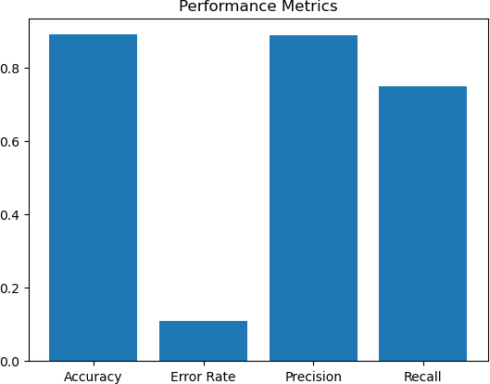

In [ ]:

