In [37]:
import pandas as pd
import numpy as np
import matplotlib.pyplot as plt

from sklearn.model_selection import train_test_split
from sklearn.naive_bayes import GaussianNB
from sklearn.metrics import confusion_matrix ,ConfusionMatrixDisplay

GaussianNB → Naïve Bayes model confusion_matrix → evaluate model

2: Load Dataset
In | [38]: | df = pd.read_csv('iris.csv') print(df.head())
sepal.length sepal.width petal.length petal.width variety
0 5.1 3.5 1.4 0.2 Setosa
1 4.9 3.0 1.4 0.2 Setosa
2 4.7 3.2 1.3 0.2 Setosa
3 4.6 3.1 1.5 0.2 Setosa
4 5.0 3.6 1.4 0.2 Setosa

In [39]:
df.columns

Out[39]:

In [40]:
X = df[['sepal.length', 'sepal.width', 'petal.length', 'petal.width']] #independ
y = df['variety']
Index(['sepal.length', 'sepal.width', 'petal.length', 'petal.width', 'variety'],
dtype='object')

3: Select Features & Target

 |  | 4: Split Dataset
In | [41]: | X_train, X_test, y_train, y_test = train_test_split(X, y, test_size=0.25, random
In | [42]: | #random_state → same result every time
 |  | 5: Apply Naïve Bayes
In | [43]: | model = GaussianNB()  model.fit(X_train, y_train) #using traing data train model

Out[43]:
▾ GaussianNB
i ?
Parameters

6: Prediction

In [44]:
y_pred = model.predict(X_test)

In [60]:
y_pred

Out[60]:

In [45]:

Out[45]:

In [51]:
[[13 | 0 | 0]
[ 0 | 16 | 0]
[ 0 | 0 | 9]]

In [52]:
TN=cm[0][0]
TP=cm[1][1]
FN=cm[1][0]
FP=cm[0][1]
print(f"TN:{TN}")
print(f"FN:{FN}")
print(f"FP:{FP}")
print(f"TP:{TP}")
array(['Virginica', 'Versicolor', 'Setosa', 'Virginica', 'Setosa',
'Virginica', 'Setosa', 'Versicolor', 'Versicolor', 'Versicolor', 'Virginica', 'Versicolor', 'Versicolor', 'Versicolor',
'Versicolor', 'Setosa', 'Versicolor', 'Versicolor', 'Setosa', 'Setosa', 'Virginica', 'Versicolor', 'Setosa', 'Setosa',
'Virginica', 'Setosa', 'Setosa', 'Versicolor', 'Versicolor', 'Setosa', 'Virginica', 'Versicolor', 'Setosa', 'Virginica',
'Virginica', 'Versicolor', 'Setosa', 'Versicolor'], dtype='<U10')
plt.scatter(y_test,y_pred)
<matplotlib.collections.PathCollection at 0x224fbbe7750>
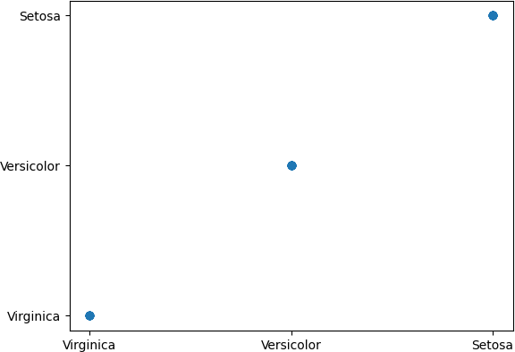

7: Confusion Matrix
cm = confusion_matrix(y_test, y_pred) print(cm)

TN:13 FN:0 FP:0 TP:16

In [53]:
confuDisp=ConfusionMatrixDisplay(cm)

In [54]:
confuDisp.plot()

Out[54]:

In [ ]:
<sklearn.metrics._plot.confusion_matrix.ConfusionMatrixDisplay at 0x224fbe6d950
>
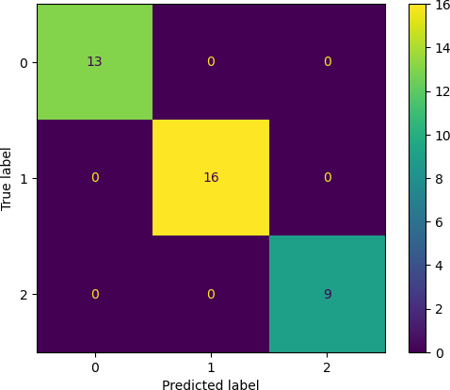

8: Accuracy

In [55]:
acc=(TP+TN)/(TP+TN+FP+FN)
print(acc)

1.0

In [ ]:

9: Error Rate

In [56]:
error_rate = 1 - acc
print("Error Rate:", error_rate)

Error Rate: 0.0

Precision

In [58]:
pre=TP/(TP+FP)
print(pre)

1.0

Recall

In [59]:
recall=TP/(TP+FN) print(recall)

1.0

In [ ]:

