

| ARCHITECTURE ASSESSMENT

<Customer Name>
Architecture Gaps and Recommendations

Draft for validation | Version <version> | <date>
Prepared by <Enterprise Architecture / Customer Success Engineering>

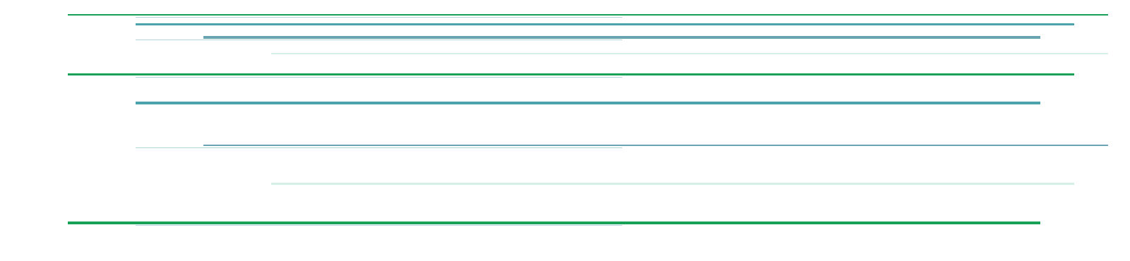

About this architecture assessment
This report assesses the fitness of <Customer> architecture against the outcomes represented in the reviewed Architecture Blueprint and the current/target conditions recorded in the Architecture Blueprint Review.
The assessment distinguishes incomplete information from evidenced architecture mismatches and presents each material finding together with its corresponding architecture response. It is intended as a structured basis for architecture discussion and planning rather than an audit verdict unless explicitly scoped otherwise.
How to read this document
Each detailed assessment is presented vertically. The Architecture finding explains the evidence, material mismatch and impact. The Recommendation follows immediately with the target direction, response path, benefits and validation/acceptance points.

Scope
• <Architecture domain / platform scope>
• <Business / data-service scope>
• <Explicit exclusions>

Evidence rule
A finding is recorded as a gap only when the expected architecture condition is sufficiently clear, the current condition is sufficiently evidenced, and a material mismatch can be stated. Unknown or undocumented information remains a coverage finding or Validation Item.
Assessment principle
Unknown is not automatically a gap. Evidence of a material mismatch creates a Candidate Gap; confirmation is required before the gap is treated as Active.

Table of Contents
About this architecture assessment
Executive assessment
Assessment approach and classification
Findings and recommendations at a glance
Detailed architecture findings and recommended responses
Cross-gap architecture themes
Validation items and evidence to capture
Aggregated architecture conclusions
Assessment disposition
Document status

Executive assessment
<Summarize the overall architecture position, what is already strong, the material review findings, and the dominant target-state themes. Keep this evidence-led and customer-facing.>
Candidate + Active gaps | High / Critical priority | Validation items | Recommendations
<n> | <n> | <n> | <n>

Priority discussion areas
• <Priority theme and architecture direction>
• <Priority theme and architecture direction>
• <Priority theme and architecture direction>

Assessment approach and classification
The review starts from the validated architecture baseline and asks whether the current or intended implementation is fit for the outcomes represented in the Blueprint. It does not treat a missing feature, an unanswered discovery question or a technology opportunity as a gap by itself.

How findings are promoted
Classification | Meaning | Treatment
Coverage finding | Information is incomplete, weakly traced or inconsistent. | Retain as review-confidence evidence.
Validation item | A potentially material concern exists, but the current condition is not sufficiently evidenced. | Validate before gap classification.
Candidate gap | Evidence supports a material mismatch, but customer/design confirmation remains. | Discuss and validate; recommendation may be prepared conditionally.
Active gap | The material mismatch is confirmed. | Govern remediation, priority and architecture change.

How recommendations are categorized
Response class | Architecture ownership | Typical use
Current capability | Can be implemented with capabilities already available. | Optimisation, control closure, operational hardening.
Strategic / expanded capability | Provides a materially different managed or target-state path. | Strategic simplification and platform evolution.
Adjacent technology / domain | Primary decision sits outside the reviewed platform. | Platform, security, governance or business-domain decisions.
Hybrid | Response spans more than one class. | Cross-domain target architecture.

Benefit model
Benefit | Architecture value
Reliability & Risk | Resilience, recoverability, integrity, security/compliance and risk reduction.
Operational Efficiency | Reduced manual work, maintenance, troubleshooting and operational complexity.
Performance & Scalability | Improved throughput, latency, concurrency, elasticity and predictability.
Agility & Time to Value | Easier change, onboarding, automation and reuse.
Governance & Architectural Sustainability | Better ownership, standardisation, traceability, lifecycle management and lower technical debt.

Coverage constraints that affect interpretation
• Overall Blueprint review-confidence is <score/level>.
• <Important unresolved coverage limitation>.

Findings and recommendations at a glance
The portfolio below is the customer-discussion register. Counts and values must be generated from the authoritative Review OKF.
Architecture finding | Priority | State | Response path | Horizon
<GAP-NNN - gap title> | High | Candidate | Hybrid | Next
<GAP-NNN - gap title> | Medium | Candidate | Current capability | Now

Validation items - deliberately not gaps
Observation | Required validation
<VAL-NNN - observation> | <Evidence required before classification>

Detailed architecture findings and recommended responses
Repeat the following structured block once for every in-scope Candidate or Active Gap.
| <REVIEW LENS / CATEGORY>

<GAP-NNN - Gap title>
PRIORITY | CONFIDENCE | RESPONSE | HORIZON
<High> | <High> | <Response class> | <Now/Next/Later>

Architecture finding

Expected architecture condition
<Expected architecture outcome or control condition.>

Architecture context / current condition
<Evidence-supported current state.>

Architecture gap
<Precise, solution-independent material mismatch.>

Impact if not addressed
• <Material consequence>
• <Material consequence>

Recommendation

Recommended architectural direction
<Target architecture condition / design direction.>

Current capability path
<Current implementation path if relevant.>

Strategic / expanded path
<Strategic/expanded path if relevant.>

Expected benefits
• Reliability & Risk - <benefit>
• Operational Efficiency - <benefit>
• Governance & Architectural Sustainability - <benefit>

Acceptance / validation
• <Observable measure or customer validation question>

Traceability
<GAP / REC / Blueprint IDs>

Cross-gap architecture themes

<Theme 1>
<Synthesize a recurring architecture pressure or target principle supported by multiple gaps.>

<Theme 2>
<Synthesize a recurring architecture pressure or target principle supported by multiple gaps.>

<Theme 3>
<Synthesize a recurring architecture pressure or target principle supported by multiple gaps.>

Validation items and evidence to capture

<VAL-NNN - Validation item>
<Explain why this remains a validation item and what evidence must be captured before gap classification.>

Aggregated architecture conclusions
The detailed assessment records individual gaps independently. The conclusions below synthesize multiple findings and are not additional GAP records.
Aggregated finding | Target direction
<Finding 1> | <Target direction>
<Finding 2> | <Target direction>
<Finding 3> | <Target direction>

<Aggregated conclusion 1>

Architecture conclusion
<Executive synthesis of several detailed findings.>

Recommended architectural direction
<Coherent target direction supported by the corresponding recommendations.>

<Aggregated conclusion 2>

Architecture conclusion
<Executive synthesis of several detailed findings.>

Recommended architectural direction
<Coherent target direction supported by the corresponding recommendations.>

<Aggregated conclusion 3>

Architecture conclusion
<Executive synthesis of several detailed findings.>

Recommended architectural direction
<Coherent target direction supported by the corresponding recommendations.>

Combined target direction
<Explain how the aggregated findings combine into one coherent evolution path.>

Assessment disposition
<State what is sufficiently evidenced, what needs customer/design validation, and how accepted recommendations should be governed.>
Decision point
A Candidate Gap becomes Active only when the current condition and materiality are confirmed. Recommendation acceptance should then drive the corresponding Architecture Decision Record, Blueprint and delivery-plan updates.

Document status
Item | Value
Version | <version>
Date | <date>
Status | Draft for customer validation
Source baseline | <Architecture Blueprint OKF name/version>
Source review | <Architecture Blueprint Review OKF name/version>

