Back to [ObjectJ Examples](http://simon.bio.uva.nl/objectj/7a-Examples.html)

**AlignFluorChannels**

author: Norbert Vischer

date: 15-nov-2012

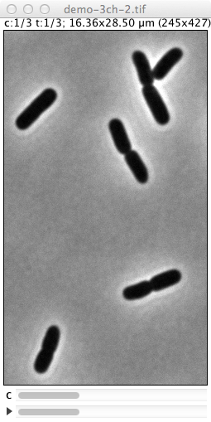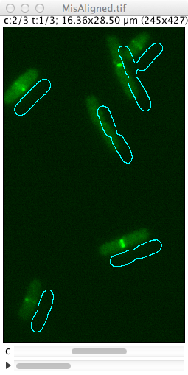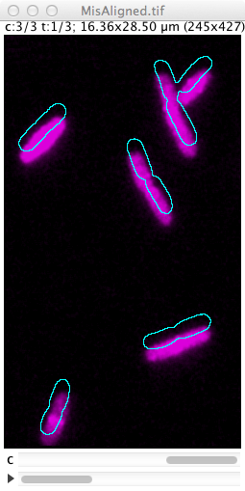

Fig 1: before alignment

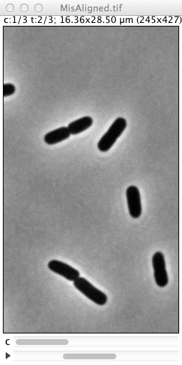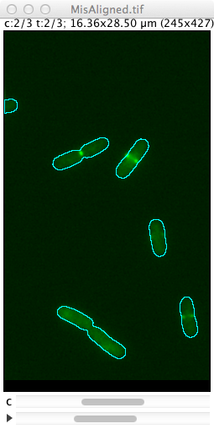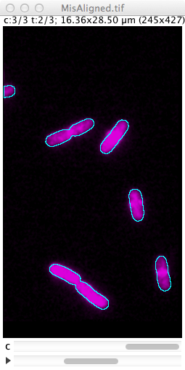

Fig 2: after alignment

This macro repairs channel-misalignment of hyperstacks showing bacterial images.

Alignment can be performed manually or automatically.

Fluorescent channels are aligned with respect to phase contrast in channel 1.

For trying out, load macro file AlignFluorChannels_4.txt (or higher)

and open demo stack "MisAligned.tif"; see:

<http://simon.bio.uva.nl/objectj/examples/AlignFluorChannels/>

**Manual Alignment :**

Select a fluorescent channel and choose:

"Plugins>Macros>Show PhC Outlines [1]"

This shows the misalignment.

Now drag the outlines to the correct position

then choose:

"Plugins>Macros>Manual Align [2]

You can repeat this for all fluorescent channels.

**Automatic Alignment :**

Align entire hyperstack by choosing:

"Plugins>Macros>Align Fluorescence Channels [4]"

After the entire hyperstack is aligned, again check result via

"Plugins>Macros>Show PhC Outlines", also observe the Log window.

"Plugins>Macros>Align All Stacks in Folder... [5] "

will batch-process an entire stack. Stacks will be overwritten

with an aligned version, so make sure you have a back-up!

**Notes for automatic FFT alignment:**

Either multiple slices or multiple frames are allowed, not both (i.e. no 5D stack)

If stack has multiple slices, they are converted to multiple frames.

First channel must be used for phase contrast,

followed by one or more fluorescent channels. If in doubt, choose:

Image>Color>Arrange Channels..

If required absolute shift is > 30 pixels, user is asked for confirmation.

Alignment is performed via a 1024 * 1024 FFT image. This

also defines precision of alignment, independent of

the image size. Increasing fftSize=1024 by factors of 2 will improve resolution

but process slower.

**Automatic FFT alignment method:**

Phase contrast channel is converted to a mask, so objects have intensity = 1 and background has intensity 0. This mask is multiplied with the underlying fluorescence channel, and the total fluorescence of the product is measured. By shifting the mask in x and y direction, this value will change. Those offsets that yield the maximum result will be used for alignment. Using FFT correlation, this process can be done in a single step.

**Limitations:**

This automatic method works best if there is statistically enough material, i.e. if there are many cells, and if fluorescence is evenly distributed inside the cell (which is the case in the demo file). Conversely, it may fail in other cases.