Go back to [ObjectJ Examples](http://simon.bio.uva.nl/objectj/7a-Examples.html)

Eucalyptus leafs

Using filament tracer to measure Eucalyptus leafs

Watch the [Quicktime Movie](http://simon.bio.uva.nl/objectj/examples/eucalyptus/eucalyptus.mov) (90 sec) or [Download](http://simon.bio.uva.nl/objectj/examples/eucalyptus/eucalyptus-tracer.zip) zipped sample project

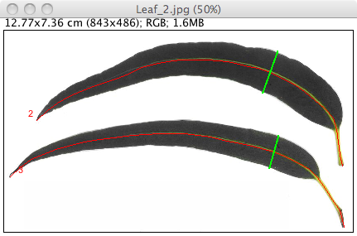

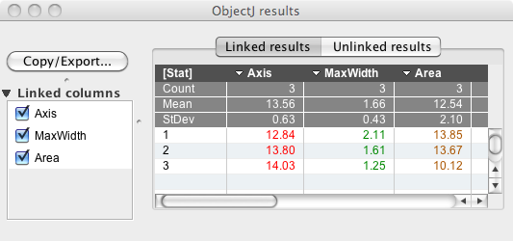

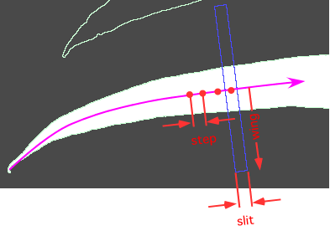

**a) Features:**  
- Traces leafs by moving a slit-shaped aperture along the axis  
- Axis and MaxWidth are non-destructively marked.

**b) Installation:**

- put newest objectj_.jar into the plugin folder of ImageJ .

- download test project, and drag the .ojj project file into the ImageJ main window.

- ObjectJ menu is now visible

- choose menu "ObjectJ>Analyze Leafs" to run the demo

**c) General remarks:**

* you can use various filetypes like jpg, tiff etc.
* stacks are supported, except .zip format
* this demo scales all linked non-tiff images to 66 pixels/cm (see macro)
* scale of jpg etc is stored in project file
* choose menu "ObjectJ>Show Embedded Macros" to change the   
  macro text, then click "Install under ObjectJ Menu", and save   
  it in the .ojj file via ObjectJ>Save Project
* choose menu "ObjectJ>Project>Save an Empty Copy" to start your own project
* Adjust macro parameters step, wing, slit, minSize, commonScale to your needs
* This demo first deletes all previous object markers before analyzing leafs