Go back to [ObjectJ Examples](http://simon.bio.uva.nl/objectj/7a-Examples.html)

Marking bacteria

11-sep-2010

Automatic and manual measurements of bacteria.

Watch the [movie](http://simon.bio.uva.nl/objectj/examples/filaments/fil-800-600.mov) (4 minutes)

Watch the [slide show](http://simon.bio.uva.nl/objectj/examples/filaments/Coli-slides/Coli-slides.htm) (9 slides)

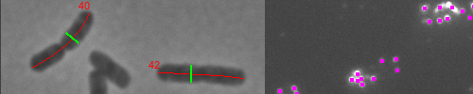

1. Download the newest [objectj_.jar](http://simon.bio.uva.nl/objectj/download/download_ObjectJ/) , put it into ImageJ's plugin folder, and restart ImageJ

1. Download and unpack the bacterial [filaments project](http://simon.bio.uva.nl/objectj/examples/filaments/filament-project).

The zipped demo folder contains the project file and two image files:

- Filaments-91.ojj

- BW-TY-01.tiff

- BW-TY-02.tiff

1. Choose menu File>Open, and open "Filaments-91.ojj"  
   (you also could drag&drop it onto the ImageJ main window)

Now the project window appears, showing that two images

are already linked to the project.

Additionally, the menu bar now contains the "ObjectJ" menu. The lower  
part of this menu is populated by commands that are defined for this specific project via

embedded macros that are part of the ".ojj" project file.

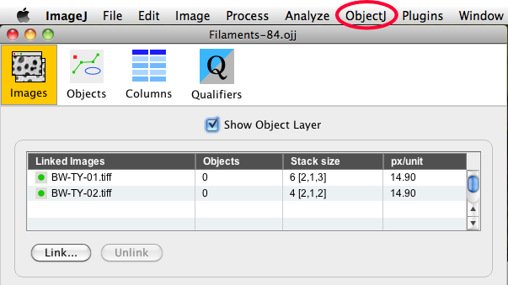

1. Choose menu ObjectJ>Mark Filaments  
   This will mark those images that are not marked yet, i.e. that appear

in the "Images" panel to appear with zero objects.

1. Choose menu ObjectJ>Mark Spots  
   This will mark spots in the fluorescence channel.
2. Choose menu ObjectJ>Show ObjectJ Results to study the results.