[Back to Examples](http://simon.bio.uva.nl/objectj/examples/)

GlassWindow in ObjectJ

GlassWindow is an extension to the ObjectJ plugin. It allows to mark and snap

any underlying live image that is displayed by a foreign application. Markers

appear both on the glass window and on the currently linked stack that can

receive any number of snapshots.

*Applications include:*

- Marking live images provided by any camera acquisition program

- Marking movies from any source, and only store those frames that are relevant

*Macro Commands:*

Show GlassWindow

Shows the GlassWindow whose size and position can be adjusted to cover the underlying live image.

Connect New Stack

Creates a stack of same size as the GlassWindow for receiving snapshots.

Update Snapshot

In the connected stack, the current snapshot is refreshed.

Append Snapshot

A new snapshot is appended to the connected stack.

Toggle Visibility Range

Toggles between these two cases:

a) markers are only visible if their home slice is selected

b) all markers from all stack slices are visible (shining through).

The visibility range has effect on the glass window and all linked images.

Close GlassWindow

Same as clicking on the GlassWindows red close button.

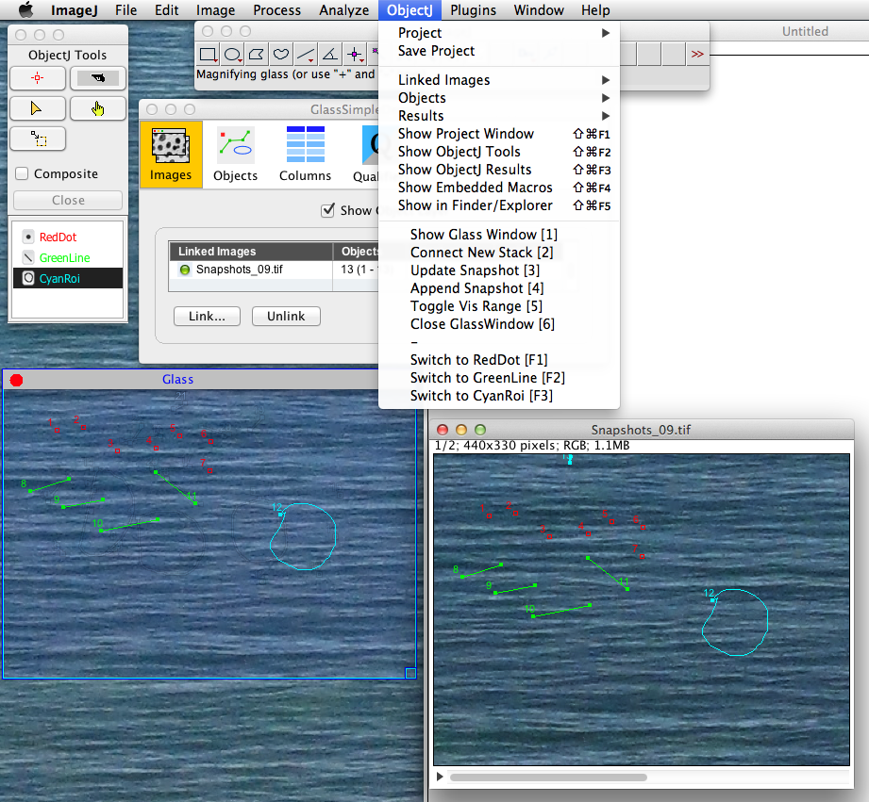

Fig 1: Glass Window and corresponding macro commands

Tutorial:

- This is a very simple example where you can set red dots, green lines and cyan rois onto the GlassWindow.

- Make sure objectj_.jar is in ImageJ`s plugins folder

- Windows users: Java 1.7 is required

- Open demo project [GlassDemo.ojj](http://simon.bio.uva.nl/objectj/examples/glasswindow/)

- Start your foreign acquisition program so that its (live) image appears on the screen.

- Arrange these windows so they can conveniently be accessed (similar to fig 1):

-- ImageJ window,

-- ObjectJ Tools

-- Live window

- Choose menu ObjectJ> Show Glass Window

and adjust size and position so it covers the live image to be anlayzed

- Choose menu ObjectJ> Connect New Stack

A stack with same size as the GlassWindow is prepared and linked to the project. It is automatically filled

with the first screenshot. You can now zoom out or send the image to the dock, so it does not occupy real

estate on the screen.

- Select any item type from the ObjectJ Tools window (e.g. BlueDot) and start to set markers onto the

GlassWindow. The markers will be placed onto the linked image (although it may be minimized in the dock),

but also appear on the GlassWindow. In this demo, you can quickly switch to a different dot type with macro shortcuts F1 ..F3.

- At any time you have the possibility to add a new snapshot to the linked stack, which will receive

subsequent markers (menu ObjectJ >Append Snapshot).

It is possible to adjust the visibility range of the markers so that they either appear upon any slice,

or only when their home slice is active.

- If itemtype is a single point (such as "RedDot" in the example), you can use the right mouse button

for marking, which will first append a new screenshot, and then set the marker into the new slice.

Notes:

- While setting markers on the glass window, ImageJ is in the foreground, i.e. the foreign acquisition program

must be able to create the live image without being in the foreground.

- Generally, changing position of glass window or live window during marking would disturb analysis and should be avoided.

- GlassWindow simply captures RGB images as they appear on the screen, not being aware of their processing history.