Go back to [ObjectJ Examples](http://simon.bio.uva.nl/objectj/7a-Examples.html)

Cindy's Fish egg macros

updated 10-aug-2010

[Download](http://simon.bio.uva.nl/objectj/examples/CindysFisheggs/cindy-project) demo project

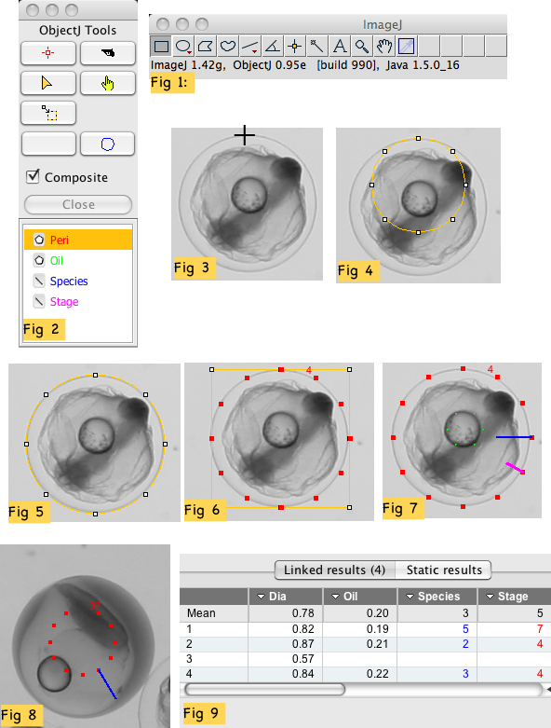

In this project, fish eggs have to be measured to obtain these parameters:

- Diameter of egg

- Diameter of oil droplet

- Species ( a number 1 .. 10)

- Stage ( a number 1 ..5)

procedure:

==========

1. Make sure "objectj_.jar" is in the plugins folder.

2. currently versions: ObjectJ 1.03d (see version at Help> About Plugins> ObjectJ)

and ImageJ 1.48e.

3. open project file "FishEggs-Cindy-59.ojj "

by dragging it into the ImageJ main window

4. At least now, the ObjectJ menu should be visible, and show a list of macro

commands, starting with

ObjectJ Tools should now show an "Egg Tool": blue circle (Fig 2)

5. link one or several images by dragging them from the project folder

into the "Images" panel.

6. Open the first linked image by double-clicking it in the

Images panel

7. choose menu ObjectJ> Init [F1]

this command guarantees to start at defined state.

Egg tool will now be selected, ObjectJ tools are shown (Fig 1, Fig 2).

8. click with the egg tool at the top of an egg (Fig 3) and keep mouse down.

circular roi becomes visible (Fig 4)

move cursor down to increase

move cursor horizontal to align vertical axis (Fig 5)

release mouse button:

12 red markers appear to indicate perimeter (Fig 6),

additionally, system is prepared for the oil droplet

9. Optionally (if there is an oil droplet), click with the egg tool at

the top of an oildrop and keep mouse down.

continue as before to match the perimeter of the oildrop

release mouse button:

6 green markers appear to indicate oil droplet,

additionally, system is prepared for species

10. In order to assign "Species = 3", choose menu ObjectJ> Number 3 [3]

11. In order to assign "Stage = 4", choose menu ObjectJ> Number 4 [4]

Classification is shown like the hand on a clock, i.e. "3 o'clock" and "4 o'clock"

(Fig 7).

12. You can exit half way by choosing menu Plugins> Macros> Abort: unfinished

cell will be deleted, and system is prepared to start with a new cell.

13. Look at results by choosing menu ObjectJ> Calc + Show Results [F3].

Although Species and Stage is recalculated from their line orientations,

so the column shows "3" and "4" in this example.

14. You also have the possibility to only define the species number, without marking

marking the diameter: In "normal state" (e.g. after pressing F1), position the

cursor in the center of an egg without clicking. Then, for example, press key "5"

to set species number to 5. See Fig. 8 for screenshot: Object #32 is marked with

11 dots, resembling a small clock with missing 12'o clock. The blue line marks

the species number.

In the ObjectJ results, the diameter field consequently appears empty.

15. Choose menu ObjectJ>Calc and Show Results to recalculate and show all results.

16. Periodically choose menu ObjectJ> Save Project to save your manual work. Also,

keep some older files as back-up in case something is cleared accidentally.