Go back to [ObjectJ Examples](http://simon.bio.uva.nl/objectj/7a-Examples.html)

Marking and categorizing oocytes

Version 27

01-apr-2010 vischer at science.uva.nl

This project allows automatic and manual measurements of oocyte cells.

Resulting parameters are cell size and elliptical aspect ratio. Size

is visualized by a red line indicating the diameter of equivalent circle with same area.

A category (1..9) can be added manually, and is visualized by the "hand of a clock".

You can get statistics of any subset of objects that meets a combination of properties

[Download oocytes project](http://simon.bio.uva.nl/objectj/examples/oocytes/oocytes-project/)

Watch the [movie](http://simon.bio.uva.nl/objectj/examples/oocytes/oocytes-a.mov)

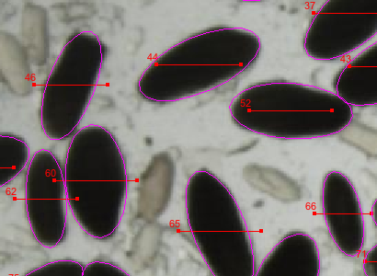

***A - Install ObjectJ***

1. Download ObjectJ from http://simon.bio.uva.nl/objectj/

go to "download" and choose the version with the

highest number, currently ObjectJ 1.01n)

2. put objectj_.jar into the plugins folder of the ImageJ folder

3. Restart ImageJ

4. choose menu Plugins>ObjectJ

5. Now the menu bar should show "ObjectJ" (between "Analyze" and "Plugins")

6. (Next time, ObjectJ can be upgraded simultaneously with ImageJ

via: menu Help>Update ImageJ)

***B - Download Sample Project***

1. Download oocytes-27

(version number may be higher)

Folder contains:

project file= oocytes-27.ojj

Anchovy_oocytes.jpg

Fec 5.jpg

2. Make sure these files are in the same folder

after unpacking, we call it the "project folder". You can replace

the sample image by any number of your own images

3. Drag the .ojj file into the ImageJ main window to

open this project, wait until the project window

appears showing the names of "Linked Images"

(Alternatively, choose menu ObjectJ>Open Project..).

***C - Usage***

**1. Automatic marking of diameters**

- chose menu ObjectJ>Mark Oocytes...

- In the dialog, if threshold is set to zero, you are asked to

threshold each image interactively.

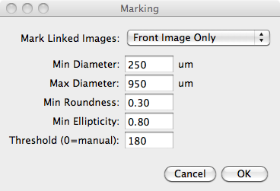

2. **Categorize any marked cell**

- With no Roi visible, locate the cursor above a marked cell and press

key 1..9 for category. Cell will obtain that category as hand of a clock

(e.g. 4 o'clock is category 4), - or cell will

be killed if 0 is pressed. (You also could kill a cell

with the pistol tool).

**3. Label cell only without measuring it**

A a line of fixed length (185 um at 45 deg) is used to

mark the existence of a cell type.

- Choose menu ObjectJ>Fixed Diameter [F] (or select

the "F" button in the ObjectJ tools window).

Then, click on the center of a cell to mark it.

**4. Show/Hide floating circle**

A floating circle that follows the cursor movement

can help to visually estimate cell sizes. It's diameter is 185 um.

- Choose ObjectJ>Variable Diameter (toggle circle) [V],

or press "V" key.

This activates the "V" tool in the ObjectJ Tools window;

and switches the floating circle on or off. If the mouse rests for

10 sec, the floating circle will be switched off.

You can press V again to switch it on again.

**5. Show/Hide Ellipses**

Shows or hides the ellipse items of marked cells.

**6. Manually marking of ellipses:**

- make sure the variable ellipse tool (button marked with "V") in ObjectJ Tools is selected

- click and drag along a line A-B to follow the ellipse major axis (or

diameter in case of a circle).

After releasing the mouse, a circular roi is shown.

- if you want to leave this circular roi as such,

move the cursor further outside until the roi flashes

- otherwise, if you want to change the circle into an ellipse, then move the cursor back

inside, which decreases the minor axis. During this phase, you also can

fine-adjust the orientation.

Now you need a second mouse-down click to confirm the current ellipse.

Before again releasing the mouse button, you can re-adjust the ellipse's position.

- At any moment during ellipse editing, you can press any category key (1..9)

to finalize and categorize the ellipse.

**7. Convert ellipse roi into marked and categorized cell**

- when an elliptical roi is visible, it can be marked and categorized with

key 1..9. After that, the "V" tool remains activated.

**8. Categorizing marked cells sequentially:**

This mode is intended to visit marked cells in sequence (1, 2, 3..),

in order to categorize them.

- The sequential modus is active when a halo visible. The halo is

symbolized by two concentric rois.

The inner roi corresponds to the diameter of the selected cell, the

outer roi is used for "zoom to selection"

- You can enter the sequential modus by locating the cursor

above a marked cell (e.g. cell 17) and press the "Q" key, that corresponds to

Toggle Sequential Mode [Q]

The halo now highlights cell 17

(If the halo was already active, it will disappear)

- With the halo visible, press any key 1..9 to categorize that

cell, or press zero to kill it.

After 0.25 sec, the halo highlights the next cell (cell 18 in the example).

- Use previous [p] or next [n] shortcuts to navigate the halo.

**9. Applying a default category**

- You can set a default category to all objects that have no category yet.

This is done in all linked images.

- Choose ObjectJ>Categorize all uncategorized cells...

and after entering a number, all uncategroized cells will be categorized.

**10. Results**

- Choose ObjectJ>Show Project Results

to display numeric results. These columns are implemented:

Dia equivalent diameter in um

Cat category 1..9

Roundn. same as Minor/Major (range 0..1)

Ellipt. ellipticity= ellipse perimeter/actual perimeter

(range 0..1, or empty for manual marking)

Minor minor axis (um)

Major major axis (um)

Area3 area (unit is 10^3 um^2 for convenience)

**11. Saving**

- Periodically save the colored markers via menu ObjectJ>Save project.

(Note that menu "File>Save" only saves an image, not the markers)

**12. Mark your own images**

-  once the described sample project works satisfactory, you can save an empty copy

of the project file via ObjectJ>Project File> Save an Empty Copy… and relaunch ImageJ.

- The empty copy contains all internal structure and macros, but no markers or linked images.

- Link your images via ObjectJ>Linked Images> Link Image from project Folder

- Make sure your linked images are scaled correctly (eg pixels per um)

**13. Notes**

- cells with fixed diameters don't have any quantitative result entries.

- category 0 cannot be applied, it is rather used to delete an object under the cursor

- marking a cell with "fixed diameter" does not invite to add a category

- Categorize all unmarked cells also categorizes those with fixed diameter