[Back to Examples](http://simon.bio.uva.nl/objectj/examples/)

Perspective Stack View

[PerspectiveStackView.txt](http://simon.bio.uva.nl/objectj/examples/PerspectiveStackView/PerspectiveStackView.txt)

author: Norbert Vischer

date: 08-Nov-2012 21:46

url: http://simon.bio.uva.nl/objectj/examples/

- Creates perspective stack view for publications and presentations

- Supports transparent background when saved as .png.

- Adjustable parameters

From the current (hyper-)stack, two perspective displays are created:

a) a stack containing individual perspective slices

b) a montage showing perspectival "stack impression".

If stack is a hyperstack, all channels of current slice and frame

setting are used.

Otherwise, all slices of stack are used (max: 10).

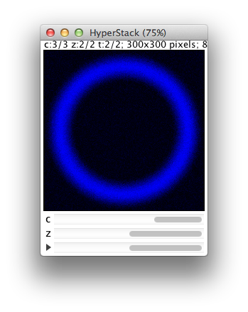 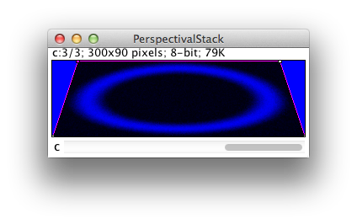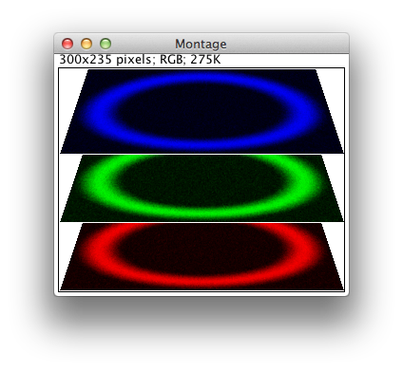

A. Hyperstack is converted to perspective montage

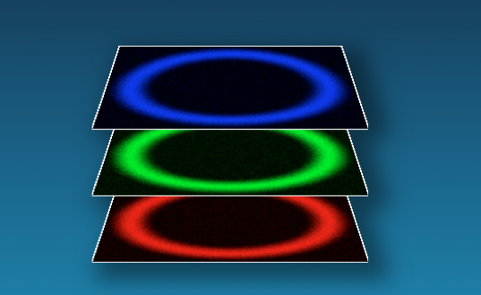

B. Montage is imported in Powerpoint with transparent

background