**SIPchart plugin for ImageJ**

*Norbert Vischer*

*University of Amsterdam*

[vischer@uva](mailto:vischer@science.uva) (add .nl)

13-sep-2011

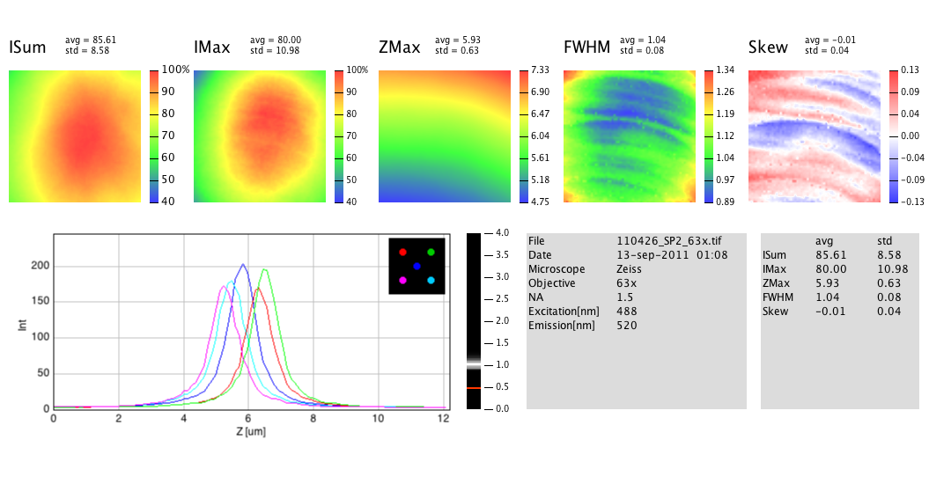

A SIPchart is suitable to quantify the sectioning quality of a confocal microscope. It is obtained by processing the 3D image of a thin fluorescent layer. This documentation describes the SIPchart plugin running under ImageJ.

Before creating the first SIPchart from a 3D image (also called "stack"), it is necessary to install the ImageJ application (on Windows, OS X, or Linux) and to download the plugin "SIPchart_.jar" .

Look for the newest versions here:

<http://imagej.nih.gov/ij/>

<http://simon.bio.uva.nl/sipcharts/download/>

**Installation:**

- make sure ImageJ is installed

- put plugin "SIPchart_.jar" into ImageJ's plugin folder

- restart ImageJ, or choose *Help>Refresh Menus*

- choose menu *Plugins> SIPchart*

*This installs the macro commands. Now menu "Plugins>Macros>" should contain "Make SIPchart" (see below)*

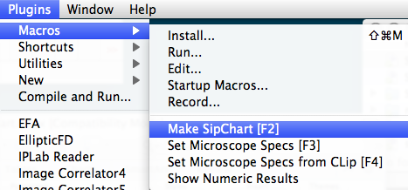

**Prepare:**

- in ImageJ, open the 3D-stack to be examined.

- alternatively - if your z series is not organized as stack yet - choose menu

*File > Import> Image Sequence* in order to create a stack from individual images.

- you also can download a zipped test image from <http://simon.bio.uva.nl/sipcharts/sip043.zip>

- Optionally, choose *Image>Transform>* to flip horizontally, vertically, or Z. This may be convenient if different display conventions are involved.

- Choose menu *Image>Properties*

and make sure that voxel size is entered correctly,

- Optionally, choose menu *Plugins>Macros>Set Microscope Specs*

*here you can to enter lens and instrument data - they will appear in the output plot. If NA, Excitation and Emission wave lengths are entered, the program will draw the theoretical FWHM limit as red line into the resolution bar.*

- Optionally, choose menu *Plugins>Macros>Add Microscope Specs from Clip*

*so you can re-use specifications from clipboard without re-typing*

**Run:**

with the stack in front, choose menu "*Plugins> Macros> Make SIPchart*

*The SIPchart will be created within a few seconds.*

*(Please don*'*t disturb process with mouse clicks inside ImageJ windows).*

*The program will performs the following actions:*

*Before creating the charts, the source stack is downscaled to x*y = 64*64 pixels using bilinear interpolation. The prefix* "*binned-*" *will be added to the original image name. If the original image is not square, only the largest centered square will be evaluated.*

*From each xy position, a z-profile will be analyzed:*

*Results are stored in a* "*PanelStack*" *containing five 32-bit images (you can navigate between ISum, IMax, ZMax, FWHM, Skew). Each slice holds the corresponding parameters for all x-y positions. The status bar shows the parameter that belongs to the current cursor position and panel.*

*The final SIPchart is composed of these five panels in false color, a resolution bar (histogram of FWHMs), five z-profile plots (at image center and four quadrant centers), plus a textual summary.*

*Numerical output is stored as metadata in the chart, and will be preserved if you store the file in .tif format. You can make it visible via Plugins> Macros> Show Numerical Results* *and copy-paste it to a spreadsheet, or re-use it for the microscope specs.*

**Z-Tool and Live Profile:**

The z-tool appears in the main ImageJ window with a "Z" icon (see figure). Activate this icon and click on the "PanelStack": the status field shows the corresponding numeric value under the mouse (e.g. FWHM in mocrons if the FWHM channel is activated). Click and drag to obtain a live z-profile plot.



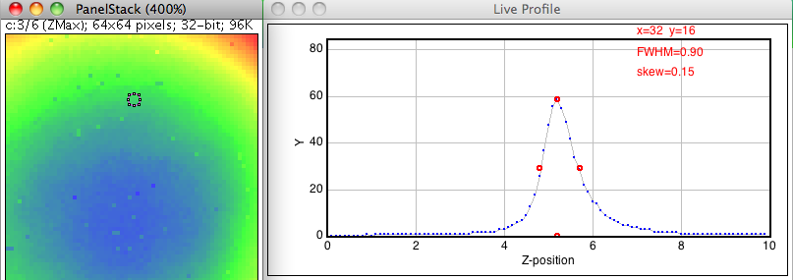

**Technical information**

The algorithms used here are simple and performed in a few seconds. Results match well with the former server-based SIPchart programme. As this plugin is open-source, more sophisticated algorithms can be appended. The source code is included in the SIPchart_.jar file.

Current algorithm:

Peak height and position are obtained by a polygon that represents the tip (top-most 25% of profile). Its center of gravity (cx, cy) is calculated.

PeakpositionX = cx

PeakMaximum = cy/0.85

The FWHM points are found where the profile crosses half maximum.

The Skew is calculated from (b-a)/(b+a), where a and b are left and right width of half maximum, respectively.

Backgroud is taken from the lowest value found in first and last slice of the binned image.