Back to [ObjectJ Examples](http://simon.bio.uva.nl/objectj/7a-Examples.html)

Stabilize Movie in Chunks

[Download Stabilize in Chunks](http://simon.bio.uva.nl/objectj/examples/StabilizeChunks/StabilizeChunks-4.txt.zip)

Norbert Vischer

[vischer(at)science.uva.nl](mailto:vischer@science.uva.nl)

4-oct-2012

If a movie is "shaky", this macro possibly can stabilize it. The user can limit space and time within which a particle can serve as fiducial point. Within the chosen roi and time window, the particle analyser detects the current x-y position of the largest particle found and identifies it as fiducial object. It records its x-y position that is later used for compensating any undesired movement.

Hyperstacks:

If used for hyperstacks, fiducial objects must be in channel 1, and all other channels will undergo the same translation.Note that the hyperstack must not be 5D (i.e. either nChannels or nFrames must be 1). Use **Image>Color>Arrange Channels** if necessary.

Installation:

Open StabilizeChunks-4.txt in ImageJ

Usage:

1. Open the unstable movie and adjust threshold so that a refence particle is well defined as "foreground" (red color in Fig 1).
2. Create a rectangular roi that so that the reference particle is the only object inside the roi during the desired stabilisation period.
3. Navigate to the start slice where stabilisation should start and choose   
    Plugins>Macros> **Mark Chunk Begin [F1]**  
   Roi will appear green and stored as first roi in RoiManager.
4. Without changing the roi, navigate to the end of stabilisation period and choose   
    Plugins> Macros> **Mark Chunk End [F2]**  
   Roi will appear red and stored as second roi in RoiManager
5. Choose Plugins>Macros> **Stabilize Chunk [F3]**  
   Program will now calculate the particle's trajectory, and ask for confirmation. Stabilization is then performed by sub-pixel translation. In order to avoid any “jump” after the end of the chunk, also slices beyond the chunk end will be translated.

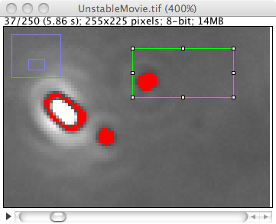 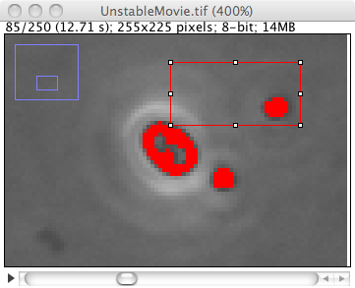

Fig 1:

Unstable movie, showing slice 37 and 85: the particle inside the roi appeared to be suitable as fiducial point during this period; roi was chosen so that it contained no other object. Begin roi (green) and End roi (red) have same coordinates.

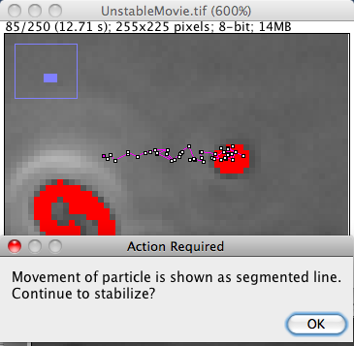

Fig 2:

Before translating slices 38 .. 250, the particle’s trajectory during slice 37 .. 85 is shown as segmented line, asking for confirmation (OK or Esc).