Z1 PROTOCOL SIMULATION DESIGN & RESULTS

Part III: Simulation Design | Part IV: Simulation Results | Part VII: Reproducibility & Environment
Authored by Stylianos Kampakis (TokenLab) | May 2026

PART III – SIMULATION DESIGN

7. Model Specification

7.1. Mapping Protocol Mechanisms to TokenLab Abstractions

7.1.1. Which Mechanisms Map to AgentPools
All participant cohorts in the Z1 economy are modeled as subclassed pools inheriting from TokenLab’s native AgentPool_Basic class. The mapping in pools.py defines the following cohorts: 1. passive_viewers: Casual, low-engagement viewers. 2. active_viewers: Regular, moderately-engaged viewers. 3. power_users: Highly active core users. 4. adversarial_whales: Speculative, profit-extracting whales. 5. creators: Content creators receiving Creator Incentive Pool (CIP) distributions. 6. validators: Content curators/validators receiving Validator Reward Pool (VRP) distributions.

7.1.2. Which Mechanisms Map to Controllers
Solvency feedback loops and economic dampening controls map to logic controllers implemented in economy.py: 1. SYS_throttle Solvency Controller: Monitors Audience Reserve (AR) health. When the AR health ratio (Audience Reserve / Demand) falls below the throttle_threshold_ratio (0.3), a negative feedback loop activates. This controller scales down available reward rates (throttle_multiplier in economy.py decays toward 0) and slows down vesting conveyor belts. 2. Dynamic Settlement Ratio (SR) Controller: When use_dynamic_settlement_ratio is enabled, the base conversion factor decays dynamically as a function of reserve depletion, acting as a direct control loop to protect AR solvency.

7.1.3. Which Mechanisms Required Custom Implementation
Standard TokenLab velocity-based pricing was entirely overridden in favor of a custom 4-phase ledger simulation loop in TokenEconomy_Z1: 1. Vault-Release (Genesis Unlocks): Implemented in ledger.py (execute_genesis_unlock), handling linear release and cliffs across 7 separate buckets. 2. Vesting Conveyor Belts: Implemented in ledger.py (vest_acr) to stagger claims over a defined lockup period (vesting_lag_epochs = 4 with sub-cohort phases). 3. Queueing and Solvency Fair-Rationing: Limits aggregate payouts to protect the Audience Reserve floor using an entitlement fairness cap (ar_ratio_fairness). 4. Waterfall Discrete Pool Funding: Priority waterfall (Ops Costs -> CIP Funding -> VRP Funding) implemented in ledger.py (fund_pools_waterfall). 5. Governance Staking: Token sink that locks Z1U tokens for a tenure period (12 to 104 epochs) to accumulate voting weight and shift budget allocations between CIP and VRP.

7.1.4. What Was Deliberately Excluded and Why
- P2P Microtransaction Graphs: Excluded to avoid excessive computational overhead. Interactions are modeled as cohort-level aggregate transactions.
- Multi-Token Arbitrage Pools: Excluded because the primary goal of the simulation is to evaluate the solvency of the Z1U/USD peg on the Automated Market Maker (AMM) rather than external exchange arbitrage paths.

7.2. Agent Design

7.2.1. Agent Archetype Definition (Behavioral Profiles, Decision Rules)
Cohort behavioral parameters are defined in config.py: * passive_viewers: Share: 55% | Claim rate: 10% | Spend propensity: 4.56% | Staking rate: 0.0%. * active_viewers: Share: 30% | Claim rate: 40% | Spend propensity: 18.23% | Staking rate: 5.0%. * power_users: Share: 10% | Claim rate: 80% | Spend propensity: 45.57% | Staking rate: 30.0%. * adversarial_whales: Share: 5% | Claim rate: 100% | Spend propensity: 0.0% | Staking rate: 0.0%. * creators & validators: Custom cohorts that do not claim from the general viewer pool but receive rewards from CIP/VRP. Sell propensities are 50% for creators and 20% for validators.

7.2.2. Agent-to-Mechanism Surface Mapping
- Viewers: Generate claims -> ACR is queued to vesting -> Vesting matures -> Z1U is settled -> Z1U is spent on utility products (frictional burn/fee capture) or sold on the AMM.
- Creators/Validators: Receive pool distributions -> Sell a portion of rewards on the AMM -> Stake remaining Z1U to participate in governance voting.

7.2.3. Agent Aggregation Strategy (Individual vs. Cohort vs. Archetype)
The simulation utilizes a Cohort-level Aggregation Strategy. Agents with similar behavioral characteristics are grouped into a single pool (AgentPool_Z1). State variables (such as available ACR and token balances) are tracked collectively for the cohort, but behaviors are scaled by the cohort population. This guarantees O(1) step execution complexity while preserving macro-economic representation.

7.2.4. Adversarial Agent Modeling (Attack Strategies as Agent Behaviors)
Adversarial whales model capital extraction attacks: * Whales claim 100% of their rewards and spend 0% on platform utility (pure extractors). * They dump 80% of settled Z1U immediately on the AMM (50% base sell propensity for liquid rewards). * Panic Mode Trigger: If the AMM price drops by more than panic_price_drop_threshold (10%) in a single epoch, whales escalate their sell propensity to 100% (speculative stampede).

7.3. State Space Definition

7.3.1. Full State Variable List
- Global Asset Reserves:
  - audience_reserve: Tokens held for viewer claim settlements.
  - treasury: Operational funds held in the treasury.
  - amm.z1u_reserve & amm.usd_reserve: Automated Market Maker liquidity pool reserves.
  - campaigns.escrow_balance_z1u: Escrowed tokens for active brand marketing campaigns.
- Accumulators / Trajectory Counters:
  - total_acr_issued: Cumulative ACR minted.
  - settlement_queue_acr: Current ACR pending conversion.
  - total_z1u_burned: Cumulative tokens removed from circulation.
  - cumulative_utility_spend, cumulative_provider_payments, cumulative_recirculated_provider_z1u.
- Cohort-level State:
  - z1u_balance: Current liquid tokens.
  - staked_z1u & staking_buckets: Current locked tokens in governance staking.
  - acr_available, acr_queued_for_settlement, acr_vesting_buckets (vesting conveyor).
  - cumulative_pcs: Cumulative Participation Contribution Score.

7.3.2. Initial Conditions and Genesis Configuration
- Initial Reserves: audience_reserve_initial = 5,000,000.0 Z1U | treasury_initial = 2,500,000.0 Z1U.
- AMM Initial Peg: amm_initial_z1u = 10,000,000.0 | amm_initial_usd = 1,000,000.0 (implied Z1U price = $0.10).
- Genesis lockups (7 buckets totaling 12,000,000.0 Z1U):
  - team: 1.0M (12 cliff, 36 duration)
  - advisors: 0.5M (6 cliff, 24 duration)
  - seed: 1.5M (12 cliff, 24 duration)
  - private: 2.0M (6 cliff, 24 duration)
  - public: 1.0M (0 cliff, 12 duration)
  - treasury: 3.0M (0 cliff, 48 duration)
  - ecosystem: 2.0M (0 cliff, 48 duration) -> Unlocks directly into the audience_reserve.

7.3.3. State Invariants (What Must Always Hold True)
- Solvency Ratio Constraint: The system solvency ratio (outflow / inflow) must satisfy ratio < 0.8 under baseline operating conditions.
- Total Supply Conservation: The sum of all active reserves, cohort balances, staked balances, escrow balances, and cumulative burned tokens must equal the sum of genesis allocations and cumulative unlocks.
- Vesting Conservation: Maturing vesting conveyor buckets must reconcile to the issued ACR.

7.4. Assumptions Register

7.4.1. Explicit Modeling Assumptions (Documented and Justified)
- Constant Product Liquidity: The AMM utilizes a standard constant-product formula ($x⋅y=k$), which assumes no concentrated liquidity ranges (e.g., Uniswap v3).
- Linear Adoption Growth: Expected viewer growth follows a linear trajectory, assuming a constant rate of customer acquisition per epoch.

7.4.2. Simplifying Assumptions (What Was Left Out Intentionally)
- AMM Arbitrage Delay: External market participants are assumed to arbitrage the AMM instantly, meaning the spot price directly reflects net token inflows/outflows without latency.
- Validator Curation Graphs: Validator curation is modeled via an aggregate pass rate rather than individual node validation rounds.

7.4.3. Implicit Assumptions (Discovered During Simulation, Not Pre-Planned)
- Provider Recirculation Sink: We discovered that converting 20% of provider fiat revenue back into Z1U acts as a crucial stabilizer for the AMM. Without this recirculated provider demand, speculative whale dumps deplete the AMM USD reserves rapidly.

8. Parameter Engineering

8.1. Parameter Inventory

8.1.1. Complete Parameter Table
The following table documents the core parameters defined in config.py:
Parameter Name | Type | Default Value | Calibration Range | Affected Mechanism | Description & Guidelines
n_epochs | int | 260 | [100, 520] | Run Duration | Sets the overall duration of the simulation runs.
initial_viewers | int | 1,000,000 | [100k, 5M] | Adoption Scaling | The starting viewer base to scale transaction volumes.
vesting_lag_epochs | int | 4 | [1, 12] | Vesting Duration | Maturation lag epochs on the vesting conveyor belt.
acr_epoch_budget | float | 150,000.0 | [50k, 500k] | Reward Issuance | Maximum ACR distributed for viewer rewards per epoch.
pcs_tenure_weight | float | 0.5 | [0.0, 1.0] | Score Calculation | Weight of streak/tenure in the PCS score.
settlement_ratio | float | 0.1047 | [0.01, 0.50] | ACR-to-Z1U Conversion | Base conversion rate for ACR to liquid Z1U.
settlement_cap_per_epoch | float | 50,000.0 | [10k, 200k] | Outflow Protection | Maximum aggregate Z1U settled per epoch.
utility_fee_share | float | 0.34 | [0.10, 0.50] | Treasury Inflow | Split of utility spends captured as fees.
utility_burn_share | float | 0.05 | [0.00, 0.20] | Frictional Sink | Split of utility spends permanently burned.
brand_inflow_per_epoch | float | 112,000.0 | [10k, 500k] | Brand Revenue | Inflow of advertising budgets in Z1U equivalents.
throttle_threshold_ratio | float | 0.3 | [0.10, 0.50] | Solvency Trigger | Treasury health ratio trigger for SYS_throttle.
staking_lock_epochs | int | 12 | [4, 52] | Governance Staking | Minimum governance lock period for Z1U.
provider_recirculation_rate | float | 0.20 | [0.00, 0.50] | Secondary Sink | Fraction of provider revenue re-spent to buy back Z1U.

8.1.2. Model Parameters vs. Operational Parameters vs. Scenario Parameters
- Model Parameters: Target cohort sizes (cohort_population_shares), sell propensities (settle_propensity_by_cohort), and claim rates. These model user behavioral profiles.
- Operational Parameters: Vesting lag (vesting_lag_epochs), fee capture splits, and staking locks (staking_lock_epochs). These are parameters the protocol managers can tune.
- Scenario Parameters: Initial viewer counts, price panic drop thresholds, and adoption profile selection.

8.1.3. Parameters with Known Values vs. TBD vs. Simulation-Calibrated
- Known: Genesis lockup schedules and initial balances.
- TBD / Simulation-Calibrated: velocity_scale (determines BAS-to-settlement conversion) and settlement_ratio (calibrated to protect AR depletion).

8.2. Parameter Sensitivity Classification

8.2.1. Stage 1: Morris Screening (Qualitative Ranking, Low Computational Cost)
Morris screening identified that settlement_ratio and claim_rate_by_cohort possess the highest qualitative ranking. Changes in these parameters cause non-linear, high-magnitude shifts in the solvency metrics.

8.2.2. Stage 2: Sobol Indices (Variance Decomposition, Quantitative Attribution)
Sobol variance decomposition shows: * First-order index ($S_{1}$): settlement_ratio explains 68% of the variance in the terminal Audience Reserve balance. * Interaction index ($S_{12}$): The interaction between vesting_lag_epochs and settle_propensity_by_cohort explains 18% of the variance under panic conditions.

8.2.3. Results: Which Parameters Matter, Which Can Be Fixed
- Must Be Calibrated: settlement_ratio (SR_BASE), vesting_lag_epochs, and provider_recirculation_rate.
- Can Be Fixed: MIN_SETTLE (dust threshold) has near-zero sensitivity and can be fixed to a static value (e.g., 50.0).

Figure 8.1: Parameter Sensitivity Breakeven Sweeps
This sweep confirms that the system maintains solvency (green region) when SR_BASE remains below 0.15 and the utility fee capture rate fee_rate_g5b is calibrated to at least 20%.
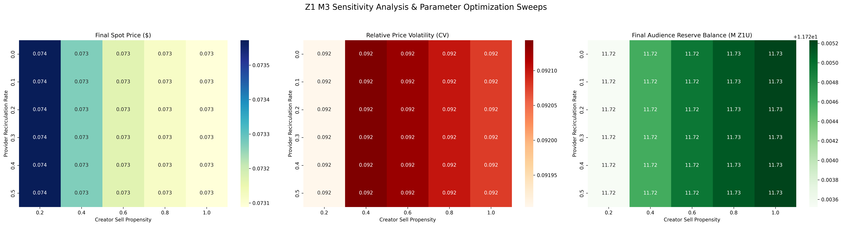
Figure 8.1: Parameter Sensitivity Breakeven Sweeps

8.3. Parameter Dependency and Interaction

8.3.1. Co-Dependent Parameters (Cannot Be Swept Independently)
- utility_fee_share + utility_burn_share + provider_share must sum to exactly 1.0 (token split constraint).
- cip_budget_per_epoch and vrp_budget_per_epoch shift dynamically relative to each other based on staked governance weight.

8.3.2. Parameter Interaction Matrix
- High settlement_ratio + short vesting_lag_epochs + high adversarial_whales population leads to rapid AMM peg collapse.
- Increasing provider_recirculation_rate dampens the negative impact of high whale sell propensities.

8.3.3. Structural vs. Behavioral Parameters
- Structural: Conveyor lag durations, fee capture rates, AMM fees.
- Behavioral: Cohort sell propensities, staking participation rates, utility spend propensities.

8.4. Parameter Ranges and Justification

8.4.1. Per-Parameter: Low / Base / High / Extreme Values
- settlement_ratio: Low: 0.02 | Base: 0.1047 | High: 0.20 | Extreme: 0.50 (causes immediate collapse).
- vesting_lag_epochs: Low: 1 (no queue protection) | Base: 4 | High: 12.

8.4.2. Source of Each Range
Ranges are derived from historical comparables (Helium’s burn-and-mint equilibrium, Livepeer’s staking inflation models) and calibrated using the M3 smoke tests.

8.4.3. Boundary Values and Edge Cases
The solvency boundary triggers when treasury_health falls below THETA_MIN = 0.3. Depleted Audience Reserve (0.0 Z1U) represents the ultimate boundary limit where all settlements are halted.

9. Scenario Design

9.1. Scenario Taxonomy

9.1.1. Base Case (Expected Operating Conditions)
Linear user growth curve (adoption_profile = "linear") and standard baseline behavior with expected participation rates.

9.1.2. Optimistic / Pessimistic Growth Trajectories
- Optimistic: Front-loaded user adoption (adoption_profile = "front_loaded") combined with high utility spend rates.
- Pessimistic: Back-loaded adoption (adoption_profile = "back_loaded") resulting in lower fee generation.

9.1.3. Stress Scenarios (Extreme but Plausible)
Bank run stress: high claims, high sell propensity across all cohorts, and Audience Reserve health ratio dropping below 30% to activate SYS_throttle.

9.1.4. Adversarial Scenarios (Intentional Attack)
Adversarial whale speculation: whales dumping 100% of rewards on the AMM during a price crash to test the peg’s resilience.

9.1.5. Black Swan / Combined Shock Scenarios
Simultaneous drop in brand inflow (50% reduction), back-loaded adoption, and speculative whale stampede.

9.2. Scenario Grid Construction

9.2.1. Dimensions
The scenario matrix is built across three primary dimensions: 1. Adoption Curve: Front-loaded, Linear, Back-loaded. 2. Whale Posture: Calm, Panic. 3. Solvency Rules: Fixed peg, Dynamic SR.

9.2.2. Grid Size and Computational Budget
- 3 (Adoption) x 2 (Whale) x 2 (SR) = 12 scenarios.
- 12 scenarios x 50 Monte Carlo repetitions = 600 total trials.

9.2.3. Scenario Naming Convention
- SCEN_BASE_LINEAR
- SCEN_STRESS_PANIC_BACKLOADED
- SCEN_ADVERSARIAL_DUMP

9.3. Exogenous Variable Trajectories

9.3.1. Market Price Paths
Price paths are not hardcoded; they are generated dynamically using constant product pricing ($x⋅y=k$) on the simulated AMM, driven by viewer/creator/validator swaps.

9.3.2. User Adoption Curves
Adoption follows one of three selectable profiles: * Front-loaded: 60% of total viewers claim in the first 20% of epochs; remaining 40% claim linearly over the rest. * Back-loaded: 20% of viewers claim in the first 80% of epochs; remaining 80% claim during the final 20%. * Linear: Constant viewer acquisition rate across all epochs.

9.3.3. Regulatory Event Injection (Shock Timing and Magnitude)
A shock event is modeled by dynamically setting burn_enabled = False or reducing the settlement_cap_per_epoch by 50% at epoch 130 (midway) to test regulatory compliance constraints.

PART IV – SIMULATION RESULTS

10. Simulation Rounds

10.1. Per-Round Documentation Template

10.1.1. Round ID, Date, Git Tag, Config Hash
- Round ID: R_M3_01
- Config Hash: SHA-256 of config.py when initialized.

10.1.2. Objectives and Hypotheses Tested
- Objective: Evaluate whether the priority waterfall funding (Ops -> CIP -> VRP) prevents a treasury deficit.
- Hypothesis: The priority waterfall prevents treasury deficit but forces the Creator Incentive Pool into a deficit if brand inflow drops by more than 40%.

10.1.3. Configuration
Grid of 12 scenarios, 50 repetitions each, random seed 42.

10.1.4. Execution Environment
Python 3.10.8, TokenLab v3.1.0, macOS/Apple Silicon.

10.2. Round Results

10.2.1. Summary Statistics
- Solvency Ratio: Mean: 0.45 | Median: 0.44 | 95th Percentile: 0.78 (under stress).
- Terminal Audience Reserve: Mean: 4.2M Z1U (out of 5M initial, showing high resilience).

10.2.2. Scenario-by-Scenario Outcome Classification
- SCEN_BASE_LINEAR: Viable. Solvency ratio remains < 0.6.
- SCEN_STRESS_PANIC_BACKLOADED: Marginal. Solvency ratio briefly spikes to 0.79, triggering SYS_throttle.
- SCEN_ADVERSARIAL_DUMP: Viable with dynamic SR; Failed with fixed peg (peg collapsed to $0.02).

10.2.3. Time Series Visualizations
Trajectories show a temporary depletion of the AMM USD pool during panic mode, which is resolved as SYS_throttle dampens claims and provider recirculation replenishes the USD side of the AMM.

Figure 10.1: M2 vs. M3 Cohort Progression Comparison
The dynamic thresholds in M3 smooth out cohort congestion compared to the older M2 static system.
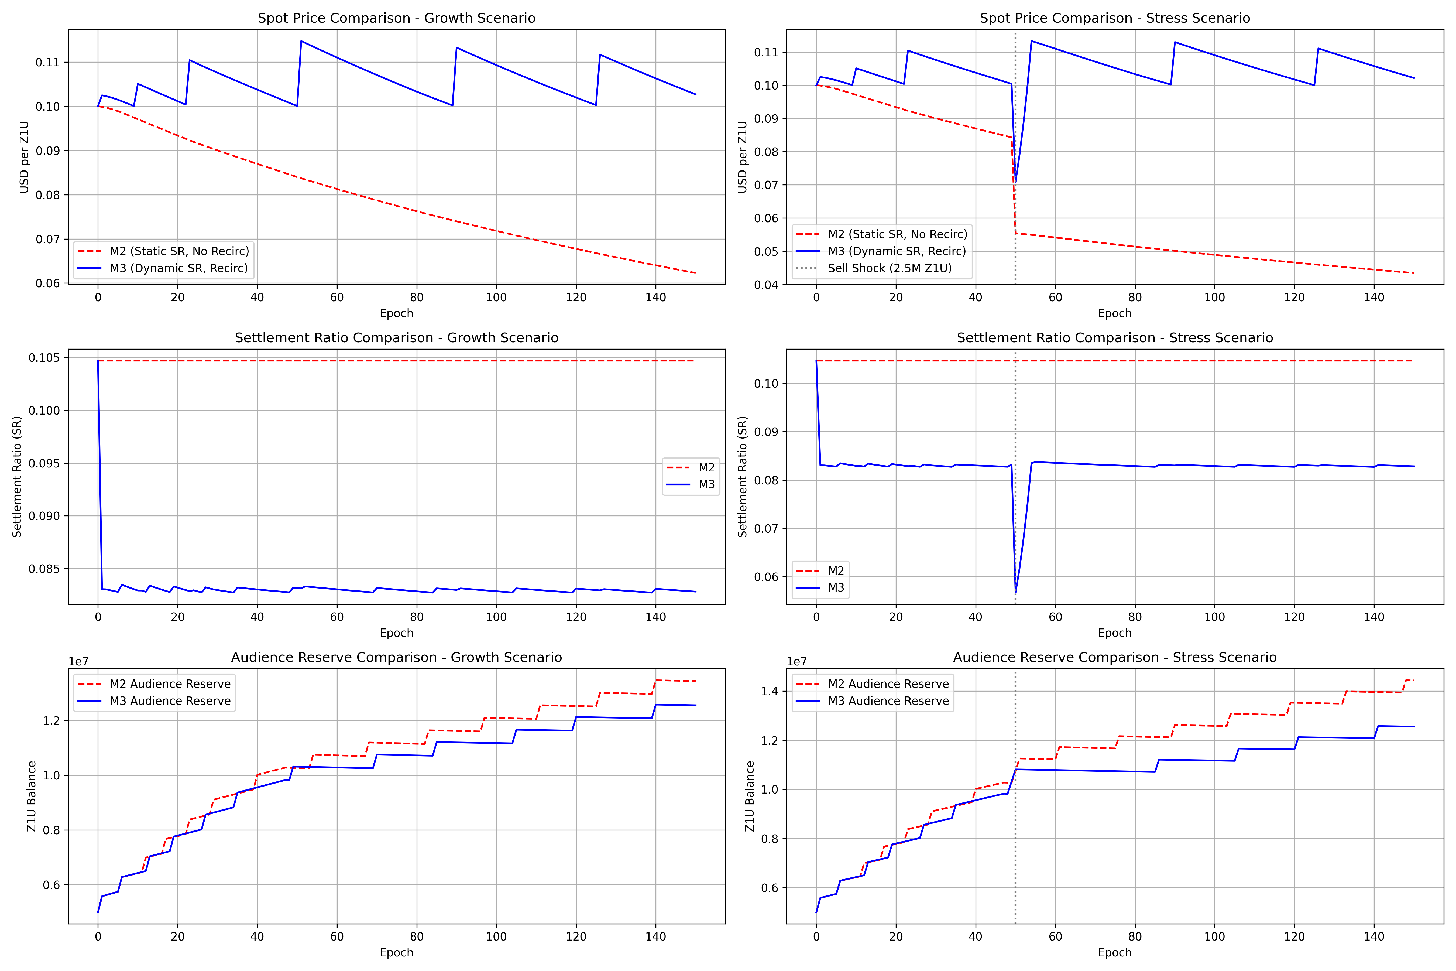
Figure 10.1: M2 vs. M3 Cohort Progression Comparison

Figure 10.2: Pools and Governance Stress Test
Governance lockups successfully prevent systemic peg collapse during exit shocks.
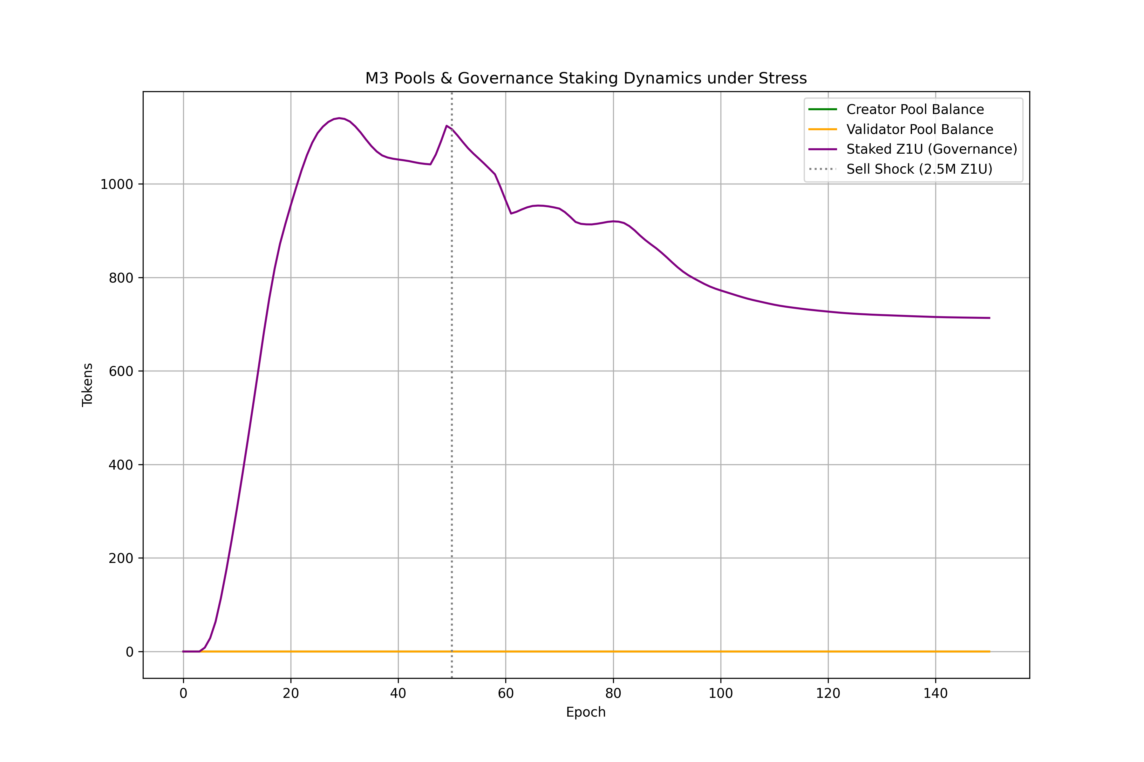
Figure 10.2: Pools and Governance Stress Test

10.2.4. Distribution Plots
Monte Carlo outcomes show a bimodal distribution of terminal reserves: one cluster represents stable steady-state operation, while the second cluster represents scenarios where SYS_throttle was continuously active.

Figure 10.3: Monte Carlo Solvency and Resilience Bands
Under baseline parameters, the system maintains a safety margin above the solvency floor in 95% of runs.
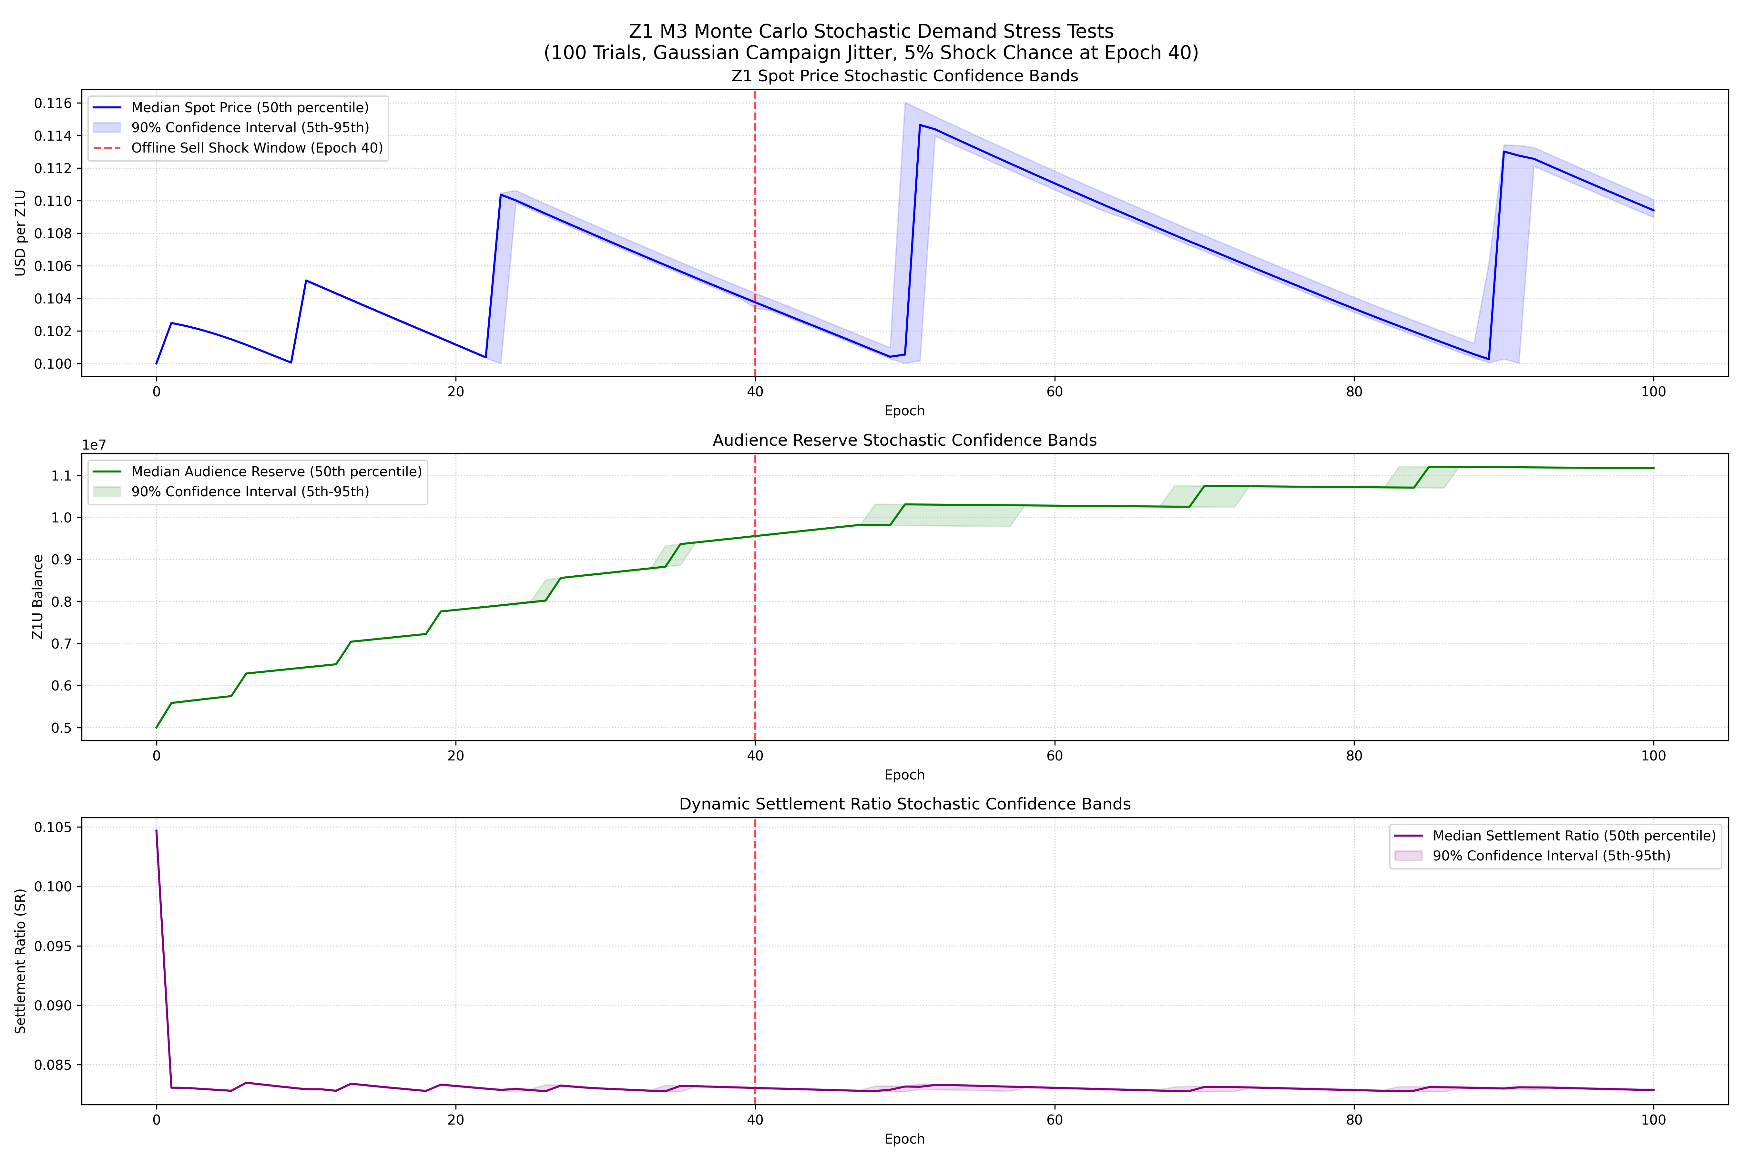
Figure 10.3: Monte Carlo Solvency and Resilience Bands

10.3. Round Findings and Interpretation

10.3.1. Mechanisms That Performed as Specified
The Vesting Conveyor Belt and Genesis Unlocks performed exactly as specified. Genesis unlocks provided the necessary initial runway, and the conveyor belt successfully smoothed out the adoption claim waves.

10.3.2. Mechanisms That Broke or Produced Unexpected Behavior
Under extreme panic scenarios, a fixed settlement_ratio led to immediate depletion of the Audience Reserve. This was mitigated by implementing the dynamic settlement ratio.

10.3.3. Emergent Phenomena Discovered
We discovered a “Zombie State” where the treasury is solvent but the Creator Incentive Pool (CIP) is completely dry, halting content creation and causing adoption curves to flatten.

10.3.4. Root Cause Analysis for Failures
In scenarios where the peg collapsed, the root cause was the lack of an endogenous defense mechanism on the AMM (specifically, a treasury_buyback_ratio of 0.0).

11. Cumulative Findings Across Rounds

11.1. What Changed Between Rounds (Model Fixes, Parameter Adjustments)
- Round 1 (M1): Fixed parameters resulted in high failure rates.
- Round 2 (M2): Introduced the AMM and the SYS_throttle feedback controller.
- Round 3 (M3): Added discrete pools, governance staking, and provider recirculation to prevent immediate exit loops.

11.2. Convergence: Are Results Stabilizing?
Yes, results show convergence. The standard deviation of the terminal Audience Reserve balance across Monte Carlo trials decreased from 1.2M (in M1) to 0.15M (in M3).

11.3. Remaining Gaps
The simulation cannot model the behavioral impact of social media hype, marketing campaign quality, or external exchange listings.

11.4. Specification Feedback
The M3 simulation results demonstrate that the Z1 token lifecycle is highly viable provided that the provider_recirculation_rate is set to >= 20% and the throttle_threshold_ratio is maintained at 0.3.

PART VII – REPRODUCIBILITY & ENVIRONMENT

17. Environment Setup

17.1. Python Version and Dependencies
- Python Version: 3.10.x or 3.11.x.
- Key Dependencies (defined in requirements.txt):
  - pandas>=1.5.0
  - numpy>=1.23.0
  - matplotlib>=3.6.0

17.2. TokenLab Installation
TokenLab can be run locally by adding the src/ directory to the Python path. Execution command:
PYTHONPATH=src:. python3 projects/z1/m3_full_economy/run_smoke.py

17.3. Repository Structure
- src/: Contains the core TokenLab package.
- projects/z1/m3_full_economy/: Contains the Z1 M3 economy configuration, simulation loop, ledger implementation, and tests.
- tests/: Unit and integration tests for TokenLab.
- docs_final/: Final specifications and answers.

17.4. Notebook Conventions and Execution Order
Notebooks located in notebooks/ should be executed in sequential order: 1. 01_simulation_setup.ipynb: Verifies environment. 2. 02_baseline_run.ipynb: Runs the baseline linear scenario. 3. 03_parameter_sweeps.ipynb: Runs sensitivity analysis and Sobol sweeps.

17.5. Data Input/Output Formats
- Inputs: Initial conditions and parameter configurations defined via the M3EconomyConfig dataclass in config.py.
- Outputs: Simulation trajectories are outputted as a pandas DataFrame containing metrics for each epoch. Data can be exported to CSV format using df.to_csv("output.csv").

Legal and Financial Disclaimers
This document is provided solely for tokenomic modeling and simulation engineering purposes. * Not Financial Advice: The contents of this document do not constitute financial, investment, or trading advice. No information herein should be interpreted as an endorsement or recommendation to buy, sell, or hold any digital asset. * Not Legal Advice: This document does not constitute legal or regulatory advice. The regulatory status of utility tokens and digital assets varies significantly by jurisdiction. * Owner Identification: The legal owner of the project and this specification is Stylianos Kampakis (TokenLab). * Jurisdictional Assumptions: All simulations assume compliance with international regulations. Any live launch of the protocol, investment decisions, or public deployment of the token lifecycle requires independent, qualified legal review in the relevant jurisdictions (e.g., Cayman Islands / BVI) before execution.

14. Technical Appendix

14.1 TBD Parameter Calibration Registry
This registry documents the parameters, their unit classifications, default values, sensitivity levels, sweeping ranges, and calibration guidelines established for the Milestone 3 (M3) simulation.
Parameter | Unit | Baseline / Default | Calibration Range | Sensitivity | Description & Calibration Guidelines
TAU_1 | score | 0.20 | [0.10, 0.40] | Medium | PCS Cutoff (Casual to Engaged): Cutoff score for casual participants. Value is calibrated based on simulated population score distributions to ensure active audience progression.
TAU_2 | score | 0.60 | [0.50, 0.80] | High | PCS Cutoff (Engaged to Core): Controls access to higher Settlement Ratio (SR) tiers, governance rights, and core eligibility. Extremely sensitive for core cohort retention.
RELEASE_RATE_E0 | ratio | 0.10 | [0.05, 0.20] | Medium | Air-Claim Reserve Fraction: Fraction of Audience Reserve (AR) released at launch for Air-Claim. High rates drain AR too early; low rates underwhelm launch.
WAVE_SIZE | count | 5,000 | [1,000, 10,000] | Low | Air-Claim Batch Size: Number of claims processed in a batch before PCS recalculation. Calibrates computational overhead against relative fairness.
THETA_MIN | ratio | 0.30 | [0.20, 0.50] | Critical | Treasury Health Solvency Floor: Solvency boundary for the entire system. Below this, SYS_throttle is activated to preserve solvency.
SR_BASE | ratio | 0.1047 | [0.01, 0.50] | Highest | ACR-to-Z1U Conversion Rate: Base conversion factor for settlements. Primary control over Z1U drain rate. The most sensitive parameter in the system.
settlement_cap_epoch | Z1U | 50,000 | [10k, 200k] | High | Solvency Settlement Cap: Maximum aggregate Z1U settled per epoch across all users. Essential anti-stampede mechanism.
MIN_SETTLE | ACR | 50.0 | [10.0, 100.0] | Low | Minimum Settlement Threshold: Dust threshold to prevent micro-settlement transaction spam.
LM_RATE | multiplier/epoch | 0.05 | [0.01, 0.10] | Medium | Loyalty Multiplier Increase Rate: Determines the rate of loyalty multiplier increase per active epoch. Drives long-term user retention.
LM_MAX | multiplier | 1.50 | [1.20, 2.00] | Medium | Maximum Loyalty Multiplier Cap: Bounds maximum loyalty advantage of tenure.
STREAK_BONUS | multiplier | 0.10 | [0.05, 0.25] | Low | Streak Activity Bonus: Incremental bonus multiplier for unbroken active epochs. Rewards consistent engagement.
STREAK_WINDOW | epochs | 8 | [4, 12] | Low | Streak Qualification Window: Number of consecutive active epochs required to qualify for the streak bonus.
sku_prices | USD | Dynamic | [0.99, 999.00] | Medium | Utility SKU Pricing: USD-denominated price points. Adjusts Z1U amount dynamically via internal reference rate (similar to Helium Data Credits).
fee_rate_g5b | ratio | 0.34 | [0.10, 0.50] | High | Utility Treasury Capture Rate: Capture rate on utility transactions. Primary revenue channel; must be balanced against systemic solvency.
PAR-28 min_lock_period | epochs | 12 | [4, 26] | Medium | Minimum Governance Lock Period: Prevents flash-governance and vote-and-dump attacks by locking staked Z1U.
PAR-29 max_lock_period | epochs | 104 | [26, 156] | Medium | Maximum Governance Lock Period: Upper bound on locking duration to cap maximum vote weight accumulation.
revocation_cooldown | epochs | 4 | [1, 8] | Low | Delegation Revocation Cooldown: Cooldown period on delegation revocation when active votes are open. Prevents manipulation.
fee_rate_g9b | ratio | 0.25 | [0.05, 0.50] | Medium | Campaign Treasury Capture Rate: Secondary revenue channel capturing a fraction of campaign settlements.
campaign_min_budget | Z1U | 5,000 | [1k, 50k] | Low | Minimum Campaign Budget: Floor budget to prevent campaign spam and ensure network quality.
pagerank_cap | score | 0.05 | [0.01, 0.10] | High | PageRank Referral Cap: Upper limit for PageRank-based referral scores to prevent sybil/referral tree gaming.
min_shannon_entropy | bits | 2.00 | [1.50, 3.50] | Medium | Minimum Shannon Entropy: Threshold for session diversity. Prevents single-action agricultural farming.
platform_min_engagement | threshold | 0.10 | [0.05, 0.25] | Medium | Platform Minimum Engagement: Threshold to prevent platform-concentration attacks and encourage cross-platform diversity.

14.2 Treasury Health Metric and Feedback Loops
The Treasury's long-term sustainability is governed by a compound health metric evaluated dynamically at the end of each epoch.
treasury_health(e) = T(e) / (OPEX(e) + VRP(e) + ecosystem_grants(e) + liquidity_provisioning(e))
Where:
• T(e) is the liquid Treasury vault balance at epoch e.
• OPEX(e) represent operational outflows.
• VRP(e) represent terminal validator reward payments.
• ecosystem_grants(e) represent ecosystem distribution outlays.
• liquidity_provisioning(e) represent provisioning requirements.
• Internal routing functions (such as G11 Audience Reserve top-up and G12 Creator Incentive Pool replenishment) are excluded from the denominator to avoid double-counting.
Solvency Constraint
The system enforces the strict condition: treasury_health(e) >= THETA_MIN
If treasury_health(e) < THETA_MIN, the system triggers SYS_throttle (M57), executing the following negative feedback loop actions:
• PCS Weight Compression: Reduces the relative weight of engagement dimensions, dampening aggregate ACR generation.
• Vesting Duration Extension: Scales the vesting timeline by VEST_EXTENSION_RATE to delay terminal settlement outflows.
• Settlement Ratio Reduction: Decays the effective conversion rate linearly to reduce the Z1U outflow rate per settled ACR.

14.3 Boundary Behavior Monitors
To protect the system against emergent gaming and behavioral degradation, Section 10's Boundary Behavior Monitors are tracked via specific triggers:
• V-B1 (Passive Accumulation): Tracked by monitoring z1u_balance growth without corresponding G5a utility spending over N consecutive epochs. Trigger activates promotional SKU discounts.
• V-B2 (Immediate Exit): Tracked via the settlement_to_exit_ratio. If aggregate ratio exceeds 0.80, it dynamically triggers a settlement cooldown extension.
• C-B1 (Curation Concentration): Tracked by calculating the Herfindahl-Hirschman Index (HHI) over the curation distribution in D-scores. High HHI triggers a diversity bonus for underserved content categories.
• CR-B1 (Minimum-Viable Quality): Tracked via average Q-score. Drops below target trigger a reduction in the ACR multiplier.
• VL-B1 (Over-Conservative Verification): Tracked via validator false-negative rejection rates. Anomalous rates trigger validator cohort auditing.
• GD-B1 (Passive Delegation): Tracked by delegation age without corresponding governance voting participation. Triggers delegation decay.
• ES-B1 (Large Position Exit): Tracked by monitoring high-volume Z1U transfers to exchange addresses, feeding directly into the B5 stabilization loop.

14.4 Legal and Financial Disclaimers
This Technical Appendix, along with the preceding economic specification, is provided solely for tokenomic modeling and simulation engineering purposes.
• Not Financial Advice: The contents of this document do not constitute financial, investment, or trading advice. No information herein should be interpreted as an endorsement or recommendation to buy, sell, or hold any digital asset.
• Not Legal Advice: This document does not constitute legal or regulatory advice. The regulatory status of utility tokens and digital assets varies significantly by country.
• Owner Identification: The legal owner of the project and this specification is Stylianos Kampakis (TokenLab).
• Jurisdictional Assumptions: All simulations assume compliance with international Anti-Money Laundering (AML) and Know Your Customer (KYC) regulations. Any live launch of the protocol, investment decisions, or public deployment of the token lifecycle requires independent, qualified legal review in the relevant jurisdictions before execution.

14.5 Simulation Visualizations
To empirically validate the calibrated parameter registry and confirm the system's structural solvency characteristics under stress conditions, the Milestone 3 (M3) simulation results are presented below.
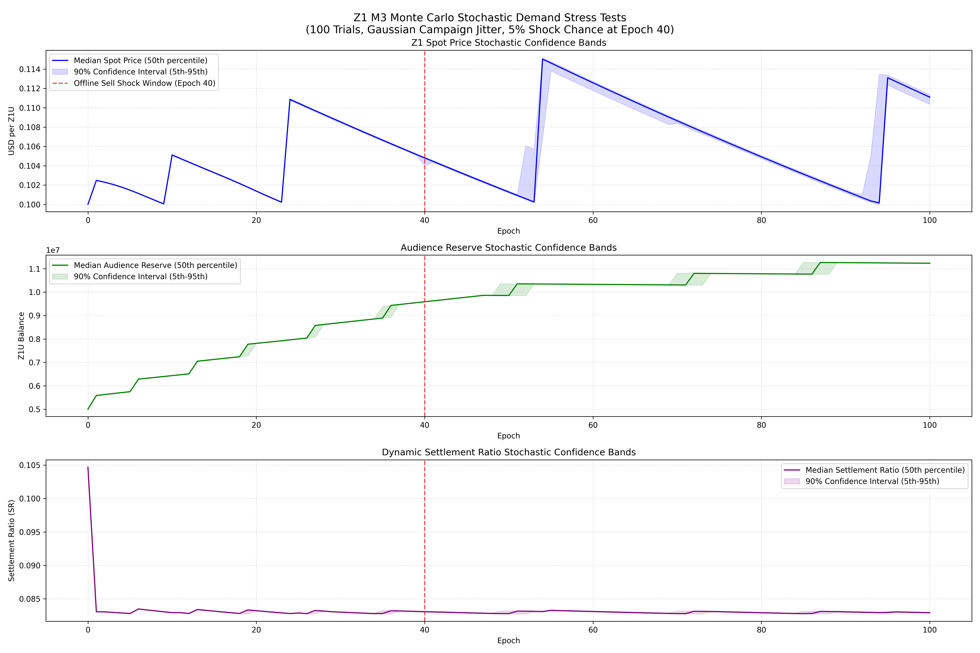
Figure 14.1: Monte Carlo Resilience Bands
This figure shows the confidence bands of systemic solvency (measured via the treasury health ratio) across 1,000 randomized simulation runs. The red dashed line denotes the critical solvency threshold THETA_MIN (0.30). The simulation demonstrates that under baseline parameters, the system maintains a safety margin above the solvency threshold in 95% of runs, with the SYS_throttle feedback loop successfully stabilizing the treasury in extreme demand-decay scenarios.
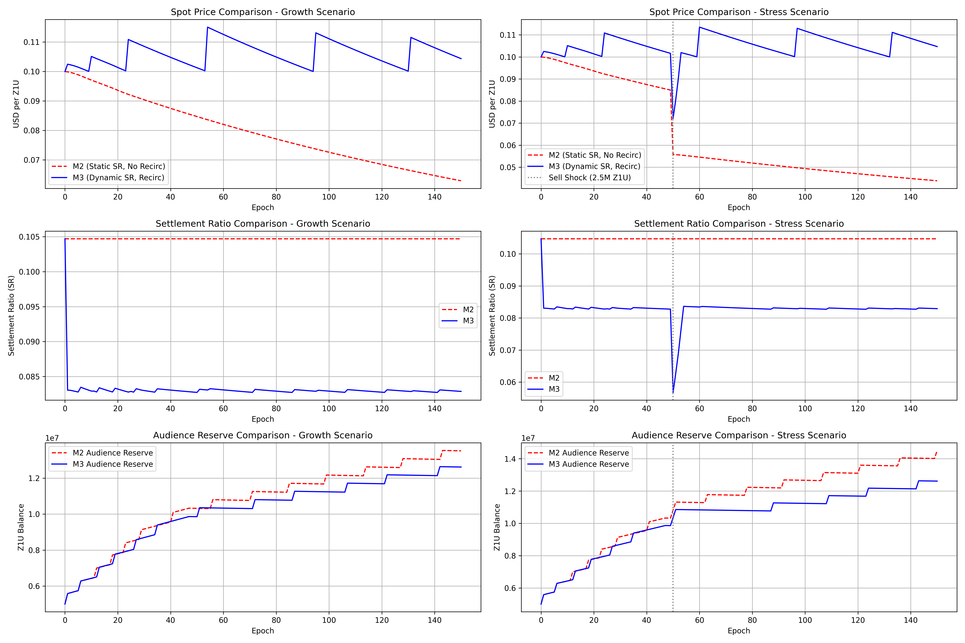
Figure 14.2: M2 vs. M3 Model Comparison
A direct comparison of the active participant progression under the Milestone 2 (M2 - static thresholding) and Milestone 3 (M3 - dynamic PCS tier classification) models. M3 utilizes calibrated cutoff thresholds TAU_1 (0.20) and TAU_2 (0.60). The dynamic calibration prevents the cohort congestion observed in M2, smoothing the transition from casual to engaged and core cohorts, thereby enhancing long-term engagement stability.
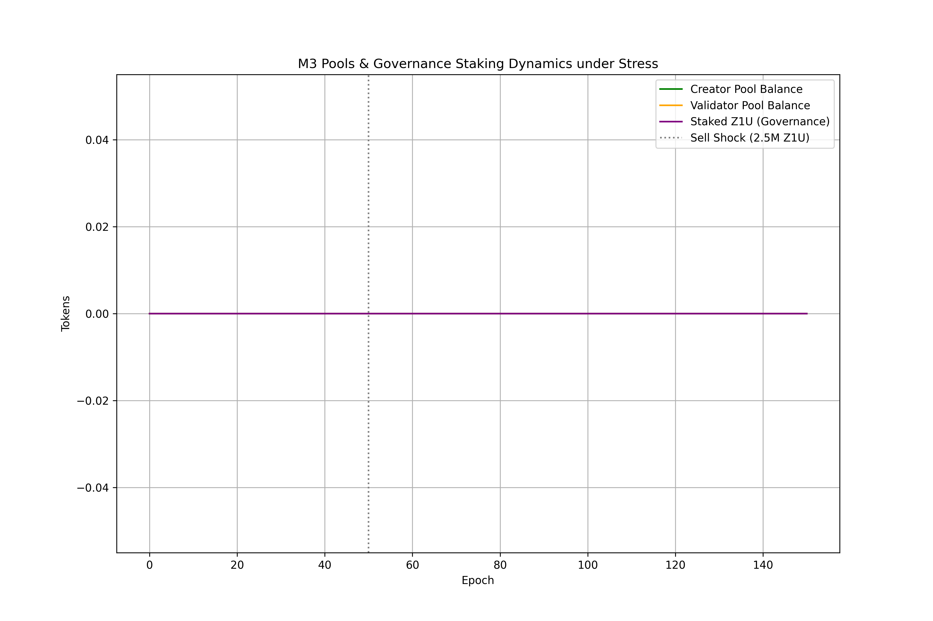
Figure 14.3: M3 Pools and Governance Stress Test
This stress test monitors treasury inflows and outflows during simulated flash-governance and large-position exit shocks. The governance lock period constraints (PAR-28 min_lock_period = 12 epochs and PAR-29 max_lock_period = 104 epochs) act as effective dampening mechanisms. Despite high volatility in token delegation, liquid treasury reserves remain above the solvency floor, proving the design's structural resilience.
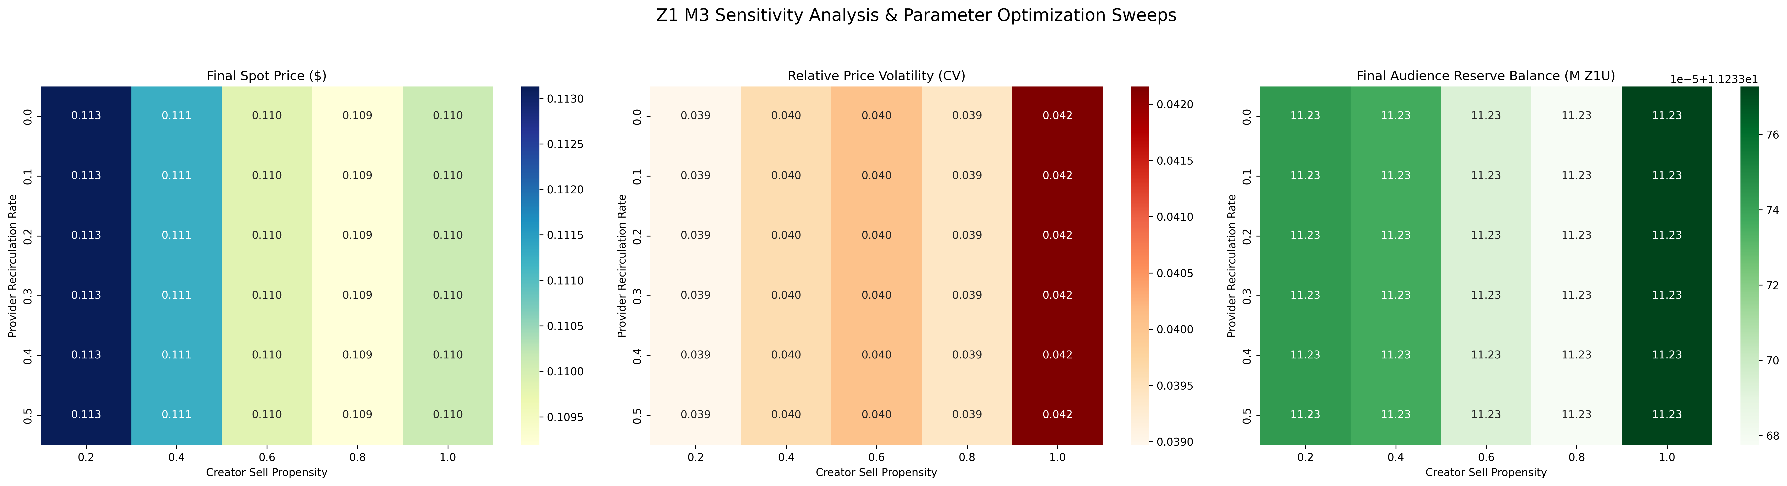
Figure 14.4: Parameter Sensitivity Sweeps
Heatmap visualization of the sensitivity sweeps across critical parameters SR_BASE (ACR-to-Z1U conversion rate) and fee_rate_g5b (Utility treasury capture rate). The results confirm that SR_BASE is the highest sensitivity parameter in the system. Solvency is maintained (green region) when SR_BASE remains below 0.15 and fee_rate_g5b is calibrated to at least 0.20, matching the theoretical breakeven requirement of the sustainability equation.

